Supplementary appendix
Supplementary Table 1. Detailed search strategies used in this review
Supplementary Table 2. Study quality evaluated by a tool developed by Hoy and colleagues
Supplementary Figure 1. Publication bias of studies on the anemia prevalence among children living with HIV
Supplementary Figure 2. Forest plots of severe anemia prevalence among children living with HIV
Supplementary Figure 3. Publication bias of studies on the severe anemia prevalence among children living with HIV
Supplementary Figure 4. Publication bias of studies on the severe anemia prevalence among children living with HIV
Supplementary Figure 5. Forest plots of severity of anemia prevalence among adults living with HIV
Supplementary Figure 6. Publication bias of studies on the mild anemia prevalence among adults living with HIV
Supplementary Figure 7. Publication bias of studies on the moderate anemia prevalence among adults living with HIV
Supplementary Figure 8. Publication bias of studies on the severe anemia prevalence among adults living with HIV
Supplementary Figure 9. Funnel plot of publication bias of studies on the anemia prevalence among pregnant women living with HIV

Supplementary Table 1. Detailed search strategies used in this review
Database | Search terms
PubMed | (“Anemia”[Mesh] OR anemi*[tiab] OR anaemi*[tiab]) AND (“HIV”[Mesh] OR “acquired immunodeficiency syndrome”[Mesh] OR human immunodeficiency virus*[tiab] OR HIV*[tiab] OR acquired immunodeficiency syndrome*[tiab] OR AIDS*[tiab]) AND (“prevalence”[Mesh] OR “incidence”[Mesh] OR“epidemiology”[Mesh] OR prevalence*[tiab] OR incidence*[tiab] OR epidemiology*[tiab])
EMBASE | (‘Anemia’/exp OR ‘anemi*’:ti,ab OR ‘anaemi*’:ti,ab) AND (‘human immunodeficiency virus’/exp OR ‘acquired immune deficiency syndrome’/exp OR ‘HIV*’:ti,ab OR ‘acquired immunodeficiency syndrome*’:ti,ab OR ‘AIDS*’:ti,ab) AND (‘prevalence’/exp OR ‘incidence/exp OR ‘epidemiology/exp OR ‘prevalence*’:ti,ab OR ‘incidence*’:ti,ab OR ‘epidemiology*’:ti,ab)
Web of Science | TS=(anemi* OR anaemi*) AND TS=(human immunodeficiency virus* OR HIV* OR acquired immunodeficiency syndrome* OR AIDS*) AND TS=(prevalence* OR incidence* OR epidemiology*)
Cochrane Library | ((Anemia[Mesh] OR (anemi* OR anaemi*):ab,ti,kw)) AND ((HIV[Mesh] OR acquired immunodeficiency syndrome[Mesh] OR (human immunodeficiency virus* OR HIV* OR acquired immune deficiency syndrome* AIDS*):ab,ti,kw)) AND (prevalence[Mesh] OR incidence[Mesh] OR epidemiology[Mesh] OR (prevalence*):ab,ti,kw OR (incidence*):ab,ti,kw OR (epidemiology*):ab,ti,kw))

Supplementary Table 2. Study quality evaluated by a tool developed by Hoy and colleagues
First author, year | Risk of bias item |  |  |  |  |  |  |  |  |  | Overall score
First author, year | Was the study’s target population a close representation of the national population in relation to relevant variables, e.g. age, sex, occupation? | Was the sampling frame a true or close representation of the target population? | Was some form of random selection used to select the sample, OR, was a census undertaken? | Was the likelihood of non-response bias minimal? | Were data collected directly from the subjects (as opposed to a proxy)? | Was an acceptable case definition used in the study? | Was the study instrument that measured the parameter of interest (e.g. prevalence of low back pain) shown to have reliability and validity (if necessary)? | Was the same mode of data collection used for all subjects? | Was the length of the shortest prevalence period for the parameter of interest appropriate? | Were the numerator(s) and denominator(s) for the parameter of interest appropriate? | Overall score
Bayleyegn et al., 2021 ⁴¹ | No | No | No | Yes | Yes | Yes | No | Yes | Yes | Yes | 6
Geleta et al., 2021 ¹⁷ | No | No | No | Yes | Yes | Yes | No | Yes | Yes | Yes | 6
Melku et al., 2020 ⁴² | No | No | No | Yes | Yes | Yes | No | Yes | Yes | Yes | 6
Tsegay et al., 2017 ⁴³ | No | No | No | Yes | Yes | Yes | No | Yes | Yes | Yes | 6
Ahumareze et al., 2016 ¹⁹ | No | No | No | Yes | Yes | Yes | No | Yes | Yes | Yes | 6
Shet et al., 2015 ⁴⁴ | No | No | No | Yes | Yes | Yes | No | Yes | Yes | Yes | 6
Ezeonwu et al., 2014 ⁴⁵ | No | No | No | Yes | Yes | Yes | No | Yes | Yes | Yes | 6
Kapavarapu et al., 2012 ⁴⁶ | No | No | No | Yes | Yes | Yes | No | Yes | Yes | Yes | 6
Shet et al., 2012 ⁴⁷ | No | No | No | Yes | Yes | Yes | No | Yes | Yes | Yes | 6
Damtie et al., 2021 ⁴⁸ | No | No | No | Yes | Yes | Yes | No | Yes | Yes | Yes | 6
Butt et al., 2020 ⁵⁹ | No | No | No | Yes | Yes | Yes | No | Yes | Yes | Yes | 6
Baye et al., 2020 ⁵⁰ | No | No | No | Yes | Yes | Yes | No | Yes | Yes | Yes | 6
Berhane et al., 2020 ⁵¹ | No | No | No | Yes | Yes | Yes | No | Yes | Yes | Yes | 6
Dobe et al., 2020 ¹⁸ | No | No | No | Yes | Yes | Yes | No | Yes | Yes | Yes | 6
Khatri et al., 2020 ⁵² | No | No | No | Yes | Yes | Yes | No | Yes | Yes | Yes | 6
Sah et al., 2020 ⁵³ | No | No | No | Yes | Yes | Yes | No | Yes | Yes | Yes | 6
Zanni et al., 2020 ⁵⁴ | No | No | No | Yes | Yes | Yes | No | Yes | Yes | Yes | 6
Albrecht et al., 2019 ⁶ | No | No | No | Yes | Yes | Yes | No | Yes | Yes | Yes | 6
Ageru et al., 2019 ⁵⁵ | No | No | No | Yes | Yes | Yes | No | Yes | Yes | Yes | 6
Tamir et al., 2019 ⁵⁶ | No | No | No | Yes | Yes | Yes | No | Yes | Yes | Yes | 6
Yesuf et al., 2019 ⁵⁷ | No | No | No | Yes | Yes | Yes | No | Yes | Yes | Yes | 6
Ezeamama et al., 2018 ⁵⁸ | No | No | No | Yes | Yes | Yes | No | Yes | Yes | Yes | 6
Hentzien et al., 2018 ⁵⁹ | No | No | No | Yes | Yes | Yes | No | Yes | Yes | Yes | 6
Katemba et al., 2018 ⁶⁰ | No | No | No | Yes | Yes | Yes | No | Yes | Yes | Yes | 6
Beyene et al., 2017 ⁶¹ | No | No | No | Yes | Yes | Yes | No | Yes | Yes | Yes | 6
Fiseha et al., 2017 ⁶² | No | No | No | Yes | Yes | Yes | No | Yes | Yes | Yes | 6
Jin et al., 2017a ⁶³ | No | No | No | Yes | Yes | Yes | No | Yes | Yes | Yes | 6
Jin et al., 2017b ⁶⁴ | No | No | No | Yes | Yes | Yes | No | Yes | Yes | Yes | 6
Gunda et al., 2017a ⁶⁵ | No | No | No | Yes | Yes | Yes | No | Yes | Yes | Yes | 6
Gunda et al., 2017b ⁶⁶ | No | No | No | Yes | Yes | Yes | No | Yes | Yes | Yes | 6
Melese et al., 2017 ⁶⁷ | No | No | No | Yes | Yes | Yes | No | Yes | Yes | Yes | 6
Sahle et al., 2017 ⁶⁸ | No | No | No | Yes | Yes | Yes | No | Yes | Yes | Yes | 6
Widiyanti et al., 2017 ⁶⁹ | No | No | No | Yes | Yes | Yes | No | Yes | Yes | Yes | 6
Gunda et al., 2016 ⁷⁰ | No | No | No | Yes | Yes | Yes | No | Yes | Yes | Yes | 6
Obirikorang et al. 2016 ⁷¹ | No | No | No | Yes | Yes | Yes | No | Yes | Yes | Yes | 6
Oo et al., 2016 ²¹ | No | No | No | Yes | Yes | Yes | No | Yes | Yes | Yes | 6
Akinyemi et al., 2015 ⁷² | No | No | No | Yes | Yes | Yes | No | Yes | Yes | Yes | 6
Akilimali et al., 2015 ⁷³ | No | No | No | Yes | Yes | Yes | No | Yes | Yes | Yes | 6
Kerkhoff et al., 2015 ⁷⁴ | No | No | No | Yes | Yes | Yes | No | Yes | Yes | Yes | 6
Minchella et al., 2015 ⁷⁵ | No | No | No | Yes | Yes | Yes | No | Yes | Yes | Yes | 6
Mijiti et al., 2015 ⁷⁶ | No | No | No | Yes | Yes | Yes | No | Yes | Yes | Yes | 6
Erqou et al., 2014 ⁷⁷ | No | No | No | Yes | Yes | Yes | No | Yes | Yes | Yes | 6
Kerkhoff et al., 2014 ⁷⁸ | No | No | No | Yes | Yes | Yes | No | Yes | Yes | Yes | 6
Kyeyune et al., 2014 ⁷⁹ | No | No | No | Yes | Yes | Yes | No | Yes | Yes | Yes | 6
Martin et al., 2014 ⁸⁰ | No | No | No | Yes | Yes | Yes | No | Yes | Yes | Yes | 6
Santiago et al., 2014 ⁸¹ | No | No | No | Yes | Yes | Yes | No | Yes | Yes | Yes | 6
Shet et al., 2014 ⁸² | No | No | No | Yes | Yes | Yes | No | Yes | Yes | Yes | 6
Tesfaye et al., 2014 ⁸³ | No | No | No | Yes | Yes | Yes | No | Yes | Yes | Yes | 6
Ferede et al., 2013 ⁸⁴ | No | No | No | Yes | Yes | Yes | No | Yes | Yes | Yes | 6
Hadgu et al., 2013 ⁸⁵ | No | No | No | Yes | Yes | Yes | No | Yes | Yes | Yes | 6
Khasanova et al., 2013 ⁸⁶ | No | No | No | Yes | Yes | Yes | No | Yes | Yes | Yes | 6
Liu et al., 2013 ⁸⁷ | No | No | No | Yes | Yes | Yes | No | Yes | Yes | Yes | 6
Zhou et al., 2013 ⁸⁸ | No | No | No | Yes | Yes | Yes | No | Yes | Yes | Yes | 6
Akinbo et al., 2012 ⁸⁹ | No | No | No | Yes | Yes | Yes | No | Yes | Yes | Yes | 6
Meidani et al., 2012 ⁹⁰ | No | No | No | Yes | Yes | Yes | No | Yes | Yes | Yes | 6
De Santis et al., 2011 ³⁶ | No | No | No | Yes | Yes | Yes | No | Yes | Yes | Yes | 6
Subbaraman et al., 2009 ⁹¹ | No | No | No | Yes | Yes | Yes | No | Yes | Yes | Yes | 6
Erhabor et al., 2006 ⁹² | No | No | No | Yes | Yes | Yes | No | Yes | Yes | Yes | 6
Berhane et al., 2004 ⁹³ | No | No | No | Yes | Yes | Yes | No | Yes | Yes | Yes | 6
Semba et al., 2001 ⁹⁴ | No | No | No | Yes | Yes | Yes | No | Yes | Yes | Yes | 6
Delicio et al., 2018 ⁹⁵ | No | No | No | Yes | Yes | Yes | No | Yes | Yes | Yes | 6
Manyanga et al., 2014 ⁹⁶ | No | No | No | Yes | Yes | Yes | No | Yes | Yes | Yes | 6
Ezechi et al., 2013 ⁹⁷ | No | No | No | Yes | Yes | Yes | No | Yes | Yes | Yes | 6

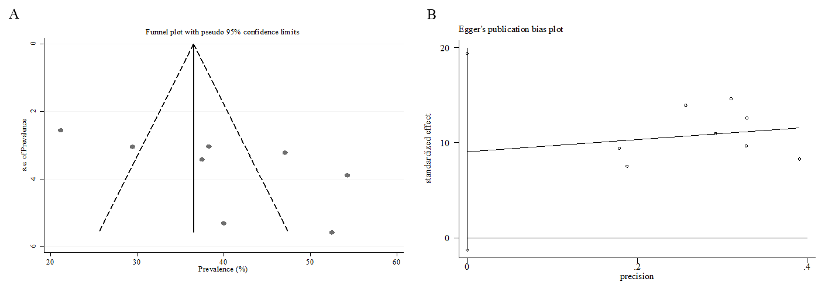Supplementary Figure 1. Publication bias of studies on the anemia prevalence among children living with HIV:(A) Funnel plot; (B) Egger’s test

Supplementary Figure 2. Forest plots of severe anemia prevalence among children living with HIV

Supplementary Figure 3. Publication bias of studies on the severe anemia prevalence among children living with HIV:(A) Funnel plot; (B) Egger’s test
Supplementary Figure 4. Publication bias of studies on the severe anemia prevalence among children living with HIV:(A) Funnel plot; (B) Egger’s test
Supplementary Figure 5. Forest plots of severity of anemia prevalence among adults living with HIV
Supplementary Figure 6. Publication bias of studies on the mild anemia prevalence among adults living with HIV:(A) Funnel plot; (B) Egger’s test

Supplementary Figure 7. Publication bias of studies on the moderate anemia prevalence among adults living with HIV:(A) Funnel plot; (B) Egger’s test

Supplementary Figure 8. Publication bias of studies on the severe anemia prevalence among adults living with HIV:(A) Funnel plot; (B) Egger’s test
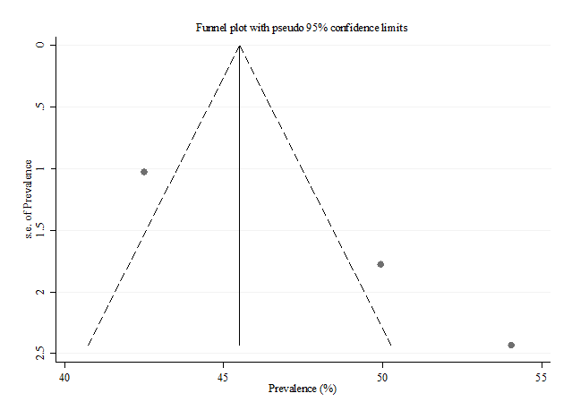
Supplementary Figure 9. Funnel plot of publication bias of studies on the anemia prevalence among pregnant women living with HIV

