Trial | Study duration | Study arms included  in meta-analysis | Number  (n) | Age  (years) | Uric acid  (mg/dl) |  | Creatinine  (mg/dl) |  | eGFR  (ml/min/1.73m²) |  |  | eGFR formula
Kimura  2018 | 108weeks | Febuxostat | 219 | 65.3±11.8 | 7.8 ± 0.9 |  | 1.25±0.26 |  | 45.2 ± 9.5 |  |  | JSN-CKDI
Kimura  2018 | 108weeks | Placebo | 222 | 65.4±12.3 | 7.8 ± 0.9 |  | 1.25±0.26 |  | 45.2 ± 9.5
Kojima  2019 | 36 months | Febuxostat | 537 | 75.4 ± 6.7 | 7.54 ±1.06 |  |  |  | 54.62 ±14.11 |  | Japanese GFR equation
Kojima  2019 | 36 months | Non-febuxostat* | 533 | 76.0 ± 6.5 | 7.50 ±1.03 |  |  |  | 55.35 ±15.16
Badve2020 | 104weeks | Allopurinol | 182 | 62.3±12.6 | 8.2±1.8 |  |  |  | 31.6±11.7 |  | CKD-EPI
Badve2020 | 104weeks | Placebo | 181 | 62.6±12.9 | 8.2±1.7 |  |  |  | 31.9±12.4
Siu2006 | 12 months | Allopurinol | 25 | 47.7±12.9 | 9.75 ±1.18 |  | 1.64±0.63
Siu2006 | 12 months | Standard therapy$ | 26 | 48.8±16.8 | 9.92±1.68 |  | 1.86±0.69
Sircar2015 | 6 months | Febuxostat | 45 | 56.22±10.87 | 9.0±2.0 |  | 2.21±0.75 |  | 31.5±13.6 |  | MDRD
Sircar2015 | 6 months | Placebo | 48 | 58.42±14.52 | 8.2±1.1 |  | 2.22±0.63 |  | 32.6±11.6
Tanaka  2020 | 24months | Febuxostat | 239 | 69.1 ±10.1 | 7.76 ± 0.98 |  |  |  | 56.26 ±15.41
Tanaka  2020 | 24months | Standard therapy$ | 244 | 69.1 ±10.7 | 7.73 ±1.04 |  |  |  | 57.12 ±15.83
Golmohammadi2017 | 12 months |  |  |  | mild GFR | severe GFR | mild GFR | severe GFR | mild GFR | severe GFR
Golmohammadi2017 | 12 months | Allopurinol | 96 |  | 7.86±1.36 | 7.85±1.41 | 1.66 ± 0.30 | 3.40 ± 0.95 | 50.37±11.26 | 20.84 ± 5.80
Golmohammadi2017 | 12 months | placebo | 100 |  | 7.77±1.26 | 7.70±0.95 | 1.68 ± 0.37 | 2.89 ± 0.56 | 50.38 ± 13.22 | 24.57 ± 3.97
Jalal2017 | 12weeks | Allopurinol | 39 | 55.9±13.7 | 8.3±1.4 |  | 1.81±0.37 |  | 41.3±8.9 |  | CKD-EPI
Jalal2017 | 12weeks | placebo | 41 | 58.9±9.3 | 8.7±1.6 |  | 1.75±0.42 |  | 42.4±9.6
Liu2015 | three years | Allopurinol | 82 | 50 ± 10 | 433 ± 11& |  | 75.6 ± 11.0& |  | 90.1 ± 17.5
Liu2015 | three years | Conventional  treatment group⁑ | 70 | 51 ± 11 | 432 ± 9& |  | 75.0 ± 10.9& |  | 90.1 ± 18.4
Mukri2018 | 6  months | Febuxostat | 47 | 64 (10)# | 539.5 ± 104& |  | 195.2 ± 51.8& |  | 26.2 (14.3)# |  | CKD-EPI
Mukri2018 | 6  months | No treatment | 46 | 67 (6)# | 537.3 ± 70.6& |  | 194.2 ± 56.2& |  | 28.2 (19.8)#
Takir2015 | 3 months | Allopurinol | 40 | 52.15± 15.86 | 7.86 ± 0.62 |  | 0.9 ± 0.15
Takir2015 | 3 months | Control group∆ | 33 | 49.88 ± 12.46 | 7.45 ± 0.9 |  | 1.07 ± 0.2
Table S1. Baseline characteristics of the study population
* Non-febuxostat:100 mg of oral allopurinol was considered if serum uric acid levels were elevated during the study period starting from the time of enrollment; $ Standard therapy: continue and adjust the usual therapy such as antihypertensive drugs, lipid-lowering agents, antiplatelet drugs or steroid or cytotoxic drugs, or non-pharmacological lifestyle modification for hyperuricemia, such as a healthy diet and exercise therapy; ∆Control group: non-pharmacological treatment of hyperuricemia. ⁑Conventional treatment group: received no uric acid lowering therapy. JSN-CKDI: Japanese Society of Nephrology-Chronic Kidney Disease Initiatives. & The unit is umol/L. Data are mean ±SD expect # (Data are median (IQR));

A
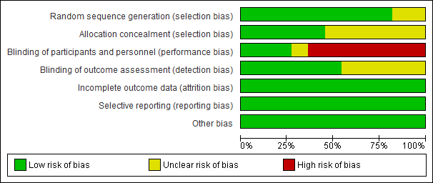

B
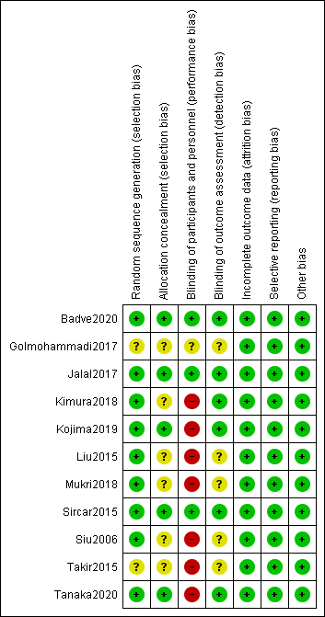
Supplemental Figure S1. Risk of bias of included studies (A) Risk of bias graph (B) Risk of bias summary

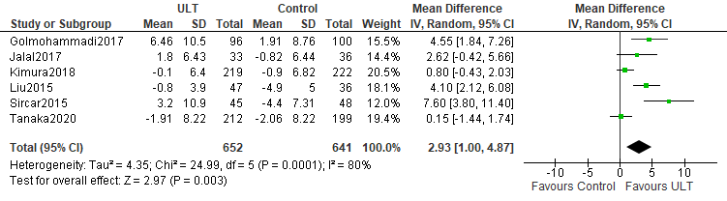
Supplemental Figure S2. eGFR: ULT vs control group

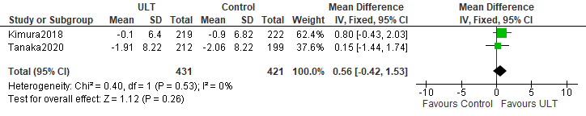
Supplemental Figure S3. eGFR of patients more than 100 in each group: ULT vs control group

A.
B. Egger's test
------------------------------------------------------------------------------
Std_Eff | Coef. Std. Err. t P>|t| [95% Conf. Interval]
-------------+----------------------------------------------------------------
slope | -1.540286 .695327 -2.22 0.054 -3.113225 .0326532
bias | -7.29893 3.909015 -1.87 0.095 -16.14174 1.543877
------------------------------------------------------------------------------

C.
Supplemental Figure S4. Publication bias (A) Begg's plot (B) P value for Egger's test (C) Egger's plot

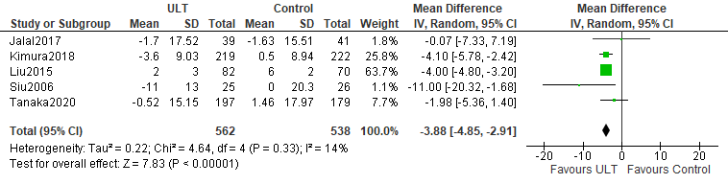
Supplemental Figure S5. Systolic blood pressure: ULT vs control group

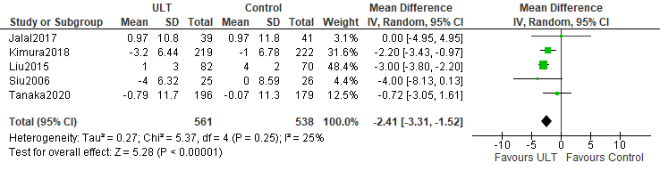
Supplemental Figure S6. Diastolic blood pressure: ULT vs control group

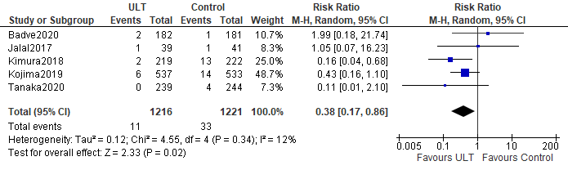
Supplemental Figure S7. Gout episodes: ULT vs control group

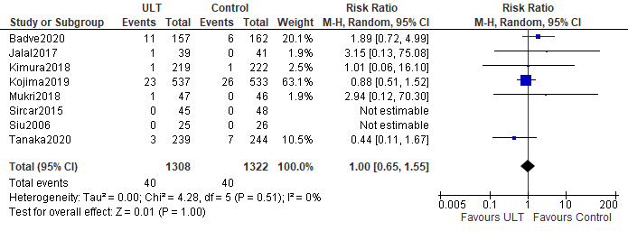
Supplemental Figure S8. All-cause mortality: ULT vs control group

