Supplemental materials (Tables S1-S3 and Figures S1-S8) to

Can exercise promote additional benefits on body composition in patients with obesity after bariatric surgery? A systematic review and meta-analysis of Randomized Controlled Trials

Giorjines Boppre, Florêncio Diniz-Sousa, Lucas Veras, José Oliveira, Hélder Fonseca

Research Centre in Physical Activity, Health and Leisure (CIAFEL), Faculty of Sport, University of Porto, Porto, Portugal

Table of Contents
Supplementary table 1: Effect of exercise participation following BS on anthropometric and body composition 2
Supplementary table 2: Sub-analyses of the effect of different exercise intervention onsets on anthropometry and body composition after bariatric surgery 2
Supplementary table 3: Sub-analyses of the effects of exercise on anthropometry and body composition according to exercise intervention duration 3
Supplementary figure 1. Effects of combined exercise interventions after bariatric surgery. 4
Supplementary figure 2: Effects of aerobic exercise interventions after bariatric surgery. 5
Supplementary figure 3: Effects of resistance exercise interventions after bariatric surgery. 5
Supplementary figure 4: Effects exercise interventions with onset <6 months after bariatric surgery. 6
Supplementary figure 5: Effects exercise interventions with onset >6 months after bariatric surgery. 7
Supplementary figure 6: Exercise interventions <12-weeks protocol duration. 7
Supplementary figure 7: Exercise interventions >12-weeks protocol duration. 8
Supplementary figure 8: Sensitivity analysis according to the substantial I². 9

Supplementary table 1: Effect of exercise participation following BS on anthropometric and body composition

 |  | BS + Exercise vs BS only
Outcomes | N | MD (95% CI) | I² (p) | Z (p)
Body weight (kg) | 11 | -2.51 (-4.74; -0.27) | 0% (0.78) | -2.20 (0.03)
Waist circumference (cm) | 4 | -4.14 (-8.16; -0.12) | 9% (0.35) | -2.02 (0.04)
BMI (kg∙m-2) | 8 | -0.84 (-1.60; -0.08) | 0% (0.63) | -2.16 (0.03)
Fat mass (kg) | 3 | -1.40 (-4.84; 2.03) | 68% (0.04) | -0.80 (0.42)
Lean Mass (kg) | 3 | 0.87 (-0.65; 2.24) | 0% (0.83) | 1.12 (0.28)

Note: Data are presented in mean difference (MD), confidence interval (CI), heterogeneity and p-value I² (p), test for overall effect and p-value Z (p) and statistical significance p<0.05.
Abbreviation: Bariatric surgery (BS), body mass index (BMI) and number of studies (N).

Supplementary table 2: Sub-analyses of the effect of different exercise intervention onsets on anthropometry and body composition after bariatric surgery
<6-months
Outcomes | N | MD (95% CI) | I² (p) | Z (p)
Body weight (kg) | 8 | -0.12 (-3.17; 2.93) | 0% (1.00) | -0.08 (0.94)
Waist circumference (cm) | 3 | -4.30 (-11.30, 2.70) | 39% (0.20) | -1.20 (0.23)
BMI (kg∙m-2) | 6 | -0.16 (-1.15; 0.82) | 0% (1.00) | -0.33 (0.74)
Fat mass (kg) | 2 | 0.49 (-1.71; 2.69) | 0% (0.64) | 0.44 (0.66)
Lean Mass (kg) | 3 | 0.87 (-0.65; 2.40) | 0% (0.83) | 1.12 (0.26)
>6-months
Outcomes | N | MD (95% CI) | I² (p) | Z (p)
Body weight (kg) | 3 | -5.25 (-8.52; -1.97) | 0% (0.82) | -3.14 (<0.01)
BMI (kg∙m-2) | 2 | -1.84 (-3.04; -0.64) | 0% (0.44) | -3.01 (<0.01)

Note: Data are presented in mean difference (MD), confidence interval (CI), heterogeneity and p-value I² (p), test for overall effect and p-value Z (p) and statistical significance p<0.05.
Abbreviation: Bariatric surgery (BS), body mass index (BMI), less than 6 months (<6-months) and more than 6 months (>6-months)

Supplementary table 3: Sub-analyses of the effects of exercise on anthropometry and body composition according to exercise intervention duration
 |  | <12-weeks
Outcomes | N | MD (95% CI) | I² (p) | Z (p)
Body weight (kg) | 5 | -1.68 (-7.67; 4.32) | 0% (0.99) | -0.55 (0.58)
Waist circumference (cm) | 2 | -6.44 (-18.69; 5.81) | 59% (0.12) | -1.03 (0.30)
BMI (kg∙m-2) | 4 | -0.40 (-2.54; 1.74) | 0% (0.99) | -0.37 (0.71)
 |  | >12-weeks
Outcomes | N | MD (95% CI) | I² (p) | Z (p)
Body weight (kg) | 4 | -2.28 (-6.31; 1.75) | 48% (0.12) | -1.11 (0.27)
Waist circumference (cm) | 2 | -3.38 (-7.66; 0.90) | 0% (0.55) | -1.55 (0.12)
BMI (kg∙m-2) | 4 | -0.85 (-2.05; 0.35) | 40% (0.17) | -1.39 (0.16)
Fat mass (kg) | 3 | -1.40 (-4.84; 2.03) | 68% (0.04) | -0.80 (0.42)
Lean Mass (kg) | 2 | 0.92 (-0.65;2.50) | 0% (0.58) | 1.15 (0.25)

Note: Data are presented in mean difference (MD), confidence interval (CI), heterogeneity and p-value I² (p), test for overall effect and p-value Z (p) and statistical significance p<0.05.
Abbreviation: Bariatric surgery (BS), body mass index (BMI), number of studies (N), less than 12 weeks (<12-weeks) and more than 12 weeks (>12-weeks)

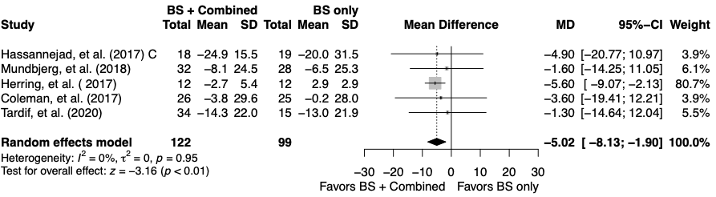
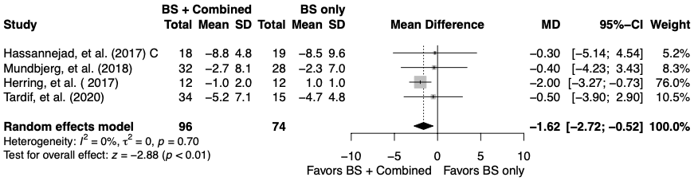

Supplementary figure 1. Effects of combined exercise interventions after bariatric surgery.
Note: Data are presented in mean ± SD, mean difference (MD), 95% confidence interval (95%-CI), statistical significance (p <0.05).
Abbreviation: Bariatric surgery (BS), body weight (BW), body mass index (BMI) and combined exercise (C).
BW (kg)
BMI (kg∙m-2)

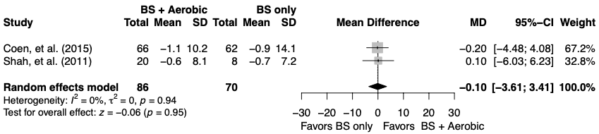
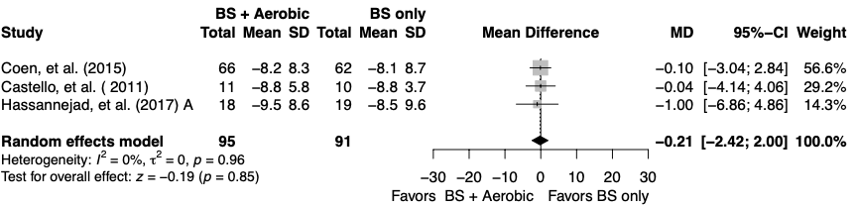
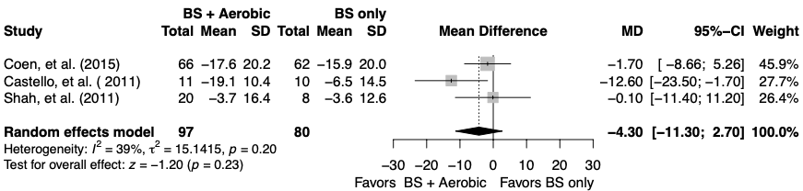
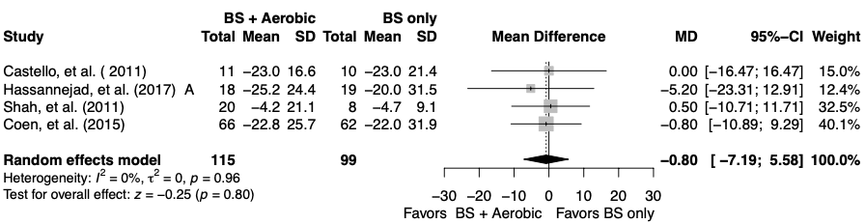

Supplementary figure 2: Effects of aerobic exercise interventions after bariatric surgery.
Note: Data are presented in mean ± SD, mean difference (MD), 95% confidence interval (95%-CI), statistical significance (p <0.05).
Abbreviation: Bariatric surgery (BS), body weight (BW), waist circumference (WC), body mass index (BMI), lean mass (LM) and aerobic exercise (A).
BW (kg)
WC (cm)
BMI (kg∙m-2)
LM (kg)

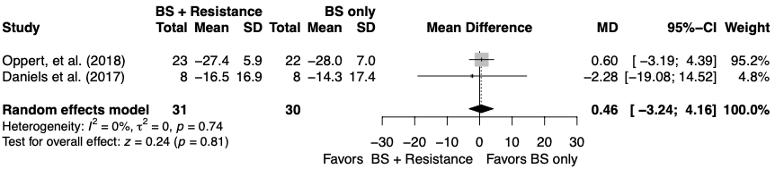

Supplementary figure 3: Effects of resistance exercise interventions after bariatric surgery.
Note: Data are presented in mean ± SD, mean difference (MD), 95% confidence interval (95%-CI), statistical significance (p <0.05).
Abbreviation: Bariatric surgery (BS) and body weight (BW).
BW (kg)

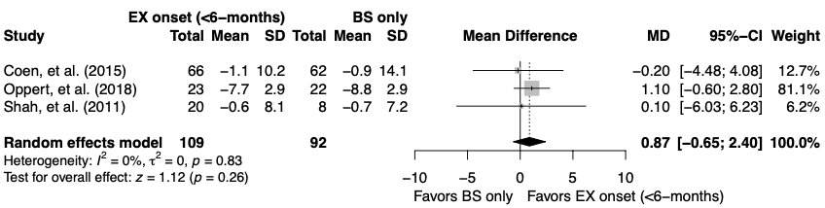
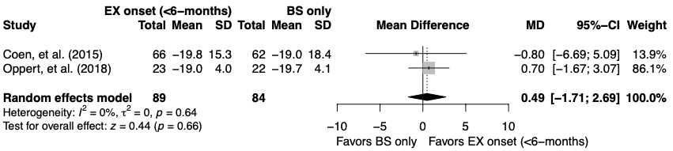
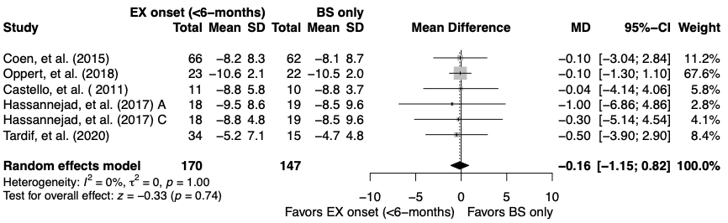
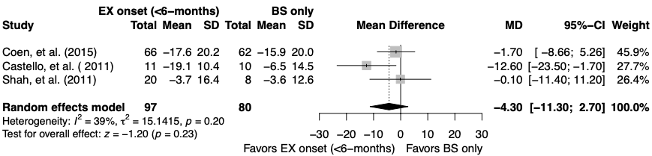
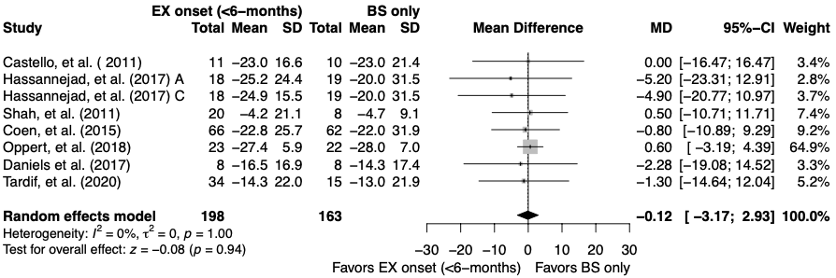
BW (kg)
WC (cm)
BMI (kg∙m-2)
FM (kg)
LM (kg)

Supplementary figure 4: Effects exercise interventions with onset <6 months after bariatric surgery.
Note: Data are presented in mean ± SD, mean difference (MD), 95% confidence interval (95%-CI), statistical significance (p <0.05).
Abbreviation: Bariatric surgery (BS), body weight (BW), waist circumference (WC), body mass index (BMI), fat mass (FM) and lean mass (LM).aerobic exercise (A), combined exercise (C) and exercise (EX).

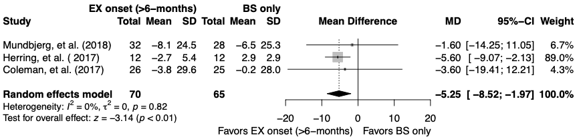
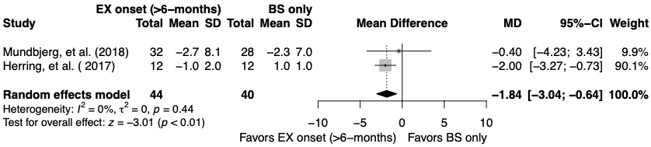

Supplementary figure 5: Effects exercise interventions with onset >6 months after bariatric surgery.
Note: Data are presented in mean ± SD, mean difference (MD), 95% confidence interval (95%-CI), statistical significance (p <0.05).
Abbreviation: Bariatric surgery (BS), body weight (BW), body mass index (BMI) and exercise (EX).
BW (kg)
BMI (kg∙m-2)

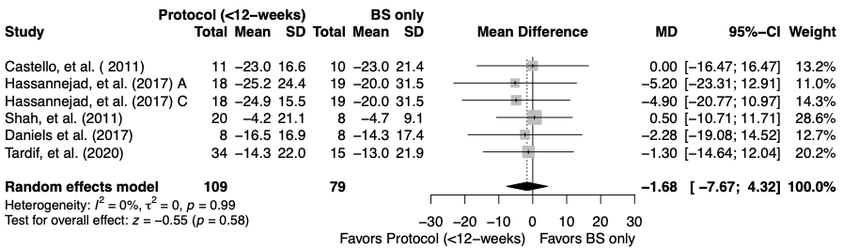
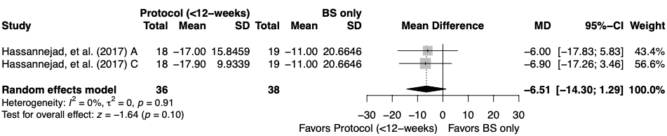
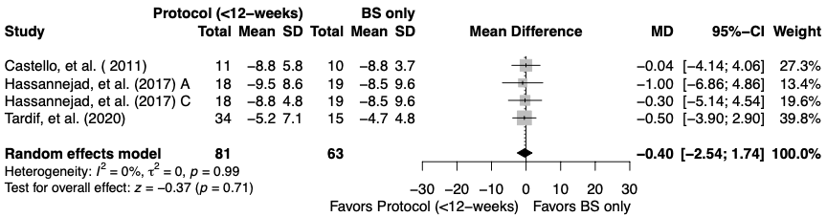
BW (kg)
WC (cm)
BMI (kg∙m-2)

Supplementary figure 6: Exercise interventions <12-weeks protocol duration.
Note: Data are presented in mean ± SD, mean difference (MD), 95% confidence interval (95%-CI), statistical significance (p <0.05).
Abbreviation: Bariatric surgery (BS), body weight (BW), waist circumference (WC), body mass index (BMI), aerobic exercise (A) and combined exercise (C).

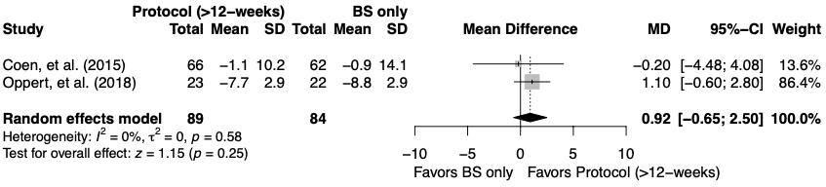
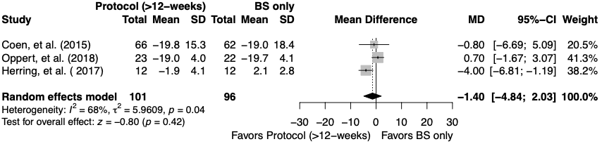
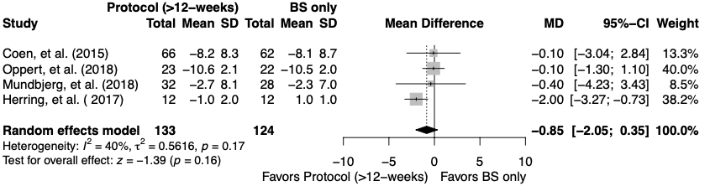
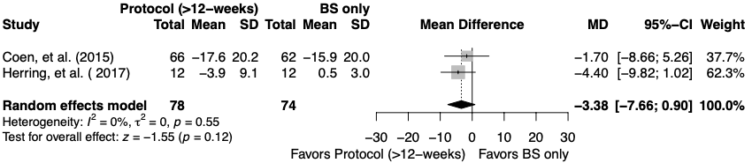
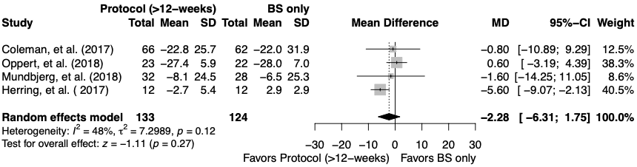
LM (kg)
FM (kg)
BMI (kg∙m-2)
WC (cm)
BW (kg)

Supplementary figure 7: Exercise interventions >12-weeks protocol duration.
Note: Data are presented in mean ± SD, mean difference (MD), 95% confidence interval (95%-CI), statistical significance (p <0.05).
Abbreviation: Bariatric surgery (BS), body weight (BW), waist circumference (WC), body mass index (BMI), fat mass (FM) and lean mass (LM).

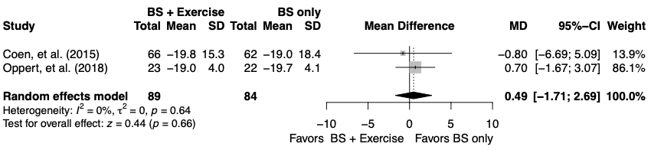
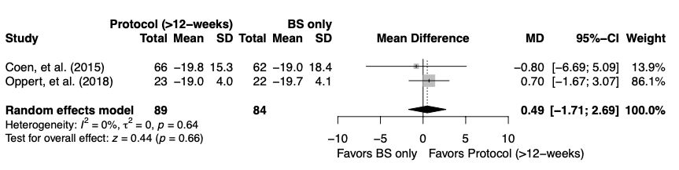

Supplementary figure 8: Sensitivity analysis according to the substantial I².
Note: Data are presented in mean ± SD, mean difference (MD), 95% confidence interval (95%-CI), statistical significance (p <0.05).
Abbreviation: Bariatric surgery (BS) and fat mass (FM).
FM (kg)
FM (kg)

