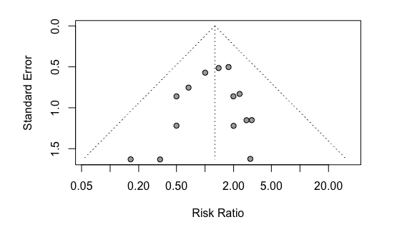
Additional file S 6: Funnel plot of comparison: dihydroartemisinin-piperaquine versus artemether-lumefantrine for treatment of uncomplicated plasmodium falciparum malaria among African children, outcome: Serious adverse event (including death).

