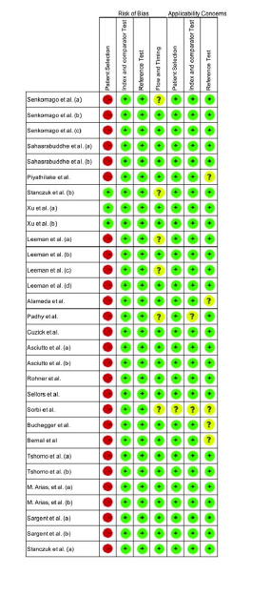
Fig. S1. Quality assessment (Quality Assessment of Diagnostic Accuracy Studies-2).

