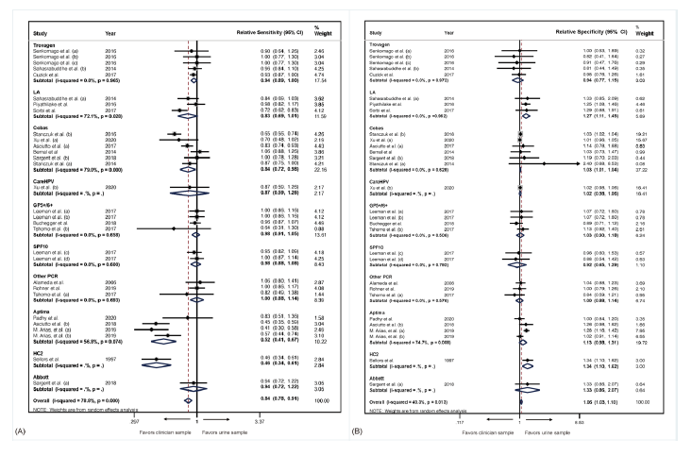
Fig. S2. Relative sensitivity (A) and specificity (B) of urinary versus cervical HPV test, by HPV assays, for detection of CIN2 or worse.

