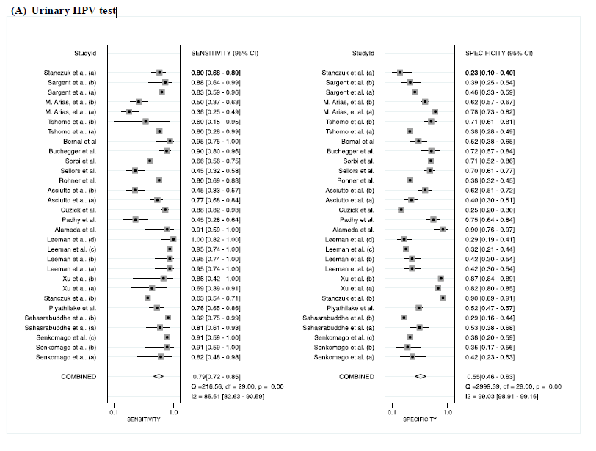
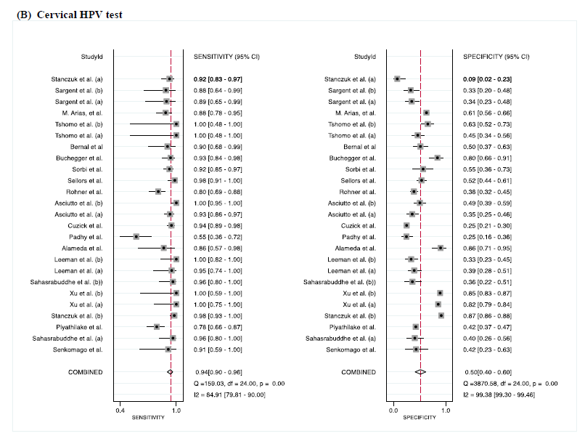
Fig. S3. Forest plot of absolute sensitivity and specificity of (A) urinary HPV test and (B) cervical HPV test.
CI, confidence interval; HPV, human papillomavirus.

