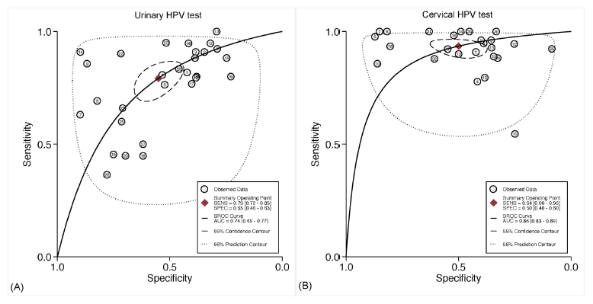
Fig. S4. Summary of receiver operating characteristics curves of (A) urinary HPV test and (B) cervical HPV test for the detection of cervical intraepithelial neoplasia 2 or worse.
HPV, human papillomavirus.

