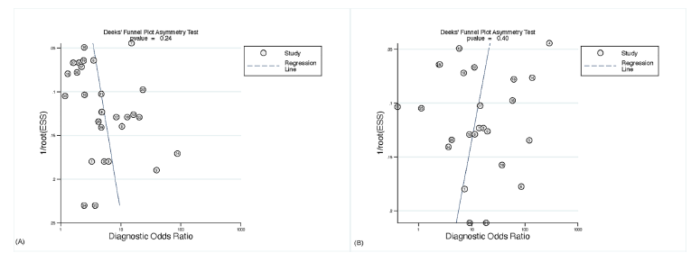
Fig. S5. Funnels for publication bias in studies of (A) urinary HPV and (B) cervical HPV.
HPV, human papillomavirus.

