Section / topic | # | Checklist item | Reported on page #
TITLE
Title | 1 | Convalescent plasma may be a possible treatment for COVID-19：a systematic review | Title
ABSTRACT
Structured summary | 2 | The coronavirus disease 2019 (COVID-19) pandemic has spread globally. Therapeutic options including antivirals, anti-inflammatory compounds, and vaccines are under study. Convalescent plasma(CP) immunotherapy was an effective method for fighting against similar viral infections such as SARS-CoV, and MERS-CoV. In the of epidemic, a large number of literature reported the application of CP. This systematic review was designed to evaluate the existing evidence and experience related to CP immunotherapy for COVID-19. A literature search was conducted on Pubmed, Cochrane Library, Clinical Key, Wanfang Database; China National Knowledge Infrastructure (CNKI) were used to search for the proper keywords such as SARS-CoV-2, COVID-19, plasma, serum, immunoglobulins, blood transfusion, convalescent, novel coronavirus, immune and the related words for publications published until 30.6.2020. Other available resources were also used to identify relevant articles. The present systematic review was performed based on PRISMA protocol. Data extraction and quality valuation of articles were performed by two reviewers. Based on the inclusions and exclusions criteria, 9 articles were included in the final review. We found that CP therapy is applicable to a wide range of people, which is still effective 7 days after the onset of symptoms. Despite CP vary in the dose and titer, patients still benefit after infusion and no severe adverse reactions related to CP were found. As a conclusion of this systematic review demonstrated that CP immunotherapy for this virus could be a suitable option. | Abstract
INTRODUCTION
Rationale | 3 | The coronavirus disease 2019, an outbreak caused by the severe acute respiratory syndrome coronavirus 2(SARS-CoV-2), continues to spread, and as per the World Health Organization(WHO) data on November 10, 2020, it has reported cumulative numbers to over 49.7 million confirmed cases and over 1.2 million deaths. The case fatality rate in COVID-19 may be as high as 2.3% overall and from 10% to 40% among severely affected individuals. Very few effective antivirals treatments exist, although hundreds of registered clinical trials are still ongoing, including several phase Ⅲ vaccine trials. In addition, we have to face an extremely challenge that some drugs are not widely available across the world. Therefore, other affordable, effective, and available therapies are in need. Over the past two decades, Convalescent Plasma(CP) therapy was successfully used in the treatment of severe acute respiratory syndrome(SARS), middle east respiratory syndrome(MERS), avian influenza A(H5N1), and 2009 H1N1 pandemic . Since the virological and clinical characteristics share similarity among SARS, MERS, and COVID-19. | Introduction
Objectives | 4 | Given the absence of effective drugs, CP therapy may be one of a few promising treatments for COVID-19. The experiences of CP therapy are gradually enriched with the increasing number of patients. However, there is controversy over the efficacy of convalescent plasma therapy for COVID-19. Some recent systematic reviews on the efficacy of CP therapy for the COVID-19 patients reported a potential reduction in mortality and significant improvement in clinical symptoms, whether in addition to antiviral drugs or not. Another systematic review and meta-analysis founded that whether CP decreases mortality (hazard ratio (HR) 0.64, 95% CI 0.33 to 1.25) and improvement of clinical symptoms at seven days (RCT: risk ratio (RR) 0.98, 95% CI 0.30 to 3.19) were very uncertain. Hence, we conducted this study to systematically analyze the latest evidence of the effect and safety of CP therapy in COVID-19 patients.  Intervention(s)：The patients treated with convalescent plasma, convalescent serum.  Comparator(s)/control: Placebo or gave patients standard treatment without convalescent blood products.  Outcome(s): Improvement of clinical symptoms (such as: changed score of assessment scale, improvement rate, time to improvement, et al.). Any other outcome associated with the intervention.  Study: Systematic reviews, meta-analyses, randomized clinical trials, quasi-experimental studies, cohort studies, case series, case reports, clinical guidelines, protocols for clinical trials, any other grey literature will be included. | Introduction
METHODS
Protocol and registration | 5 | The study protocol was registered with the National Institute for Health Research international prospective register of systematic reviews.  Citation: Ying Wang, Kun Zhu, Pengfei Huo, Yiming Guo, Tingting Guo, Shengnan Bi, Qian Yu. The efficacy and safety of convalescent plasma for Coronavirus Disease 2019 (COVID-19): a systematic review. PROSPERO 2020 CRD42020193625 Available from: https://www.crd.york.ac.uk/prospero/display_record.php?ID=CRD42020193625 | Materials and Methods
Eligibility criteria | 6 | The study population of interest was patients who are diagnosed with COVID-19. The intervention of interest was convalescent plasma, convalescent serum or hyperimmune immunoglobulin. Comparator treatments included placebo, sham therapy, or no intervention; studies with no comparator group were also included. Outcome measures were derived from the protocol research questions to ascertain the clinical effectiveness of therapy. | Materials and Methods
Information sources | 7 | Electronic searches will be carried out in Pubmed, the Cochrane Library, Clinical Key, Wanfang Database; China National Knowledge Infrastructure (CNKI).  The search terms we used were “SARS-CoV-2”, “COVID-19”,"plasma", "serum", "immunoglobulins", "blood transfusion", "convalescent", "Novel Coronavirus" and “immune".  Other relevant studies were manually screened by investigators from the reference list of included studies for further analysis. We applied no restrictions on the type of trial and language. Eligible articles were identified for inclusion by screening the titles, abstracts, and full text. Other relevant studies were manually screened by investigators from the reference list of included studies for further analysis. | Materials and Methods
Search | 8 | Pubmed  ((((SARS-CoV-2[Title/Abstract]) OR (Novel Coronavirus[Title/Abstract])) OR (COVID-19[Title/Abstract])) AND ((((((blood transfusion[Title/Abstract]) OR (convalescent[Title/Abstract])) OR (immune[Title/Abstract])) OR (immunoglobulins[Title/Abstract])) OR (plasma[Title/Abstract])) OR (serum[Title/Abstract]))) AND ((((((((((((((((Systematic reviews[Publication Type]) OR (meta-analyses[Publication Type])) OR (randomized clinical trials[Publication Type])) OR (quasi-experimental studies[Publication Type])) OR (cohort studies[Publication Type])) OR (case series[Publication Type])) OR (case report[Publication Type])) OR (clinical guideline[Publication Type])) OR (protocols for clinical trial[Publication Type])) OR (review[Title/Abstract])) OR (meta[Title/Abstract])) OR (randomized[Title/Abstract])) OR (experiment[Title/Abstract])) OR (case[Title/Abstract])) OR (cohort[Title/Abstract])) OR (observation[Title/Abstract])) | Materials and Methods
Study selection | 9 | State the process for selecting studies (i.e., screening, eligibility, included in systematic review, and, if applicable, included in the meta-analysis).  Following the removal of duplicate entries, a three-stage screening process was followed to identify eligible records through the sequential examination of each title, abstract, and full text. Two reviewers(Y.W and K.Z) screened each record, with provision for arbitration from a third reviewer(Q.Y). | Materials and Methods
Data collection process | 10 | Describe method of data extraction from reports (e.g., piloted forms, independently, in duplicate) and any processes for obtaining and confirming data from investigators.  The studies retrieved during the searches will be screened against the eligibility criteria, and those meeting the criteria will be selected for inclusion. Data will then be extracted from the eligible studies using a template by two independent authors(Y.W and K.Z) and validated by a third(Q.Y) | Materials and Methods
Data items | 11 | List and define all variables for which data were sought (e.g., PICOS, funding sources) and any assumptions and simplifications made.  The following information will be extracted: authors and country of the study, study design, population characteristics (sample size, age, sex), comparator, associated interventions, outcomes, and results. The review will be constantly updated during the pandemic. | Materials and Methods
Risk of bias in individual studies | 12 | Describe methods used for assessing risk of bias of individual studies (including specification of whether this was done at the study or outcome level), and how this information is to be used in any data synthesis.  Two researchers (Y.W and RL.D) assessed the potential bias in each selected study independently. The third researcher (X.L) was consulted for resolving any difference of opinion.  The ‘Risk of Bias’ 2.0 tool was used to assess the randomized clinical trials, which includes five domains: ‘randomization process’, ‘deviations from intended interventions’, ‘missing outcome data’, ‘measurement of the outcome’, and ‘selection of the reported results’. The ‘Risk of Bias In Non-randomized studies-of Interventions (ROBINS-I)’ tool was applied to assess the risk of bias in controlled non-randomized studies of interventions(NRSIs). It comprises of seven domains: ‘bias due to confounding’, ‘selection of participants, classification of intervention’, ‘deviations from intended interventions’, ‘missing data’, ‘measurement of outcomes’ and ‘selection of the reported results’. Each domain is judged as ‘low’, ‘moderate’, ‘serious’ and ‘critical’. The 'Risk of bias' assessment criteria tool for observational studies provided by Cochrane Childhood Cancer was used to assessed the methodological quality and risk of bias for included non-controlled NRSIs. It comprises of following domains: ‘Unrepresentative study group (selection bias)’, ‘Incomplete outcome assessment/follow-up (attrition bias)’, ‘Outcome assessors unblinded to investigated determinant (detection bias)’, ‘Important prognostic factors or follow-up not taken adequately into account (confounding)’, ‘Poorly defined study group (reporting bias)’, ‘Poorly defined follow-up (reporting bias)’, ‘Poorly defined outcome (reporting bias)’, ‘Poorly defined risk estimates (analyses)’.For every criterion, risk of bias judgements are ‘high’, ‘unclear’ or ‘low’.  The National Institute for Health and Care Excellence’s Quality Assessment for Case Series will be used to evaluate the quality of case series. The total score is 8 points, in which a score of 4-8 is high quality, and a score less than 4 is low quality. | Materials and Methods
Summary measures | 13 | State the principal summary measures (e.g., risk ratio, difference in means).  For dichotomous outcomes, the number of events and total number of participants in two groups were recorded. Fixed-effects model was used if the result of the Q test was significant (p＞0.1) or I2＜50%. But the different types of studies were analyzed separately (such as RCTs and controlled NRSIs). If we could not perform a meta-analysis, we had planned to comment on the results as a narrative with the results from all studies presented in tables. The odd’s ratio(OR) and the risk ratio(RR) with 95% confidence intervals(CIs) was assessed for RCTs and controlled NRSIs respectively. | Materials and Methods
Synthesis of results | 14 | Describe the methods of handling data and combining results of studies, if done, including measures of consistency (e.g., I²) for each meta-analysis.  A Chi² test with a significance level at P≤0.1 was used to assess heterogeneity of treatment effects between trials. The I² statistic was used to quantify possible heterogeneity (I² statistic: 30% to 60% may represent moderate heterogeneity, 75% to 100% considerable heterogeneity). If heterogeneity had been above 80%, we would explore potential causes through sensitivity and subgroup analyses. If we had not found a reason for heterogeneity, we would not have performed a meta-analysis. | Materials and Methods

Page 1 of 2
Section/topic | # | Checklist item | Reported on page #
Risk of bias across studies | 15 | Specify any assessment of risk of bias that may affect the cumulative evidence (e.g., publication bias, selective reporting within studies).  The ROB 2.0 and ROBINS-I: Each domain is judged as ‘low’, ‘moderate’, ‘serious’ and ‘critical’.  he 'Risk of bias' assessment criteria tool for observational studies provided by Cochrane Childhood Cancer was used to assessed the methodological quality and risk of bias for included non-controlled NRSIs. .For every criterion, risk of bias judgements are ‘high’, ‘unclear’ or ‘low’.  The National Institute for Health and Care Excellence’s Quality Assessment for Case Series will be used to evaluate the quality of case series. The total score is 8 points, in which a score of 4-8 is high quality, and a score less than 4 is low quality. | Materials and Methods
Additional analyses | 16 | Describe methods of additional analyses (e.g., sensitivity or subgroup analyses, meta-regression), if done, indicating which were pre-specified.  Subgroup analyses will be conducted, if appropriate based on the data retrieved. | Materials and Methods
RESULTS
Study selection | 17 | Give numbers of studies screened, assessed for eligibility, and included in the review, with reasons for exclusions at each stage, ideally with a flow diagram.  The search process yielded 5605 records. Following screening of titles and abstracts and removing duplicates, we evaluated 153 articles in full text. Among these, we found 45 relevant articles (4RCTs, 11 controlled NRSIs, 7 non-controlled NRSIs and 23 case reports) | Results
Study characteristics | 18 | For each study, present characteristics for which data were extracted (e.g., study size, PICOS, follow-up period) and provide the citations.  Among these, we found 45 relevant articles (4RCTs, 11 controlled NRSIs, 7 non-controlled NRSIs and 23 case reports) . Extracted details are presented in Table 1(RCTs, controlled NRSIs, and non-controlled NRSIs) and table 2(case reports). | Results
Risk of bias within studies | 19 | Present data on risk of bias of each study and, if available, any outcome level assessment (see item 12).  All studies were considered to have risk of bias owing to a combination of non-randomized evaluations, confounding, predictor description and poor methodological conduct for participant selection, dosage of CP, and duration of therapy. | Results
Results of individual studies | 20 | For all outcomes considered (benefits or harms), present, for each study: (a) simple summary data for each intervention group (b) effect estimates and confidence intervals, ideally with a forest plot.  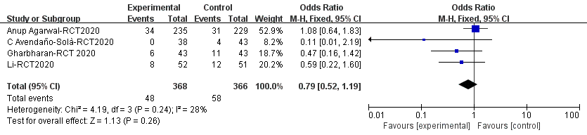  Figure 3a The mortality outcome of CP therapy on COVID-19 patients(results from RCTs)  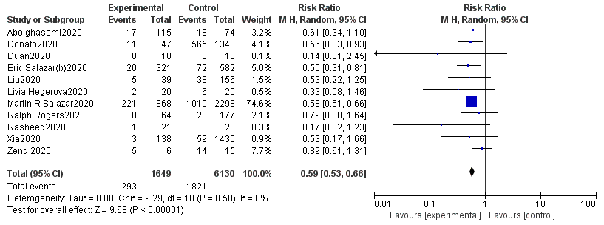  Figure 3b The mortality outcome of CP therapy on COVID-19 patients (results from controlled NRSIs)  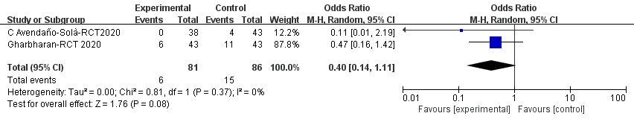  Figure 4a The mortality outcome of CP therapy on COVID-19 patients, which the treatment time point within 10days (results from RCTs)  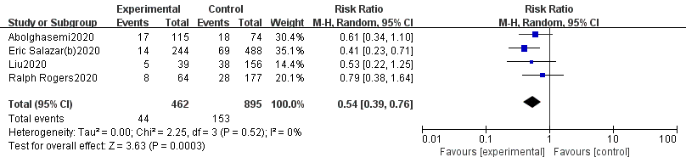  Figure 4b The mortality outcome of CP therapy on COVID-19 patients, which the treatment time point within 10days (results from controlled NRSIs)  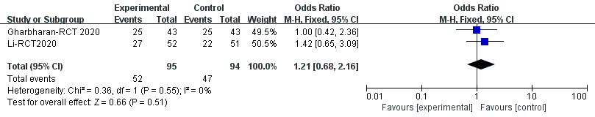  Figure 5 The clinical improvement outcome of CP therapy on COVID-19 patients (results from RCTs) | Results
Synthesis of results | 21 | Present results of each meta-analysis done, including confidence intervals and measures of consistency.  Mortality: Compared to the control group, the results of RCTs showed that the use of CP transfusion may reduce the mortality rate (OR 0.72, 95% CI 0.4 to 1.29, I²=28%). But there was no significant difference between the two groups. The results of controlled NRSIs showed similar findings (RR 0.59, 95% CI 0.53 to 0.66, I²=0%), but there is statistically significant.  CP treatment time point on mortality: Compared to the control group, the results of RCTs showed that the use of CP transfusion may be reduce the mortality of patients, if the treatment time point was within 10days(OR 0.4, 95%CI 0.14-1.11; I²=0%). But there was no significant difference between the two groups. Similar results were found in controlled NRSIs (RR 0.54, 95%CI 0.39 to 0.76; I²=0%), but there is statistically significant.  Clinical improvement: Compared to the control group, the results of RCTs showed that the use of CP transfusion may be beneficial to the improvement of patients' clinical symptoms (OR 1.21, 95%CI 0.68 to 2.16; I2=0%).But there was no significant difference between the two groups. | Results
Risk of bias across studies | 22 | Present results of any assessment of risk of bias across studies (see Item 15).  We assessed the methodological quality and risk of bias for RCTs, controlled NRSIs and non-controlled NRSIs for different outcomes (such as mortality, clinical improvement (efficacy) and safety) respectively, the results were summarized in figure 2a, 2b and 2c respectively. Some studies reported only one or two of mortality, clinical improvement, or safety outcomes, and we assess the risk of bias for the results reported in the study. For example, bias in measurement of outcomes was not applicable for clinical improvement for Ralph Rogers, because they did not report this outcome. | Results
Additional analysis | 23 | Give results of additional analyses, if done (e.g., sensitivity or subgroup analyses, meta-regression [see Item 16]).  None | Results
DISCUSSION
Summary of evidence | 24 | Summarize the main findings including the strength of evidence for each main outcome; consider their relevance to key groups (e.g., healthcare providers, users, and policy makers).  4.1 CP therapy  Currently, treatment strategies for COVID-19 patients are lacking. There are no approved specific antivirals targeting the virus, while some drugs are still under investigation. To this end, there are urgent needs to develop COVID-19-specific treatment to alleviate the symptoms and reduce the mortality.  CP therapy, a classic adaptive immunotherapy, has been applied to the prevention and treatment of many infectious diseases for more than one century. During the 2009 H1N1 infection outbroke, a study in Hong Kong showed that CP therapy with antibody titer≥1:160 could significantly reduce respiratory viral load and mortality [9]. Mair JJ et al analyzed 32 studies, the results showed that CP could significantly reduce the mortality of SARS, and the effect of early use is more obvious . KO et al found that CP with antibody titer≥1:80 was effective in the treatment of MERS-CoV infection . Luke TC et al performed a meta-analysis on the therapeutic effect of CP in patients with Spanish influenza, they identified eight studies involving 1703 patients with influenza pneumonia who received an infusion of influenza-convalescent human blood products, which showed the range of absolute risk differences in mortality between the treatment and control groups was 8% to 26% (pooled risk difference, 21% [95% CI, 15% to 27%]), suggesting that CP would be a possible treatment for H5N1 .. In 2014, the use of CP collected from patients who had recovered from Ebola virus disease was recommended by WHO as an empirical treatment during outbreaks . The recent COVID-19 outbreak has refocused attention on the use of CP therapy. It has recently been suggested by Food and Drug Administration that administration and study of investigational CP treatment may provide a clinical effect for COVID-19 during the public health emergency . CP therapy was mentioned in the “Diagnosis and Treatment Guidelines of COVID-19(trial 6th, 7th, and 8th)” issued by NHC, especially for severe and critical cases with rapid disease progression .  This systematic review identified and summarized 4 RCTs, 11 controlled NRSIs, 7 non-controlled NRSIs and 24 case reports(series) to evaluate the effect and safety of CP treatment. First, because of the inadequacy of randomized controlled trials, we also conducted meta-analysis of the data from non-randomized controlled trials. Meta-analysis results of RCTs showed that, there were no statistically significant differences between CP transfusion and the control group in terms of reducing mortality and improving clinical symptoms. However, the results of controlled NRSIs showed that CP therapy may reduce mortality in COVID-19 patients and is more effective in early use(the time point of administration within 10days). There are not sufficiently RCTs for CP treatment for COVID-19 patients until now. Therefore, the available evidence from controlled NRSIs may also serve as an option for COVID-19 treatment. Second, limited safety data suggested that CP is a well-tolerated therapy with a low incidence of AEs. But, due to lack of safety data for the control group, it is really not easy to determine whether CP transfusion has an impact on moderate to serious AEs. Thirdly, for children, pregnant, elderly (older than 90), tumor and immunocompromised patients, CP may be a well-tolerated therapy, if the disease cannot be controlled and continues to progress.  However, the optimal timing, titers and dosage of CP therapy is unknown. We found that there were significant differences in CP titers, duration of administration, and doses in the included studies, which were likely to affect the efficacy of CP therapy. The optimal time, dose, and titer for CP therapy still require large, high-quality studies to provide data. | Discussion
Limitations | 25 | Discuss limitations at study and outcome level (e.g., risk of bias), and at review-level (e.g., incomplete retrieval of identified research, reporting bias).  A lack of high-quality studies and a paucity in the volume of relevant literature limited our analyses. The confidence of the results from meta-analysis is limited by insufficient data of the RCTs. Due to the evidence from controlled studies was insufficient, we included case reports(series), and had a moderate to high risk of bias. Some articles that are not accessible to full texts and those in languages other than English were excluded from the analysis. This might have led to overlook some critical findings or observations. | Discussion
Conclusions | 26 | Provide a general interpretation of the results in the context of other evidence, and implications for future research.  Although the results of limited RCTs showed that CP cannot significantly reduce mortality, some non-RCTs and case report(series) have found that CP may help patients improve clinical symptoms, clear the virus, and reduce mortality, especially for patients with COVID-19 within ten days of illness. We speculate that CP may be a possible treatment option. High-quality studies are needed for establishing stronger quality of evidence and pharmacists should also be actively involved in the CP treatment process and provide close pharmaceutical care. | Discussion
FUNDING
Funding | 27 | Describe sources of funding for the systematic review and other support (e.g., supply of data); role of funders for the systematic review.  None | Acknowledgments

From: Moher D, Liberati A, Tetzlaff J, Altman DG, The PRISMA Group (2009). Preferred Reporting Items for Systematic Reviews and Meta-Analyses: The PRISMA Statement. PLoS Med 6(6): e1000097. doi:10.1371/journal.pmed1000097
For more information, visit: www.prisma-statement.org.
Page 2 of 2

