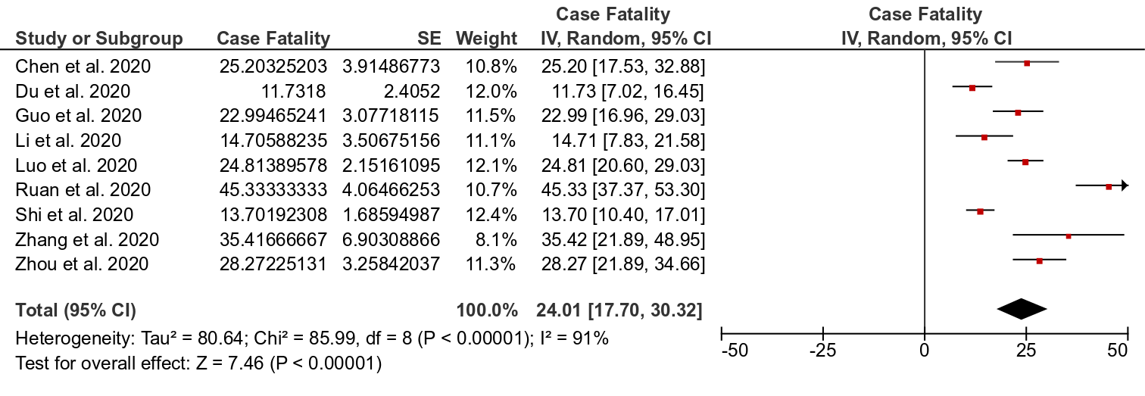
Figure S1: The pooled case fatality rate among COVID-19 patients in the included studies.

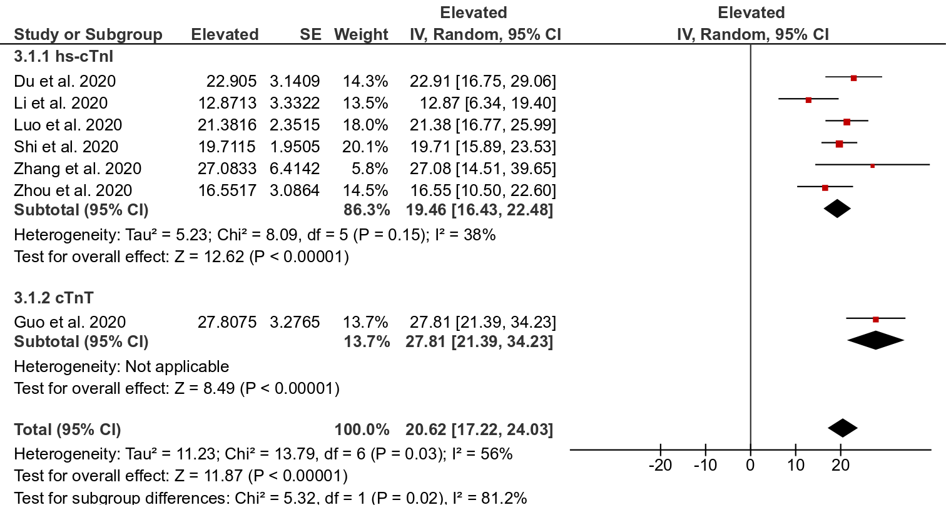
Figure S2: The pooled prevalence of elevated cTn among hospitalized patients with COVID-19.

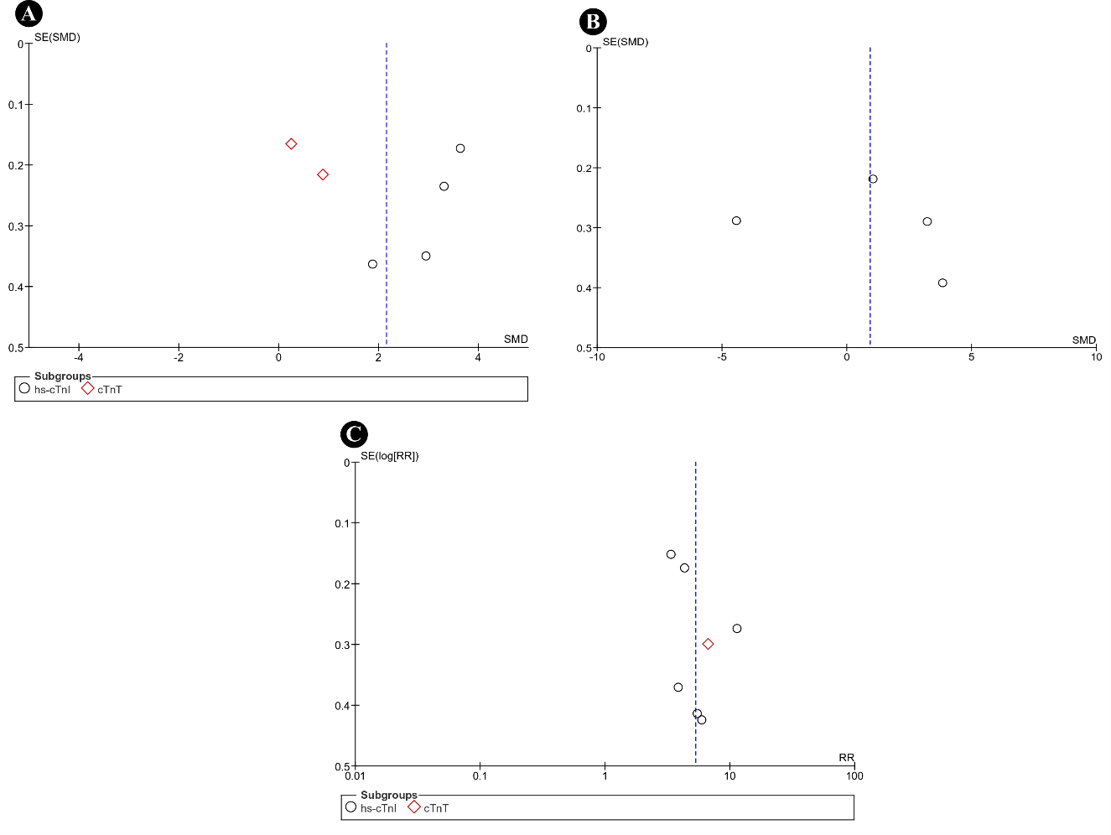
Figure S3: Funnel plots investigating the publication bias for the outcomes of standardized mean differences in cTn (A) and NT-proBNP (B) as well as the risk of death among patients with normal or abnormal cTn (C).

