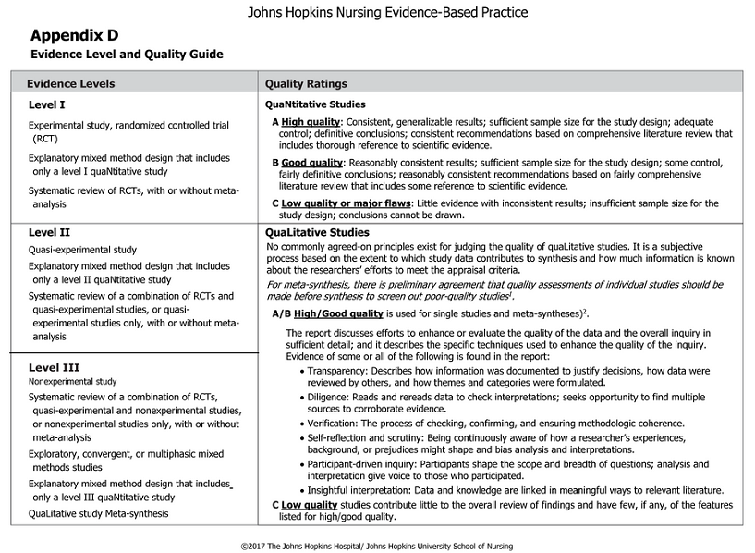
S4 File. Johns Hopkins Nursing Evidence-Based Practice Appraisal Tool

