Supplemental Files
Table S1 Search Strategy and Search Results

Table S1 Search Strategy and Search Results
A Medline Search
Entry | Medline Search Strategy |  |  |  |  |  |  |  |  |  |  |  |  | Results
1 | (cancer or cancers or tumor or tumors or neoplasm or neoplasms or adenoma or adenomas or carcinoma or carcinomas).mp. [mp=title, abstract, original title, name of substance word, subject heading word, floating sub-heading word, keyword heading word, organism supplementary concept word, protocol supplementary concept word, rare disease supplementary concept word, unique identifier, synonyms] |  |  |  |  |  |  |  |  |  |  |  |  | 3920545
2 | (2019-ncov or novel coronavirus or COVID-19 or SARS-CoV-2).mp. [mp=title, abstract, original title, name of substance word, subject heading word, floating sub-heading word, keyword heading word, organism supplementary concept word, protocol supplementary concept word, rare disease supplementary concept word, unique identifier, synonyms] |  |  |  |  |  |  |  |  |  |  |  |  | 7450
3 | #1 AND #2 |  |  |  |  |  |  |  |  |  |  |  |  | 258
B Embase Search
Entry | Embase Search Strategy |  |  |  |  |  |  |  |  |  |  |  |  | Results
1 | (cancer or cancers or tumor or tumors or neoplasm or neoplasms or adenoma or adenomas or carcinoma or carcinomas).mp. [mp=title, abstract, original title, name of substance word, subject heading word, floating sub-heading word, keyword heading word, organism supplementary concept word, protocol supplementary concept word, rare disease supplementary concept word, unique identifier, synonyms] |  |  |  |  |  |  |  |  |  |  |  |  | 5463874
2 | (2019-ncov or novel coronavirus or Covid-19 or SARS-CoV-2).mp. [mp=title, abstract, original title, name of substance word, subject heading word, floating sub-heading word, keyword heading word, organism supplementary concept word, protocol supplementary concept word, rare disease supplementary concept word, unique identifier, synonyms] |  |  |  |  |  |  |  |  |  |  |  |  | 6534
3 | #1 AND #2 |  |  |  |  |  |  |  |  |  |  |  |  | 285
C Web of Science Search
Entry | Web of Science Search Strategy |  |  |  |  |  |  |  |  |  |  |  |  | Results
1 | TS = (cancer or cancers or tumor or tumors or neoplasm or neoplasms or adenoma or adenomas or carcinoma or carcinomas) |  |  |  |  |  |  |  |  |  |  |  |  | 3,731,583
2 | TS = (2019-ncov or novel coronavirus or covid-19 or SARS-CoV-2) |  |  |  |  |  |  |  |  |  |  |  |  | 3,289
3 | #1 AND #2 |  |  |  |  |  |  |  |  |  |  |  |  | 94
D Cochrane Library Search
Entry | Cochrane Library Search Strategy |  |  |  |  |  |  |  |  |  |  |  |  | Results
1 | cancer or cancers or tumor or tumors or neoplasm or neoplasms or adenoma or adenomas or carcinoma or carcinomas |  |  |  |  |  |  |  |  |  |  |  |  | 211213
2 | “novel coronavirus” or “COVID-19” |  |  |  |  |  |  |  |  |  |  |  |  | 68
3 | #1 AND #2 |  |  |  |  |  |  |  |  |  |  |  |  | 8
4 | Cochrane Central Register of Controlled Trials |  |  |  |  |  |  |  |  |  |  |  |  | 3

Table S2 AHRQ for assessing the quality of studies in the systematic review

Table S2 AHRQ for assessing the quality of studies in the systematic review
First author | Country | Study Design | Q1 | Q2 | Q3 | Q4 | Q5 | Q6 | Q7 | Q8 | Q9 | Q10 | Q11 | Total score
Beyrouti R [26] | UK | Case Series | Y | N | Y | Y | N | Y | U | N | U | Y | Y | 6
Cai Q [27] | China | Retrospective Cohort | Y | N | Y | Y | N | Y | N | N | N | N | N | 4
Chen J [28] | China | Retrospective Cohort | Y | N | Y | Y | N | Y | N | N | N | N | N | 4
Chen L [29] | China | Retrospective Cohort | Y | N | Y | Y | N | Y | N | N | N | N | N | 4
Chen N [30] | China | Retrospective Cohort | Y | N | Y | Y | N | Y | N | N | Y | Y | N | 6
Chen T [31] | China | Case Series | Y | N | Y | Y | N | Y | N | N | Y | U | N | 5
Cheng Y [32] | China | Retrospective Cohort | Y | N | Y | Y | N | Y | N | N | N | N | U | 4
Conversano A [32] | Italy | Retrospective Cohort | Y | N | Y | Y | U | Y | N | N | N | Y | U | 5
Dai M [33] | China | Retrospective Cohort | Y | N | Y | N | N | Y | Y | Y | N | Y | Y | 7
Deng G [34] | China | Retrospective Cohort | Y | N | Y | Y | N | Y | U | N | N | Y | Y | 6
Du RH [35] | China | Retrospective Cohort | Y | N | Y | N | U | Y | N | N | N | N | N | 3
Du Y [36] | China | Retrospective Cohort | Y | N | Y | Y | N | Y | N | N | N | N | N | 4
Duanmu Y [37] | USA | Cross-Sectional Study | Y | N | Y | U | N | Y | N | N | N | N | N | 3
Feng Y [38] | China | Retrospective Cohort | Y | N | Y | Y | U | Y | N | N | N | N | U | 4
Fernández-Ruiz M [39] | Spain | Case Series | Y | N | Y | U | N | Y | N | Y | U | N | U | 4
Grasselli G [40] | Italy | Case Series | Y | N | Y | Y | N | Y | N | N | N | Y | Y | 6
Grillet F [41] | France | Retrospective Cohort | Y | N | Y | Y | N | Y | N | N | N | N | U | 4
Guan WJ [42] | China | Retrospective Cohort | Y | N | Y | N | N | Y | N | N | N | N | N | 3
Guan WJ [42] | China | Retrospective Cohort | Y | N | Y | Y | N | Y | N | N | N | N | U | 4
Guo W [43] | China | Retrospective Cohort | Y | N | Y | Y | U | Y | N | N | N | N | N | 4
He Y [32] | China | Retrospective Cohort | Y | N | Y | U | N | Y | N | Y | N | N | N | 4
Hou W [44] | China | Retrospective Cohort | Y | N | Y | U | N | Y | N | N | N | N | N | 3
Hu L [45] | China | Retrospective Cohort | Y | N | Y | U | N | Y | N | N | N | N | N | 3
Huang C [46] | China | Retrospective Cohort | Y | N | Y | U | N | Y | N | N | N | U | U | 3
Ihle-Hansen H [47] | Norway | Retrospective Cohort | Y | N | Y | Y | U | Y | N | N | N | U | N | 4
Inciardi R M [48] | Italy | Retrospective Cohort | Y | N | Y | Y | U | Y | N | N | N | U | N | 4
Ji M [49] | China | Retrospective Cohort | Y | N | Y | U | N | Y | N | N | N | U | N | 3
Jin X [50] | China | Retrospective Cohort | Y | N | Y | U | N | Y | N | N | Y | N | N | 4
KCDC [51] | Korea | Cross-Sectional Study | Y | N | Y | U | U | Y | N | N | N | N | N | 3
Kalligeros M [52] | USA | Retrospective Cohort | Y | N | Y | Y | N | Y | N | N | N | U | N | 4
Li J [53] | China | Case Series | Y | N | Y | U | N | Y | N | N | N | U | N | 3
Li K [32, 54] | China | Retrospective Cohort | Y | N | Y | Y | N | Y | N | Y | N | U | N | 5
Li X [55] | China | Retrospective Cohort | Y | N | Y | Y | N | Y | Y | N | N | Y | N | 6
Liang W [5] | China | Retrospective Cohort | Y | N | Y | U | N | Y | Y | N | N | U | Y | 5
Lin L [56] | China | Case-Control Study | Y | N | Y | U | N | Y | N | N | N | N | N | 3
Liu K [57] | China | Retrospective Cohort | Y | N | Y | U | N | Y | N | N | N | U | N | 3
Liu W [58] | China | Retrospective Cohort | Y | N | Y | U | U | Y | N | N | N | N | N | 3
Liu Y [59] | China | Case Series | Y | N | Y | U | N | Y | N | N | N | N | N | 3
Lovell N [60] | UK | Case Series | Y | N | Y | U | U | Y | N | N | N | U | Y | 4
Luong-Nguyen M [61] | France | Retrospective Cohort | Y | N | Y | U | N | Y | N | N | N | N | N | 3
Malard F [62] | France | Retrospective Cohort | Y | N | Y | Y | U | Y | N | N | N | U | N | 4
Mancia G [63] | Italy | Case-Control Study | Y | N | Y | U | N | Y | N | Y | Y | U | U | 5
Mao L [64] | China | Case Series | Y | N | Y | U | N | Y | N | N | N | U | N | 3
Meng Y [65] | China | Retrospective Cohort | Y | N | Y | Y | N | Y | Y | N | Y | N | U | 6
Million M [66] | France | Retrospective Cohort | Y | N | Y | U | N | Y | Y | N | Y | Y | Y | 7
Miyashita H [1] | USA | Retrospective Cohort | Y | N | Y | U | U | Y | N | Y | N | N | N | 4
Molina JM [67] | France | Retrospective Cohort | Y | N | Y | Y | N | Y | N | N | N | N | N | 4
Montopoli M [68] | Italy | Case-Control Study | Y | N | Y | U | N | Y | N | N | N | N | U | 3
Myers LC [69] | USA | Retrospective Cohort | Y | N | Y | U | N | Y | N | N | N | N | U | 3
Nair V [70] | USA | Case Series | Y | N | Y | U | N | Y | N | N | N | N | U | 3
O'Reilly GM [71] | Australia | Retrospective Cohort | Y | N | Y | U | U | Y | N | N | U | Y | Y | 5
Pan L [72] | China | Cross-Sectional Study | Y | N | Y | U | N | Y | N | N | N | U | N | 3
Pereira MR [73] | USA | Case Series | Y | N | Y | U | N | Y | Y | N | N | U | Y | 5
Qi X [74] | China | Retrospective Cohort | Y | N | Y | Y | N | Y | N | N | N | N | U | 4
Qin C [75] | China | Retrospective Cohort | Y | N | Y | U | N | Y | N | N | N | N | N | 3
Safiya Richardson [76] | USA | Case Series | Y | N | Y | Y | N | Y | N | N | N | U | U | 4
Shi H [77] | China | Retrospective Cohort | Y | N | Y | U | U | Y | N | N | N | N | U | 3
Shi S [78] | China | Retrospective Cohort | Y | N | Y | Y | N | Y | N | N | N | U | U | 4
Shi Y [79] | China | Retrospective Cohort | Y | N | Y | U | N | Y | N | N | N | N | U | 3
Stroppa EM [80] | Italy | Retrospective Cohort | Y | N | Y | Y | U | Y | N | N | N | N | U | 4
Sun B [81] | China | Retrospective Cohort | Y | N | Y | U | N | Y | N | N | N | N | N | 3
Sun H [82] | USA | Case Series | Y | N | Y | U | N | Y | N | N | N | N | N | 3
Sun Y [83] | Singapore | Case-Control Study | Y | N | Y | U | N | Y | N | N | N | U | N | 3
Wan S [84] | China | Case Series | Y | N | Y | U | U | Y | N | N | N | N | N | 3
Wang B [85] | China | Case Series | Y | N | Y | U | N | Y | N | N | N | N | N | 3
Wang D [86] | China | Case Series | Y | N | Y | N | N | Y | N | N | N | N | N | 3
Wang K [87] | China | Case Series | Y | N | Y | U | U | Y | N | N | N | N | N | 3
Wang L [88] | China | Case Series | Y | N | Y | U | N | Y | N | N | N | N | N | 3
Wang L [89] | China | Retrospective Cohort | Y | N | Y | U | N | Y | N | N | N | U | N | 3
Wang L [90] | China | Retrospective Cohort | Y | N | Y | Y | N | Y | Y | N | N | U | U | 5
Wang Y [91] | China | Retrospective Cohort | Y | N | Y | U | U | Y | N | N | N | N | N | 3
Wang Z [92] | China | Case Series | Y | N | Y | Y | N | Y | Y | N | N | Y | Y | 7
Wang, K. [93] | China | Retrospective Cohort | Y | N | Y | U | N | Y | N | N | N | N | N | 3
Wu C [94] | China | Retrospective Cohort | Y | N | Y | U | U | Y | Y | N | N | Y | U | 5
Wu J [95] | China | Retrospective Cohort | Y | N | Y | U | N | Y | N | N | N | N | N | 3
Xie J [96] | China | Retrospective Cohort | Y | N | Y | U | N | Y | Y | N | N | Y | Y | 6
Xu X [97] | China | Case Series | Y | N | Y | Y | N | Y | N | N | N | U | N | 4
Yang F [98] | China | Retrospective Cohort | Y | N | Y | U | U | Y | N | N | N | U | N | 3
Yang F [99] | China | Retrospective Cohort | Y | N | Y | U | N | Y | U | N | N | N | U | 3
Yang X [100] | China | Retrospective Cohort | Y | N | Y | U | N | Y | U | N | Y | N | U | 4
Yao Q [101] | China | Retrospective Cohort | Y | N | Y | Y | N | Y | Y | N | N | U | N | 5
Yasukawa K [102] | USA | Retrospective Cohort | Y | N | Y | U | N | Y | N | N | N | N | N | 3
Yin L [103] | China | Case-Control Study | Y | N | Y | U | N | Y | N | N | N | N | N | 3
Yu Q [104] | China | Retrospective Cohort | Y | N | Y | U | N | Y | N | N | U | N | U | 3
Yuan M [105] | China | Retrospective Cohort | Y | N | Y | Y | N | Y | N | N | N | U | U | 4
Zhang J [106] | China | Retrospective Cohort | Y | N | Y | U | U | Y | Y | N | N | N | N | 4
Zhang J [107] | China | Retrospective Cohort | Y | N | Y | U | N | Y | N | N | N | N | N | 3
Zhang L [108] | China | Retrospective Cohort | Y | N | Y | U | N | Y | N | N | N | N | N | 3
Zhang R [109] | China | Case Series | Y | N | Y | Y | U | Y | N | N | N | N | N | 4
Zhang X [110] | China | Retrospective Cohort | Y | N | Y | U | N | Y | N | N | N | N | N | 3
Zhou F [111] | China | Retrospective Cohort | Y | N | Y | U | N | Y | N | N | N | N | U | 3
Zhou Z [112] | China | Retrospective Cohort | Y | N | Y | U | N | Y | N | N | U | N | N | 3
Zhu W [113] | China | Retrospective Cohort | Y | N | Y | U | U | Y | N | N | N | N | N | 3
Ziehr DR [114] | USA | Retrospective Cohort | Y | N | Y | U | N | Y | N | N | N | N | U | 3
Note:
*Total score was calculated as follows: Y(Yes)=1, N(No)/U(Unclear)=0
*Article quality was assessed as follows: low quality=0-3; moderate quality=4-7; high quality=8-11
AHRQ Items
1) Define the source of information (survey, record review);
2) List inclusion and exclusion criteria for exposed and unexposed subjects (cases and controls) or refer to previous publications;
3) Indicate time period used for identifying patients;
4) Indicate whether or not subjects were consecutive if not population-based;
5) Indicate if evaluators of subject components of study were masked to other aspects of the status of the participants;
6) Describe any assessments undertaken for quality assurance purposes (e.g., test/ retest of primary outcome measurements);
7) Explain any patient exclusions from analysis;
8) Describe how confounding was assessed and/or controlled;
9) If applicable, explain how missing data were handled in the analysis;
10) Summarize patient response rates and completeness of data collection;
11) Clarify what follow-up, if any, was expected and the percentage of patients for which incomplete data or follow-up was obtained.

Table S3 Newcastle-Ottawa Scale for assessing the quality of comparative studies in the systematic review
Table S3 Newcastle-Ottawa Scale for assessing the quality of comparative studies in the systematic review
First author | Country | Study Design | Selection |  |  |  | Comparability |  | Exposure |  |  | Total Score
First author | Country | Study Design | S1 | S2 | S3 | S4 | C1 | C2 | E1 | E2 | E3 | Total Score
Dai M [33] | China | Retrospective Cohort |  | ★ | ★ |  | ★ |  | ★ | ★ | ★ | 6
Guan WJ [42] | China | Retrospective Cohort |  | ★ | ★ |  |  |  | ★ | ★ |  | 4
He W [115] | China | Retrospective Cohort |  | ★ | ★ |  |  |  | ★ | ★ | ★ | 5
Liang W [8] | China | Retrospective Cohort |  |  | ★ |  |  |  | ★ | ★ | ★ | 4
Luo J [116] | China | Retrospective Cohort |  | ★ | ★ |  |  |  | ★ | ★ | ★ | 5
Ma J [117] | USA | Retrospective Cohort |  |  | ★ |  |  |  | ★ | ★ | ★ | 4
Martín-MoroF [118] | China | Retrospective Cohort |  |  | ★ |  |  |  | ★ | ★ | ★ | 4
Mehta V [119] | Spain | Retrospective Cohort |  |  | ★ |  |  |  | ★ | ★ | ★ | 4
Miyashita H [120] | USA | Retrospective Cohort |  |  | ★ |  |  |  | ★ | ★ | ★ | 4
Montopoli M [68] | USA | Retrospective Cohort |  | ★ | ★ |  |  |  | ★ | ★ | ★ | 5
Nicole M Kuderer [121] | Italy | Case-Control Study | ★ |  |  | ★ |  |  | ★ | ★ |  | 4
Rafi Kabarriti NPB [122] | USA/Canada/Spain | Retrospective Cohort |  |  | ★ |  |  |  | ★ | ★ | ★ | 4
Stroppa EM [80] | USA | Retrospective Cohort |  |  | ★ |  |  |  | ★ | ★ | ★ | 4
T de Rojas [123] | Italy | Retrospective Cohort |  |  | ★ |  |  |  | ★ | ★ | ★ | 4
Wei X [124] | China | Retrospective Cohort |  | ★ | ★ |  | ★ | ★ | ★ | ★ | ★ | 7
Yang F [99] | Spain | Case Series | NA | NA | NA | NA | NA | NA | NA | NA | NA | NA
Yang KY [125] | China | Retrospective Cohort |  |  | ★ |  |  |  | ★ | ★ | ★ | 4
Yu J [126] | China | Retrospective Cohort |  |  | ★ |  |  |  | ★ | ★ |  | 3
Zhang L [11] | China | Retrospective Cohort |  |  | ★ |  |  |  | ★ | ★ | ★ | 4
Dai M [33] | China | Case Series | NA | NA | NA | NA | NA | NA | NA | NA | NA | NA
Guan WJ [42] | China | Retrospective Cohort |  |  | ★ |  |  |  | ★ | ★ | ★ | 4
Lee LY[127] | UK | Retrospective Cohort |  | ★ | ★ |  |  |  | ★ | ★ | ★ | 5
Garassino MC[128] | Italy/ Spain/ France/Switzerland/Netherlands/USA/UK/China | Retrospective Cohort |  | ★ | ★ |  |  |  | ★ | ★ | ★ | 5
Note:
NA=Not applicable. Case series study was not applied for Newcastle-Ottawa Scale.
Guidelines for review
Selection:
S1, Case definition adequacy: ★a) requires independent validation (>1 person/record/time/process to extract information or reference to primary record sources such as colonoscopy or medical/hospital records); b) record linkage or self-report with no reference to primary record; c) no description
S2, Representativeness of the cases: ★a) consecutive or representative series of cases; b) potential for selection biases or not stated
S3, Selection of controls: ★a) community controls; b) hospital controls, within same community as cases; c) no description
S4, Definition of controls: ★a) no history of colorectal cancer or adenoma; b) no description of the source
Comparability:
C1, ★ Study adjusted for confounder, such as age and sex (the most important factors);
C2, ★ Study adjusted for any additional confounders (1> additional factors, e.g., BMI, drinking or smoking)
Exposure:
E1, Ascertainment of exposure: ★a) secure record (e.g., medical records); ★b) structured interview were blind to case/control status; c) interview not blinded to case/control status; d) written self-report or medical record only; e) no description
E2, Same method of ascertainment for cases and controls: ★a) yes; b) no
E3, Non-response rate: ★a) the same rate for both groups; b) non-respondents described; c) rate different and no designation

Figure S1 Overall Cancer Prevalence in COVID-19 Patients.
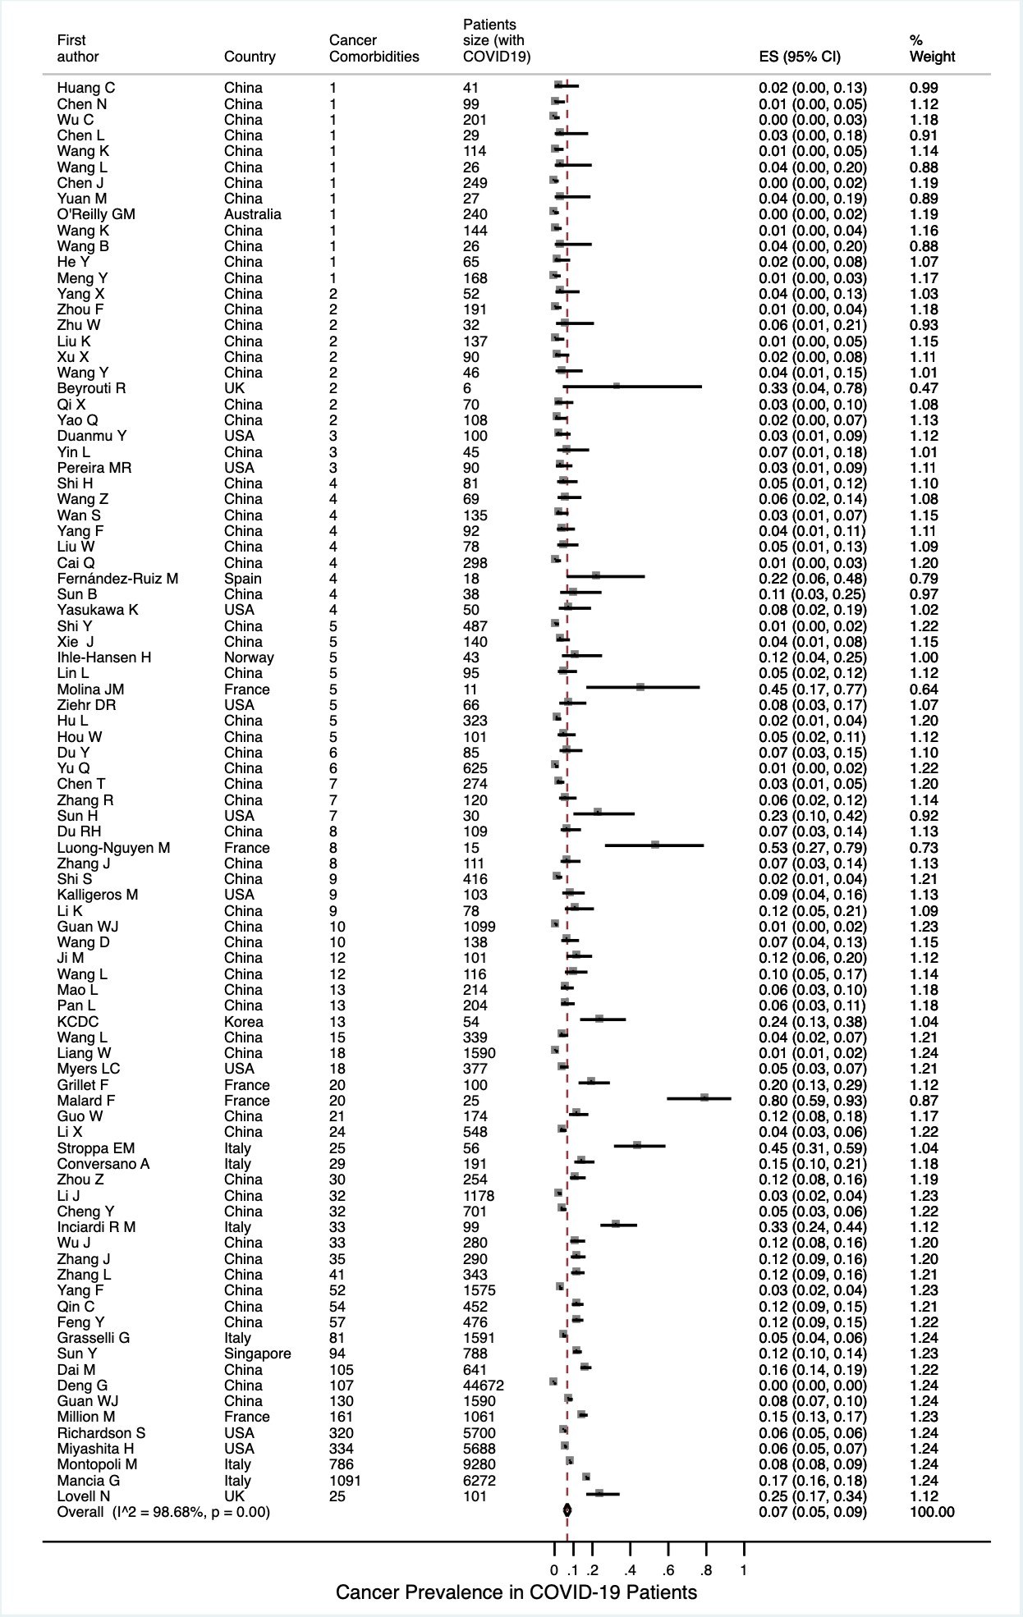
Figure S2 Cancer Prevalence in COVID-19 Patients, Stratified according to Continent.
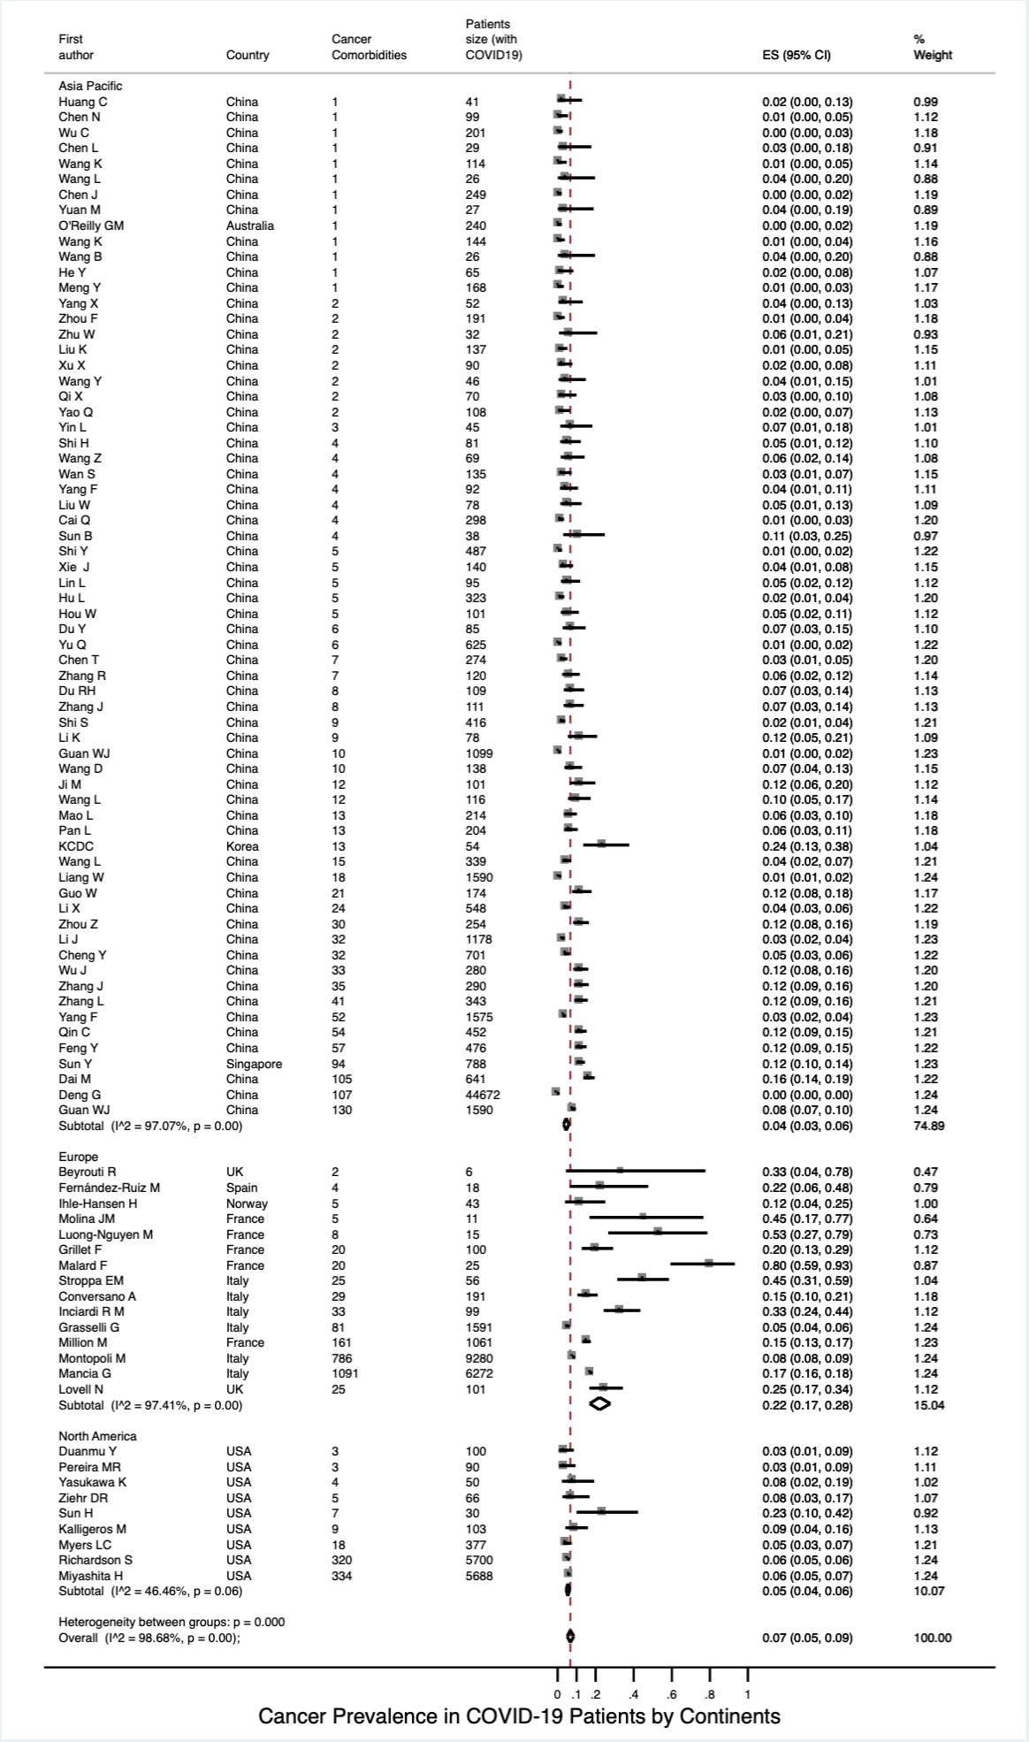
Figure S3 Cancer Prevalence in COVID-19 Patients, Stratified according to Country.
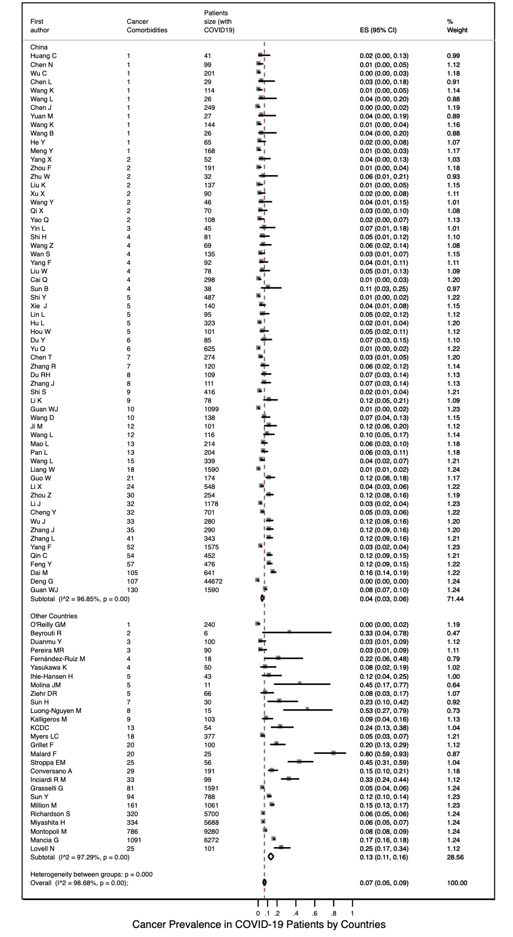
Figure S4 Cancer Prevalence in COVID-19 Patients, Stratified according to Age Group.
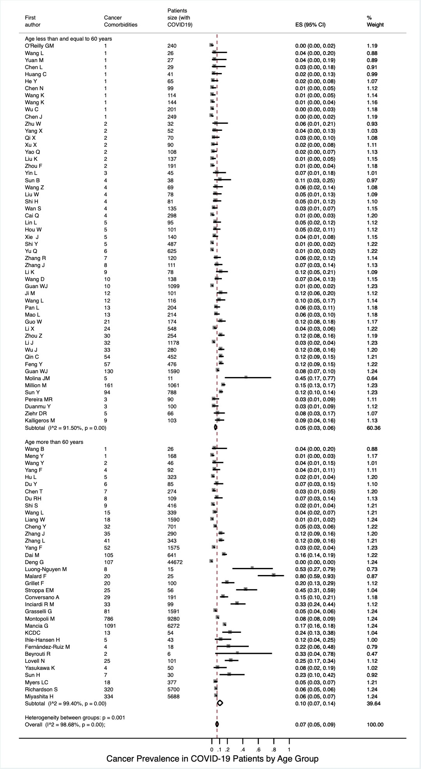
Figure S5 Cancer Prevalence in COVID-19 Patients, Stratified according to Sample Size.
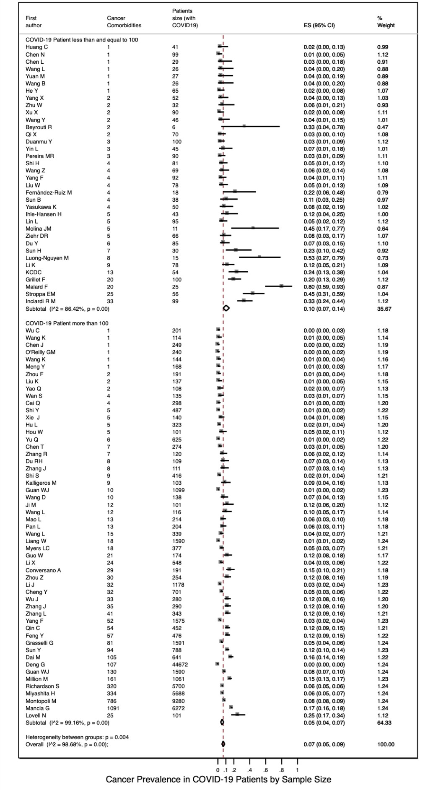
Figure S6 Cancer Prevalence in COVID-19 Patients, Stratified according to Study Design.
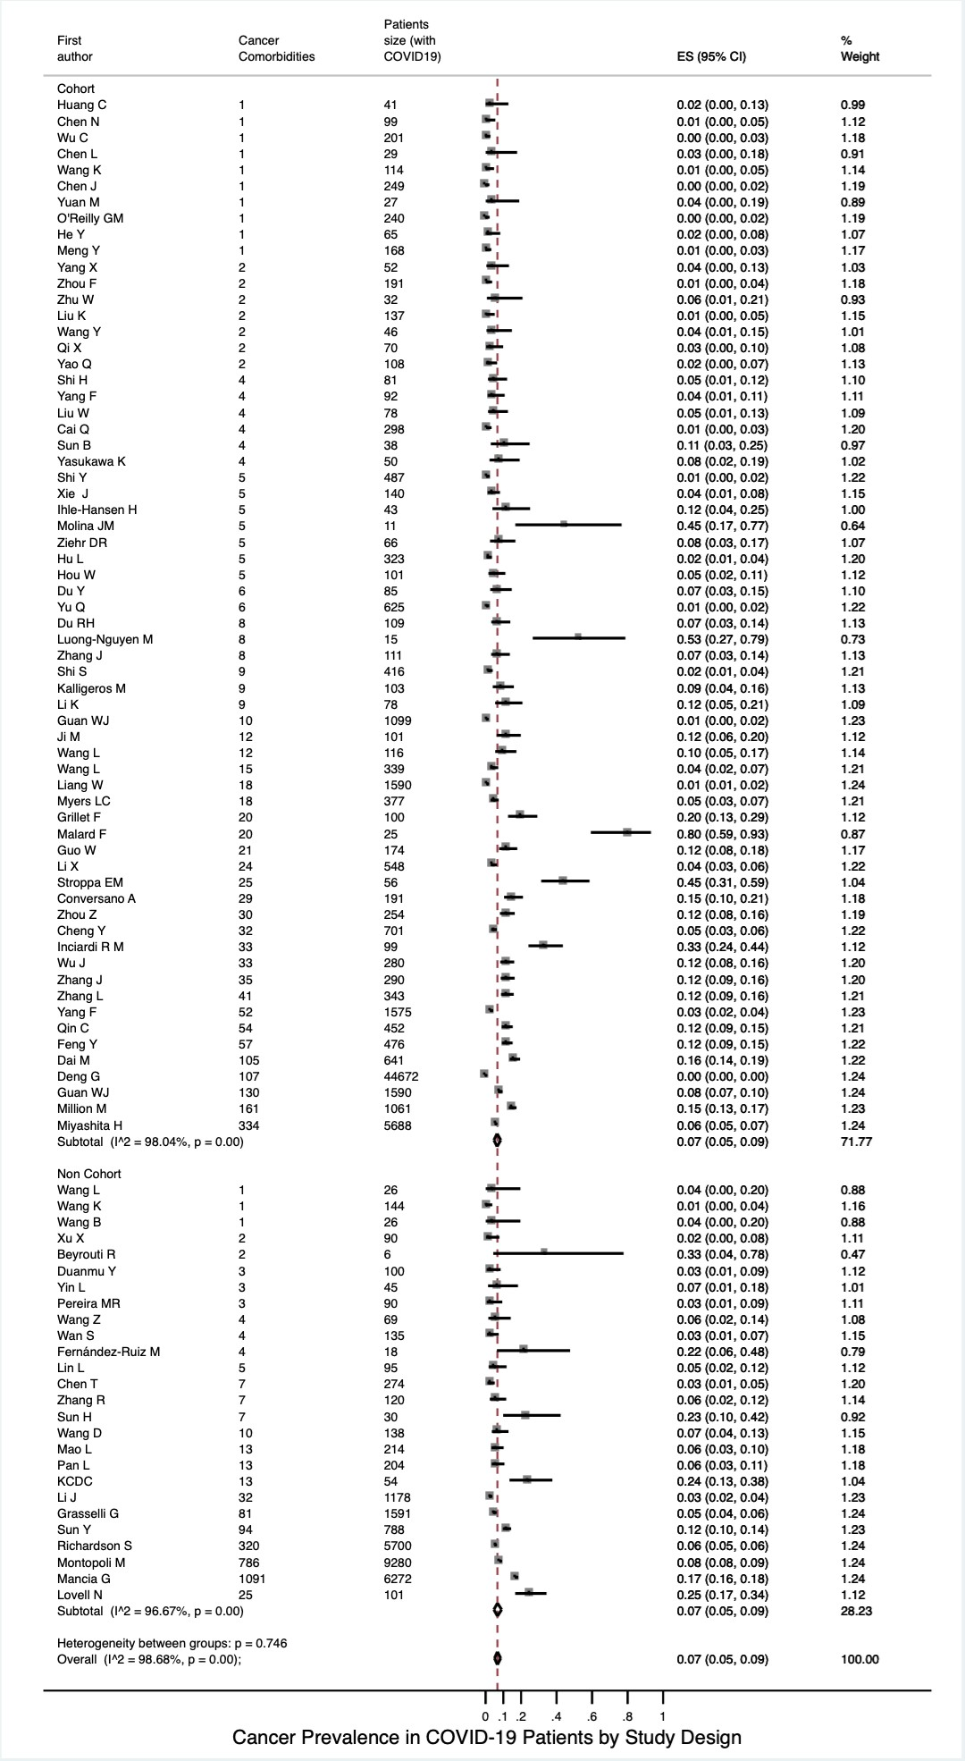
Figure S7 (A) Overall Cancer Prevalence in COVID-19 Patients (Metan Approach).
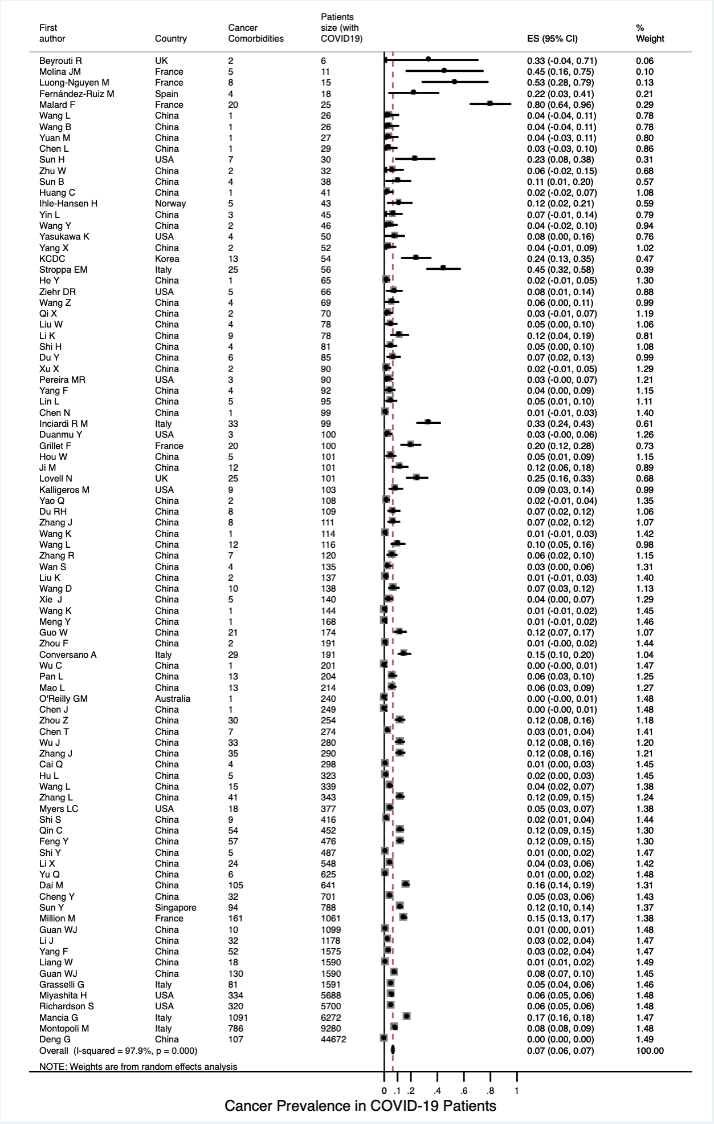

Figure S7 (B) Cancer Prevalence in COVID-19 Patients Stratified by Continent (Metan Approach).
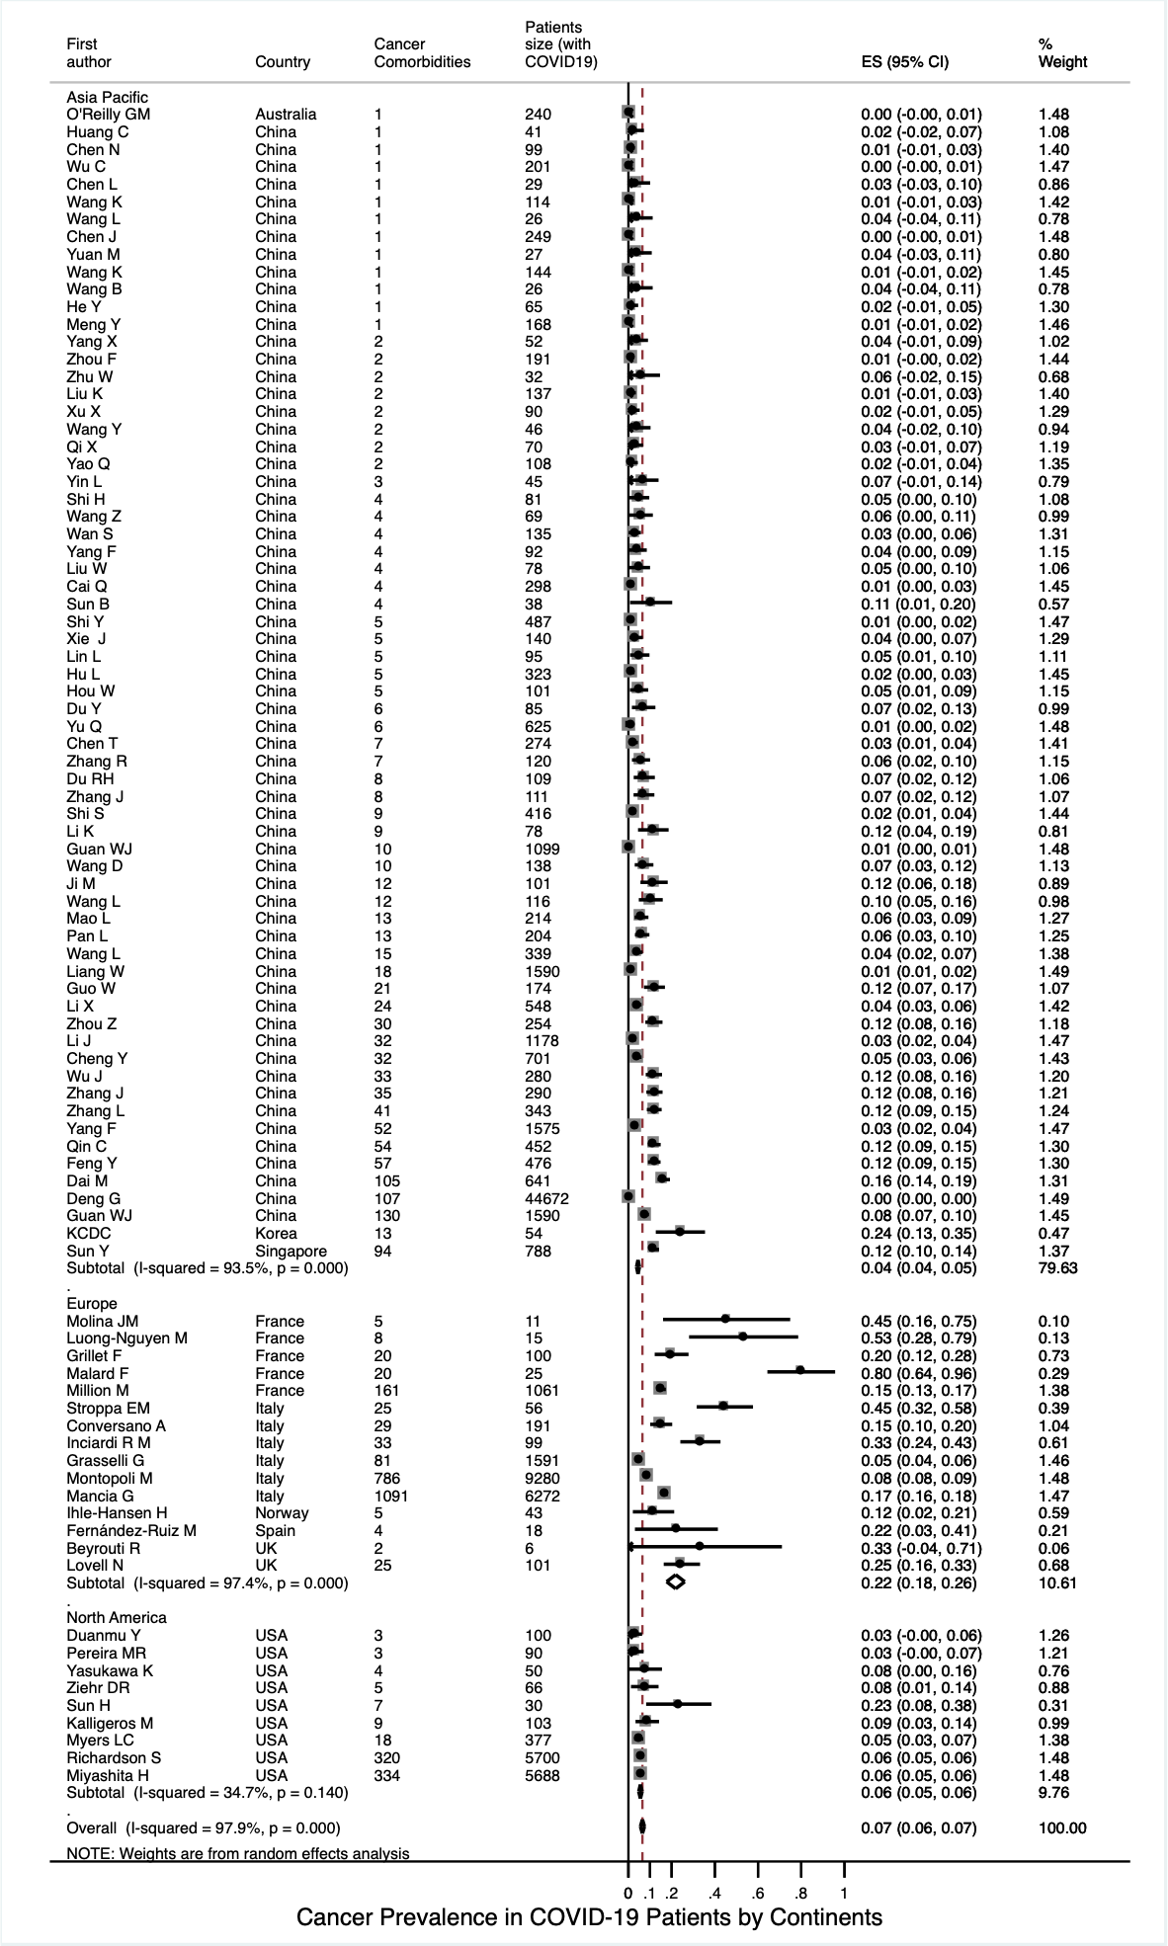

Figure S7 (C) Cancer Prevalence in COVID-19 Patients Stratified by Country (Metan Approach).
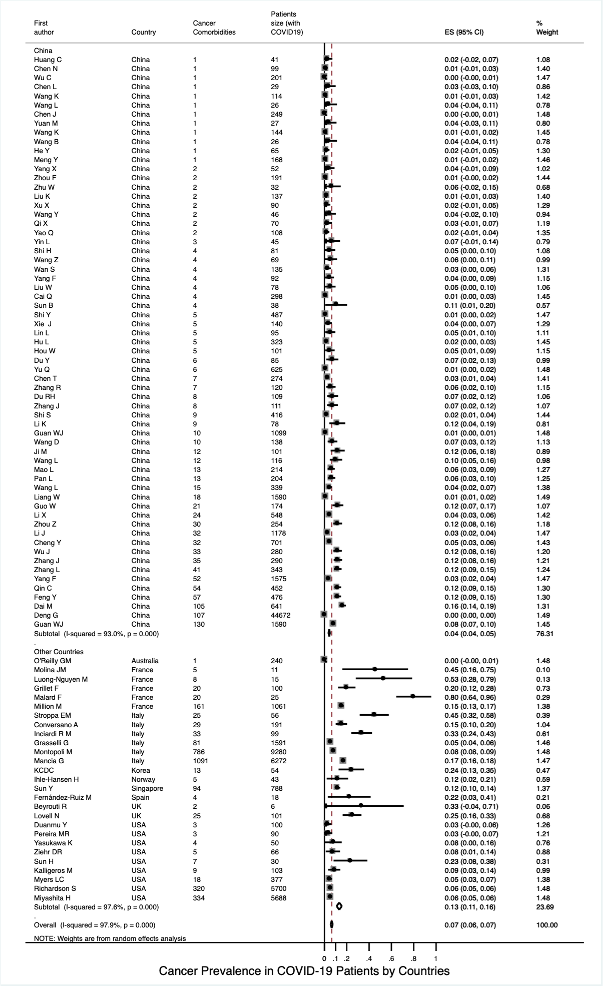
Figure S7 (D) Cancer Prevalence in COVID-19 Patients Stratified by Age Group (Metan Approach).
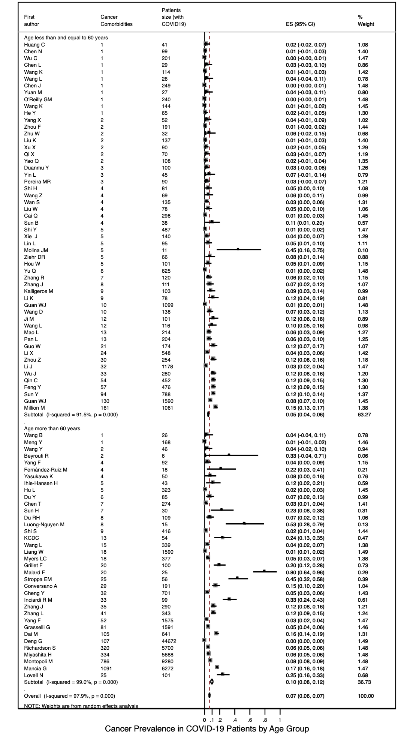
Figure S7 (E) Cancer Prevalence in COVID-19 Patients Stratified by Sample Size (Metan Approach).
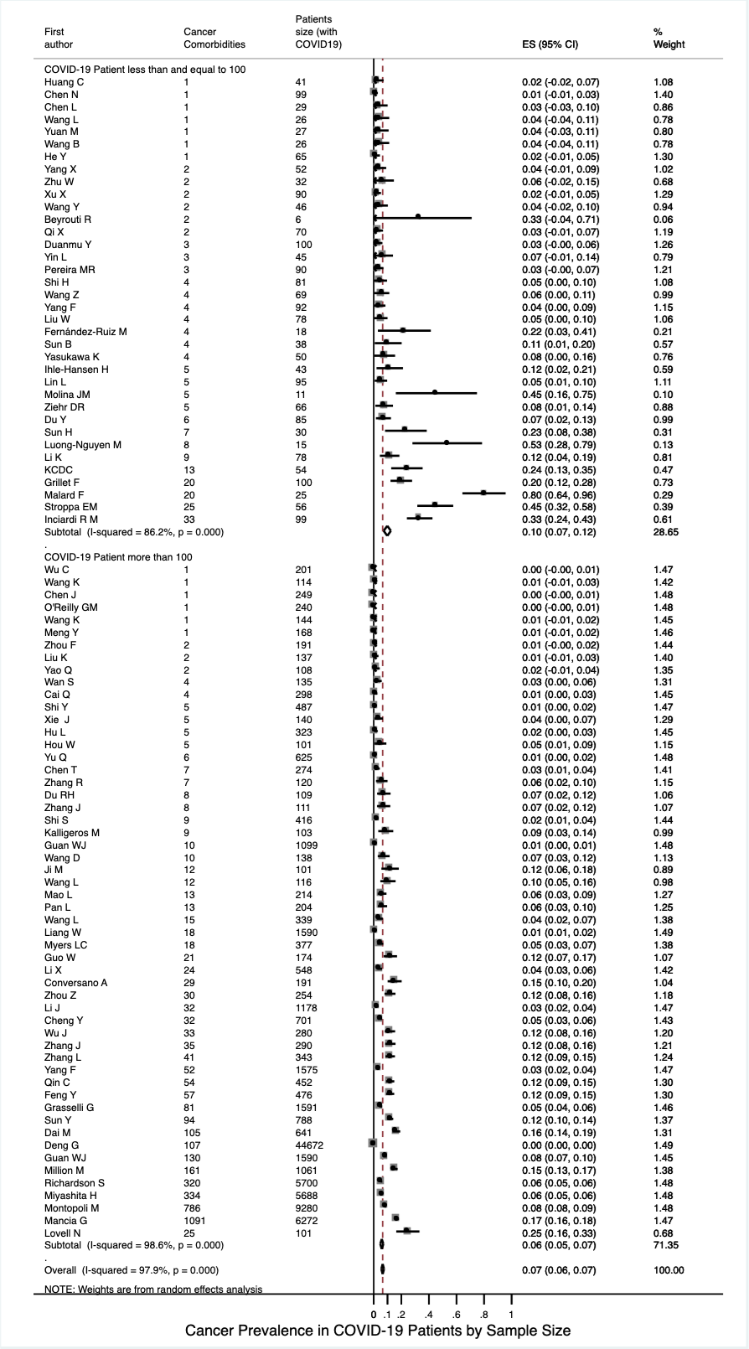
Figure S7 (F) Cancer Prevalence in COVID-19 Patients Stratified by Study Design (Metan Approach).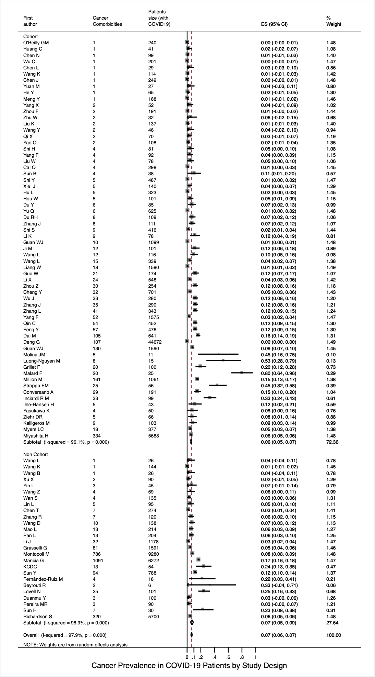

Figure S8 (A) Severe Illness Incidence in Non-Cancer Patients with COVID-19.
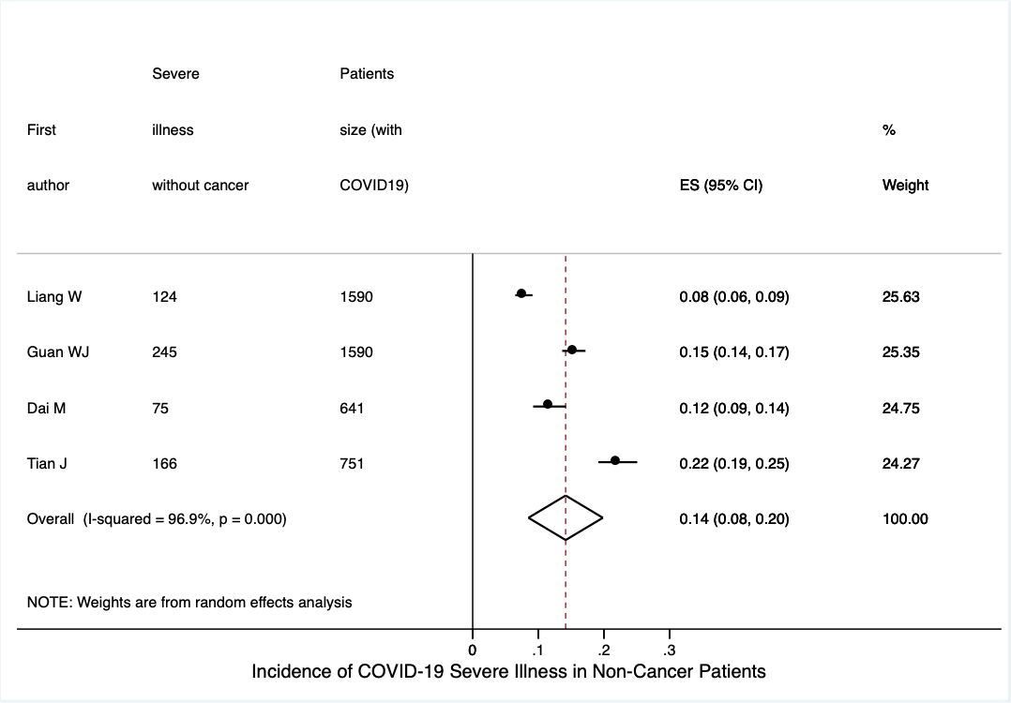
Figure S8 (B) Mortality Rate in Non-Cancer Patients with COVID-19.


