Overall Survival Benefits of First-Line Treatments for Asian Patients with Advanced Epidermal Growth Factor Receptor-mutated Non-small-cell Lung Cancer Harboring L858R Mutation: A Systematic Review and Network Meta-analysis

Supplemental Digital Content

Supplementary Methods 1. Literature Search Criteria.
Supplementary Methods 2. Methods of Bayesian Approach.
Supplementary Table 1. PRISMA Checklist for the Network Meta-analysis
Supplementary Table 2. Frequentist Net-splitting Analysis of Inconsistency
Supplementary Table 3. Bayesian Ranking Results of Network Meta-analysis in the First Sensitivity Analysis
Supplementary Table 4. Bayesian Node-splitting Analysis of Inconsistency in the First Sensitivity Analysis
Supplementary Figure 1. (A) Summary of the risk of bias assessment in 7 domains in the 17 studies included in the network meta-analysis. (B) Graphical representation of the overall risk of bias in the 7 domains.
Supplementary Figure 2. Forest plot for (A) overall survival and (B) progression-free survival showing results comparing treatment regimens against pemetrexed-free chemotherapy from the network meta-analysis
Supplementary Figure 3. Pooled estimates of the exploratory analyses for overall survival and progression-free survival. (A) Pooled hazard ratios (95% confidence intervals) for overall survival and progression-free survival stratified by the generation of treatment regimens. (B) Pooled hazard ratios (95% confidence intervals) for overall survival and progression-free survival stratified by the reversibility of the treatment regimens. (C) Pooled hazard ratios (95% confidence intervals) for overall survival and progression-free survival in the cohort of exon 19 deletion.
Supplementary Figure 4. Pooled estimates of the exploratory analyses for adverse events of grade ≥3.
Supplementary Figure 5. Toxicity profile in relation to the incidence (%) of each specific adverse event based on the overall population of each treatment included in the network meta-analysis.
Supplementary Figure 6. Pooled estimates of the network meta-analysis in the first sensitivity analysis by Bayesian approach.
Supplementary Figure 7. Convergence of the three chains established by inspection of the history feature and the Brooks-Gelman-Rubin diagnostic for (A) overall survival, (B) progression-free survival, and (C) adverse events of grade ≥3.
Supplementary Figure 8. Pooled estimates of the network meta-analysis after including only phase III trials in the second sensitivity analysis.
Supplementary Figure 9. Pooled estimates of the network meta-analysis after excluding FLAURA studies in the third sensitivity analysis.
Supplementary references

Supplementary Methods 1. Literature Search Criteria.
(((((((((((((non-small-cell lung cancer[title] OR non-small cell lung cancer[title]) OR non small-cell lung cancer[title]) OR non small cell lung cancer[title]) OR non-small-cell lung carcinoma[title]) OR non-small cell lung carcinoma[title]) OR non small-cell lung carcinoma[title]) OR non small cell lung carcinoma[title]) OR nsclc[title]) AND (epidermal growth factor receptor[title/abstract] OR EGFR[title/abstract])) AND ((((((((((((((((treatment[title/abstract] OR therapy[title/abstract]) OR tyrosine kinase inhibitor[title/abstract]) OR TKI[title/abstract]) OR osimertinib[title/abstract]) OR dacomitinib[title/abstract]) OR afatinib[title/abstract]) OR erlotinib[title/abstract]) OR gefitinib[title/abstract]) OR icotinib[title/abstract]) OR chemotherapy[title/abstract]) OR first-line[title/abstract]) OR first line[title/abstract]) OR treatment-naive[title/abstract]) OR treatment-naïve[title/abstract]) OR untreated[title/abstract])) AND (((((compare[title/abstract] OR comparison[title/abstract]) OR comparative[title/abstract]) OR comparing[title/abstract]) OR versus[title/abstract]) OR vs[title/abstract])) AND ((((((Randomized Controlled Trial[ptyp] OR controlled clinical trial[ptyp]) OR randomized[title/abstract]) OR randomised[title/abstract]) OR randomly[title/abstract]) OR trial[title/abstract]) OR phase[title/abstract])) AND ("0001/01/01"[Date - Publication] : "2021/11/30"[Date - Publication])

Supplementary Methods 2. Methods of Bayesian Approach.
Network meta-analysis (NMA) within the Bayesian framework in the first sensitivity analysis was performed using Markov Chain Monte Carlo simulation technique with the R package gemtc (version 4.0.5, R Foundation for Statistical Computing, Vienna, Austria). For each outcome measure, a fixed-effects consistency model was used, as most direct evidence was from one trial.¹ Three independent Markov chains were established for running 100,000 burn-ins and 150,000 sample iterations per chain simultaneously with a thinning interval of 1. This process was intended to obtain a posterior distribution, with model convergence of the iterations being evaluated and visualized using Brooks-Gelman-Rubin diagnostic (Supplementary Fig. 7). Once convergence was established, the posterior distributions for the model parameters were obtained as the output of the NMA estimate (hazard/odds ratio and the corresponding 95% credible interval). In the presence of minimally informative priors, credible intervals can be interpreted like conventional confidence intervals.² The Bayesian approach also provided overall ranking probabilities for each regimen, making it possible to rank each outcome measurement from the best to the worst, and were then visualized by calculating the surface under the cumulative ranking curves on the basis of the ranking profiles.² The node splitting approach was used to calculate the inconsistency of the model for closed loops in the network where direct and indirect evidence were separately contrasted on a particular comparison (node).³⁻⁵ Significant inconsistency was indicated if node-splitting analysis derived P < 0.05 of disagreement between direct and indirect evidence.

Supplementary Table 1. PRISMA Checklist for the Network Meta-analysis
Section and Topic | Item # | Checklist item | Location where item is reported
TITLE
Title | 1 | Identify the report as a systematic review. | 1, 3
ABSTRACT
Abstract | 2 | See the PRISMA 2020 for Abstracts checklist. | 3-4
INTRODUCTION
Rationale | 3 | Describe the rationale for the review in the context of existing knowledge. | 5-6
Objectives | 4 | Provide an explicit statement of the objective(s) or question(s) the review addresses. | 5-6
METHODS
Eligibility criteria | 5 | Specify the inclusion and exclusion criteria for the review and how studies were grouped for the syntheses. | 6
Information sources | 6 | Specify all databases, registers, websites, organisations, reference lists and other sources searched or consulted to identify studies. Specify the date when each source was last searched or consulted. | 6-7
Search strategy | 7 | Present the full search strategies for all databases, registers and websites, including any filters and limits used. | 6-7
Selection process | 8 | Specify the methods used to decide whether a study met the inclusion criteria of the review, including how many reviewers screened each record and each report retrieved, whether they worked independently, and if applicable, details of automation tools used in the process. | 7-8
Data collection process | 9 | Specify the methods used to collect data from reports, including how many reviewers collected data from each report, whether they worked independently, any processes for obtaining or confirming data from study investigators, and if applicable, details of automation tools used in the process. | 7-8
Data items | 10a | List and define all outcomes for which data were sought. Specify whether all results that were compatible with each outcome domain in each study were sought (e.g. for all measures, time points, analyses), and if not, the methods used to decide which results to collect. | 7-8
Data items | 10b | List and define all other variables for which data were sought (e.g. participant and intervention characteristics, funding sources). Describe any assumptions made about any missing or unclear information. | 8
Study risk of bias assessment | 11 | Specify the methods used to assess risk of bias in the included studies, including details of the tool(s) used, how many reviewers assessed each study and whether they worked independently, and if applicable, details of automation tools used in the process. | 8-9
Effect measures | 12 | Specify for each outcome the effect measure(s) (e.g. risk ratio, mean difference) used in the synthesis or presentation of results. | 8-9
Synthesis methods | 13a | Describe the processes used to decide which studies were eligible for each synthesis (e.g. tabulating the study intervention characteristics and comparing against the planned groups for each synthesis (item #5)). | 8-9
Synthesis methods | 13b | Describe any methods required to prepare the data for presentation or synthesis, such as handling of missing summary statistics, or data conversions. | 8-9
Synthesis methods | 13c | Describe any methods used to tabulate or visually display results of individual studies and syntheses. | 8-9
Synthesis methods | 13d | Describe any methods used to synthesize results and provide a rationale for the choice(s). If meta-analysis was performed, describe the model(s), method(s) to identify the presence and extent of statistical heterogeneity, and software package(s) used. | 8-9
Synthesis methods | 13e | Describe any methods used to explore possible causes of heterogeneity among study results (e.g. subgroup analysis, meta-regression). | 8-9
Synthesis methods | 13f | Describe any sensitivity analyses conducted to assess robustness of the synthesized results. | 8-9
Reporting bias assessment | 14 | Describe any methods used to assess risk of bias due to missing results in a synthesis (arising from reporting biases). | 8-9
Certainty assessment | 15 | Describe any methods used to assess certainty (or confidence) in the body of evidence for an outcome. | 8-9
RESULTS
Study selection | 16a | Describe the results of the search and selection process, from the number of records identified in the search to the number of studies included in the review, ideally using a flow diagram. | 10
Study selection | 16b | Cite studies that might appear to meet the inclusion criteria, but which were excluded, and explain why they were excluded. | 10
Study characteristics | 17 | Cite each included study and present its characteristics. | 10
Risk of bias in studies | 18 | Present assessments of risk of bias for each included study. | 10
Results of individual studies | 19 | For all outcomes, present, for each study: (a) summary statistics for each group (where appropriate) and (b) an effect estimate and its precision (e.g. confidence/credible interval), ideally using structured tables or plots. | 10-12
Results of syntheses | 20a | For each synthesis, briefly summarise the characteristics and risk of bias among contributing studies. | 10-12
Results of syntheses | 20b | Present results of all statistical syntheses conducted. If meta-analysis was done, present for each the summary estimate and its precision (e.g. confidence/credible interval) and measures of statistical heterogeneity. If comparing groups, describe the direction of the effect. | 10-13
Results of syntheses | 20c | Present results of all investigations of possible causes of heterogeneity among study results. | 10-13
Results of syntheses | 20d | Present results of all sensitivity analyses conducted to assess the robustness of the synthesized results. | 12-13
Reporting biases | 21 | Present assessments of risk of bias due to missing results (arising from reporting biases) for each synthesis assessed. | 10
Certainty of evidence | 22 | Present assessments of certainty (or confidence) in the body of evidence for each outcome assessed. | 10-13
DISCUSSION
Discussion | 23a | Provide a general interpretation of the results in the context of other evidence. | 13-14
Discussion | 23b | Discuss any limitations of the evidence included in the review. | 15-16
Discussion | 23c | Discuss any limitations of the review processes used. | 15-16
Discussion | 23d | Discuss implications of the results for practice, policy, and future research. | 15-16
OTHER INFORMATION
Registration and protocol | 24a | Provide registration information for the review, including register name and registration number, or state that the review was not registered. | 7
Registration and protocol | 24b | Indicate where the review protocol can be accessed, or state that a protocol was not prepared. | 7
Registration and protocol | 24c | Describe and explain any amendments to information provided at registration or in the protocol. | 7
Support | 25 | Describe sources of financial or non-financial support for the review, and the role of the funders or sponsors in the review. | NA
Competing interests | 26 | Declare any competing interests of review authors. | NA
Availability of data, code and other materials | 27 | Report which of the following are publicly available and where they can be found: template data collection forms; data extracted from included studies; data used for all analyses; analytic code; any other materials used in the review. | NA
PRISMA, Preferred Reporting Items for Systematic Reviews and Meta-Analysis.

Supplementary Table 2. Frequentist Net-splitting Analysis of Inconsistency
Nets | Direct Effect | Indirect Effect | Overall | P
Progression-free survival
Afatinib, PbCT | 0.76  (0.46-1.17) | 0.29  (0.14-0.69) | 0.60  (0.34-1.07) | 0.081
Afatinib, PfCT | 0.32  (0.19-0.52) | 1.09  (0.61-1.42) | 0.41  (0.23-0.75) | 0.083
Erlotinib, Osimertinib | 2.08  (1.35-3.23) | 1.73  (1.41-2.00) | 1.96  (1.20-2.78) | 0.721
Erlotinib, PfCT | 0.39  (0.14-0.61) | 0.46  (0.26-0.73) | 0.41  (0.26-0.64) | 0.720
Gefitinib, Gefitinib+PbCT | 2.22  (1.51-6.66) | 6.97  (3.01-8.62) | 2.64  (1.34-5.86) | 0.075
Gefitinib, Osimertinib | 1.78  (1.32-2.45) | 2.14  (1.77-3.10) | 1.86  (1.23-2.78) | 0.721
Gefitinib, PfCT | 0.43  (0.21-0.61) | 0.24  (0.18-0.66) | 0.39  (0.28-0.54) | 0.188
Gefitinib+PbCT, PbCT | 0.11  (0.04-0.28) | 0.47  (0.28-0.74) | 0.21  (0.10-0.46) | 0.076
Adverse events of grade ≥3
Afatinib, PbCT | 1.03  (0.39-2.74) | 0.22  (0.11-0.84) | 0.82  (0.28-2.38) | 0.311
Afatinib, PfCT | 0.37  (0.23-0.58) | 1.36  (0.42-1.58) | 0.42  (0.19-0.85) | 0.321
Erlotinib, Osimertinib | 1.38  (0.89-1.17) | 0.79  (0.55-1.23) | 1.01  (0.54-1.89) | 0.138
Erlotinib, PfCT | 0.19  (0.06-0.52) | 0.14  (0.03-0.28) | 0.20  (0.01-0.38) | 0.178
Gefitinib, Gefitinib+PbCT | 0.16  (0.07-0.48) | 0.77  (0.24-1.52) | 0.36  (0.08-1.00) | 0.311
Gefitinib, Osimertinib | 0.89  (0.64-3.21) | 2.50  (1.23-3.10) | 1.10  (0.53-1.85) | 0.138
Gefitinib, PfCT | 0.26  (0.18-0.42) | 0.09  (0.04-0.24) | 0.21  (0.13-0.34) | 0.102
Gefitinib+PbCT, PbCT | 0.80  (0.20-3.22) | 3.79  (1.44-4.86) | 1.19  (0.32-4.34) | 0.312
* The frequentist net-splitting analysis was applied to evaluate inconsistency for closed loops in the network. No closed loop is found in the network of overall survival.
PbCT, pemetrexed-based chemotherapy; PfCT, pemetrexed-free chemotherapy.

Supplementary Table 3. Bayesian Ranking Results of Network Meta-analysis in the First Sensitivity Analysis
Treatment | Rank of Possibility (%)
Treatment | 1 | 2 | 3 | 4 | 5 | 6 | 7 | 8 | 9 | 10 | 11 | 12
Overall survival
Osimertinib | 1.2 | 4.1 | 9.3 | 9.2 | 9.1 | 8.5 | 10.5 | 9.7 | 12.7 | 25.7 | NA | NA
Dacomitinib | 20.5 | 39.1 | 18.7 | 10.6 | 5.4 | 2.8 | 1.5 | 0.8 | 0.4 | 0.2 | NA | NA
Afatinib | 0 | 0.2 | 0.9 | 2.4 | 5.0 | 7.4 | 10.8 | 18.8 | 25.1 | 29.5 | NA | NA
Erlotinib | 0.2 | 0.2 | 0.9 | 18.1 | 15.1 | 14.9 | 13.2 | 10.7 | 9.9 | 6.8 | NA | NA
Gefitinib | 0 | 0 | 2.1 | 6.2 | 11.2 | 17.7 | 19.5 | 18.6 | 17.1 | 7.3 | NA | NA
Icotinib | 3.1 | 6.2 | 9.0 | 10.0 | 8.8 | 7.5 | 7.4 | 10.0 | 14.2 | 23.7 | NA | NA
Erlotinib+  Bevacizumab | 10.9 | 19.7 | 23.9 | 13.4 | 10.0 | 6.8 | 5.0 | 4.1 | 3.6 | 2.5 | NA | NA
Gefitinib+  PbCT | 60.0 | 18.2 | 8.7 | 5.0 | 2.8 | 6.8 | 5.0 | 4.1 | 3.6 | 2.5 | NA | NA
Ramucirumab+  Erlotinib | NA | NA | NA | NA | NA | NA | NA | NA | NA | NA | NA | NA
Apatinib+  Gefitinib | NA | NA | NA | NA | NA | NA | NA | NA | NA | NA | NA | NA
PbCT | 4.0 | 9.7 | 14.8 | 14.4 | 11.4 | 0.3 | 9.6 | 13.6 | 10.7 | 2.5 | NA | NA
PfCT | 0 | 0 | 3.8 | 10.7 | 21.1 | 23.4 | 21.2 | 12.8 | 5.3 | 1.1 | NA | NA
Progression-free survival
Osimertinib | 5.6 | 24.6 | 37.2 | 21.2 | 10.1 | 1.2 | 0 | 0 | 0 | 0 | 0 | 0
Dacomitinib | 15.3 | 33.1 | 19.6 | 13.9 | 11.6 | 4.9 | 1.2 | 0.3 | 0 | 0 | 0.4 | 0
Afatinib | 0 | 0.1 | 0.5 | 1.2 | 3.0 | 7.9 | 17.3 | 20.9 | 28.4 | 19.7 | 1.0 | 0
Erlotinib | 0 | 0 | 0 | 0 | 0.2 | 4.4 | 17.1 | 23.0 | 23.2 | 22.9 | 0.3 | 0
Gefitinib | 0 | 0 | 0 | 0 | 0.4 | 3.7 | 24.6 | 31.1 | 24.5 | 12.6 | 2.3 | 0
Icotinib | 0.5 | 1.7 | 2.4 | 3.5 | 5.2 | 14.3 | 12.0 | 15.8 | 15.5 | 31.8 | 3.0 | 0.3
Erlotinib+  Bevacizumab | 5.8 | 12.1 | 15.7 | 20.4 | 22.0 | 15.0 | 5.2 | 2.4 | 2.4 | 1.0 | 0 | 0
Gefitinib+  PbCT | 69.4 | 17.9 | 7.0 | 3.4 | 1.8 | 0.4 | 0 | 0 | 0 | 0 | 0 | 0
Ramucirumab+  Erlotinib | 2.7 | 8.2 | 13.8 | 21.8 | 26.4 | 18.0 | 5.7 | 2.3 | 0.8 | 0.2 | 0 | 0
Apatinib+  Gefitinib | 0.6 | 3.4 | 7.4 | 13.4 | 17.8 | 32.8 | 13.0 | 6.6 | 3.0 | 1.5 | 0.4 | 0
PbCT | 0 | 0 | 0 | 0 | 0 | 0.1 | 0.5 | 1.4 | 3.5 | 10.3 | 78.9 | 5.3
PfCT | 0 | 0 | 0 | 0 | 0 | 0 | 0 | 0 | 0 | 0.6 | 5.1 | 94.2
Adverse events of grade ≥3
Osimertinib | 3.1 | 49.8 | 30.9 | 10.9 | 4.0 | 1.0 | 0.2 | 0 | 0 | 0 | 0 | 0
Dacomitinib | 0.7 | 10.6 | 10.1 | 15.8 | 33.9 | 15.6 | 8.4 | 4.0 | 0.8 | 0 | 0 | 0
Afatinib | 0 | 0.3 | 0.7 | 1.8 | 8.4 | 36.1 | 31.1 | 17.1 | 4.4 | 0 | 0 | 0
Erlotinib | 1.6 | 24.0 | 33.1 | 19.8 | 14.9 | 4.5 | 1.6 | 0.4 | 0 | 0 | 0 | 0
Gefitinib | 0.1 | 5.0 | 18.6 | 44.3 | 25.3 | 5.4 | 1.2 | 0.1 | 0 | 0 | 0 | 0
Icotinib | 94.4 | 2.2 | 1.5 | 0.9 | 0.9 | 0.1 | 0 | 0 | 0 | 0 | 0 | 0
Erlotinib+  Bevacizumab | 0 | 0 | 0 | 0 | 0 | 0 | 0 | 0.4 | 1.8 | 8.4 | 54.9 | 34.4
Gefitinib+  PbCT | 0 | 4.7 | 2.4 | 2.7 | 4.3 | 9.4 | 11.4 | 18.8 | 25.7 | 12.6 | 5.2 | 2.7
Ramucirumab+  Erlotinib | 0 | 0 | 0 | 0.4 | 2.5 | 14.1 | 24.1 | 27.0 | 30.9 | 0.9 | 0 | 0
Apatinib+  Gefitinib | 0 | 0 | 0 | 0 | 0 | 0 | 0 | 0 | 0.3 | 2.6 | 34.4 | 62.7
PbCT | 0 | 3.3 | 2.7 | 3.3 | 5.8 | 13.8 | 21.6 | 29.2 | 16.9 | 3.6 | 0.9 | 0.1
PfCT | 0 | 0 | 0 | 0 | 0 | 0 | 0 | 3.8 | 19.5 | 72.1 | 4.6 | 0
*The numbers with biggest probability of ranking first and last are in bold and underscored.
NA, not available; PbCT, pemetrexed-based chemotherapy; PfCT, pemetrexed-free chemotherapy.

Supplementary Table 4. Bayesian Node-splitting Analysis of Inconsistency in the First Sensitivity Analysis
Nodes | Direct Effect | Indirect Effect | Overall | P
Progression-free survival
Afatinib, PbCT | 0.76  (0.46-1.17) | 0.30  (0.12-0.71) | 0.64  (0.41-1.08) | 0.087
Afatinib, PfCT | 0.32  (0.19-0.52) | 1.09  (0.61-1.42) | 0.39  (0.25-0.63) | 0.096
Erlotinib, Osimertinib | 2.08  (1.35-3.23) | 1.73  (1.39-2.02) | 2.00  (1.41-2.86) | 0.747
Erlotinib, PfCT | 0.39  (0.14-0.61) | 0.46  (0.25-0.68) | 0.37  (0.29-0.58) | 0.739
Gefitinib, Gefitinib+PbCT | 2.22  (1.51-6.66) | 6.97  (3.00-8.64) | 2.64  (1.34-5.86) | 0.084
Gefitinib, Osimertinib | 1.78  (1.32-2.45) | 2.14  (1.73-3.10) | 1.89  (1.39-2.56) | 0.746
Gefitinib, PfCT | 0.43  (0.21-0.61) | 0.26  (0.16-0.72) | 0.38  (0.31-0.48) | 0.229
Gefitinib+PbCT, PbCT | 0.11  (0.04-0.28) | 0.44  (0.24-0.77) | 0.24  (0.13-0.46) | 0.089
Adverse events of grade ≥3
Afatinib, PbCT | 1.03  (0.39-2.74) | 0.24  (0.18-0.88) | 0.83  (0.34-2.08) | 0.353
Afatinib, PfCT | 0.37  (0.23-0.58) | 1.33  (0.36-1.41) | 0.39  (0.25-0.61) | 0.363
Erlotinib, Osimertinib | 1.38  (0.89-1.17) | 0.79  (0.55-1.23) | 1.01  (0.74-1.63) | 0.198
Erlotinib, PfCT | 0.19  (0.06-0.52) | 0.16  (0.08-0.33) | 0.22  (0.14-0.34) | 0.201
Gefitinib, Gefitinib+PbCT | 0.16  (0.07-0.48) | 0.78  (0.22-1.57) | 0.42  (0.11-1.61) | 0.370
Gefitinib, Osimertinib | 0.89  (0.64-3.21) | 2.50  (1.21-3.11) | 1.23  (0.87-1.75) | 0.212
Gefitinib, PfCT | 0.26  (0.18-0.42) | 0.09  (0.08-0.27) | 0.24  (0.19-0.30) | 0.097
Gefitinib+PbCT, PbCT | 0.80  (0.20-3.22) | 4.22  (1.21-6.45) | 1.23  (0.37-4.00) | 0.374
* The Bayesian node-splitting analysis was applied to evaluate inconsistency for closed loops in the network. No closed loop is found in the network of overall survival.
PbCT, pemetrexed-based chemotherapy; PfCT, pemetrexed-free chemotherapy.

Supplementary Figure 1. (A) Summary of the risk of bias assessment in 7 domains in the 18 studies included in the network meta-analysis. (B) Graphical representation of the overall risk of bias in the 7 domains
A
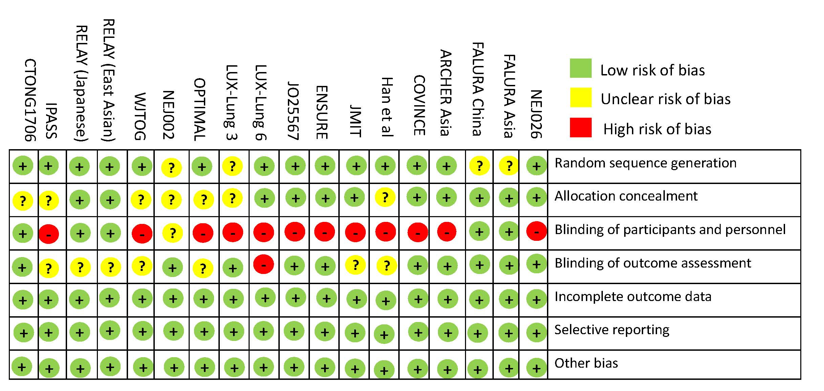

B
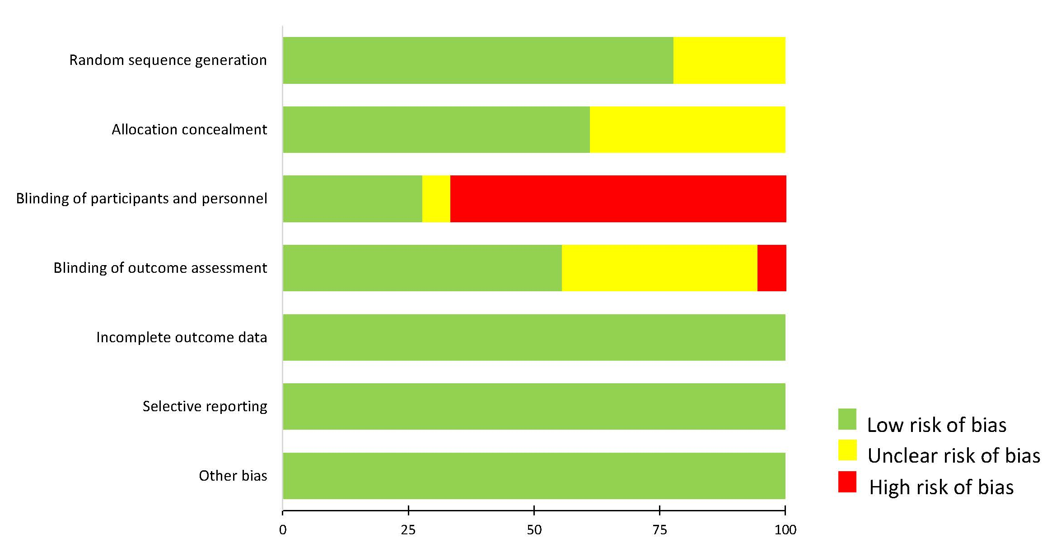

Supplementary Figure 2. Forest plot for (A) overall survival and (B) progression-free survival showing results comparing treatment regimens against pemetrexed-free chemotherapy from the network meta-analysis. Hazard ratios more than 1 favor pemetrexed-free chemotherapy. EGFR, epidermal growth factor receptor; TKIs, tyrosine kinase inhibitors; PbCT, pemetrexed-based chemotherapy; PfCT, pemetrexed-free chemotherapy; 95% CI, 95% confidence interval.
A
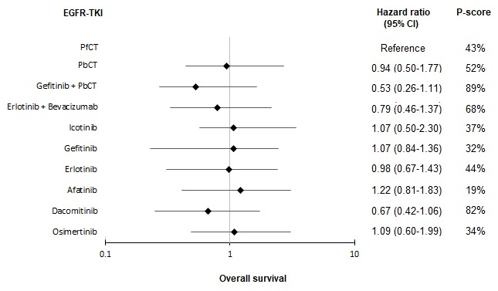
B
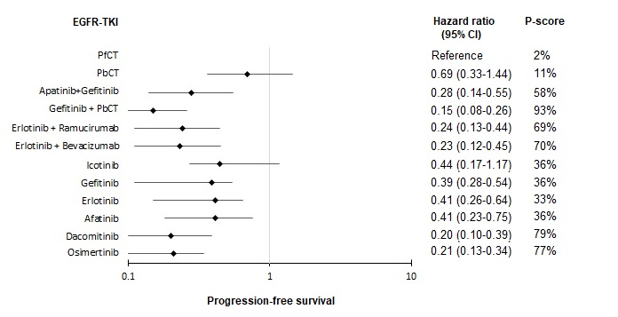

Supplementary Figure 3. Pooled estimates of the exploratory analyses for overall survival and progression-free survival. (A) Pooled hazard ratios (95% confidence intervals) for overall survival (upper triangle) and progression-free survival (lower triangle) stratified by the generation of treatment regimens. (B) Pooled hazard ratios (95% confidence intervals) for overall survival (upper triangle) and progression-free survival (lower triangle) stratified by the reversibility of the treatment regimens. (C) Pooled hazard ratios (95% confidence intervals) for overall survival (upper triangle) and progression-free survival (lower triangle) in the cohort of exon 19 deletion. P-scores for overall survival (left) and progression-free survival (right) are indicated under each treatment. (Data in each cell are hazard ratios (95% confidence intervals) for the comparison of row-defining treatment versus column-defining treatment. Hazard ratios less than 1 favor row-defining treatment. Significant results are in bold*.

A
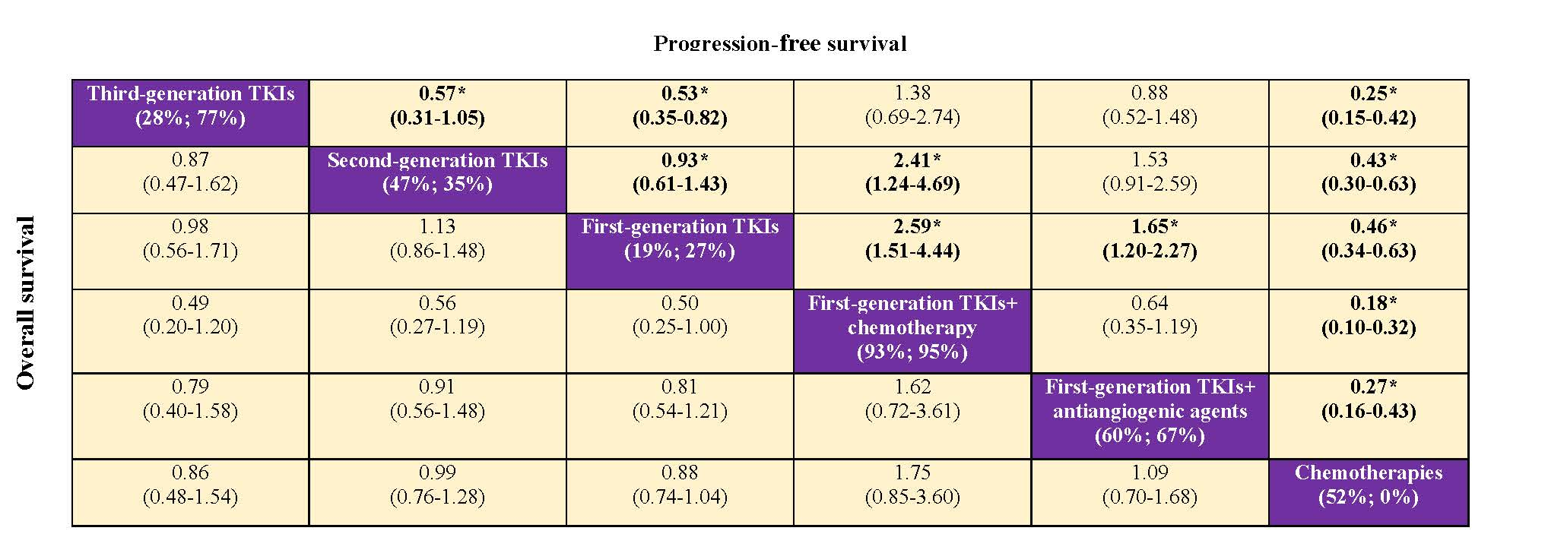

B
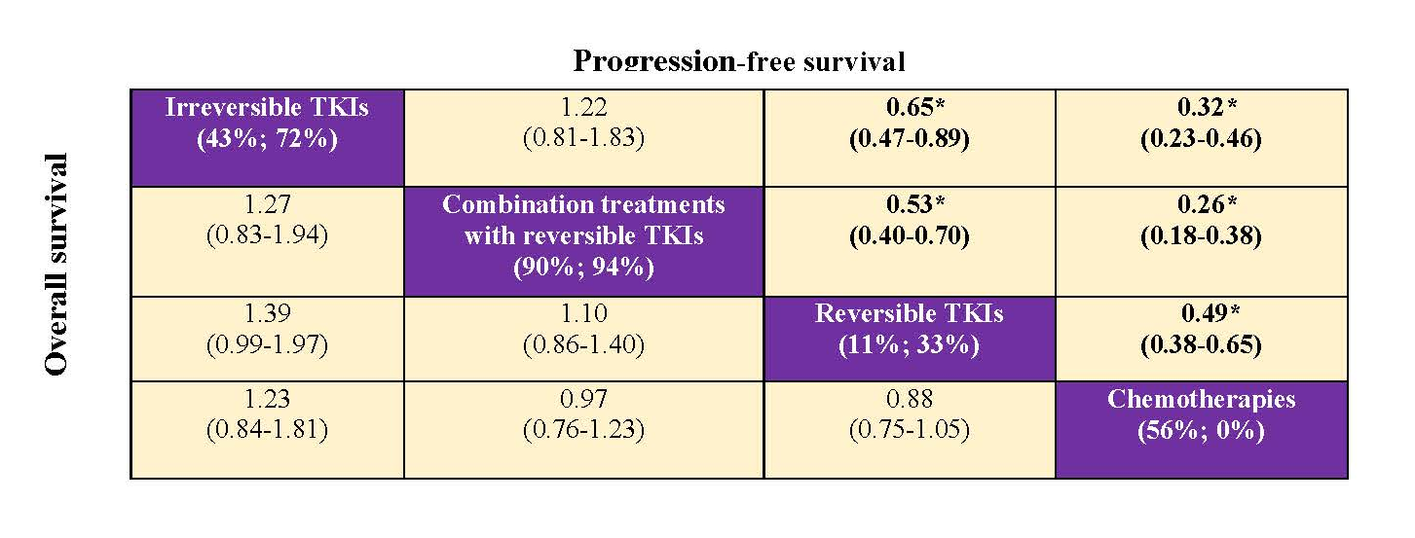

C
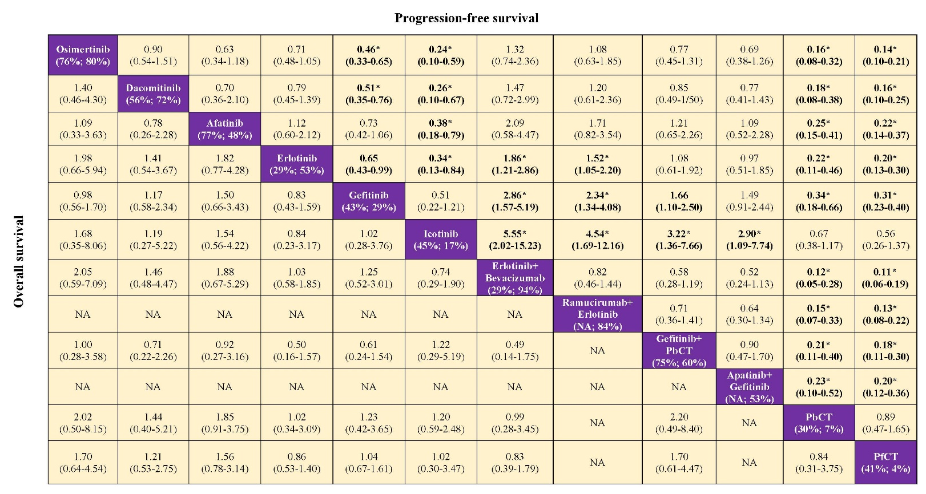

Supplementary Figure 4. Pooled estimates of the exploratory analyses for adverse events of grade ≥ 3. (A) Pooled odds ratios (95% confidence intervals) stratified by the generation of treatment regimens. (B) Pooled odds ratios (95% confidence intervals) stratified by the reversibility of the treatment regimens. P-scores are indicated under each treatment. (Data in each cell are odds ratios (95% confidence intervals) for the comparison of row-defining treatment versus column-defining treatment. Hazard ratios less than 1 favor row-defining treatment. Significant results are in bold*.

A
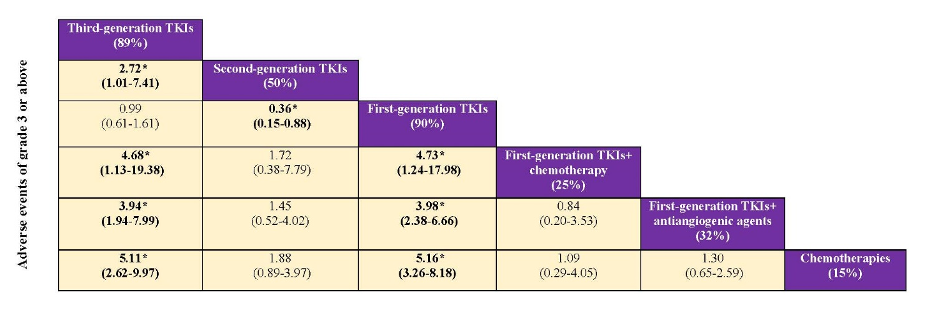

B
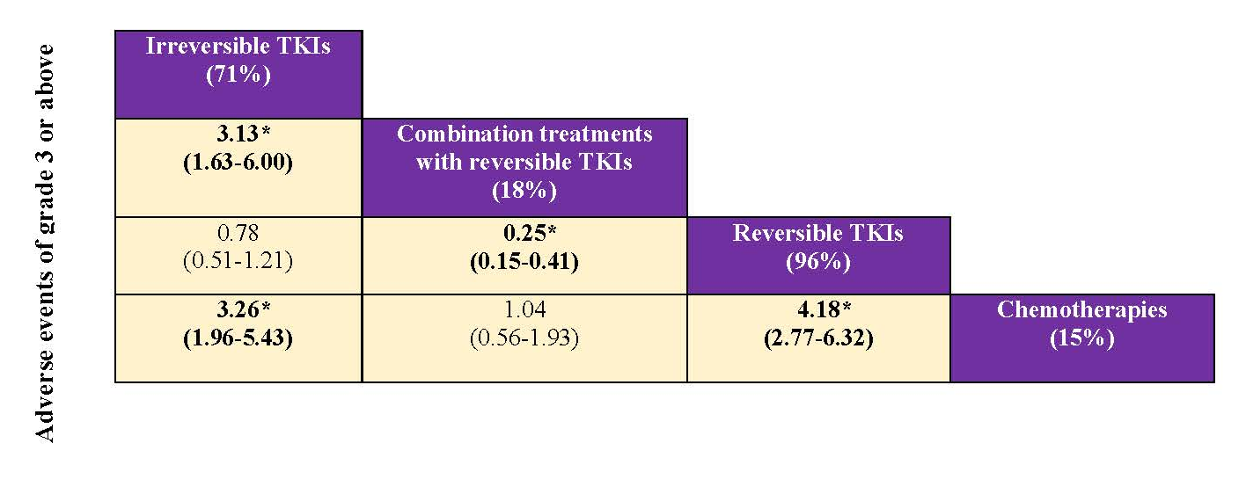

Supplementary Figure 5. Toxicity profile in relation to the incidence (%) of each specific adverse event (any grades) based on the overall population of each treatment included in the network meta-analysis.

*When not reported, liver dysfunction was represented by alanine transaminase increased as it was reported in most studies.
Notable incidences of hypertension (58.3%), hemorrhagic events (45.5%) and proteinuria (40.1%) were also associated with erlotinib plus bevacizumab group based on the report of the JO25567 and NEJ026 studies. Notable incidence of hypertension (46.5%) was associated with gefitinib plus apatinib based on CTONG1706.
Bev, bevacizumab; ILD, interstitial lung disease; NA, not available; PbCT, pemetrexed-based chemotherapy; PfCT, pemetrexed-free chemotherapy; Ram, ramucirumab.

Supplementary Figure 6. Pooled estimates of the network meta-analysis in the first sensitivity analysis by Bayesian approach. (A) Pooled hazard ratios (95% credible intervals) for overall survival (upper triangle) and progression-free survival (lower triangle). (B) Pooled odds ratios (95% credible intervals) for adverse events of grade ≥3. Data in each cell are hazard or odds ratios (95% credible intervals) for the comparison of row-defining treatment versus column-defining treatment. Hazard ratios or odds ratio less than 1 favor row-defining treatment. Significant results are in bold*. NA, not available; PbCT, pemetrexed-based chemotherapy; PfCT, pemetrexed-free chemotherapy.
A
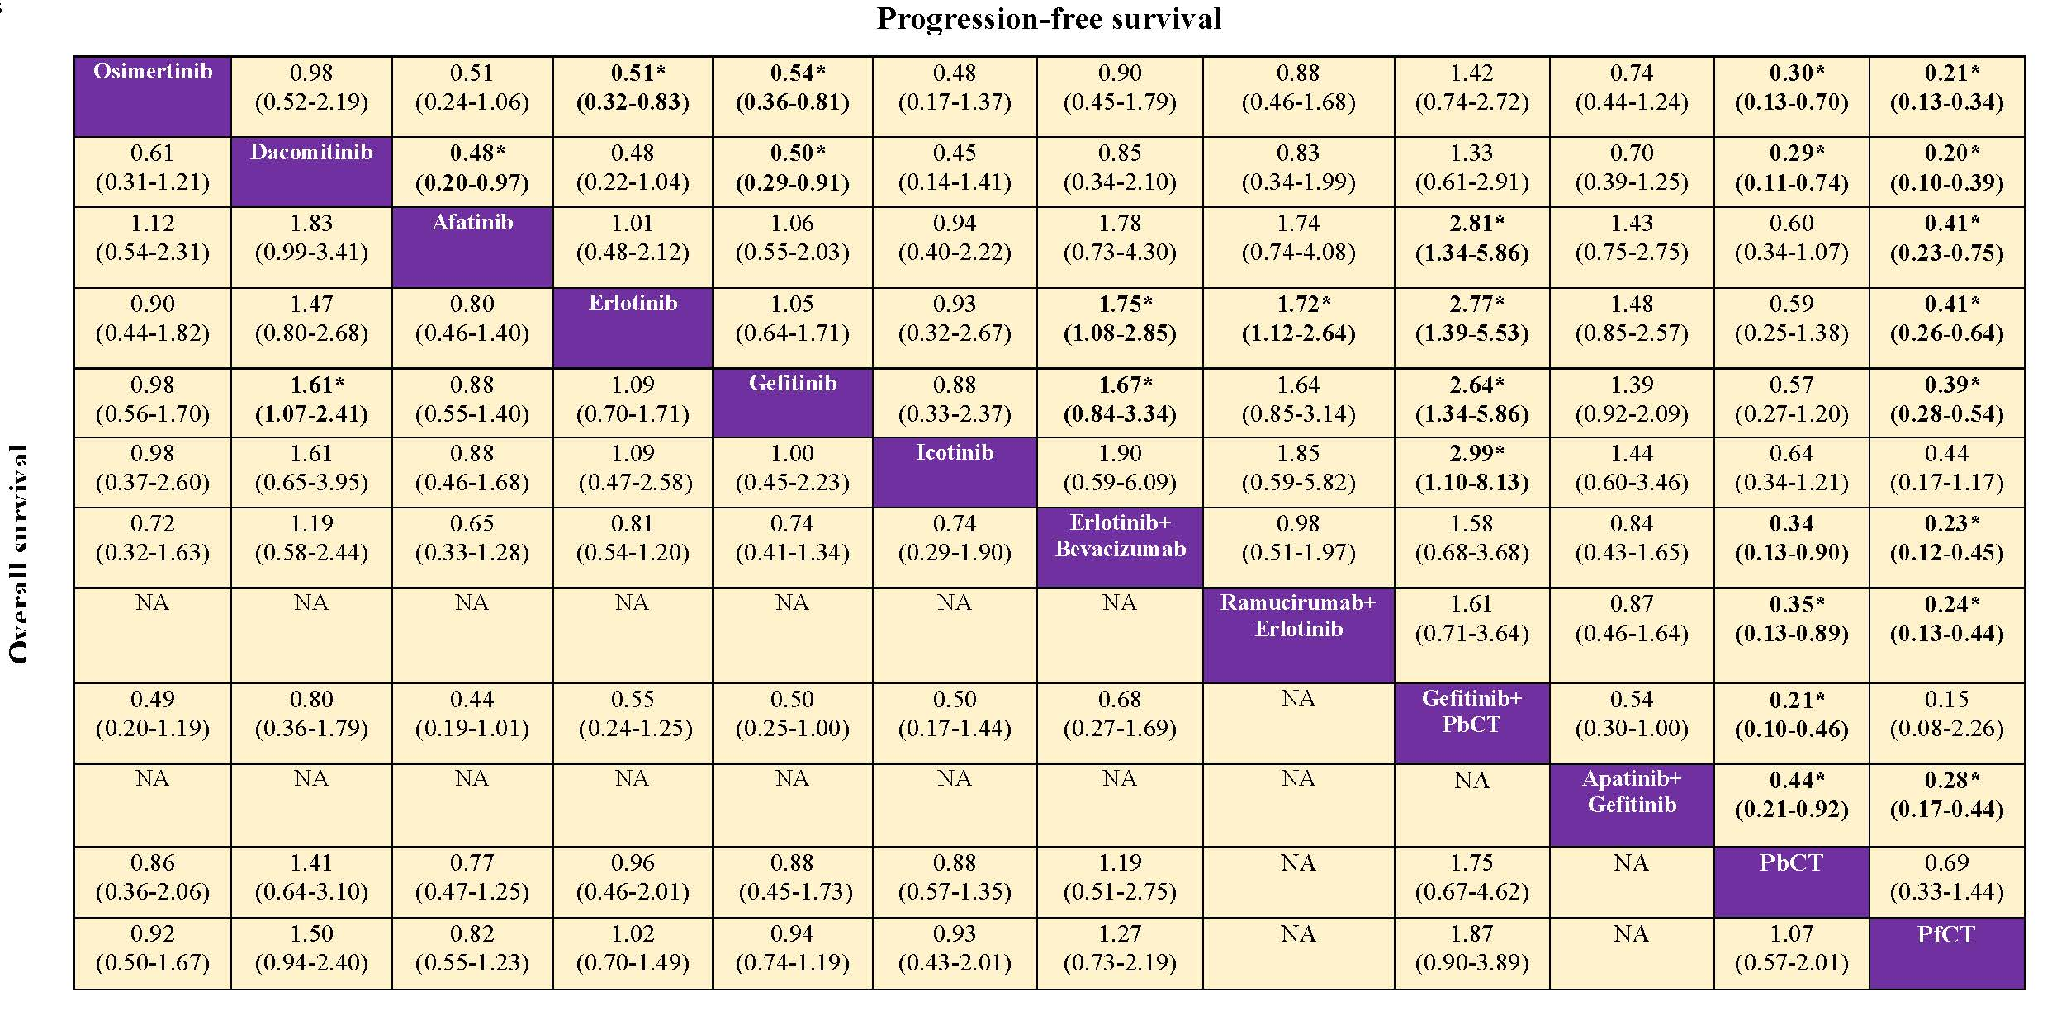
B
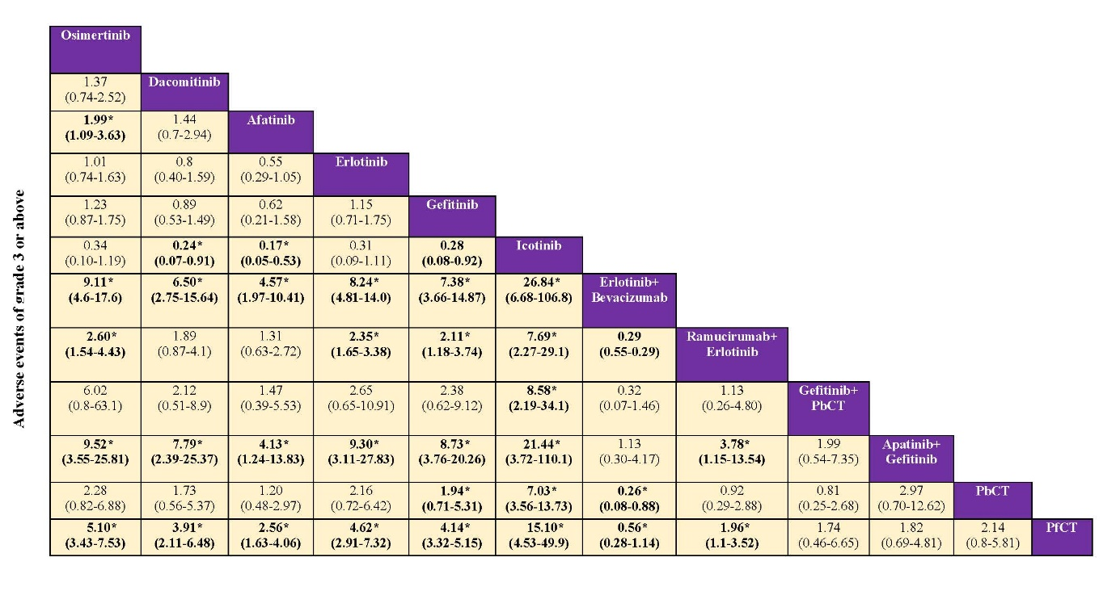

Supplementary Figure 7. Convergence of the three chains established by inspection of the history feature and the Brooks-Gelman-Rubin diagnostic for (A) overall survival, (B) progression-free survival, and (C) adverse events of grade ≥ 3.
A
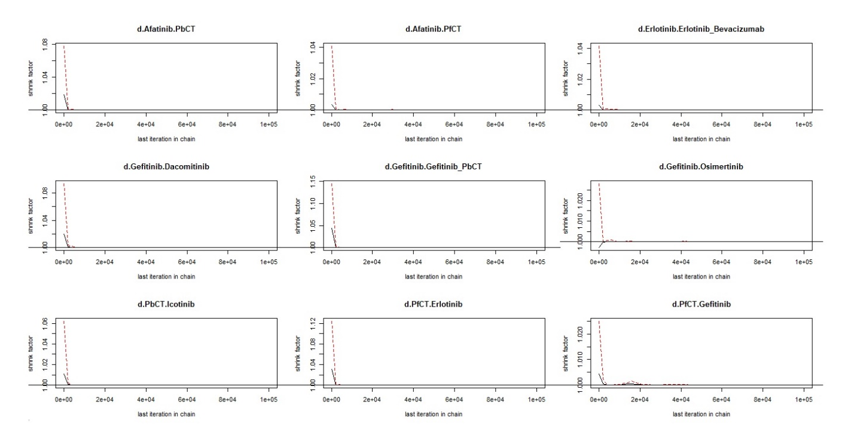
B
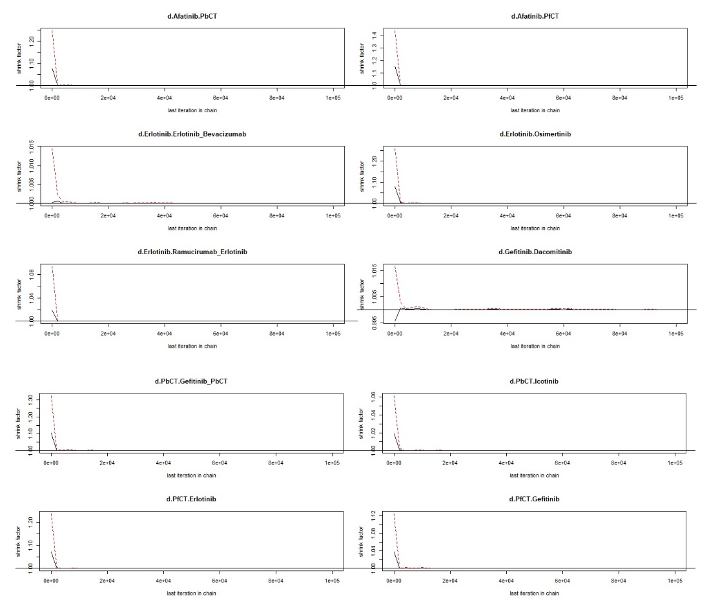

C
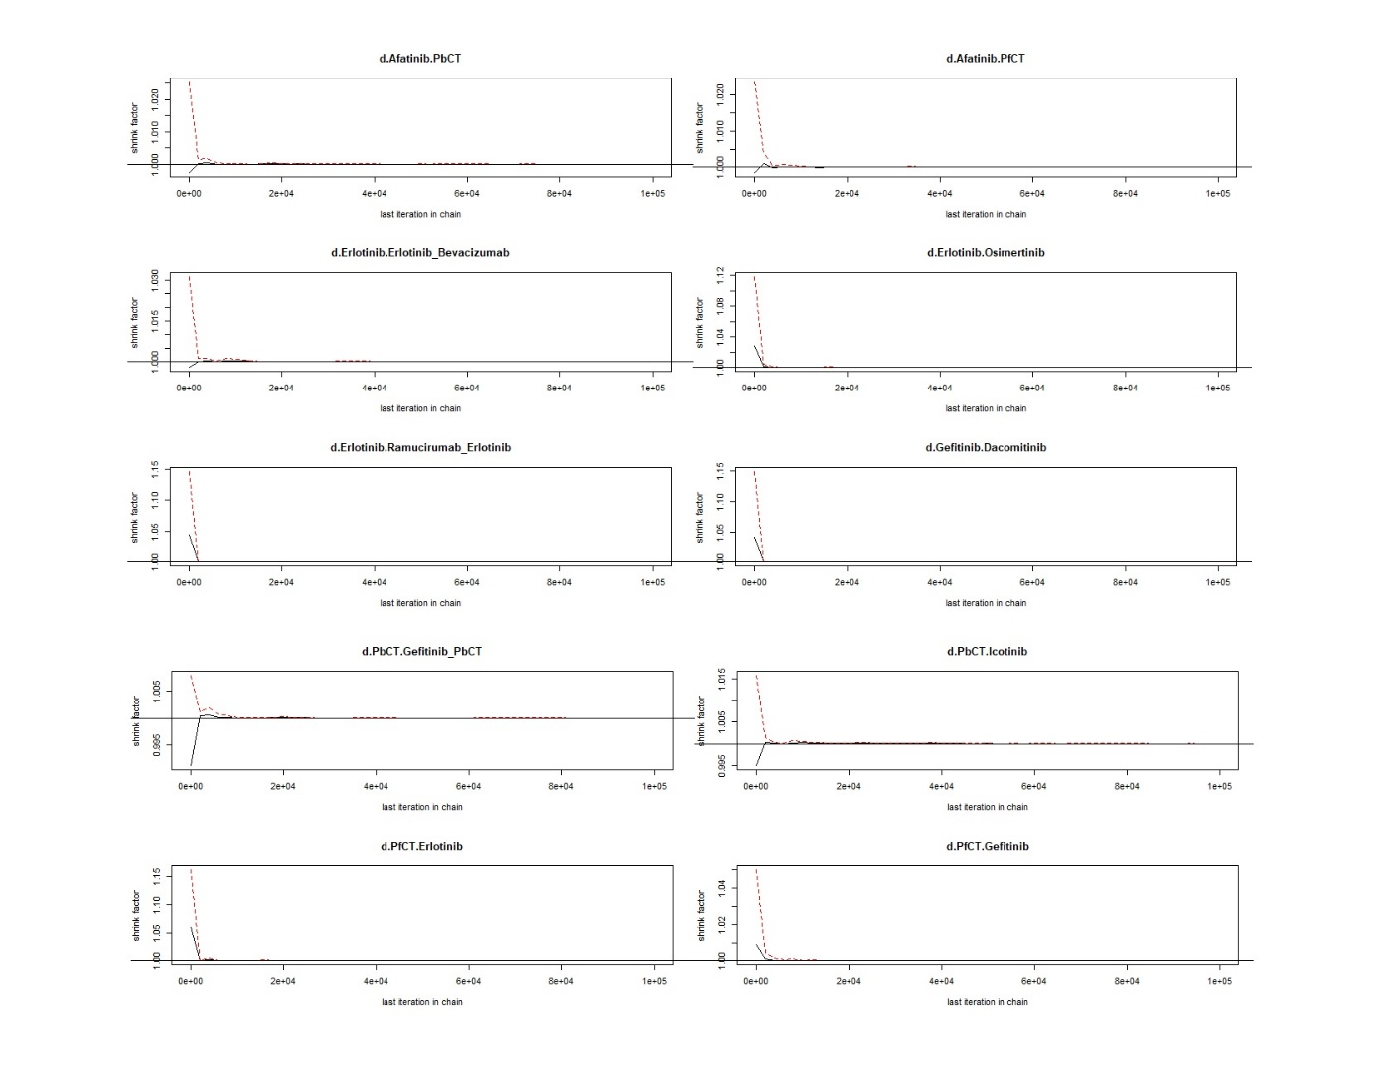

Supplementary Figure 8. Pooled estimates of the network meta-analysis after including only phase III trials in the second sensitivity analysis. (A) Pooled hazard ratios (95% confidence intervals) for overall survival (upper triangle) and progression-free survival (lower triangle). P-scores for overall survival (left) and progression-free survival (right) are indicated under each treatment. (B) Pooled odds ratios (95% confidence intervals) for adverse events of grade ≥ 3. P-scores are indicated under each treatment. Data in each cell are hazard or odds ratios (95% confidence intervals) for the comparison of row-defining treatment versus column-defining treatment. Hazard ratios or odds ratio less than 1 favor row-defining treatment. Significant results are in bold*. NA, not available; PbCT, pemetrexed-based chemotherapy; PfCT, pemetrexed-free chemotherapy.
A
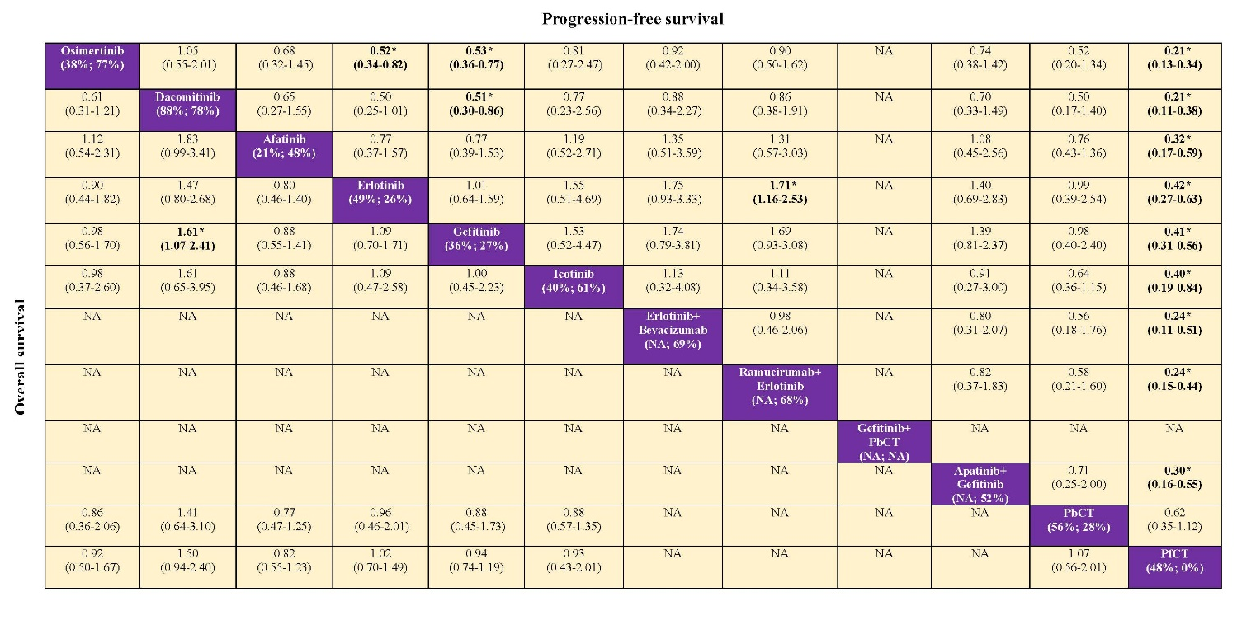
B
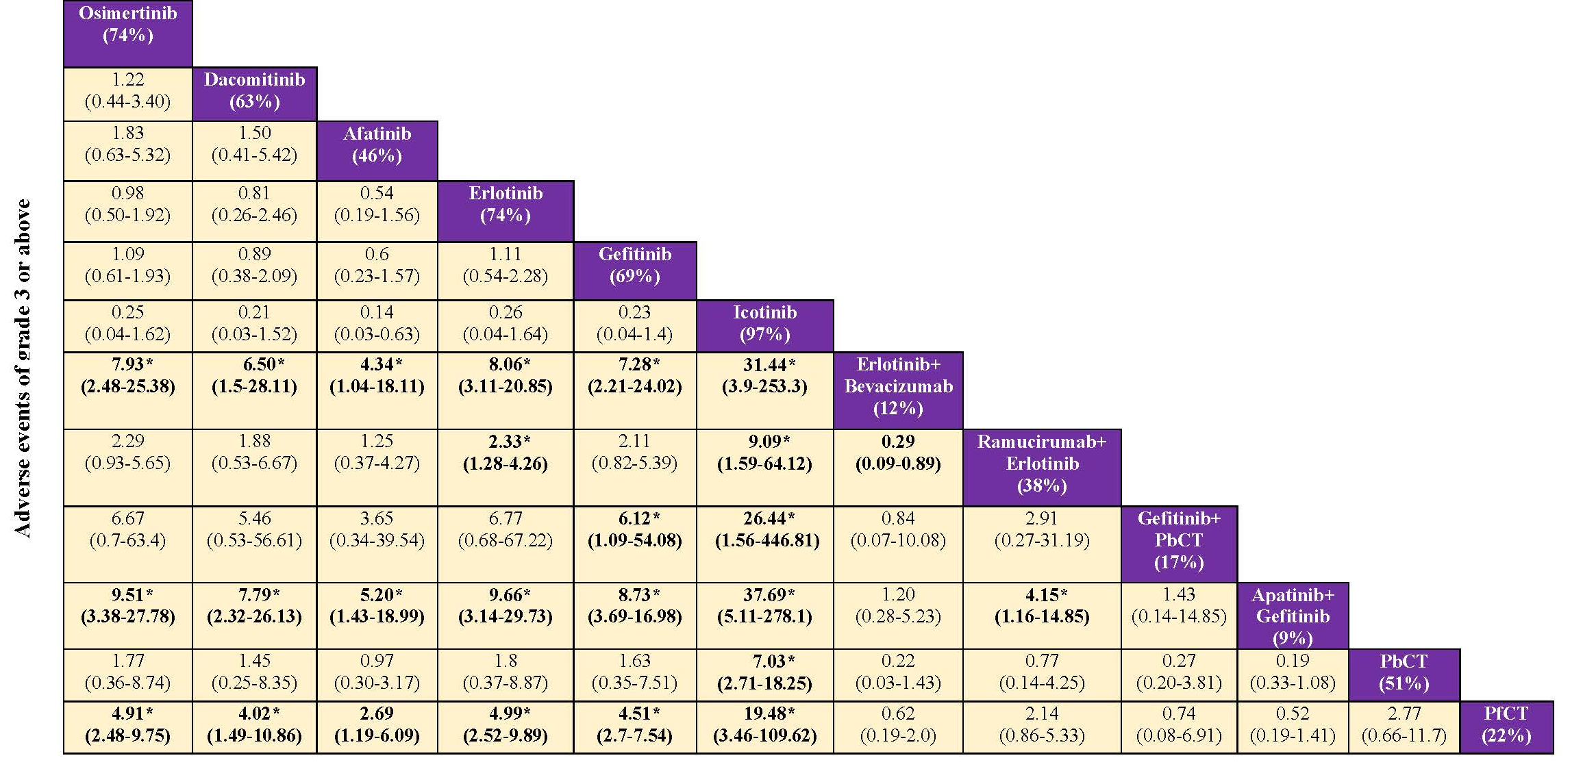

Supplementary Figure 9. Pooled estimates of the network meta-analysis after excluding FLAURA studies in the third sensitivity analysis. (A) Pooled hazard ratios (95% confidence intervals) for progression-free survival. (B) Pooled odds ratios (95% confidence intervals) for adverse events of grade ≥3. P-scores are indicated under each treatment. Data in each cell are hazard or odds ratios (95% confidence intervals) for the comparison of row-defining treatment versus column-defining treatment. Hazard ratios or odds ratio less than 1 favor row-defining treatment. Significant results are in bold*. NA, not available; PbCT, pemetrexed-based chemotherapy; PfCT, pemetrexed-free chemotherapy.
A
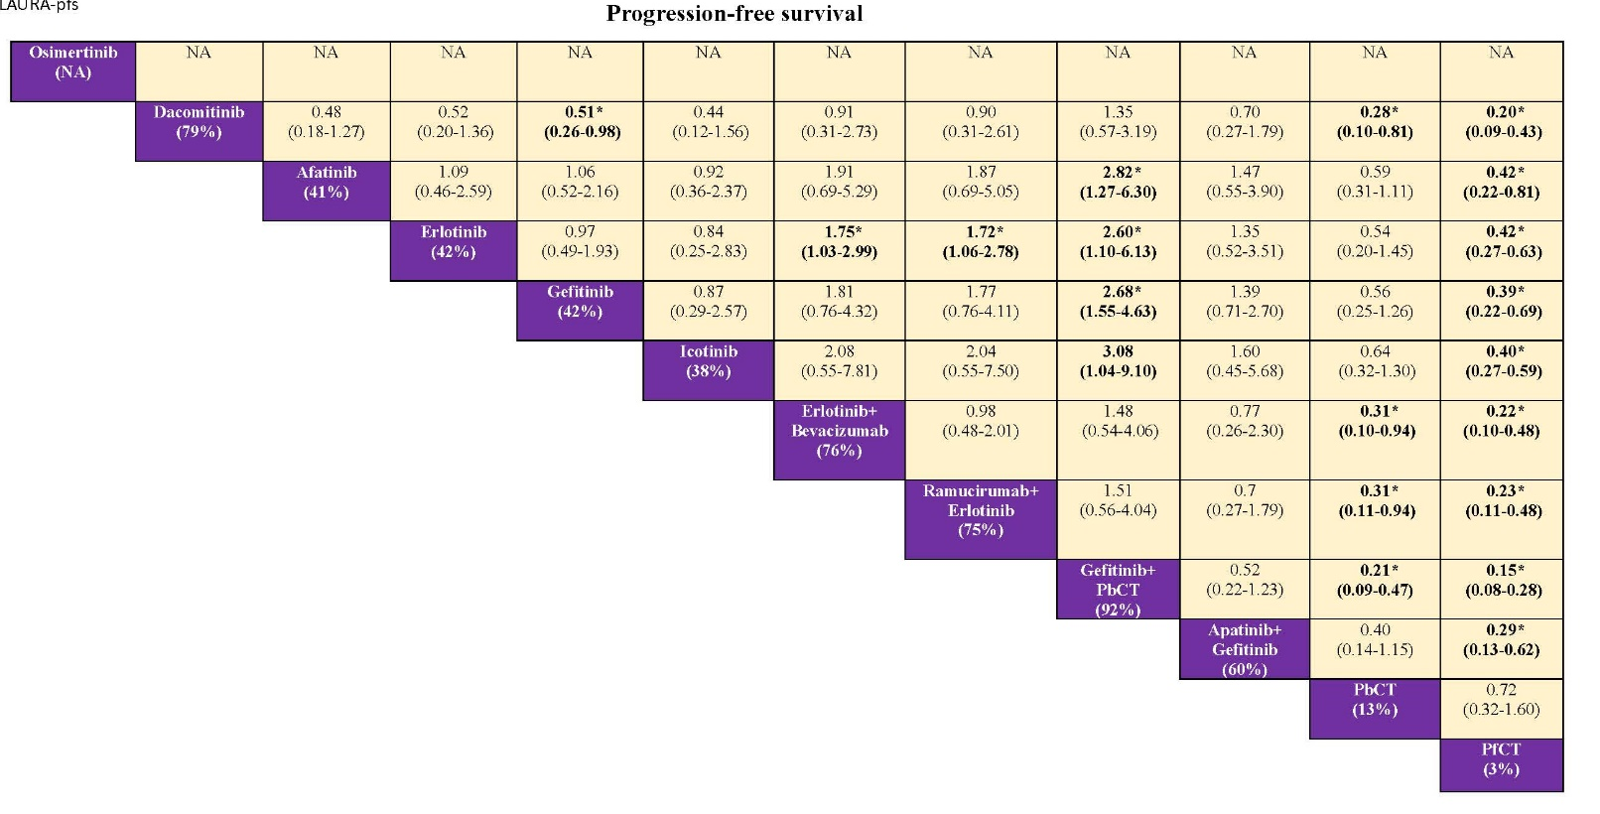
B
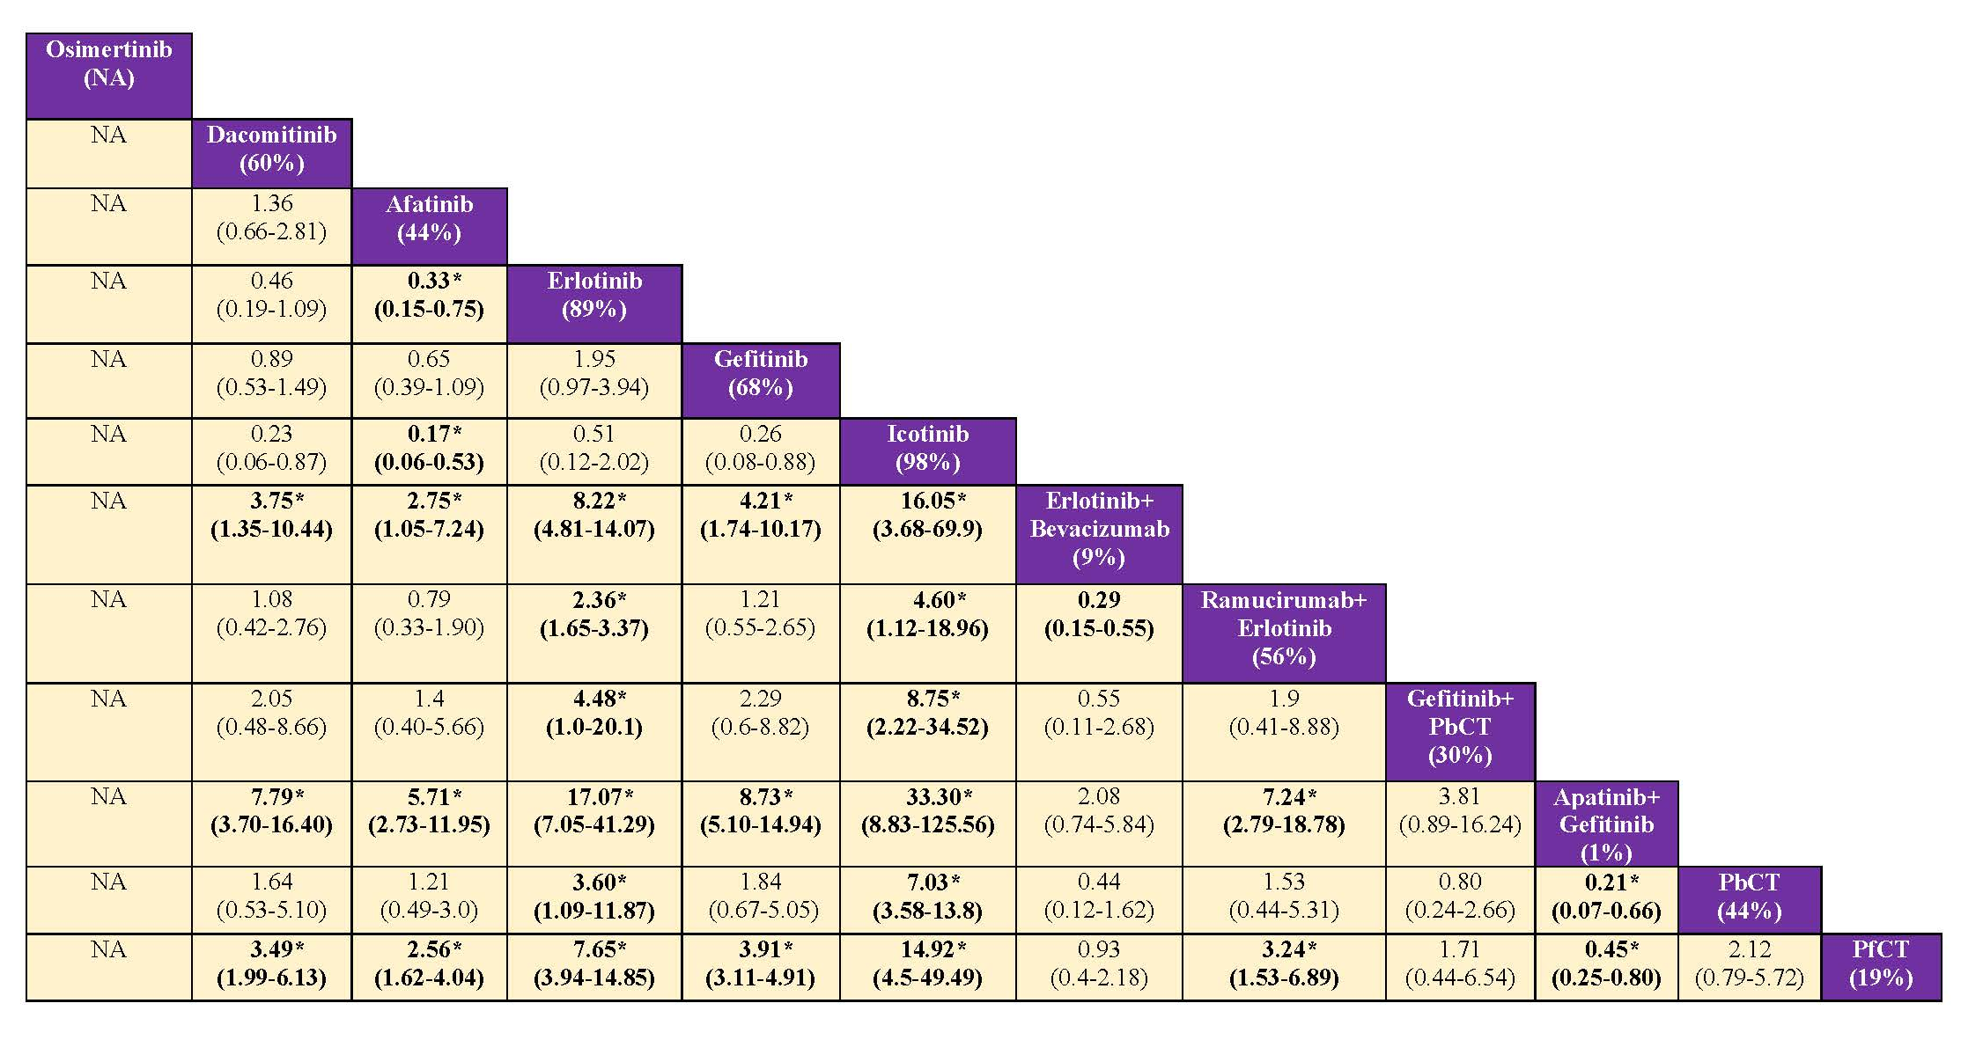

Supplementary references
1. Thress KS, Paweletz CP, Felip E, et al. Acquired EGFR C797S mutation mediates resistance to AZD9291 in non-small cell lung cancer harboring EGFR T790M. Nat Med. 2015;21:560-2.
2. Salanti G, Ades AE, Ioannidis JP. Graphical methods and numerical summaries for presenting results from multiple-treatment metaanalysis: an overview and tutorial. J Clin Epidemiol. 2011;64:163-71.
3. Dias S, Welton NJ, Caldwell DM, et al. Checking consistency in mixed treatment comparison meta-analysis. Stat Med. 2010; 29: 932–44.
4. Higgins JP, Jackson D, Barrett JK, et al. Consistency and inconsistency in network meta-analysis: concepts and models for multi-arm studies. Res Synth Methods. 2012; 3: 98-110.
5. Puhan MA, Schünemann HJ, Murad MH, et al. A GRADE Working Group approach for rating the quality of treatment effect estimates from network meta-analysis. BMJ. 2015;350:h3326.

