Supplemental material for [Comparative risk of herpes zoster in patients with psoriatic disease on systemic treatments: A systematic review and network meta-analysis]

Supplemental material, [Method S1, Supplementary Table S1-S12, Supplementary Figure S1-S6], for [Comparative risk of herpes zoster in patients with psoriatic disease on systemic treatments: A systematic review and network meta-analysis] by [Hsien-Yi Chiu, Yi-Teng Hung, Shi-Wei Huang, Yu-Huei Huang] in [Therapeutic Advances in Chronic Disease]
Correspondence: Yu-Huei Huang (huang3764@mail2000.com.tw) Chang Gung Memorial Hospital, Linkou Branch, Taoyuan, Taiwan

Method S1. Prospero protocol.
Table S1. PRISMA extension statement for reporting of systematic reviews incorporating network meta-analyses of health care interventions.
Table S2. Search terms and results in systemic review.
Table S3. Characteristics of included studies.
Table S4. Detailed information of the occurrence of herpes zoster of the included studies.
Table S5. Pairwise meta-analysis of incidence rate ratio (95% CI) of developing herpes zoster with treatments.
Table S6. Pairwise meta-analysis of incidence rate ratio (95% CI) of developing herpes zoster with treatments stratified into 12 groups.
Table S7. League table of comparison of herpes zoster risk with treatment.
Table S8. League table of comparison of herpes zoster risk with treatments stratified into 12 groups.
Table S9. Surface under the cumulative ranking curve of the risk of herpes zoster with treatments.
Table S10. Surface under the cumulative ranking curve of the risk of herpes zoster with treatments stratified into 12 groups.
Table S11. Inconsistency test for the NMA analysis of herpes zoster risk with interventions by side-splitting method.
Table S12. Using side-splitting method to test the inconsistency in the NMA analysis of herpes zoster risk with interventions stratified into 12 groups.
Figure S1. Risk of bias assessment and summary of all included randomized controlled trials.
Figure S2. ROBINS-I assessment of non-randomized controlled trials.
Figure S3. Forest plot. Forest plot of risk of herpes zoster with treatments compared with control.
Figure S4. Rankogram of herpes zoster risk with interventions.
Figure S5. Comparison-adjusted funnel plot (left) and Egger’s test (right) for the network analysis of herpes zoster risk with interventions.
Figure S6. Comparison-adjusted funnel plot (left) and Egger’s test (right) for the network analysis of herpes zoster risk with interventions stratified into 12 groups.
Method S1: Prospero protocol

- Review question
Is the use of systemic anti-psoriatic treatment in patients with psoriatic disease associated with increased risk of herpes zoster?
Which treatment confers a higher risk for the development of herpes zoster than other treatments in patients with psoriatic disease?
- Searches
We searched the following electronic bibliographic databases: PubMed, EMBASE, Cochrane library and Web of Science for all published English-language studies investigating the risk of herpes zoster in patients with psoriatic disease. The search keywords included: Psoriasis, psoriatic arthritis AND herpes zoster AND systemic treatments for psoriasis. After initial screening, full texts of included studies will be appraised by 2 reviewers (Hsien-Yi Chiu and Yu-Huei Huang) independently to verify relevance. We also manually screened the bibliography of retrieved studies to locate additional eligible studies missed by database searches. The inclusion and exclusion criteria of study selection were described below.
Inclusion criteria:
Studies were included if they met all of the following criteria: (a) studies in patients diagnosed with psoriatic disease (b) studies collecting data of herpes zoster, investigating and reporting the incidence of herpes zoster in patients with psoriatic disease on treatments or placebo control (c) studies including psoriatic participants who receive at least one systemic treatment for their psoriatic disease (d) studies published in English.
Exclusion criteria:
(a)Studies without reports of herpes zoster events in placebo and actively treated groups (b) Studies with incomplete data or conference abstract only (c) Studies without outcomes of interest extractable or only reporting irrelevant outcomes (d) case reports, review, meta-analysis, editorial or commentary studies (e) Studies with too short follow-up period (f) Studies without comparison group which couldn’t be connected to other studies in the network meta-analysis.
- Types of study to be included
Phase II, III randomized controlled study, long-term extension or open-label extension study, prospective registry study and cohort study
- Condition or domain being studied
Risk of developing herpes zoster associated with treatment
- Participants/population
Patients with psoriatic disease, including psoriasis and psoriatic arthritis.
- Intervention(s), exposure(s)
Systemic anti-psoriatic treatments: phototherapy, acitretin, methotrexate, azathioprine, 6-mercaptopurine, cyclophosphamide, cyclosporine, corticosteroids, steroids, leflunomide, mycophenolate, infliximab, adalimumab, etanercept, golimumab, certolizumab, ustekinumab, secukinumab, ixekizumab, brodalumab, guselkumab, risankizumab, apremilast, tofacinitib, biologics, mono-clonal antibodies, tumour necrosis factor antibody, anti-interleukin, disease modifying agent, disease modifying anti-rheumatic drug
- Comparator(s)/Control
We compared each treatment group with another treatment group (including placebo control) by using network meta-analysis.
- Main outcomes/ Measure of effect
Herpes zoster/ Incidence rate ratios (IRR) and incident rates (IR, per 1000 patient years exposure) of herpes zoster were calculated by the treatment modality.
- Data Extraction
We used a reference manager tool (EndNote) to aggregate references identified from electronic bibliographic databases mentioned above and all duplicate results were removed by one author (H.Y.C). Titles and abstracts were further reviewed independently by two authors (H.Y.C. and Y.H.H.) to exclude obviously irrelevant articles. Then all full-text reports were assessed for compliance of studies with eligibility criteria. Two authors (H.Y.C. and Y.H.H.) extracted the data independently using a standardized data extraction form. Extracted information included:
- study characteristics: NCT number, author, year, study design, region, study population
- description of treatment: arms, dose, duration of exposure, follow-up duration
- patient characteristics: age, gender, number of participants
- outcome data: Herpes zoster events
-endpoint assessment
-incidence rate of herpes zoster (per 1000 patient-years)
Study results posted at ClinicalTrials.gov were also checked. The discrepancies between two reviewers were resolved by discussion. Missing data was requested from study authors.
- Risk of bias (quality) assessment
Two independent authors (H.Y.C. and Y.H.H.) assessed the quality independently by using the Cochrane Collaboration Risk-of-Bias and non-randomized studies of interventions (ROBINS-I) Instrument for randomized controlled trial (RCT) and non-randomized studies, respectively. Agreement on a quality score was reached by consensus.
- Strategy for data synthesis
We first undertook pairwise meta-analysis of direct treatment effects comparing each treatment with control in the original study. Data extracted from studies was combined by a random-effects model, with effect sizes expressed as the incidence rate ratio (IRR) of developing herpes zoster with corresponding 95% confidence interval (CI). The between-study heterogeneity in meta-analysis was using the I-squared metric, whose values of less than 25%, 25–50%, or more than 50% indicate low, moderate, or high heterogeneity, respectively. Second, network meta-analysis (NMA) was performed using a multivariate, random-effects metaregression model with restricted maximum likelihood for variance estimation. Models were fit using a frequentist approach in STATA (version 14.0, StataCorp, College Station, TX, USA) using the network command. We used NMA to combines direct and indirect comparative data among the therapeutic options across a network of studies into a single effect size and to rank the treatments. The summary results were presented as IRRs of HZ for each group. To ranked the risk of HZ for all treatments, we calculated the surface under the cumulative ranking area (SUCRA) and ranking was quantified by SUCRA.
- Analysis of subgroups or subsets
Subgroup analyses were conducted by stratifying the treatments according to drug classes (corticosteroids (CS), conventional synthetic disease-modifying anti-rheumatic drugs, Janus kinase (JAK) inhibitor (tofacitinib), phosphodiesterase 4 (PDE4) inhibitor, infliximab, anti-tumor necrosis factor-α (anti-TNF-α) except infliximab, anti-interleukin (anti-interleukin-17, − 23 or − 12/23), phototherapy, acitretin, anti-TNF-α+ csDMARDs and/or CS, csDMRADs+CS, and control.
- Type and method of review
Systematic review and network meta-analysis
- Health area of the review
Skin disorder/Blood and immune system/Infection and infestation

Table S1. PRISMA extension statement for reporting of systematic reviews incorporating network meta-analyses of health care interventions
Section/Topic | Item # | Checklist Item | Reported on Page #
TITLE
Title | 1 | Identify the report as a systematic review incorporating a network meta-analysis (or related form of meta-analysis). | #1
ABSTRACT
Structured summary | 2 | Provide a structured summary including, as applicable: | #3-4
INTRODUCTION
Rationale | 3 | Describe the rationale for the review in the context of what is already known, including mention of why a network meta-analysis has been conducted. | #5-6
Objectives | 4 | Provide an explicit statement of questions being addressed, with reference to participants, interventions, comparisons, outcomes, and study design (PICOS). | #5-6
METHODS
Protocol and registration | 5 | Indicate whether a review protocol exists and if and where it can be accessed (e.g., Web address); and, if available, provide registration information, including registration number. | #7; method S1
Eligibility criteria | 6 | Specify study characteristics (e.g., PICOS, length of follow-up) and report characteristics (e.g., years considered, language, publication status) used as criteria for eligibility, giving rationale. Clearly describe eligible treatments included in the treatment network, and note whether any have been clustered or merged into the same node (with justification). | #7; method S1
Information sources | 7 | Describe all information sources (e.g., databases with dates of coverage, contact with study authors to identify additional studies) in the search and date last searched. | #7; method S1
Search | 8 | Present full electronic search strategy for at least one database, including any limits used, such that it could be repeated. | #7, table S2
Study selection | 9 | State the process for selecting studies (i.e., screening, eligibility, included in systematic review, and, if applicable, included in the meta-analysis). | #8, Fig 1
Data collection process | 10 | Describe method of data extraction from reports (e.g., piloted forms, independently, in duplicate) and any processes for obtaining and confirming data from investigators. | #7-8
Data items | 11 | List and define all variables for which data were sought (e.g., PICOS, funding sources) and any assumptions and simplifications made. | #7-8
Geometry of the network | S1 | Describe methods used to explore the geometry of the treatment network under study and potential biases related to it. This should include how the evidence base has been graphically summarized for presentation, and what characteristics were compiled and used to describe the evidence base to readers. | #9, Fig 2.
Risk of bias within individual studies | 12 | Describe methods used for assessing risk of bias of individual studies (including specification of whether this was done at the study or outcome level), and how this information is to be used in any data synthesis. | #8-9
Summary measures | 13 | State the principal summary measures (e.g., risk ratio, difference in means). Also describe the use of additional summary measures assessed, such as treatment rankings and surface under the cumulative ranking curve (SUCRA) values, as well as modified approaches used to present summary findings from meta-analyses. | #8-9
Planned methods of analysis | 14 | Describe the methods of handling data and combining results of studies for each network meta-analysis. This should include, but not be limited to:  - Handling of multi-arm trials;  - Selection of variance structure;  - Selection of prior distributions in Bayesian analyses; and  - Assessment of model fit. | #8-9
Assessment of Inconsistency | S2 | Describe the statistical methods used to evaluate the agreement of direct and indirect evidence in the treatment network(s) studied. Describe efforts taken to address its presence when found. | #8-9
Risk of bias across studies | 15 | Specify any assessment of risk of bias that may affect the cumulative evidence (e.g., publication bias, selective reporting within studies). | #8-9
Additional analyses | 16 | Describe methods of additional analyses if done, indicating which were pre-specified. This may include, but not be limited to, the following:  - Sensitivity or subgroup analyses;  - Meta-regression analyses;  - Alternative formulations of the treatment network; and  - Use of alternative prior distributions for Bayesian analyses (if applicable). | #8-9
RESULTS†
Study selection | 17 | Give numbers of studies screened, assessed for eligibility, and included in the review, with reasons for exclusions at each stage, ideally with a flow diagram. | #10; Fig 1
Presentation of network structure | S3 | Provide a network graph of the included studies to enable visualization of the geometry of the treatment network. | Fig 2
Summary of network geometry | S4 | Provide a brief overview of characteristics of the treatment network. This may include commentary on the abundance of trials and randomized patients for the different interventions and pairwise comparisons in the network, gaps of evidence in the treatment network, and potential biases reflected by the network structure. | #10, table S3-S4
Study characteristics | 18 | For each study, present characteristics for which data were extracted (e.g., study size, PICOS, follow-up period) and provide the citations. | #10; table S3&S4
Risk of bias within studies | 19 | Present data on risk of bias of each study and, if available, any outcome level assessment. | #11; Fig S1-S2
Results of individual studies | 20 | For all outcomes considered (benefits or harms), present, for each study: 1) simple summary data for each intervention group, and 2) effect estimates and confidence intervals. Modified approaches may be needed to deal with information from larger networks. | #10-11, table S3-S6
Synthesis of results | 21 | Present results of each meta-analysis done, including confidence/credible intervals. In larger networks, authors may focus on comparisons versus a particular comparator (e.g. placebo or standard care), with full findings presented in an appendix. League tables and forest plots may be considered to summarize pairwise comparisons. If additional summary measures were explored (such as treatment rankings), these should also be presented. | #11-12, Fig 3, table S5-S10
Exploration for inconsistency | S5 | Describe results from investigations of inconsistency. This may include such information as measures of model fit to compare consistency and inconsistency models, P values from statistical tests, or summary of inconsistency estimates from different parts of the treatment network. | #13; table S11-S12
Risk of bias across studies | 22 | Present results of any assessment of risk of bias across studies for the evidence base being studied. | #13; table S11-S12
Results of additional analyses | 23 | Give results of additional analyses, if done (e.g., sensitivity or subgroup analyses, meta-regression analyses, alternative network geometries studied, alternative choice of prior distributions for Bayesian analyses, and so forth). | #11-13
DISCUSSION
Summary of evidence | 24 | Summarize the main findings, including the strength of evidence for each main outcome; consider their relevance to key groups (e.g., healthcare providers, users, and policy-makers). | #13, 15-16
Limitations | 25 | Discuss limitations at study and outcome level (e.g., risk of bias), and at review level (e.g., incomplete retrieval of identified research, reporting bias). Comment on the validity of the assumptions, such as transitivity and consistency. Comment on any concerns regarding network geometry (e.g., avoidance of certain comparisons). | #16
Conclusions | 26 | Provide a general interpretation of the results in the context of other evidence, and implications for future research. | #15-16
FUNDING
Funding | 27 | Describe sources of funding for the systematic review and other support (e.g., supply of data); role of funders for the systematic review. | #17-18
PICOS = population, intervention, comparators, outcomes, study design.
* Text in italics indicate S wording specific to reporting of network meta-analyses that has been added to guidance from the PRISMA statement.
† Authors may wish to plan for use of appendices to present all relevant information in full detail for items in this section.

Table S2. Search terms and results in systemic review
PubMed | Results
(((psoriasis) OR (psoriatic arthritis)) AND ((Herpes zoster) OR (shingles))) AND ((phototherapy) OR (acitretin) OR (methotrexate) OR (azathioprine) OR (6-mercaptopurine) OR (cyclophosphamide) OR (cyclosporine) OR (corticosteroids) OR (steroids) OR (leflunomide) OR (mycophenolate) OR (infliximab) OR (adalimumab) OR (etanercept) OR (golimumab) OR (certolizumab) OR (ustekinumab) OR (secukinumab) OR (ixekizumab) OR (brodalumab) OR (guselkumab) OR (risankizumab) OR (apremilast) OR (tofacinitib) OR (biologics) OR (mono-clonal antibodies) OR (tumour necrosis factor antibody) OR (anti-interleukin) OR (disease modifying agent, disease modifying anti-rheumatic drug)) | 102
Embase | Results
#1: psoriasis OR 'psoriatic arthritis' (All field) | 101976
#2:'herpes zoster' OR shingles (All field) | 30430
#3: phototherapy OR acitretin OR methotrexate OR azathioprine OR '6 mercaptopurine' OR cyclophosphamide OR cyclosporine OR corticosteroids OR steroids OR leflunomide OR mycophenolate OR infliximab OR adalimumab OR etanercept OR golimumab OR certolizumab OR ustekinumab OR secukinumab OR ixekizumab OR brodalumab OR guselkumab OR risankizumab OR apremilast OR tofacinitib OR biologics OR ('mono clonal' AND antibodies) OR (tumour AND necrosis AND factor AND antibody) OR 'anti interleukin' OR (disease AND modifying AND agent) OR (disease AND modifying AND 'anti rheumatic' AND drug) | 868794
#1 AND #2 AND #3 | 632
Web of Science | Results
#1: All= (psoriasis OR psoriatic arthritis)  - Indexes=SCI-EXPANDED, SSCI, A&HCI, CPCI-S, CPCI-SSH, BKCI-S, BKCI-SSH, ESCI, CCR-EXPANDED Timespan=All years | 64826
#2: ALL=(Herpes zoster OR shingles) | 14893
#3: ALL=((phototherapy) OR (acitretin) OR (methotrexate) OR (azathioprine) OR (6-mercaptopurine) OR (cyclophosphamide) OR (cyclosporine) OR  (corticosteroids) OR (steroids) OR (leflunomide) OR (mycophenolate) OR (infliximab) OR (adalimumab) OR (etanercept)  OR (golimumab) OR (certolizumab) OR (ustekinumab) OR (secukinumab) OR (ixekizumab) OR (brodalumab) OR (guselkumab) OR (risankizumab) OR  (apremilast) OR (tofacinitib) OR (biologics) OR (mono-clonal antibodies) OR (tumour necrosis factor antibody) OR (anti-interleukin) OR (disease modifying agent, disease modifying anti-rheumatic drug)) | 610144
#4: #3 AND #2 AND #1 | 78
Cochrane Library
#1: (psoriasis) OR ("psoriatic arthritis") (Word variations have been searched) | 9137
#2: (Herpes zoster) OR (shingles) (Word variations have been searched) | 2287
#3: (phototherapy OR acitretin OR methotrexate OR azathioprine OR mercaptopurine OR cyclophosphamide OR cyclosporine OR corticosteroids OR steroids OR leflunomide OR mycophenolate OR infliximab OR adalimumab OR etanercept OR golimumab OR certolizumab OR ustekinumab OR secukinumab OR ixekizumab OR brodalumab OR guselkumab OR risankizumab OR apremilast OR tofacinitib OR biologics OR (mono-clonal antibodies) OR (tumour necrosis factor antibody) OR (anti-interleukin) OR (disease modifying agent, disease modifying anti-rheumatic drug) | 138451
#4: #1 AND #2 AND #3 | 32

Table S3. Characteristics of included studies
Study, year | Study Design | Treatment | No. of patients | Mean/median Age (SD)  (years) | Gender (%Female) | Patient Group | Outcome
Winthrop et al. 2017¹ | RCT (LTE)/ pooled analysis | Tofacitinib 10mg bid | 1120 | 44.3 (12.9) | 29.7 | Psoriasis | Herpes zoster
 |  | Tofacitinib 5mg bid | 1123 | 45.3 (12.8) | 29.3 | Psoriasis | Herpes zoster
 |  | Etanercept 50mg biw | 335 | 43.3 (12.2) | 30.4 | Psoriasis | Herpes zoster
 |  | Placebo control | 530 | 45.0 (12.8) | 33.8 | Psoriasis | Herpes zoster
Dreiher et al. 2012² | Retrospective/ Clalit Health Services’ computerized database | UVB | 1074 | 45.0 (17.9) | 48.0 | Psoriasis | Herpes zoster
 | Retrospective/ Clalit Health Services’ computerized database | PUVA | 1074 | 46.4 (17.6) | 46.5 | Psoriasis | Herpes zoster
 | Retrospective/ Clalit Health Services’ computerized database | Acitretin | 2497 | 50.5 (15.7) | 37.4 | Psoriasis | Herpes zoster
 |  | Cyclosporine | 94 | 42.5 (13.4) | 38.3 | Psoriasis | Herpes zoster
 |  | Methotrexate | 1382 | 51.5 (16.5) | 53.6 | Psoriasis | Herpes zoster
 |  | Inﬂiximab | 112 | 43.6 (13.9) | 44.6 | Psoriasis | Herpes zoster
 |  | Adalimumab | 129 | 43.7 (15.2) | 46.5 | Psoriasis | Herpes zoster
 |  | Corticosteroids (CS) | 4126 | N/A | N/A | Psoriasis | Herpes zoster
 |  | Placebo control | 14746 | 47.2 (20.6) | 53.1 | Psoriasis | Herpes zoster
Zisman et al. 2016³ | Retrospective/ Clalit Health Services’ computerized database | csDMARDs | 2156 | 51.1 (14.4) | 54.8 | Psoriasis (PsA) | Herpes zoster
 |  | anti-TNF-α | 587 | 46.9 (13.6) | 52.0 | Psoriasis (PsA) | Herpes zoster
 | Retrospective/ Clalit Health Services’ computerized database | anti-TNF-α + csDMARDs | 427 | 47.5 (13.1) | 52.0 | Psoriasis (PsA) | Herpes zoster
 | Retrospective/ Clalit Health Services’ computerized database | inﬂiximab or adalimumab | 375 | 45.9 (13.6) | 52.3 | Psoriasis (PsA) | Herpes zoster
 | Retrospective/ Clalit Health Services’ computerized database | inﬂiximab or adalimumab + csDMARDs | 338 | 47.0 (13.0) | 60.0 | Psoriasis (PsA) | Herpes zoster
 |  | Etanercept | 294 | 47.3 (13.4) | 51.7 | Psoriasis (PsA) | Herpes zoster
 |  | Etanercept + csDMARDs | 158 | 49.1 (12.5) | 59.5 | Psoriasis (PsA) | Herpes zoster
 |  | Placebo control | 1066 | 48.0 (14.4) | 53.5 | Psoriasis (PsA) | Herpes zoster
Shalom et al. 2019⁴ | Prospective/ PSOLAR Registry | anti-TNF-α | 5076 | 47.9 (13.4) | 43.2 | Psoriasis | Herpes zoster
 |  | Ustekinumab | 2704 | 47.3 (13.0) | 40.8 | Psoriasis | Herpes zoster
 |  | Methotrexate | 1201 | 52.3 (13.7) | 52.5 | Psoriasis | Herpes zoster
 |  | Placebo control | 1488 | 49.9 (15.9) | 49.6 | Psoriasis | Herpes zoster
Hagberg et al. 2020⁵ | Retrospective/ IBM MarketScan Commercial Claims and Encounters Database with Medicare supplement | cDMARDs | 24678 | 52 (NR) | 54.4 | Psoriasis | Herpes zoster
 |  | csDMARDs +CS | 6318 | 53 (NR) | 60.6 | Psoriasis | Herpes zoster
 |  | anti-TNF-α | 47361 | 48 (NR) | 44.1 | Psoriasis | Herpes zoster
 |  | anti-TNF-α + csDMARDs and/or CS | 9029 | 52 (NR) | 55.6 | Psoriasis | Herpes zoster
 |  | IL-17, − 23 or − 12/23 inhibitor | 12438 | 47 (NR) | 45.6 | Psoriasis | Herpes zoster
 |  | IL-17, − 23 or − 12/23 inhibitor + csDMARDs and/or CS | 1014 | 51 (NR) | 52.7 | Psoriasis | Herpes zoster
 |  | Apremilast | 9422 | 51 (NR) | 52.4 | Psoriasis | Herpes zoster
 |  | Corticosteroids (CS) | 20692 | 52 (NR) | 57.0 | Psoriasis | Herpes zoster
 |  | Placebo control | 131604 | 50 (NR) | 50.5 | Psoriasis | Herpes zoster
Shalom et al. 2015⁶ | Retrospective/ Clalit Health Services’ computerized database | UVB | 2895 | 43.9 (18) | 50.0 | Psoriasis | Herpes zoster
 |  | PUVA | 1063 | 45.9 (17) | 53.0 | Psoriasis | Herpes zoster
 | Retrospective/ Clalit Health Services’ computerized database | Acitretin | 4094 | 51.2 (16) | 36.0 | Psoriasis | Herpes zoster
 | Retrospective/ Clalit Health Services’ computerized database | Cyclosporine | 148 | 44.9 (14) | 42.0 | Psoriasis | Herpes zoster
 | Retrospective/ Clalit Health Services’ computerized database | Methotrexate | 4320 | 52.3 (16) | 55.0 | Psoriasis | Herpes zoster
 |  | Etanercept | 1030 | 44.7 (14) | 49.0 | Psoriasis | Herpes zoster
 |  | Adalimumab | 719 | 43.5 (15) | 49.0 | Psoriasis | Herpes zoster
 |  | Infliximab | 392 | 43.6 (15) | 54.0 | Psoriasis | Herpes zoster
 |  | Ustekinumab | 63 | 42.9 (14) | 40.0 | Psoriasis | Herpes zoster
 |  | Acitretin + phototherapy | 272 | 48.9 (16) | 28.0 | Psoriasis | Herpes zoster
 |  | Placebo control | 94073 | 45.7 (21) | 51.0 | Psoriasis | Herpes zoster
Levandoski et al. 2018⁷ | Retrospective/ KPNC databases | Biologics | 2056 | NR | NR | Psoriasis | Herpes zoster
 |  | csDMARDs | 3631 | 53.2 (16) | 51.0 | Psoriasis | Herpes zoster
 |  | Biologics + csDMARDs | 202 | NR | NR | Psoriasis | Herpes zoster
 |  | Placebo control | 2988 | NR | NR | Psoriasis | Herpes zoster
Burmester et al. 2020⁸ | RCT (pooled analysis) and retrospective database (US Truven MarketScan database) | Tofacitinib 5mg bid | 238 | 49.5 (12.4) | 51.0 | Psoriasis (PsA) | Herpes zoster
 |  | Tofacitinib 10mg bid | 236 | 49.4 (11.7) | 58.0 | Psoriasis (PsA) | Herpes zoster
 |  | Biologics + csDMARDs | 2542 | NR | NR | Psoriasis (PsA) | Herpes zoster
 |  | Infliximab | 615 | NR | NR | Psoriasis (PsA) | Herpes zoster
 |  | Adalimumab | 1934 | NR | NR | Psoriasis (PsA) | Herpes zoster
 |  | Etanercept | 1412 | NR | NR | Psoriasis (PsA) | Herpes zoster
 |  | Golimumab | 389 | NR | NR | Psoriasis (PsA) | Herpes zoster
 |  | Certolizumab | 267 | NR | NR | Psoriasis (PsA) | Herpes zoster
 |  | Apremilast | 617 | NR | NR | Psoriasis (PsA) | Herpes zoster
Reich et al. 2020⁹ | RCT/ pooled analysis | Tildrakizumab 200mg q12W | 622 | 45.8 (13.4) | 27.5 | Psoriasis | Herpes zoster
 |  | Tildrakizumab 100mg q12W | 616 | 45.5 (13.4) | 30.7 | Psoriasis | Herpes zoster
 |  | Etanercept 50mg biw | 313 | 45.8 (14.0) | 29.1 | Psoriasis | Herpes zoster
 |  | Placebo control | 310 | 47.1 (12.9) | 31.6 | Psoriasis | Herpes zoster
Kerkhof et al. 2016¹⁰ | RCT/ pooled analysis | Secukinumab 300mg q4w | 1410 | 45.6 (13.1) | 31.1 | Psoriasis | Herpes zoster
 |  | Secukinumab 150mg q4w | 1395 | 45.2 (13.2) | 32.7 | Psoriasis | Herpes zoster
 |  | Etanercept 50mg biw | 323 | 43.8 (13.0) | 29.1 | Psoriasis | Herpes zoster
 |  | Placebo control | 793 | 44.6 (12.7) | 30.4 | Psoriasis | Herpes zoster
Failla et al. 2012¹¹ | Retrospective/ Hospital cohort | Etanercept | NR | NR | NR | Psoriasis | Herpes zoster
 |  | Infliximab | NR | NR | NR | Psoriasis | Herpes zoster
 |  | Adalimumab | NR | NR | NR | Psoriasis | Herpes zoster
 |  | Ustekinumab | NR | NR | NR | Psoriasis | Herpes zoster
Papp et al. 2017¹² | RCT/ pooled analysis | Ixekizumab 80mg q4w/q2w | 1463 | NR | NR | Psoriasis | Herpes zoster
 |  | Etanercept 50mg biw | 739 | 45.5 (13.3) | 31.8 | Psoriasis | Herpes zoster
 |  | Placebo control | 360 | NR | NR | Psoriasis | Herpes zoster
Kalb et al. 2015¹³ | Prospective/ PSOLAR Registry | Ustekinumab | 3474 | 47.2 (13.1) | 42.5 | Psoriasis | Herpes zoster
 |  | Infliximab | 1151 | 48.5 (13.5) | 43.1 | Psoriasis | Herpes zoster
 |  | Etanercept | 1854 | 48.7 (13.7) | 44 | Psoriasis | Herpes zoster
 |  | Adalimumab | 2675 | 47.6 (13.3) | 43.7 | Psoriasis | Herpes zoster
 |  | Placebo control | 1610 | 50.1 (15.8) | 48.4 | Psoriasis | Herpes zoster
 |  | Methotrexate | 490 | 551. (13.8) | 57.8 | Psoriasis | Herpes zoster
Anti-TNF-α, anti-tumor necrosis factor-α; biw, twice weekly; CS, corticosteroids; csDMARDs, conventional synthetic disease-modifying anti-rheumatic drugs; IL, interleukin; KPNC, Kaiser Permanente Northern California; q4w, every 4 weeks; q12w, every 12 weeks; RCT, randomized controlled trial; PSOLAR, Psoriasis Longitudinal Assessment and Registry; PUVA, psoralen and ultraviolet A; UVB, ultraviolet B.

Table S4. Detailed information of the occurrence of herpes zoster of the included studies.
Study, year | Study Design | Drug | No. of events | Total No. | Event no./Total no. (%) | Follow-up duration (PYs) | Incidence (/1000 PYs)
Winthrop et al. 2017¹ | RCT/ pooled analysis | Tofacitinib 10mg bid | 20 | 1120 | 1.79 | 868.9 | 23.2
 |  | Tofacitinib 5mg bid | 8 | 1123 | 0.71 | 800.8 | 10
 |  | Etanercept 50mg biw | 2 | 335 | 0.60 | 74.6 | 26.8
 |  | Placebo control | 0 | 530 | 0.00 | 136 | 0
Dreiher et al. 2012² | Retrospective/ Clalit Health Services’ computerized database | UVB | 3 | 1074 | 0.28 | 502 | 6
 |  | PUVA | 5 | 1074 | 0.47 | 495 | 10.1
 |  | Acitretin | 11 | 2497 | 0.44 | 2025 | 5.4
 |  | Cyclosporine | 3 | 94 | 3.19 | 62 | 48.5
 |  | Methotrexate | 27 | 1382 | 1.95 | 1585 | 17
 |  | Etanercept | 4 | 271 | 1.48 | 288 | 13.9
 |  | Inﬂiximab | 2 | 112 | 1.79 | 104 | 19.3
 |  | Adalimumab | 0 | 129 | 0.00 | 88 | 0
 |  | Corticosteroids (CS) | 21 | 4126 | 0.51 | 816 | 25.7
 |  | Placebo control | 678 | 14746 | 4.60 | 146322 | 4.6
Zisman et al. 2016³ | Retrospective/ Clalit Health Services’ computerized database | csDMARDs | 100 | 2156 | 4.64 | 10 854.71 | 9.21
 |  | anti-TNF-α | 15 | 587 | 2.56 | 1735.53 | 8.64
 |  | anti-TNF-α + csDMARDs | 20 | 427 | 4.68 | 1119.76 | 17.86
 |  | inﬂiximab or adalimumab | 7 | 375 | 1.87 | 863.66 | 8.11
 |  | inﬂiximab or adalimumab + csDMARDs | 11 | 338 | 3.25 | 796.06 | 13.82
 |  | Etanercept | 8 | 294 | 2.72 | 871.87 | 9.18
 |  | Etanercept + csDMARDs | 9 | 158 | 5.70 | 323.69 | 27.80
 |  | Placebo control | 47 | 1066 | 4.41 | 6386.54 | 7.36
Shalom et al. 2019⁴ | Prospective/ PSOLAR Registry | anti-TNF-α | 29 | 5076 | 0.57 | 11717 | 2.5
 |  | Ustekinumab | 19 | 2704 | 0.70 | 6471 | 2.9
 |  | Methotrexate | 2 | 1201 | 0.17 | 1463 | 1.4
 |  | Placebo control | 5 | 1488 | 0.34 | 4374 | 1.1
Hagberg et al. 2020⁵ | Retrospective/ IBM MarketScan Commercial Claims and Encounters Database with Medicare supplement | csDMARDs | 256 | 24678 | 1.04 | 25865 | 9.0
 |  | csDMARDs +CS | 75 | 6318 | 1.18 | 5990 | 12.5
 | Retrospective/ IBM MarketScan Commercial Claims and Encounters Database with Medicare supplement | anti-TNF-α | 712 | 47361 | 1.50 | 75547 | 9.4
 |  | anti-TNF-α + csDMARDs and/or CS | 284 | 9029 | 3.15 | 23806 | 11.9
 |  | IL-17, − 23 or − 12/23 inhibitor | 173 | 12438 | 1.39 | 25654 | 6.7
 |  | IL-17, − 23 or − 12/23 inhibitor + csDMARDs and/or CS | 49 | 1014 | 4.83 | 4742 | 10.3
 |  | Apremilast | 120 | 9422 | 1.27 | 17180 | 7
 |  | Corticosteroids (CS) | 169 | 20692 | 0.82 | 13943 | 12.5
 |  | Placebo control | 433 | 131604 | 0.33 | 62723 | 6.9
Shalom et al. 2015⁶ | Retrospective/ Clalit Health Services’ computerized database | UVB | 14 | 2895 | 0.48 | 1127.7 | 12.4
 |  | PUVA | 4 | 1063 | 0.38 | 383.7 | 10.4
 |  | Acitretin | 39 | 4094 | 0.95 | 5895.5 | 6.6
 |  | Cyclosporine | 6 | 148 | 4.05 | 249.9 | 24
 |  | Methotrexate | 91 | 4320 | 2.11 | 7212.3 | 12.6
 |  | Etanercept | 18 | 1030 | 1.75 | 1461 | 12.3
 |  | Adalimumab | 8 | 719 | 1.11 | 827.4 | 9.7
 |  | Infliximab | 9 | 392 | 2.30 | 446 | 20.2
 |  | Ustekinumab | 2 | 63 | 3.17 | 61.9 | 32.3
 |  | Acitretin + phototherapy | 0 | 272 | 0.00 | 193 | 0
 |  | Placebo control | 4425 | 94073 | 4.70 | 503744 | 8.8
Levandoski et al. 2018⁷ | Retrospective/ KPNC databases | Biologics | 47 | 2056 | 2.29 | 4648 | 10.1
 |  | csDMARDs | 97 | 3631 | 2.67 | 9468 | 10.2
 |  | Biologics + csDMARDs | 11 | 202 | 5.45 | 1071 | 10.2
 |  | Placebo control | 136 | 2988 | 4.55 | 15834 | 8.6
Burmester et al. 2020⁸ | RCT (pooled analysis) and retrospective database (US Truven MarketScan database) | Tofacitinib 5mg bid | 3 | 238 | 1.26 | 153 | 20
 |  | Tofacitinib 10mg bid | 4 | 236 | 1.69 | 150 | 27
 |  | Biologics + csDMARDs | 20 | 2542 | 0.79 | 1303 | 14
 |  | Infliximab | 10 | 615 | 1.63 | 516 | 20
 |  | Adalimumab | 15 | 1934 | 0.78 | 1297 | 8
 |  | Etanercept | 11 | 1412 | 0.78 | 1000 | 10
 |  | Golimumab | 3 | 389 | 0.77 | 258 | 9
 |  | Certolizumab | 1 | 267 | 0.37 | 110 | 12
 |  | Apremilast | 5 | 617 | 0.81 | 191 | 13
Reich et al. 2020⁹ | RCT (LTE)/ pooled analysis | Tildrakizumab 200mg q12w | 1 | 622 | 0.16 | 2046.71 | 0.5
 |  | Tildrakizumab 100mg q12w | 0 | 616 | 0.00 | 2014.49 | 0
 |  | Etanercept 50mg biw | 1 | 313 | 0.32 | 153.42 | 6.5
 |  | Placebo control | 0 | 310 | 0.00 | 205.3 | 0
Kerkhof et al. 2016¹⁰ | RCT/ pooled analysis | Secukinumab 300mg q4w | 1 | 1410 | 0.07 | 1177.5 | 0.9
 |  | Secukinumab 150mg q4w | 3 | 1395 | 0.22 | 1142 | 2.6
 |  | Etanercept 50mg biw | 1 | 323 | 0.31 | 293.5 | 3.4
 |  | Placebo control | 1 | 793 | 0.13 | 201.3 | 5
Failla et al. 2012¹¹ | Retrospective/ Hospital cohort | Etanercept | 3 | NR | NR | 200 | 15
 |  | Infliximab | 0 | NR | NR | 166 | 0
 |  | Adalimumab | 0 | NR | NR | 325 | 0
 |  | Ustekinumab | 2 | NR | NR | 26 | 76.92
Papp et al. 2017¹² | RCT/ pooled analysis | Ixekizumab 80mg q4w/q2w | 0 | 1463 | 0.00 | 336.5 | 0
 |  | Etanercept 50mg biw | 1 | 739 | 0.14 | 169.2 | 6
 |  | Placebo control | 0 | 360 | 0.00 | 83.2 | 0
Kalb et al. 2015¹³ | Prospective/ PSOLAR Registry | Ustekinumab | 0 | 3474 | 0.00 | 5923 | 0
 |  | Infliximab | 1 | 1151 | 0.09 | 2253 | 0.4
 |  | Etanercept | 1 | 1854 | 0.05 | 3750 | 0.3
 |  | Adalimumab | 2 | 2675 | 0.07 | 5173 | 0.4
 |  | Placebo control | 0 | 1610 | 0.00 | 3800 | 0
 |  | Methotrexate | 0 | 490 | 0.00 | 1246 | 0
Anti-TNF-α, anti-tumor necrosis factor-α; biw, twice weekly; CS, corticosteroids; csDMARDs, conventional synthetic disease-modifying anti-rheumatic drugs; IL, interleukin; KPNC, Kaiser Permanente Northern California; q4w, every 4 weeks; q12w, every 12 weeks; RCT, randomized controlled trial; PSOLAR, Psoriasis Longitudinal Assessment and Registry; PUVA, psoralen and ultraviolet A; UVB, ultraviolet B.

Table S5. Pairwise meta-analysis of incidence rate ratio (95% CI) of developing herpes zoster with treatments.
Comparison (A vs. B) |  | Study | Pairwise meta-analysis incidence rate ratio (95% CI) | No. of events |  | Follow-up duration (PYs) |  | Weight (%)
 |  | Study | Pairwise meta-analysis incidence rate ratio (95% CI) | (A) | (B) | (A) | (B) | Weight (%)
(A) Biologics | (B) Control | Winthrop et al. 2017 | 2.611 (0.125, 54.387) | 2 | 0 | 74.6 | 136 | 0.01
(A) Biologics | (B) Control | Dreiher et al. 2012 | 1.539 (0.689, 3.437) | 6 | 678 | 480 | 146322 | 0.18
(A) Biologics | (B) Control | Zisman et al. 2016 | 1.072 (0.600, 1.918) | 15 | 47 | 1735.53 | 6386.54 | 0.35
(A) Biologics | (B) Control | Shalom et al. 2019 | 1.399 (0.541, 3.613) | 29 | 5 | 11717 | 4374 | 0.13
(A) Biologics | (B) Control | Hagberg et al. 2020 | 1.108 (0.988, 1.243) | 885 | 433 | 101201 | 62723 | 8.94
(A) Biologics | (B) Control | Shalom et al. 2015 | 1.178 (0.844, 1.642) | 35 | 4425 | 2734.4 | 503744 | 1.07
(A) Biologics | (B) Control | Levandoski et al. 2018 | 1.073 (0.770, 1.496) | 47 | 136 | 4648 | 15834 | 1.07
(A) Biologics | (B) Control | Reich et al. 2020 | 0.542 (0.026, 11.279) | 2 | 0 | 4214.62 | 205.3 | 0.01
(A) Biologics | (B) Control | Kerkhof et al. 2016 | 0.661 (0.077, 5.656) | 5 | 1 | 2613 | 201.3 | 0.03
(A) Biologics | (B) Control | Papp et al. 2017 | 0.736 (0.030, 18.065) | 1 | 0 | 505.7 | 83.2 | 0.01
(A) Biologics | (B) Control | Kalb et al. 2015 | 1.625 (0.088, 30.189) | 4 | 0 | 11176 | 3800 | 0.01
(A) Biologics | (B) Control | Pooled effect size | 1.117 (1.011, 1.235) |  |  |  |  | 11.82
(A) Biologics | (B) Control | Heterogeneity I² | 0.0%
(A) tsDMARDs | (B) Control | Winthrop et al. 2017 | 2.302 (0.143, 37.001) | 130 | 0 | 5204 | 136 | 0.02
(A) tsDMARDs | (B) Control | Hagberg et al. 2020 | 1.005 (0.821, 1.230) | 120 | 433 | 17180 | 62723 | 2.89
(A) tsDMARDs | (B) Control | Pooled effect size | 1.010 (0.825, 1.235) |  |  |  |  | 2.91
(A) tsDMARDs | (B) Control | Heterogeneity I² | 0.0%
(A) tsDMARDs | (B) Biologics | Winthrop et al. 2017 | 0.882 (0.252, 3.082) | 130 | 2 | 5204 | 74.6 | 0.08
(A) tsDMARDs | (B) Biologics | Hagberg et al. 2020 | 0.907 (0.750, 1.098) | 120 | 885 | 17180 | 101201 | 3.25
(A) tsDMARDs | (B) Biologics | Burmester et al. 2020 | 1.332 (0.701, 2.529) | 12 | 2 | 494 | 4214.62 | 0.29
(A) tsDMARDs | (B) Biologics | Pooled effect size | 0.935 (0.780, 1.120) |  |  |  |  | 3.61
(A) tsDMARDs | (B) Biologics | Heterogeneity I² | 0.0%
- Phototherapy/  Acitretin | - Control | Dreiher et al. 2012 | 1.142 (0.724, 1.801) | 19 | 678 | 3022 | 146322 | 0.57
- Phototherapy/  Acitretin | - Control | Shalom et al. 2015 | 0.944 (0.727, 1.226) | 57 | 4425 | 7406.9 | 503744 | 1.73
- Phototherapy/  Acitretin | - Control | Pooled effect size | 0.990 (0.789, 1.241) |  |  |  |  | 2.30
- Phototherapy/  Acitretin | - Control | Heterogeneity I² | 0.0%
(A) csDMARDs | (B) Control | Dreiher et al. 2012 | 1.812 (1.257, 2.612) | 30 | 678 | 1647 | 146322 | 0.88
(A) csDMARDs | (B) Control | Zisman et al. 2016 | 1.102 (0.780, 1.559) | 100 | 47 | 10854.71 | 6386.54 | 0.98
(A) csDMARDs | (B) Control | Shalom et al. 2019 | 1.081 (0.210, 5.571) | 2 | 5 | 1463 | 4374 | 0.04
(A) csDMARDs | (B) Control | Hagberg et al. 2020 | 1.169 (1.002, 1.365) | 256 | 433 | 25865 | 62723 | 4.95
(A) csDMARDs | (B) Control | Shalom et al. 2015 | 1.186 (0.970, 1.450) | 97 | 4425 | 7462.2 | 503744 | 2.92
(A) csDMARDs | (B) Control | Levandoski et al. 2018 | 1.071 (0.825, 1.389) | 97 | 136 | 9648 | 15834 | 1.74
(A) csDMARDs | (B) Control | Kalb et al. 2015 | 1.623 (0.032, 81.793) | 0 | 0 | 1246 | 3800 | 0.01
(A) csDMARDs | (B) Control | Pooled effect size | 1.191 (1.077, 1.318) |  |  |  |  | 11.53
(A) csDMARDs | (B) Control | Heterogeneity I² | 0.0%
- Corticosteroids | - Control | Dreiher et al. 2012 | 2.106 (1.364, 3.251) | 21 | 678 | 816 | 146322 | 0.63
- Corticosteroids | - Control | Hagberg et al. 2020 | 1.277 (1.069, 1.525) | 169 | 433 | 13943 | 62723 | 3.74
- Corticosteroids | - Control | Pooled effect size | 1.574 (0.971, 2.553) |  |  |  |  | 4.36
- Corticosteroids | - Control | Heterogeneity I² | 77.1%
- Biologics | - Phototherapy/Acitretin | Dreiher et al. 2012 | 1.348 (0.538, 3.375) | 6 | 19 | 480 | 3022 | 0.14
- Biologics | - Phototherapy/Acitretin | Shalom et al. 2015 | 1.247 (0.819, 1.900) | 35 | 57 | 2734.4 | 7406.9 | 0.67
- Biologics | - Phototherapy/Acitretin | Pooled effect size | 1.264 (0.862, 1.853) |  |  |  |  | 0.81
- Biologics | - Phototherapy/Acitretin | Heterogeneity I² | 0.0%
- csDMARDs | - Phototherapy/Acitretin | Dreiher et al. 2012 | 1.587 (0.893, 2.820) | 30 | 19 | 1647 | 3022 | 0.36
- csDMARDs | - Phototherapy/Acitretin | Shalom et al. 2015 | 1.256 (0.905, 1.742) | 97 | 57 | 7462.2 | 7406.9 | 1.10
- csDMARDs | - Phototherapy/Acitretin | Pooled effect size | 1.330 (1.001, 1.767) |  |  |  |  | 1.46
- csDMARDs | - Phototherapy/Acitretin | Heterogeneity I² | 0.0%
- Corticosteroids | - Phototherapy/Acitretin | Dreiher et al. 2012 | 1.844 (0.992, 3.430) | 21 | 19 | 816 | 3022 | 0.31
- Corticosteroids | - Phototherapy/Acitretin | Pooled effect size | 1.844 (0.992, 3.430) |  |  |  |  | 0.31
- Corticosteroids | - Phototherapy/Acitretin | Heterogeneity I² | -
- csDMARDs | - Biologics | Dreiher et al. 2012 | 1.178 (0.490, 2.829) | 30 | 6 | 1647 | 480 | 0.15
- csDMARDs | - Biologics | Zisman et al. 2016 | 1.028 (0.598, 1.769) | 100 | 15 | 10854.71 | 1735.53 | 0.40
- csDMARDs | - Biologics | Shalom et al. 2019 | 0.773 (0.184, 3.238) | 2 | 29 | 1463 | 11717 | 0.06
- csDMARDs | - Biologics | Hagberg et al. 2020 | 1.055 (0.918, 1.213) | 256 | 885 | 25865 | 101201 | 6.11
- csDMARDs | - Biologics | Shalom et al. 2015 | 1.007 (0.684, 1.482) | 97 | 35 | 7462.2 | 2734.4 | 0.79
- csDMARDs | - Biologics | Levandoski et al. 2018 | 0.998 (0.704, 1.413) | 97 | 47 | 9648 | 4648 | 0.97
- csDMARDs | - Biologics | Kalb et al. 2015 | 0.999 (0.054, 18.546) | 0 | 4 | 1246 | 11176 | 0.01
- csDMARDs | - Biologics | Pooled effect size | 1.042 (0.926, 1.173) |  |  |  |  | 8.50
- csDMARDs | - Biologics | Heterogeneity I² | 0.0%
- Corticosteroids | - Biologics | Dreiher et al. 2012 | 1.368 (0.552, 3.390) | 21 | 6 | 816 | 480 | 0.14
- Corticosteroids | - Biologics | Hagberg et al. 2020 | 1.152 (0.977, 1.358) | 256 | 885 | 25865 | 101201 | 4.36
- Corticosteroids | - Biologics | Pooled effect size | 1.159 (0.985, 1.362)
- Corticosteroids | - Biologics | Heterogeneity I² | 0.0%
- Corticosteroids | - csDMARDs | Dreiher et al. 2012 | 1.162 (0.665, 2.029) | 21 | 30 | 816 | 1647 | 0.38
- Corticosteroids | - csDMARDs | Hagberg et al. 2020 | 1.092 (0.899, 1.326) | 169 | 256 | 13943 | 25865 | 3.13
- Corticosteroids | - csDMARDs | Pooled effect size | 1.099 (0.915, 1.321) |  |  |  |  | 3.51
- Corticosteroids | - csDMARDs | Heterogeneity I² | 0.0%
- Biologics +csDMARDs and/or CS | - Control | Zisman et al. 20161 | 1.470 (0.871, 2.480) | 20 | 47 | 427 | 1066 | 0.43
- Biologics +csDMARDs and/or CS | - Control | Hagberg et al. 2020 | 1.256 (1.089, 1.449) | 333 | 433 | 28548 | 62723 | 5.79
- Biologics +csDMARDs and/or CS | - Control | Shalom et al. 2015 | 1.482 (0.944, 2.325) | 19 | 4425 | 874.7 | 503744 | 0.58
- Biologics +csDMARDs and/or CS | - Control | Levandoski et al. 2018 | 1.081 (0.585, 1.998) | 11 | 136 | 1071 | 15834 | 0.31
- Biologics +csDMARDs and/or CS | - Control | Pooled effect size | 1.277 (1.122, 1.452) |  |  |  |  | 7.12
- Biologics +csDMARDs and/or CS | - Control | Heterogeneity I² | 0.0%
- Biologics +csDMARDs and/or CS | - Biologics | Zisman et al. 20161 | 1.371 (0.702, 2.677) | 20 | 15 | 1119.76 | 1735.53 | 0.26
- Biologics +csDMARDs and/or CS | - Biologics | Hagberg et al. 2020 | 1.133 (0.999, 1.285) | 333 | 885 | 28548 | 101201 | 7.44
- Biologics +csDMARDs and/or CS | - Biologics | Shalom et al. 2015 | 1.258 (0.720, 2.199) | 19 | 35 | 874.7 | 2734.4 | 0.38
- Biologics +csDMARDs and/or CS | - Biologics | Levandoski et al. 2018 | 1.007 (0.522, 1.941) | 11 | 47 | 1071 | 4648 | 0.27
- Biologics +csDMARDs and/or CS | - Biologics | Burmester et al. 2020 | 1.091 (0.640, 1.858) | 20 | 42 | 1303 | 3343 | 0.42
- Biologics +csDMARDs and/or CS | - Biologics | Pooled effect size | 1.139 (1.014, 1.279) |  |  |  |  | 8.77
- Biologics +csDMARDs and/or CS | - Biologics | Heterogeneity I² | 0.0%
- Biologics +csDMARDs and/or CS | - csDMARDs | Zisman et al. 20161 | 1.333 (0.825, 2.155) | 20 | 100 | 1119.76 | 10854.71 | 0.51
- Biologics +csDMARDs and/or CS | - csDMARDs | Hagberg et al. 2020 | 1.074 (0.912, 1.264) | 333 | 256 | 28548 | 25865 | 4.45
- Biologics +csDMARDs and/or CS | - csDMARDs | Shalom et al. 2015 | 1.250 (0.764, 2.044) | 19 | 97 | 874.7 | 7462.2 | 0.49
- Biologics +csDMARDs and/or CS | - csDMARDs | Levandoski et al. 2018 | 1.009 (0.541, 1.883) | 11 | 97 | 1071 | 9648 | 0.30
- Biologics +csDMARDs and/or CS | - csDMARDs | Pooled effect size | 1.105 (0.958, 1.276) |  |  |  |  | 5.76
- Biologics +csDMARDs and/or CS | - csDMARDs | Heterogeneity I² | 0.0%
- csDMRADs+CS | - Control | Hagberg et al. 2020 | 1.325 (1.042, 1.684) | 79 | 433 | 5990 | 62723 | 2.05
- csDMRADs+CS | - Control | Pooled effect size | 1.325 (1.042, 1.684) |  |  |  |  | 2.05
- csDMRADs+CS | - Control | Heterogeneity I² | -
- csDMRADs+CS | - Biologics | Hagberg et al. 2020 | 1.195 (0.950, 1.505) | 79 | 885 | 5990 | 101201 | 2.23
- csDMRADs+CS | - Biologics | Pooled effect size | 1.195 (0.950, 1.505) |  |  |  |  | 2.23
- csDMRADs+CS | - Biologics | Heterogeneity I² | -
- tsDMARDs | - csDMARDs | Hagberg et al. 2020 | 0.860 (0.692, 1.068) | 120 | 256 | 17180 | 25865 | 2.51
- tsDMARDs | - csDMARDs | Pooled effect size | 0.860 (0.692, 1.068) |  |  |  |  | 2.51
- tsDMARDs | - csDMARDs | Heterogeneity I² | -
- csDMRADs+CS | - csDMARDs | Hagberg et al. 2020 | 1.133 (0.880, 1.458) | 79 | 256 | 5990 | 25865 | 1.86
- csDMRADs+CS | - csDMARDs | Pooled effect size | 1.133 (0.880, 1.458) |  |  |  |  | 1.86
- csDMRADs+CS | - csDMARDs | Heterogeneity I² | -
- Biologics +csDMARDs and/or CS | - tsDMARDs | Hagberg et al. 2020 | 1.249 (1.014, 1.539) | 333 | 120 | 28548 | 17180 | 2.71
- Biologics +csDMARDs and/or CS | - tsDMARDs | Burmester et al. 2020 | 0.819 (0.400, 1.676) | 20 | 12 | 1303 | 494 | 0.23
- Biologics +csDMARDs and/or CS | - tsDMARDs | Pooled effect size | 1.169 (0.865, 1.580) |  |  |  |  | 2.94
- Biologics +csDMARDs and/or CS | - tsDMARDs | Heterogeneity I² | 18.8%
- csDMRADs+CS | - tsDMARDs | Hagberg et al. 2020 | 1.318 (0.992, 1.751) | 79 | 120 | 5990 | 17180 | 1.47
- csDMRADs+CS | - tsDMARDs | Pooled effect size | 1.318 (0.992, 1.751) |  |  |  |  | 1.47
- csDMRADs+CS | - tsDMARDs | Heterogeneity I² | -
(A) Corticosteroids | (B) tsDMARDs | Hagberg et al. 2020 | 1.270 (1.005, 1.605) | 169 | 120 | 13943 | 17180 | 2.16
(A) Corticosteroids | (B) tsDMARDs | Pooled effect size | 1.270 (1.005, 1.605) |  |  |  |  | 2.16
(A) Corticosteroids | (B) tsDMARDs | Heterogeneity I² | -
- csDMRADs+CS | - Biologics +csDMARDs and/or CS | Hagberg et al. 2020 | 1.055 (0.825, 1.348) | 79 | 333 | 5990 | 28548 | 1.96
- csDMRADs+CS | - Biologics +csDMARDs and/or CS | Pooled effect size | 1.055 (0.825, 1.348) |  |  |  |  | 1.96
- csDMRADs+CS | - Biologics +csDMARDs and/or CS | Heterogeneity I² | -
- Corticosteroids | - Biologics +csDMARDs and/or CS | Hagberg et al. 2020 | 1.017 (0.845, 1.224) | 169 | 333 | 13943 | 28548 | 3.45
- Corticosteroids | - Biologics +csDMARDs and/or CS | Pooled effect size | 1.017 (0.845, 1.224) |  |  |  |  | 3.45
- Corticosteroids | - Biologics +csDMARDs and/or CS | Heterogeneity I² | -
- Corticosteroids | - csDMRADs+  CS | Hagberg et al. 2020 | 0.964 (0.738, 1.259) | 169 | 79 | 13943 | 5990 | 1.66
- Corticosteroids | - csDMRADs+  CS | Pooled effect size | 0.964 (0.738, 1.259) |  |  |  |  | 1.66
- Corticosteroids | - csDMRADs+  CS | Heterogeneity I² | -
- Biologics +csDMARDs and/or CS | - Phototherapy/Acitretin | Shalom et al. 2015 | 1.569 (0.934, 2.638) | 19 | 57 | 874.7 | 7406.9 | 0.44
- Biologics +csDMARDs and/or CS | - Phototherapy/Acitretin | Pooled effect size | 1.569 (0.934, 2.638) |  |  |  |  | 0.44
- Biologics +csDMARDs and/or CS | - Phototherapy/Acitretin | Heterogeneity I² | -
CS: corticosteroids; csDAMRDs, conventional synthetic disease-modifying anti-rheumatic drugs; tsDMARDs, targeted synthetic disease-modifying anti-rheumatic drugs. Estimated are presented as incidence rate ratio and 95% confidence intervals. Significant results are in bold and underlined.

Table S6. Pairwise meta-analysis of incidence rate ratio (95% CI) of developing herpes zoster with treatments stratified into 12 groups.
Comparison (A vs. B) |  | Study | Pairwise meta-analysis incidence rate ratio (95% CI) | No. of events |  | Follow-up duration (PYs) |  | Weight (%)
- Anti-TNF-α except INF | - Control | Study | Pairwise meta-analysis incidence rate ratio (95% CI) | (A) | (B) | (A) | (B)
- Anti-TNF-α except INF | - Control | Winthrop et al. 2017 | 9.115 (0.438, 189.865) | 2 | 0 | 74.6 | 136 | 0.06
- Anti-TNF-α except INF | - Control | Dreiher et al. 2012 | 2.296 (0.859, 6.135) | 4 | 678 | 376 | 146322 | 0.45
- Anti-TNF-α except INF | - Control | Zisman et al. 2016 | 1.174 (0.657, 2.100) | 15 | 47 | 1735.53 | 6386.54 | 0.95
- Anti-TNF-α except INF | - Control | Shalom et al. 2019 | 2.165 (0.838, 5.593) | 29 | 5 | 11717 | 4374 | 0.48
- Anti-TNF-α except INF | - Control | Hagberg et al. 2020 | 1.365 (1.212, 1.538) | 712 | 433 | 75547 | 62723 | 2.17
- Anti-TNF-α except INF | - Control | Shalom et al. 2015 | 1.293 (0.880, 1.902) | 26 | 4425 | 2288.4 | 503744 | 1.42
- Anti-TNF-α except INF | - Control | Reich et al. 2020 | 4.014 (0.164, 98.545) | 1 | 0 | 153.42 | 205.3 | 0.05
- Anti-TNF-α except INF | - Control | Kerkhof et al. 2016 | 0.686 (0.043, 10.965) | 1 | 1 | 293.5 | 201.3 | 0.07
- Anti-TNF-α except INF | - Control | Papp et al. 2017 | 1.475 (0.060, 36.212) | 1 | 0 | 169.2 | 83.2 | 0.05
- Anti-TNF-α except INF | - Control | Kalb et al. 2015 | 3.060 (0.165, 56.838) | 4 | 0 | 11176 | 3800 | 0.06
- Anti-TNF-α except INF | - Control | Pooled effect size | 1.375 (1.231, 1.535) |  |  |  |  | 5.77
- Anti-TNF-α except INF | - Control | Heterogeneity I² | 0.0%
(A) JAK inhibitor | (B) Control | Winthrop et al. 2017 | 6.821 (0.424, 109.629) | 130 | 0 | 5204 | 136 | 0.007
(A) JAK inhibitor | (B) Control | Pooled effect size | 6.821 (0.424, 109.629) |  |  |  |  | 0.007
(A) JAK inhibitor | (B) Control | Heterogeneity I² | -
(A) JAK inhibitor | (B) Anti-TNF-α except INF | Winthrop et al. 2017 | 0.748 (0.214, 2.615) | 130 | 2 | 5204 | 74.6 | 0.30
(A) JAK inhibitor | (B) Anti-TNF-α except INF | Burmester et al. 2020 | 2.052 (0.901, 4.672) | 7 | 30 | 303 | 2665 | 0.60
(A) JAK inhibitor | (B) Anti-TNF-α except INF | Pooled effect size | 1.390 (0.531, 3.640) |  |  |  |  | 0.90
(A) JAK inhibitor | (B) Anti-TNF-α except INF | Heterogeneity I² | 42.6%
- Acitretin | - Control | Dreiher et al. 2012 | 1.172 (0.646, 2.127) | 11 | 678 | 2025 | 146322 | 0.92
- Acitretin | - Control | Shalom et al. 2015 | 0.753 (0.549, 1.032) | 39 | 4425 | 5895.5 | 503744 | 1.62
- Acitretin | - Control | Pooled effect size | 0.872 (0.580, 1.311) |  |  |  |  | 2.55
- Acitretin | - Control | Heterogeneity I² | 39.6%
- Phototherapy | - Control | Dreiher et al. 2012 | 1.732 (0.863, 3.477) | 8 | 678 | 997 | 146322 | 0.75
- Phototherapy | - Control | Shalom et al. 2015 | 1.356 (0.853, 2.154) | 18 | 4425 | 1511.4 | 503744 | 1.21
- Phototherapy | - Control | Pooled effect size | 1.461 (0.994, 2.149) |  |  |  |  | 1.96
- Phototherapy | - Control | Heterogeneity I² | 0%
- csDMARDs | - Control | Dreiher et al. 2012 | 3.931 (2.727, 5.667) | 30 | 678 | 1647 | 146322 | 1.47
- csDMARDs | - Control | Zisman et al. 2016 | 1.252 (0.885, 1.770) | 100 | 47 | 10854.71 | 6386.54 | 1.53
- csDMARDs | - Control | Shalom et al. 2019 | 1.196 (0.232, 6.164) | 2 | 5 | 1463 | 4374 | 0.19
- csDMARDs | - Control | Hagberg et al. 2020 | 1.434 (1.228, 1.673) | 256 | 433 | 25865 | 62723 | 2.09
- csDMARDs | - Control | Shalom et al. 2015 | 1.480 (1.210, 1.810) | 97 | 4425 | 7462.2 | 503744 | 1.97
- csDMARDs | - Control | Levandoski et al. 2018 | 1.171 (0.902, 1.519) | 97 | 136 | 9648 | 15834 | 1.79
- csDMARDs | - Control | Kalb et al. 2015 | 3.050 (0.061, 153.698) | 0 | 0 | 1426 | 3800 | 0.03
- csDMARDs | - Control | Pooled effect size | 1.606 (1.199, 2.152) |  |  |  |  | 9.08
- csDMARDs | - Control | Heterogeneity I² | 81.1%
(A) Infliximab | (B) Control | Dreiher et al. 2012 | 4.150 (1.036, 16.629) | 2 | 678 | 104 | 146322 | 0.25
(A) Infliximab | (B) Control | Shalom et al. 2015 | 2.297 (1.194, 4.418) | 9 | 4425 | 446 | 503744 | 0.82
(A) Infliximab | (B) Control | Pooled effect size | 2.558 (1.416, 4.622) |  |  |  |  | 1.07
(A) Infliximab | (B) Control | Heterogeneity I² | 0%
- Corticosteroids | - Control | Dreiher et al. 2012 | 5.554 (3.598, 8.575) | 21 | 678 | 816 | 146322 | 1.28
- Corticosteroids | - Control | Hagberg et al. 2020 | 1.756 (1.470, 2.097) | 169 | 433 | 13943 | 62723 | 2.03
- Corticosteroids | - Control | Pooled effect size | 3.068 (0.993, 9.478) |  |  |  |  | 3.32
- Corticosteroids | - Control | Heterogeneity I² | 95.7%
- Phototherapy | - Acitretin | Dreiher et al. 2012 | 1.477 (0.594, 3.672) | 8 | 11 | 997 | 2025 | 0.51
- Phototherapy | - Acitretin | Shalom et al. 2015 | 1.800 (1.030, 3.147) | 18 | 39 | 1511.4 | 5895.5 | 0.99
- Phototherapy | - Acitretin | Pooled effect size | 1.706 (1.059, 2.746) |  |  |  |  | 1.51
- Phototherapy | - Acitretin | Heterogeneity I² | 0%
- csDMARDs | - Acitretin | Dreiher et al. 2012 | 3.353 (1.680, 6.691) | 30 | 11 | 1647 | 2025 | 0.76
- csDMARDs | - Acitretin | Shalom et al. 2015 | 1.965 (1.355, 2.849) | 97 | 39 | 7462.2 | 5895.5 | 1.46
- csDMARDs | - Acitretin | Pooled effect size | 2.363 (1.436, 3.889) |  |  |  |  | 2.22
- csDMARDs | - Acitretin | Heterogeneity I² | 43.9%
- Anti-TNF-α except INF | - Acitretin | Dreiher et al. 2012 | 1.958 (0.624, 6.150) | 4 | 11 | 376 | 2025 | 0.35
- Anti-TNF-α except INF | - Acitretin | Shalom et al. 2015 | 1.718 (1.046, 2.821) | 26 | 39 | 2288.4 | 5895.5 | 1.13
- Anti-TNF-α except INF | - Acitretin | Pooled effect size | 1.754 (1.112, 2.765) |  |  |  |  | 1.48
- Anti-TNF-α except INF | - Acitretin | Heterogeneity I² | 0%
- Infliximab | - Acitretin | Dreiher et al. 2012 | 3.540 (0.785, 15.972) | 2 | 11 | 104 | 2025 | 0.22
- Infliximab | - Acitretin | Shalom et al. 2015 | 3.050 (1.478, 6.297) | 9 | 39 | 446 | 5895.5 | 0.72
- Infliximab | - Acitretin | Pooled effect size | 3.137 (1.633, 6.028) |  |  |  |  | 0.93
- Infliximab | - Acitretin | Heterogeneity I² | 0%
- Corticosteroids | - Acitretin | Dreiher et al. 2012 | 4.738 (2.284, 9.826) | 21 | 11 | 816 | 2025 | 0.71
- Corticosteroids | - Acitretin | Pooled effect size | 4.738 (2.284, 9.826) |  |  |  |  | 0.71
- Corticosteroids | - Acitretin | Heterogeneity I² | -
- csDMARDs | - Phototherapy | Dreiher et al. 2012 | 2.270 (1.041, 4.951) | 30 | 8 | 1647 | 997 | 0.65
- csDMARDs | - Phototherapy | Shalom et al. 2015 | 1.091 (0.660, 1.805) | 97 | 18 | 7462.2 | 1511.4 | 1.11
- csDMARDs | - Phototherapy | Pooled effect size | 1.478 (0.729, 2.996)
- csDMARDs | - Phototherapy | Heterogeneity I² | 58.2%
- Anti-TNF-α except INF | - Phototherapy | Dreiher et al. 2012 | 1.326 (0.399, 4.403) | 4 | 8 | 376 | 997 | 0.33
- Anti-TNF-α except INF | - Phototherapy | Shalom et al. 2015 | 0.954 (0.523, 1.740) | 26 | 18 | 2288.4 | 1511.4 | 0.91
- Anti-TNF-α except INF | - Phototherapy | Pooled effect size | 1.019 (0.595, 1.744) |  |  |  |  | 1.24
- Anti-TNF-α except INF | - Phototherapy | Heterogeneity I² | 0%
- Infliximab | - Phototherapy | Dreiher et al. 2012 | 2.397 (0.509, 11.286) | 2 | 8 | 104 | 997 | 0.21
- Infliximab | - Phototherapy | Shalom et al. 2015 | 1.694 (0.761, 3.772) | 9 | 18 | 446 | 1511.4 | 0.62
- Infliximab | - Phototherapy | Pooled effect size | 1.823 (0.895, 3.711) |  |  |  |  | 0.83
- Infliximab | - Phototherapy | Heterogeneity I² | 0%
- Corticosteroids | - Phototherapy | Dreiher et al. 2012 | 3.207 (1.421, 7.241) | 21 | 8 | 816 | 997 | 0.61
- Corticosteroids | - Phototherapy | Pooled effect size | 3.207 (1.421, 7.241) |  |  |  |  | 0.61
- Corticosteroids | - Phototherapy | Heterogeneity I² | -
(A) Anti-TNF-α except INF | (B) csDMARDs | Dreiher et al. 2012 | 0.584 (0.206, 1.658) | 4 | 30 | 376 | 1647 | 0.41
(A) Anti-TNF-α except INF | (B) csDMARDs | Zisman et al. 2016 | 0.938 (0.545, 1.614) | 15 | 100 | 1735.53 | 10854.71 | 1.03
(A) Anti-TNF-α except INF | (B) csDMARDs | Shalom et al. 2019 | 1.810 (0.432, 7.587) | 29 | 2 | 11717 | 1463 | 0.24
(A) Anti-TNF-α except INF | (B) csDMARDs | Hagberg et al. 2020 | 0.952 (0.825, 1.098) | 712 | 256 | 75547 | 25865 | 2.12
(A) Anti-TNF-α except INF | (B) csDMARDs | Shalom et al. 2015 | 0.874 (0.567, 1.347) | 26 | 97 | 2288.4 | 7462.2 | 1.29
(A) Anti-TNF-α except INF | (B) csDMARDs | Kalb et al. 2015 | 1.003 (0.054, 18.637) | 4 | 0 | 11176 | 1246 | 0.06
(A) Anti-TNF-α except INF | (B) csDMARDs | Pooled effect size | 0.942 (0.827, 1.073) |  |  |  |  | 5.15
(A) Anti-TNF-α except INF | (B) csDMARDs | Heterogeneity I² | 0%
- Infliximab | (B) csDMARDs | Dreiher et al. 2012 | 1.056 (0.252, 4.418) | 2 | 30 | 104 | 1647 | 0.24
- Infliximab | (B) csDMARDs | Shalom et al. 2015 | 1.552 (0.784, 3.073) | 9 | 97 | 446 | 7462.2 | 0.78
- Infliximab | (B) csDMARDs | Pooled effect size | 1.445 (0.780, 2.677) |  |  |  |  | 1.01
- Infliximab | (B) csDMARDs | Heterogeneity I² | 0%
- Corticosteroids | (B) csDMARDs | Dreiher et al. 2012 | 1.413 (0.809, 2.468) | 21 | 30 | 816 | 1647 | 1.00
- Corticosteroids | (B) csDMARDs | Hagberg et al. 2020 | 1.225 (1.008, 1.487) | 169 | 256 | 13943 | 25865 | 1.99
- Corticosteroids | (B) csDMARDs | Pooled effect size | 1.244 (1.035, 1.494) |  |  |  |  | 2.98
- Corticosteroids | (B) csDMARDs | Heterogeneity I² | 0%
- Infliximab | (B) Anti-TNF-α except INF | Dreiher et al. 2012 | 1.808 (0.331, 9.869) | 2 | 4 | 104 | 376 | 0.17
- Infliximab | (B) Anti-TNF-α except INF | Shalom et al. 2015 | 1.776 (0.832, 3.790) | 9 | 26 | 446 | 2288.4 | 0.67
- Infliximab | (B) Anti-TNF-α except INF | Burmester et al. 2020 | 1.722 (0.842, 3.522) | 10 | 30 | 516 | 2665 | 0.73
- Infliximab | (B) Anti-TNF-α except INF | Failla et al. 2012 | 0.452 (0.023, 8.747) | 0 | 3 | 166 | 525 | 0.06
- Infliximab | (B) Anti-TNF-α except INF | Pooled effect size | 1.688 (1.034, 2.758) |  |  |  |  | 1.64
- Infliximab | (B) Anti-TNF-α except INF | Heterogeneity I² | 0%
- Corticosteroids | (B) Anti-TNF-α except INF | Dreiher et al. 2012 | 2.419 (0.830, 7.047) | 21 | 4 | 816 | 376 | 0.4-
- Corticosteroids | (B) Anti-TNF-α except INF | Hagberg et al. 2020 | 1.286 (1.088, 1.521) | 169 | 712 | 13943 | 75547 | 2.06
- Corticosteroids | (B) Anti-TNF-α except INF | Pooled effect size | 1.402 (0.916, 2.144) |  |  |  |  | 2.46
- Corticosteroids | (B) Anti-TNF-α except INF | Heterogeneity I² | 23.6%
(A) Corticosteroids | (B) Infliximab | Dreiher et al. 2012 | 1.338 (0.314, 5.707) | 21 | 2 | 816 | 104 | 0.23
(A) Corticosteroids | (B) Infliximab | Pooled effect size | 1.338 (0.314, 5.707) |  |  |  |  | 0.23
(A) Corticosteroids | (B) Infliximab | Heterogeneity I² | -
- Anti-TNF-α + csDMARDS and/or CS | - Control | Zisman et al. 2016 | 2.427 (1.438, 4.096) | 20 | 47 | 1119.76 | 6386.54 | 1.07
- Anti-TNF-α + csDMARDS and/or CS | - Control | Hagberg et al. 2020 | 1.728 (1.488, 2.007) | 284 | 433 | 23806 | 62723 | 2.11
- Anti-TNF-α + csDMARDS and/or CS | - Control | Pooled effect size | 1.860 (1.414, 2.446) |  |  |  |  | 3.17
- Anti-TNF-α + csDMARDS and/or CS | - Control | Heterogeneity I² | 33.2%
- Anti-TNF-α + csDMARDS and/or CS | - csDMARDs | Zisman et al. 2016 | 1.939 (1.200, 3.133) | 20 | 100 | 1119.76 | 10854.71 | 1.17
- Anti-TNF-α + csDMARDS and/or CS | - csDMARDs | Hagberg et al. 2020 | 1.205 (1.018, 1.427) | 284 | 79 | 23806 | 5990 | 2.06
- Anti-TNF-α + csDMARDS and/or CS | - csDMARDs | Pooled effect size | 1.446 (0.920, 2.275) |  |  |  |  | 3.22
- Anti-TNF-α + csDMARDS and/or CS | - csDMARDs | Heterogeneity I² | 70.2%
- Anti-TNF-α + csDMARDS and/or CS | (B) Anti-TNF-α except INF | Zisman et al. 2016 | 2.067 (1.058, 4.036) | 20 | 15 | 1119.76 | 1735.53 | 0.80
- Anti-TNF-α + csDMARDS and/or CS | (B) Anti-TNF-α except INF | Hagberg et al. 2020 | 1.266 (1.103, 1.452) | 284 | 712 | 23806 | 75547 | 2.13
- Anti-TNF-α + csDMARDS and/or CS | (B) Anti-TNF-α except INF | Burmester et al. 2020 | 1.343 (0.756, 2.385) | 19 | 30 | 1257 | 2665 | 0.96
- Anti-TNF-α + csDMARDS and/or CS | (B) Anti-TNF-α except INF | Pooled effect size | 1.294 (1.135, 1.475) |  |  |  |  | 3.89
- Anti-TNF-α + csDMARDS and/or CS | (B) Anti-TNF-α except INF | Heterogeneity I² | 0%
- Anti-IL | - Control | Hagberg et al. 2020 | 0.977 (0.819, 1.165) | 173 | 433 | 25654 | 62723 | 2.04
- Anti-IL | - Control | Reich et al. 2020 | 0.152 (0.006, 3.723) | 1 | 0 | 4061.2 | 205.3 | 0.05
- Anti-IL | - Control | Kerkhof et al. 2016 | 0.347(0.039, 3.106) | 4 | 1 | 2319.5 | 201.3 | 0.11
- Anti-IL | - Control | Papp et al.2017 | 0.247 (0.005, 12.461) | 0 | 0 | 336.5 | 83.2 | 0.03
- Anti-IL | - Control | Pooled effect size | 0.962 (0.808, 1.147) |  |  |  |  | 2.24
- Anti-IL | - Control | Heterogeneity I² | 0%
- PDE4 inhibitor | - Control | Hagberg et al. 2020 | 1.012 (0.827, 1.239) | 120 | 433 | 17180 | 62723 | 1.97
- PDE4 inhibitor | - Control | Pooled effect size | 1.012 (0.827, 1.239) |  |  |  |  | 1.97
- PDE4 inhibitor | - Control | Heterogeneity I² | -
- csDMARDs + CS | - Control | Hagberg et al. 2020 | 1.910 (1.503, 2.428) | 79 | 433 | 5990 | 62723 | 1.85
- csDMARDs + CS | - Control | Pooled effect size | 1.910 (1.503, 2.428) |  |  |  |  | 1.85
- csDMARDs + CS | - Control | Heterogeneity I² | -
- PDE4 inhibitor | - Anti-IL | Hagberg et al. 2020 | 1.036 (0.821, 1.307) | 120 | 173 | 17180 | 25654 | 1.88
- PDE4 inhibitor | - Anti-IL | Pooled effect size | 1.036 (0.821, 1.307) |  |  |  |  | 1.88
- PDE4 inhibitor | - Anti-IL | Heterogeneity I² | -
(A) csDMARDS | (B) Anti-IL | Hagberg et al. 2020 | 1.468 (1.210, 1.780) | 256 | 173 | 25865 | 25654 | 1.99
(A) csDMARDS | (B) Anti-IL | Pooled effect size | 1.468 (1.210, 1.780) |  |  |  |  | 1.99
(A) csDMARDS | (B) Anti-IL | Heterogeneity I² | -
(A) Anti-TNF-α except INF | (B) Anti-IL | Hagberg et al. 2020 | 1.398 (1.184, 1.650) | 712 | 173 | 75547 | 25654 | 2.06
(A) Anti-TNF-α except INF | (B) Anti-IL | Reich et al. 2020 | 26.471 (2.754, 254.481) | 1 | 1 | 153.42 | 4061.2 | 0.10
(A) Anti-TNF-α except INF | (B) Anti-IL | Kerkhof et al. 2016 | 1.976 (0.221, 17.677) | 1 | 4 | 293.5 | 2319.5 | 0.11
(A) Anti-TNF-α except INF | (B) Anti-IL | Papp et al. 2017 | 5.966 (0.243, 146.458) | 1 | 0 | 169.2 | 336.5 | 0.05
(A) Anti-TNF-α except INF | (B) Anti-IL | Pooled effect size | 3.351 (0.829, 13.544) |  |  |  |  | 2.43
(A) Anti-TNF-α except INF | (B) Anti-IL | Heterogeneity I² | 63.1%
- Anti-TNF-α + csDMARDS and/or CS | (B) Anti-IL | Hagberg et al. 2020 | 1.769 (1.464, 2.137) | 284 | 173 | 23806 | 25654 | 2.00
- Anti-TNF-α + csDMARDS and/or CS | (B) Anti-IL | Pooled effect size | 1.769 (1.464, 2.137) |  |  |  |  | 2.00
- Anti-TNF-α + csDMARDS and/or CS | (B) Anti-IL | Heterogeneity I² | -
- csDMARDs + CS | (B) Anti-IL | Hagberg et al. 2020 | 1.956 (1.499, 2.552) | 79 | 173 | 5990 | 25654 | 1.77
- csDMARDs + CS | (B) Anti-IL | Pooled effect size | 1.956 (1.499, 2.552) |  |  |  |  | 1.77
- csDMARDs + CS | (B) Anti-IL | Heterogeneity I² | -
(A) Corticosteroids | (B) Anti-IL | Hagberg et al. 2020 | 1.797 (1.454, 2.222) | 169 | 173 | 13943 | 25654 | 1.94
(A) Corticosteroids | (B) Anti-IL | Pooled effect size | 1.797 (1.454, 2.222) |  |  |  |  | 1.94
(A) Corticosteroids | (B) Anti-IL | Heterogeneity I² | -
- csDMARDs | - PDE4 inhibitor | Hagberg et al. 2020 | 1.417 (1.141, 1.760) |  |  |  |  | 1.92
- csDMARDs | - PDE4 inhibitor | Pooled effect size | 1.417 (1.141, 1.760) |  |  |  |  | 1.92
- csDMARDs | - PDE4 inhibitor | Heterogeneity I² | -
(A) Anti-TNF-α except INF | (B) PDE4 inhibitor | Hagberg et al. 2020 | 1.349 (1.112, 1.637) | 712 | 120 | 75547 | 17180 | 1.99
(A) Anti-TNF-α except INF | (B) PDE4 inhibitor | Burmester et al. 2020 | 0.430 (0.167, 1.108) | 30 | 5 | 2665 | 191 | 0.48
(A) Anti-TNF-α except INF | (B) PDE4 inhibitor | Pooled effect size | 0.840 (0.278, 2.534) |  |  |  |  | 2.47
(A) Anti-TNF-α except INF | (B) PDE4 inhibitor | Heterogeneity I² | 81.4%
- Anti-TNF-α + csDMARDS and/or CS | (B) PDE4 inhibitor | Hagberg et al. 2020 | 1.708 (1.380, 2.114) | 284 | 120 | 23806 | 17180 | 1.93
- Anti-TNF-α + csDMARDS and/or CS | (B) PDE4 inhibitor | Burmester et al. 2020 | 0.577 (0.216, 1.546) | 19 | 5 | 1257 | 191 | 0.45
- Anti-TNF-α + csDMARDS and/or CS | (B) PDE4 inhibitor | Pooled effect size | 1.110 (0.392, 3.140) |  |  |  |  | 2.38
- Anti-TNF-α + csDMARDS and/or CS | (B) PDE4 inhibitor | Heterogeneity I² | 77.5%
(A) csDMARDs + CS | (B) PDE4 inhibitor | Hagberg et al. 2020 | 1.888 (1.421, 2.508) | 79 | 120 | 5990 | 17180 | 1.72
(A) csDMARDs + CS | (B) PDE4 inhibitor | Pooled effect size | 1.888 (1.421, 2.508) |  |  |  |  | 1.72
(A) csDMARDs + CS | (B) PDE4 inhibitor | Heterogeneity I² | -
- Corticosteroids | (B) PDE4 inhibitor | Hagberg et al. 2020 | 1.735 (1.373, 2.193) | 169 | 120 | 13943 | 17180 | 1.87
- Corticosteroids | (B) PDE4 inhibitor | Pooled effect size | 1.735 (1.373, 2.193) |  |  |  |  | 1.87
- Corticosteroids | (B) PDE4 inhibitor | Heterogeneity I² | -
- csDMARDs + CS | - csDMARDs | Hagberg et al. 2020 | 1.333 (1.035, 1.715) | 79 | 256 | 5990 | 25865 | 1.82
- csDMARDs + CS | - csDMARDs | Pooled effect size | 1.333 (1.035, 1.715) |  |  |  |  | 1.82
- csDMARDs + CS | - csDMARDs | Heterogeneity I² | -
(A) csDMARDs + CS | (B) Anti-TNF-α except INF | Hagberg et al. 2020 | 1.399 (1.109, 1.766) | 79 | 712 | 5990 | 75547 | 1.88
(A) csDMARDs + CS | (B) Anti-TNF-α except INF | Pooled effect size | 1.399 (1.109, 1.766) |  |  |  |  | 1.88
(A) csDMARDs + CS | (B) Anti-TNF-α except INF | Heterogeneity I² | -
(A) csDMARDs + CS | (B) Anti-TNF-α + csDMARDS and/or CS | Hagberg et al. 2020 | 1.106 (0.862, 1.419) | 79 | 284 | 5990 | 23806 | 1.83
(A) csDMARDs + CS | (B) Anti-TNF-α + csDMARDS and/or CS | Pooled effect size | 1.106 (0.862, 1.419) |  |  |  |  | 1.83
(A) csDMARDs + CS | (B) Anti-TNF-α + csDMARDS and/or CS | Heterogeneity I²
(A) Corticostroids | (B) Anti-TNF-α + csDMARDS and/or CS | Hagberg et al. 2020 | 1.016 (0.840, 1.229) | 169 | 284 | 13943 | 23806 | 2.00
(A) Corticostroids | (B) Anti-TNF-α + csDMARDS and/or CS | Pooled effect size | 1.016 (0.840, 1.229) |  |  |  |  | 2.00
(A) Corticostroids | (B) Anti-TNF-α + csDMARDS and/or CS | Heterogeneity I²
(A) Corticostroids | (B) csDMARDs + CS | Hagberg et al. 2020 | 0.919 (0.704, 1.200) | 169 | 79 | 13943 | 5990 | 1.77
(A) Corticostroids | (B) csDMARDs + CS | Pooled effect size | 0.919 (0.704, 1.200) |  |  |  |  | 1.77
(A) Corticostroids | (B) csDMARDs + CS | Heterogeneity I² | -
- Infliximab | - PDE4 inhibitor | Burmester et al. 2020 | 0.740 (0.253, 2.166) | 10 | 5 | 516 | 191 | 0.39
- Infliximab | - PDE4 inhibitor | Pooled effect size | 0.740 (0.253, 2.166) |  |  |  |  | 0.39
- Infliximab | - PDE4 inhibitor | Heterogeneity I² | -
- JAK inhibitor | - PDE4 inhibitor | Burmester et al. 2020 | 0.883 (0.280, 2.781) | 7 | 5 | 303 | 191 | 0.35
- JAK inhibitor | - PDE4 inhibitor | Pooled effect size | 0.883 (0.280, 2.781) |  |  |  |  | 0.35
- JAK inhibitor | - PDE4 inhibitor | Heterogeneity I² | -
- Anti-TNF-α + csDMARDS and/or CS | - Infliximab | Burmester et al. 2020 | 0.780 (0.363, 1.677) | 19 | 10 | 1257 | 516 | 0.66
- Anti-TNF-α + csDMARDS and/or CS | - Infliximab | Pooled effect size | 0.780 (0.363, 1.677) |  |  |  |  | 0.66
- Anti-TNF-α + csDMARDS and/or CS | - Infliximab | Heterogeneity I²
- JAK inhibitor | - Infliximab | Burmester et al. 2020 | 1.192 (0.454, 3.132) | 7 | 10 | 303 | 516 | 0.47
- JAK inhibitor | - Infliximab | Pooled effect size | 1.192 (0.454, 3.132) |  |  |  |  | 0.47
- JAK inhibitor | - Infliximab | Heterogeneity I² | -
- JAK inhibitor | - Anti-TNF-α + csDMARDS and/or CS | Burmester et al. 2020 | 1.528 (0.643, 3.636) | 7 | 19 | 303 | 1257 | 0.55
- JAK inhibitor | - Anti-TNF-α + csDMARDS and/or CS | Pooled effect size | 1.528 (0.643, 3.636) |  |  |  |  | 0.55
- JAK inhibitor | - Anti-TNF-α + csDMARDS and/or CS | Heterogeneity I² | -
anti-TNF, anti-tumor necrosis factor-α; CS, corticosteroids; csDAMRDs, conventional synthetic disease-modifying anti-rheumatic drugs; INF, infliximab; JAK inhibitor; Janus kinase inhibitors; PDE4 inhibitor, phosphodiesterase type 4 inhibitor. Estimated are presented as incidence rate ratio and 95% confidence intervals. Significant results are in bold and underlined.

Table S7. League table of comparison of herpes zoster risk with treatment
Control | Phototherapy/ Acitretin | Biologics | csDMARDs | tsDMARDs | Biologics +csDMARDs and/or CS | csDMRADs and/or CS | Corticosteroids (CS)
Control | 0.98 (0.77,1.24) | 1.16 (1.02,1.31) | 1.21 (1.08,1.35) | 1.47 (0.75,2.90) | 1.05 (0.84,1.30) | 0.95 (0.55,1.66) | 1.32 (1.13,1.55)
1.02 (0.81,1.30) | Phototherapy/ Acitretin | 1.18 (0.90,1.55) | 1.23 (0.95,1.61) | 1.07 (0.77,1.48) | 1.35 (1.01,1.81) | 1.41 (0.99,1.99) | 1.43 (1.05,1.95)
0.87 (0.76,0.99) | 0.85 (0.64,1.11) | Biologics | 1.04 (0.92,1.19) | 0.91 (0.74,1.11) | 1.15 (0.99,1.32) | 1.19 (0.93,1.52) | 1.21 (1.01,1.44)
0.83 (0.74,0.93) | 0.81 (0.62,1.05) | 0.96 (0.84,1.09) | csDMARDs | 0.87 (0.70,1.08) | 1.10 (0.94,1.28) | 1.14 (0.89,1.47) | 1.16 (0.96,1.40)
0.68 (0.35,1.34) | 0.93 (0.68,1.29) | 1.10 (0.90,1.35) | 1.15 (0.93,1.43) | tsDMARDs | 1.26 (1.01,1.57) | 1.31 (0.98,1.77) | 1.33 (1.04,1.70)
0.95 (0.77,1.18) | 0.74 (0.55,0.99) | 0.87 (0.76,1.01) | 0.91 (0.78,1.07) | 0.79 (0.64,0.99) | Biologics +csDMARDs and/or CS | 1.04 (0.81,1.35) | 1.06 (0.87,1.28)
1.05 (0.60,1.83) | 0.71 (0.50,1.01) | 0.84 (0.66,1.07) | 0.88 (0.68,1.13) | 0.76 (0.57,1.02) | 0.96 (0.75,1.24) | csDMRADs and/or CS | 1.01 (0.77,1.34)
0.76 (0.64,0.89) | 0.70 (0.51,0.96) | 0.83 (0.69,0.99) | 0.86 (0.71,1.05) | 0.75 (0.59,0.96) | 0.95 (0.78,1.15) | 0.99 (0.75,1.30) | Corticosteroids
CS: corticosteroids; csDAMRDs, conventional synthetic disease-modifying anti-rheumatic drugs; tsDMARDs, targeted synthetic disease-modifying anti-rheumatic drugs. Estimated are presented as incidence rate ratio and 95% confidence intervals. Shaded cells: therapeutic interventions. Data in unshaded cells are incidence rate ratio (95% confidence interval; 95% CI) of column-defining treatment compared with the row-defining treatment. Statistically significant differences are in bold.

Table S8. League table of comparison of herpes zoster risk with treatments stratified into 12 groups.
Control | Acitretin | Phototherapy | Anti-IL | PDE4 inhibitor | csDMARDs | Anti-TNF-α except INF | Infliximab (INF) | Anti-TNF-α + csDMARDs and/or CS | csDMARDs + CS | Corticosteroids (CS) | JAK inhibitor
Control | 0.78 (0.46,1.33) | 1.30 (0.72,2.35) | 0.94 (0.54,1.66) | 1.46 (0.84,2.55) | 1.62 (1.18,2.22) | 1.61 (1.13,2.30) | 2.32 (1.27,4.21) | 2.13 (1.38,3.31) | 2.26 (1.23,4.17) | 2.56 (1.59,4.13) | 2.34 (1.03,5.32)
1.28 (0.74,2.18) | Acitretin | 1.67 (0.82,3.34) | 1.20 (0.58,2.50) | 1.87 (0.90,3.86) | 2.07 (1.20,3.56) | 2.06 (1.17,3.64) | 2.96 (1.44,6.09) | 2.73 (1.44,5.16) | 2.89 (1.34,6.24) | 3.28 (1.71,6.27) | 2.99 (1.17,7.63)
0.77 (0.43,1.38) | 0.60 (0.30,1.20) | Phototherapy | 0.72 (0.33,1.56) | 1.12 (0.52,2.42) | 1.24 (0.68,2.26) | 1.24 (0.66,2.30) | 1.78 (0.83,3.81) | 1.64 (0.82,3.25) | 1.74 (0.77,3.90) | 1.97 (0.98,3.94) | 1.79 (0.68,4.73)
1.06 (0.60,1.87) | 0.83 (0.40,1.72) | 1.38 (0.64,2.99) | Anti-IL | 1.55 (0.77,3.13) | 1.72 (0.97,3.06) | 1.71 (0.96,3.04) | 2.46 (1.15,5.27) | 2.27 (1.23,4.19) | 2.40 (1.17,4.95) | 2.72 (1.42,5.21) | 2.48 (0.97,6.34)
0.68 (0.39,1.19) | 0.54 (0.26,1.11) | 0.89 (0.41,1.93) | 0.64 (0.32,1.30) | PDE4 inhibitor | 1.11 (0.63,1.94) | 1.10 (0.64,1.91) | 1.59 (0.76,3.32) | 1.46 (0.81,2.62) | 1.55 (0.76,3.15) | 1.75 (0.94,3.28) | 1.60 (0.65,3.96)
0.62 (0.45,0.85) | 0.48 (0.28,0.83) | 0.81 (0.44,1.47) | 0.58 (0.33,1.04) | 0.90 (0.52,1.58) | csDMARDs | 1.00 (0.69,1.44) | 1.43 (0.78,2.63) | 1.32 (0.85,2.06) | 1.40 (0.76,2.60) | 1.58 (0.97,2.58) | 1.44 (0.63,3.32)
0.62 (0.44,0.88) | 0.49 (0.27,0.86) | 0.81 (0.43,1.51) | 0.58 (0.33,1.04) | 0.91 (0.52,1.56) | 1.00 (0.69,1.45) | Anti-TNF except INF | 1.44 (0.79,2.60) | 1.32 (0.86,2.04) | 1.40 (0.76,2.60) | 1.59 (0.97,2.62) | 1.45 (0.66,3.18)
0.43 (0.24,0.79) | 0.34 (0.16,0.69) | 0.56 (0.26,1.21) | 0.41 (0.19,0.87) | 0.63 (0.30,1.32) | 0.70 (0.38,1.26) | 0.70 (0.38,1.26) | Infliximab (INF) | 0.92 (0.48,1.76) | 0.98 (0.44,2.17) | 1.11 (0.55,2.23) | 1.01 (0.40,2.51)
0.47 (0.30,0.73) | 0.37 (0.19,0.69) | 0.61 (0.31,1.21) | 0.44 (0.24,0.82) | 0.68 (0.38,1.23) | 0.76 (0.49,1.18) | 0.76 (0.49,1.17) | 1.09 (0.57,2.08) | Anti-TNF + csDMARDs and/or CS | 1.06 (0.55,2.03) | 1.20 (0.69,2.08) | 1.09 (0.47,2.52)
0.44 (0.24,0.81) | 0.35 (0.16,0.75) | 0.58 (0.26,1.29) | 0.42 (0.20,0.86) | 0.65 (0.32,1.31) | 0.71 (0.39,1.32) | 0.71 (0.38,1.32) | 1.02 (0.46,2.27) | 0.94 (0.49,1.80) | csDMARDs + CS | 1.13 (0.58,2.22) | 1.03 (0.39,2.71)
0.39 (0.24,0.63) | 0.31 (0.16,0.58) | 0.51 (0.25,1.02) | 0.37 (0.19,0.70) | 0.57 (0.30,1.07) | 0.63 (0.39,1.03) | 0.63 (0.38,1.04) | 0.90 (0.45,1.82) | 0.83 (0.48,1.44) | 0.88 (0.45,1.74) | Corticosteroids (CS) | 0.91 (0.37,2.24)
0.43 (0.19,0.97) | 0.33 (0.13,0.86) | 0.56 (0.21,1.47) | 0.40 (0.16,1.03) | 0.63 (0.25,1.55) | 0.69 (0.30,1.59) | 0.69 (0.31,1.52) | 0.99 (0.40,2.47) | 0.91 (0.42,2.11) | 0.97 (0.37,2.55) | 1.10 (0.45,2.69) | JAK inhibitor
anti-TNF-α, anti-tumor necrosis factor-α; CS, corticosteroids; csDAMRDs, conventional synthetic disease-modifying anti-rheumatic drugs; INF, infliximab; JAK inhibitor; Janus kinase inhibitors; PDE4 inhibitor, phosphodiesterase type 4 inhibitor. Shaded cells: therapeutic interventions. Data in unshaded cells are incidence rate ratio (95% confidence interval; 95% CI) of column-defining treatment compared with the row-defining treatment. Statistically significant differences are in bold.

Table S9. Surface under the cumulative ranking curve of the risk of herpes zoster with treatments.
Treatment | SUCRA
Control | 11.9
Phototherapy/ Acitretin | 14.6
Biologics | 41.3
csDMARDs | 56.2
tsDMARDs | 27.6
Biologics +csDMARDs and/or CS | 77.1
csDMRADs+CS | 83.5
Corticosteroids | 87.7
CS: corticosteroids; csDAMRDs, conventional synthetic disease-modifying anti-rheumatic drugs; SUCRA, surface under the cumulative ranking area; tsDMARDs, targeted synthetic disease-modifying anti-rheumatic drugs

Table S10. Surface under the cumulative ranking curve of the risk of herpes zoster with treatments stratified into 12 groups.
Treatment | SUCRA
Control | 15.5
Acitretin | 5.9
Phototherapy | 35.3
Anti-interleukin (anti-IL-17, −23 or −12/23) | 14.0
PDE4 inhibitor | 41.9
csDMARDs | 49.8
Anti-TNF-α except INF | 49.8
Infliximab (INF) | 77.1
Anti-TNF-α +csDMARDs and/or CS | 73.5
csDMARDs + CS | 75.1
Corticosteroids (CS) | 86.0
JAK inhibitor | 76.1
anti-TNF-α: anti-tumor necrosis factor-α; CS: corticosteroids; csDAMRDs, conventional synthetic disease-modifying anti-rheumatic drugs; INF: infliximab; JAK inhibitor, Janus kinase inhibitors; PDE4 inhibitor, phosphodiesterase type 4 inhibitor; SUCRA, surface under the cumulative ranking area.

Table S11. Inconsistency test for the network meta-analysis of herpes zoster risk with interventions by side-splitting method.
Side | Direct |  | Indirect |  | Difference |  | P>z | tau
Side | Coef. | Std. Err. | Coef. | Std. Err. | Coef. | Std. Err.
A B | -0.0063749 | 0.1241148 | -0.375894 | 0.2260705 | 0.3695191 | 0.2120992 | 0.081 | 0.0391187
A C | 0.1446322 | 0.0664244 | -0.0766191 | 0.4911925 | 0.2212513 | 0.4933769 | 0.654 | 0.0444607
A D | 0.1875581 | 0.578553 | -0.3476429 | 1.377788 | 0.5352009 | 1.379229 | 0.698 | 0.0356557
A E | 0.0233516 | 0.1159001 | 0.2674795 | 0.1885391 | -0.2441279 | 0.2005055 | 0.223 | 0.0581004
A F | 0.2389215 | 0.0626207 | 0.7916183 | 0.2226997 | -0.5526968 | 0.225359 | 0.014 | 6.67e-11
A G | 0.2811392 | 0.1365834 | 0.4898003 | 0.2112812 | -0.2086611 | 0.206391 | 0.312 | 0.0607234
A H | 0.3798006 | 0.1165709 | 0.195683 | 0.2030807 | 0.1841176 | 0.2204934 | 0.404 | 0.0799644
B C | 0.2182224 | 0.198028 | 0.0920778 | 0.2447928 | 0.1261447 | 0.347756 | 0.717 | 0.0474139
B D | 0.2844477 | 0.1502589 | 0.0439635 | 0.2075624 | 0.2404842 | 0.2353507 | 0.307 | 0.0444748
B F | 0.4567866 | 0.2462625 | 0.1646801 | 0.1963952 | 0.2921065 | 0.3554806 | 0.411 | 1.61e-09
B H | 0.6362159 | 0.3163207 | 0.2724025 | 0.1560287 | 0.3638134 | 0.3515806 | 0.301 | 1.12e-10
C D | 0.0420773 | 0.066508 | 0.3029495 | 0.4450341 | -0.2608722 | 0.4483651 | 0.561 | 0.0446333
C E | -0.0545605 | 0.1107981 | -0.0961538 | 0.2587353 | 0.0415932 | 0.2535744 | 0.870 | 0.0644488
C F | 0.1339001 | 0.0615595 | -0.1460191 | 0.5167629 | 0.2799192 | 0.5140842 | 0.586 | 0.0134361
C G | 0.1784418 | 0.137064 | 0.1881469 | 0.2517242 | -0.0097051 | 0.2430947 | 0.968 | 0.0706992
C H | 0.1917527 | 0.10451 | 0.2381191 | 0.2395507 | -0.0463664 | 0.2466473 | 0.851 | 0.0708569
D E | -0.1387036 | 0.133983 | -0.0065377 | 0.2053975 | -0.1321658 | 0.2338816 | 0.572 | 0.0766458
D F | 0.1086661 | 0.068903 | -0.4786156 | 0.3000831 | 0.5872817 | 0.3060326 | 0.055 | 8.47e-10
D G | 0.1246728 | 0.1492066 | 0.1736899 | 0.2352668 | -0.0490172 | 0.2451717 | 0.842 | 0.075486
D H | 0.0945258 | 0.1125449 | 0.3799176 | 0.2230757 | -0.2853918 | 2.2432697 | 0.241 | 0.0708993
E F | 0.1816249 | 0.1106228 | 0.3579386 | 0.3125522 | -0.1763137 | 0.3152183 | 0.576 | 0.0397304
E G | 0.2760422 | 0.1481629 | -0.3978395 | 0.5794457 | 0.6738817 | 0.5908128 | 0.254 | 0.0309947
E H | 0.2259095 | 0.1192041 | 0.5110159 | 0.3501171 | -0.2851064 | 0.3686046 | 0.439 | 1.11e-09
F G | 0.0533317 | 0.1355485 | -0.0283307 | 0.3024436 | 0.0816624 | 0.3008905 | 0.786 | 0.0520784
F H | 0.0337352 | 0.1049287 | 0.2006134 | 0.2309215 | -0.1668782 | 0.2485248 | 0.502 | 0.0458156
G H | -0.0366698 | 0.1362916 | 0.8772845 | 0.4694653 | -0.9139543 | 0.4748588 | 0.054 | 9.07e-10
The inconsistency checking in network. Tau <1 means that there is a low risk of bias in the model. A, control; B, phototherapy/acitretin; C, biologics; D, conventional synthetic disease-modifying anti-rheumatic drugs (csDMARDs); E, targeted synthetic disease-modifying anti-rheumatic drugs (tsDMARDs); F, biologics+ csDMARDs and/or corticosteroids; G, csDMARDs+ corticosteroids; H, corticosteroids.

Table S12. Using side-splitting method to test the inconsistency in the network meta-analysis of herpes zoster risk with interventions stratified into 12 groups.
Side | Direct |  | Indirect |  | Difference |  | P>z | tau
Side | Coef. | Std. Err. | Coef. | Std. Err. | Coef. | Std. Err.
A B | -0.0592032 | 0.2584527 | -1.062964 | 0.4720228 | 1.003761 | 0.4921505 | 0.041 | 0.2893064
A C | 0.4545504 | 0.2885841 | -0.5492106 | 0.4892123 | 1.003761 | 0.4921499 | 0.041 | 0.289306
A D | -0.2687056 | 0.3411354 | 0.4861446 | 0.5350516 | -0.7548502 | 0.6305642 | 0.231 | 0.3460638
A E | 0.0217429 | 0.3483582 | 0.8762414 | 0.420063 | -0.8544985 | 0.539923 | 0.114 | 0.3328311
A F | 0.4875423 | 0.1631811 | -0.0917984 | 1.451116 | 0.5793407 | 1.459021 | 0.691 | 0.3463751
A G | 0.5425536 | 1.868941 | -0.1295116 | 0.5517565 | 0.6720652 | 0.5787425 | 0.246 | 0.3402291
A H | 1.209936 | 0.3505682 | 0.4076021 | 0.3738599 | 0.8023338 | 0.4374946 | 0.067 | 0.2980364
A I | 0.664137 | 0.2785258 | 0.9356704 | 0.3817242 | -0.2715334 | 0.4698453 | 0.563 | 0.3508319
A J | 0.6473469 | 0.3704131 | 1.213401 | 0.5530782 | -0.566054 | 0.649926 | 0.384 | 0.3496257
A K | 1.074074 | 0.2625677 | 0.4350786 | 0.4801772 | 0.6389958 | 0.5281064 | 0.226 | 0.3345015
A L | 0.7018436 | 1.100133 | 0.8885868 | 0.5044731 | -0.1867432 | 1.29347 | 0.885 | 0.3497714
B F | 0.8995498 | 0.301313 | 0.1099488 | 0.5297029 | 0.789601 | 0.5845192 | 0.177 | 0.3343048
B G | 0.5767196 | 0.3681002 | 1.072121 | 0.588653 | -0.4954011 | 0.7250235 | 0.494 | 0.3598007
B H | 1.157109 | 0.4358719 | 0.7813472 | 1.028298 | 0.3757614 | 1.18507 | 0.751 | 0.3551655
B K | 1.61452 | 0.4987003 | 0.8707236 | 0.4247447 | 0.7437962 | 0.6533224 | 0.255 | 0.3361915
C F | 0.3882573 | 0.3277155 | -0.4013436 | 0.5448414 | 0.7896009 | 0.5845191 | 0.177 | 0.3343046
C G | 0.661086 | 0.3901803 | 0.5615098 | 0.6026233 | -0.4954011 | 0.7250231 | 0.494 | 0.3598074
C H | 0.6467603 | 0.4546976 | 0.2709989 | 1.035864 | 0.3757614 | 1.18507 | 0.751 | 0.3551655
C K | 1.232686 | 0.5172775 | 0.2548457 | 0.4429103 | 0.9778399 | 0.6724057 | 0.146 | 0.3232213
D E | 0.0337538 | 0.3312095 | 2.585247 | 0.8273531 | -2.551494 | 0.8916215 | 0.004 | 0.309182
D F | 0.3884798 | 0.384787 | 0.8355678 | 0.5071081 | -0.447088 | 0.6350708 | 0.481 | 0.3719533
D G | 0.6638567 | 0.3511825 | 0.2129631 | 0.5831955 | 0.4508936 | 0.6704025 | 0.501 | 0.362098
D I | 0.5753391 | 0.3704822 | 1.442994 | 0.589121 | -0.8676554 | 0.6944787 | 0.212 | 0.3577178
D J | 0.6707644 | 0.3586877 | 3.857258 | 1.370944 | -3.186493 | 1.412228 | 0.024 | 0.3319914
D K | 0.5861528 | 0.3099824 | 2.408132 | 0.6260089 | -1.821979 | 0.6986408 | 0.009 | 0.2905024
E F | 0.3398711 | 0.3735792 | -0.2571911 | 0.4533499 | 0.5970622 | 0.5838956 | 0.307 | 0.3568646
E G | 0.0089684 | 0.3234753 | 0.3906354 | 0.5680853 | -0.381667 | 0.5317306 | 0.546 | 0.3641339
E H | -0.1509273 | 0.6367513 | 0.7929051 | 0.4628565 | -0.9438325 | 0.7950521 | 0.235 | 0.3409867
E I | 0.2833216 | 0.3186291 | 1.154435 | 0.8517746 | -0.8711131 | 0.8942882 | 0.330 | 0.3504226
E J | 0.6356106 | 0.3581221 | -1.597832 | 1.166565 | 2.233443 | 1.216748 | 0.066 | 0.3275056
E K | 0.5442111 | 0.3777002 | 0.5950075 | 0.6639813 | -0.0507964 | 0.7635322 | 0.947 | 0.3583456
E L | -0.0353803 | 0.6767461 | 0.9354365 | 0.6476571 | -0.9708168 | 0.9547828 | 0.309 | 0.3430166
F G | -0.0879076 | 0.2030969 | 0.5453351 | 0.5182196 | -0.6332427 | 0.5571909 | 0.256 | 0.3505499
F H | 0.1210136 | 0.3893701 | 0.6215725 | 0.4044108 | -0.5005589 | 0.5024097 | 0.319 | 0.3385561
F I | 0.3799379 | 0.2801638 | 0.0561002 | 0.4078178 | 0.3238377 | 0.4899758 | 0.509 | 0.35803
F J | 0.2870697 | 0.3875651 | 0.457025 | 0.5915065 | -0.1699553 | 0.6946817 | 0.807 | 0.3655711
F K | 0.2430846 | 0.2622228 | 1.178211 | 0.4781475 | -0.9351259 | 0.5393991 | 0.083 | 0.3172682
G H | 0.4993368 | 0.3332139 | -0.1584206 | 0.5813619 | 0.6577574 | 0.6230049 | 0.291 | 0.3560543
G I | 0.3863119 | 0.2492919 | -0.2858534 | 0.5734308 | 0.6721653 | 0.6265233 | 0.283 | 0.360229
G J | 0.3360335 | 0.3841996 | 0.3378589 | 0.5927097 | -0.0018254 | 0.6902222 | 0.998 | 0.3654403
G K | 0.4784518 | 0.3193036 | 0.4238473 | 0.5392988 | 0.0546045 | 0.6501043 | 0.933 | 0.3634327
G L | 0.4150125 | 0.4351831 | 0.16218 | 0.8062151 | 0.2528324 | 0.8541131 | 0.767 | 0.3570435
H I | -0.279817 | 0.5258092 | 0.0490791 | 0.4266372 | -0.3288961 | 0.6685298 | 0.623 | 0.3559731
H K | 0.780421 | 0.6632957 | -0.1526417 | 0.3995073 | 0.9330627 | 0.7694322 | 0.225 | 0.3211557
H L | 0.1552543 | 0.6042782 | -0.1986797 | 0.7181978 | 0.353934 | 0.9265125 | 0.702 | 0.3519211
I J | 0.1003198 | 0.3840561 | -0.0955739 | 0.7293139 | 0.1958938 | 0.8130951 | 0.810 | 0.3623807
I K | 0.0207461 | 0.3669058 | 0.4357363 | 0.4546924 | -0.4149902 | 0.5836266 | 0.477 | 0.3538229
I L | 0.4113856 | 0.5581096 | -0.2865156 | 0.6001821 | 0.6979011 | 0.7775914 | 0.369 | 0.3516478
J K | -0.0844353 | 0.3404757 | 1.318963 | 0.8122766 | -1.403399 | 0.8730606 | 0.108 | 0.312007
The inconsistency checking in network. Tau <1 means that there is a low risk of bias in the model. A, control; B, acitretin; C, phototherapy; D, anti-interleukin (anti-IL-17, −23 or −12/23); E, PDE4 inhibitor; F, conventional synthetic disease-modifying anti-rheumatic drugs (csDMARDs); G, anti-tumor necrosis factor-α except infliximab; H, infliximab; J, csDMARDs and/or corticosteroids; K, corticosteroids; L, Janus kinase (JAK) inhibitor.

Figure S1. Risk of bias assessment and summary of all included randomized controlled trials
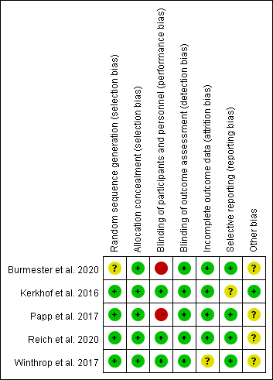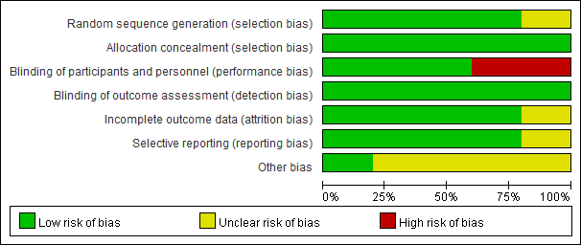

Figure S2. ROBINS-I assessment of non-randomized controlled trials
Study | Confounding | Selection of participants | Classification of interventions | Deviation from intended interventions | Missing data | Measurements of outcome | Selection of reported result | Overall
Dreiher et al. 2012 | ◉ | ◉ | ◉ | ◉ | ◉ | ◉ | ◉ | ◉
Zisman et al. 2016 | ◉ | ◉ | ◉ | ◉ | ◉ | ◉ | ◉ | ◉
Shalom et al. 2019 | ◉ | ◉ | ◉ | ◉ | ? | ◉ | ◉ | ◉
Hagberg et al. 2020 | ◉ | ◉ | ◉ | ◉ | ◉ | ◉ | ◉ | ◉
Shalom et al. 2015 | ◉ | ◉ | ◉ | ◉ | ◉ | ◉ | ◉ | ◉
Levandoski et al. 2018 | ◉ | ◉ | ◉ | ◉ | ? | ◉ | ◉ | ◉
Failla et al. 2012 | ◉ | ◉ | ◉ | ◉ | ? | ◉ | ◉ | ◉
Kalb et al. 2015 | ◉ | ◉ | ◉ | ◉ | ? | ◉ | ◉ | ◉
Low ◉ Moderate ◉ Serious ◉ Critical ◉ No information ?

Figure S3. Forest plot. Forest plot of risk of herpes zoster with treatments compared with control.
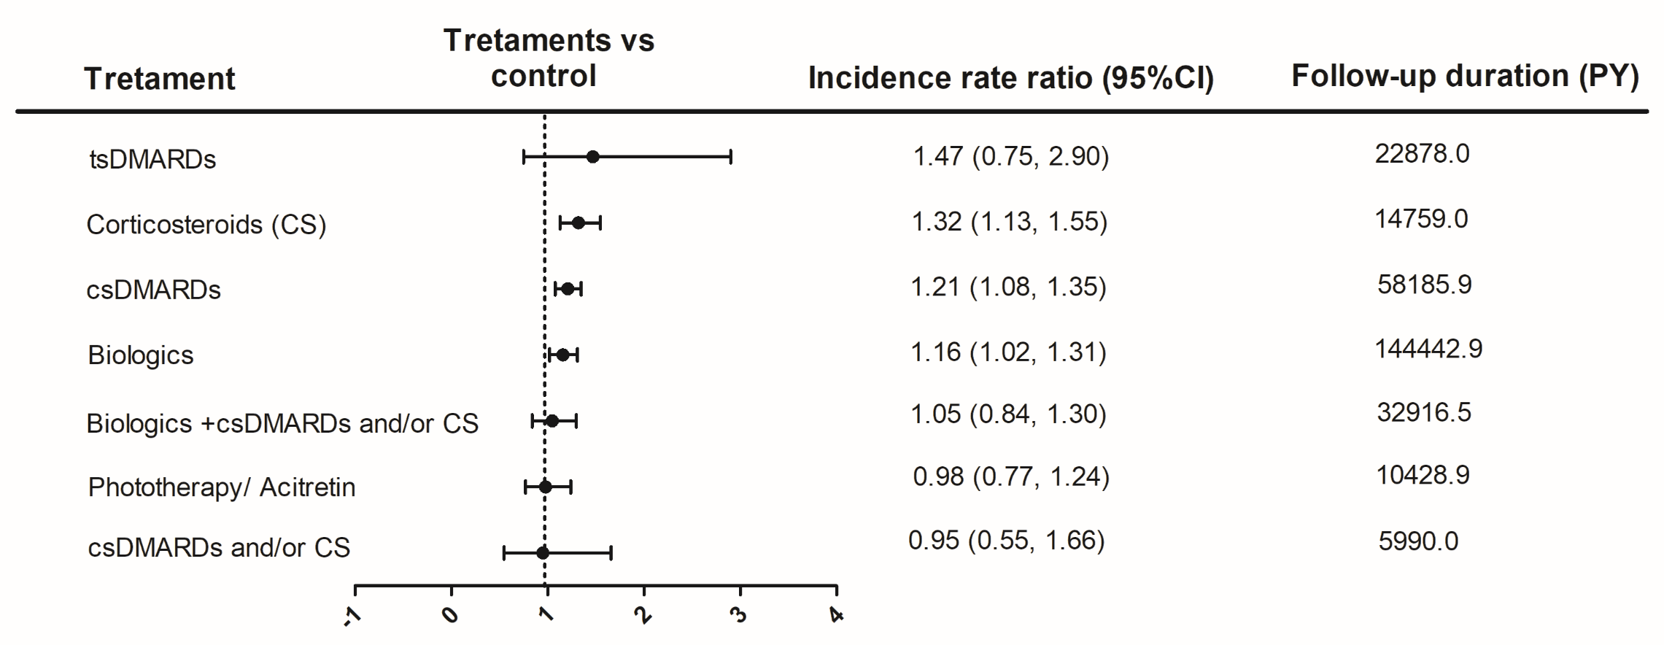
CS: corticosteroids; csDAMRDs, conventional synthetic disease-modifying anti-rheumatic drugs; PY: patient-year; tsDMARDs, targeted synthetic disease-modifying anti-rheumatic drugs.

Figure S4. Rankogram of intervenions. Rankogram of herpes zoster risk with interventions. The horizontal axis demonstrates ranks, the vertical axis shows cumulative ranking probability from 0 to 1. CS: corticosteroids; csDAMRDs, conventional synthetic disease-modifying anti-rheumatic drugs; tsDMARDs, targeted synthetic disease-modifying anti-rheumatic drugs.
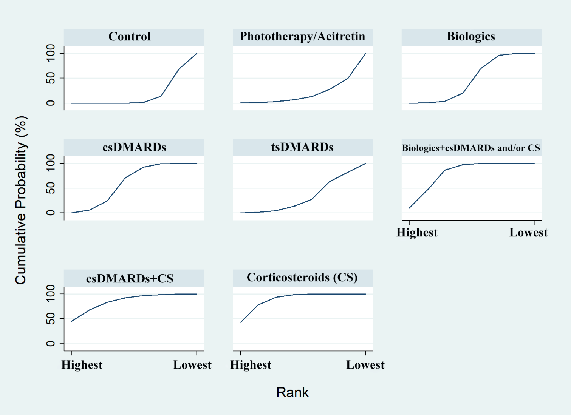

Figure S5. Comparison-adjusted funnel plot (left) and Egger’s test (right) for the network analysis of herpes zoster risk with interventions.
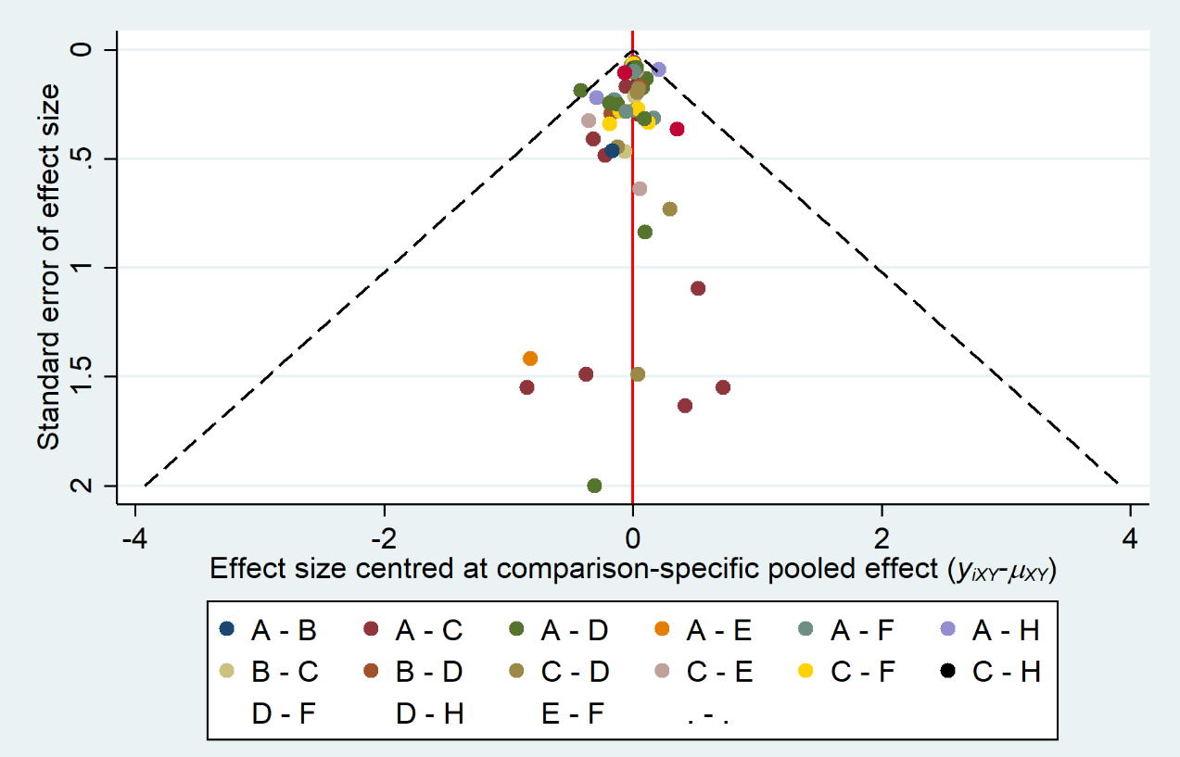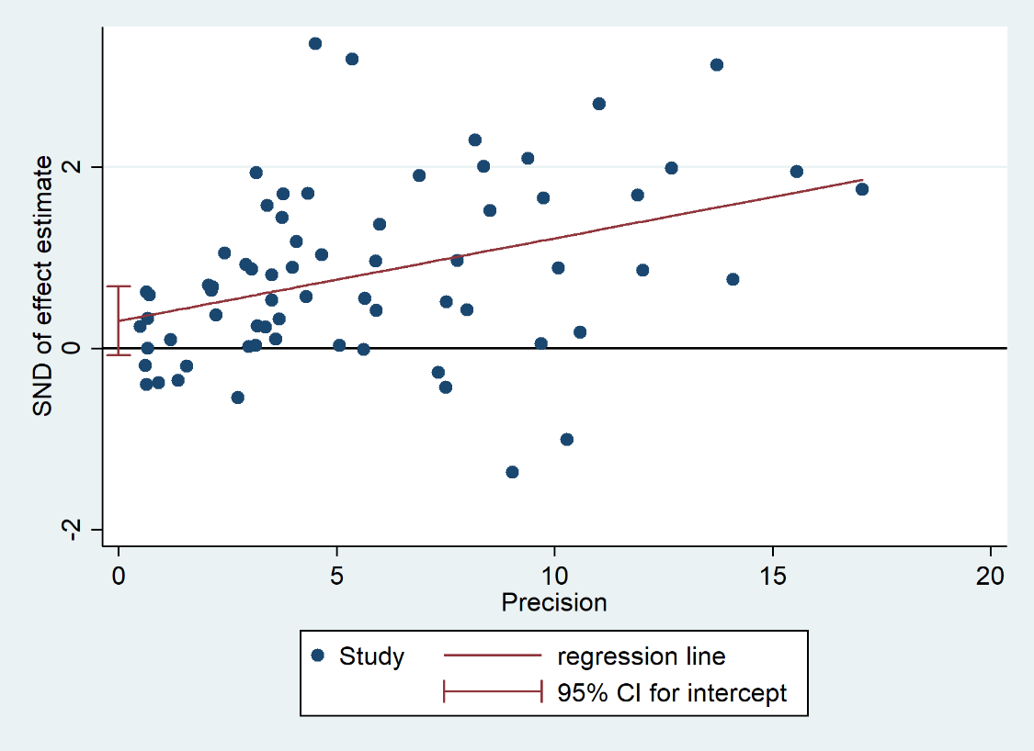
A, control; B, phototherapy/acitretin; C, biologics; D, conventional synthetic disease-modifying anti-rheumatic drugs (csDMARDs); E, targeted synthetic disease-modifying anti-rheumatic drugs (tsDMARDs); F, biologics+ csDMARDs and/or corticosteroids; G, csDMARDs+ corticosteroids; H, corticosteroids.

Figure S6. Comparison-adjusted funnel plot (left) and Egger’s test (right) for the network analysis of herpes zoster risk with interventions stratified into 12 groups. 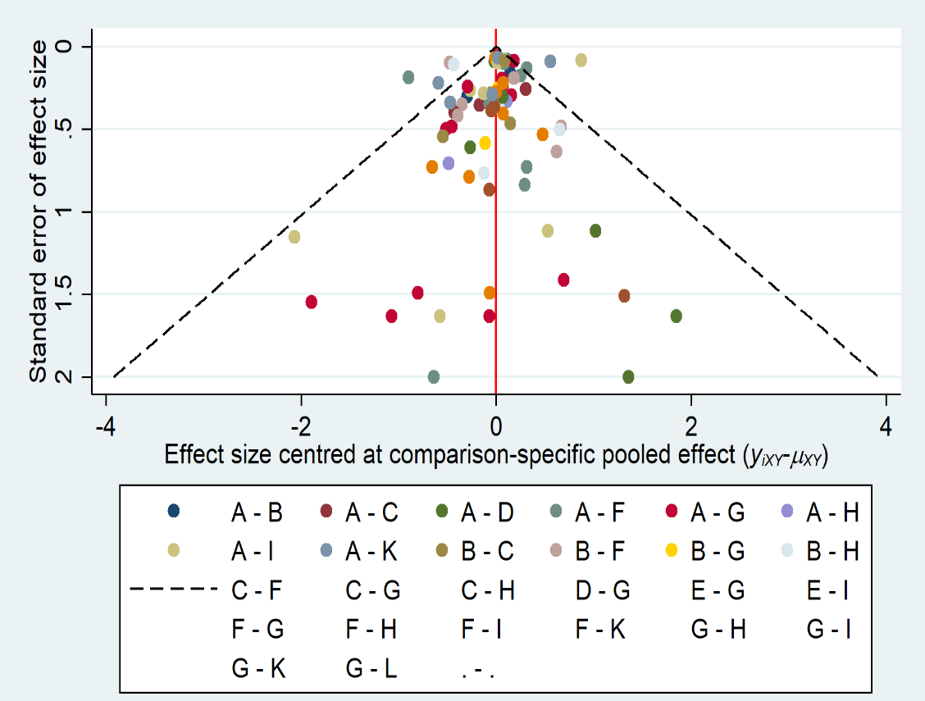 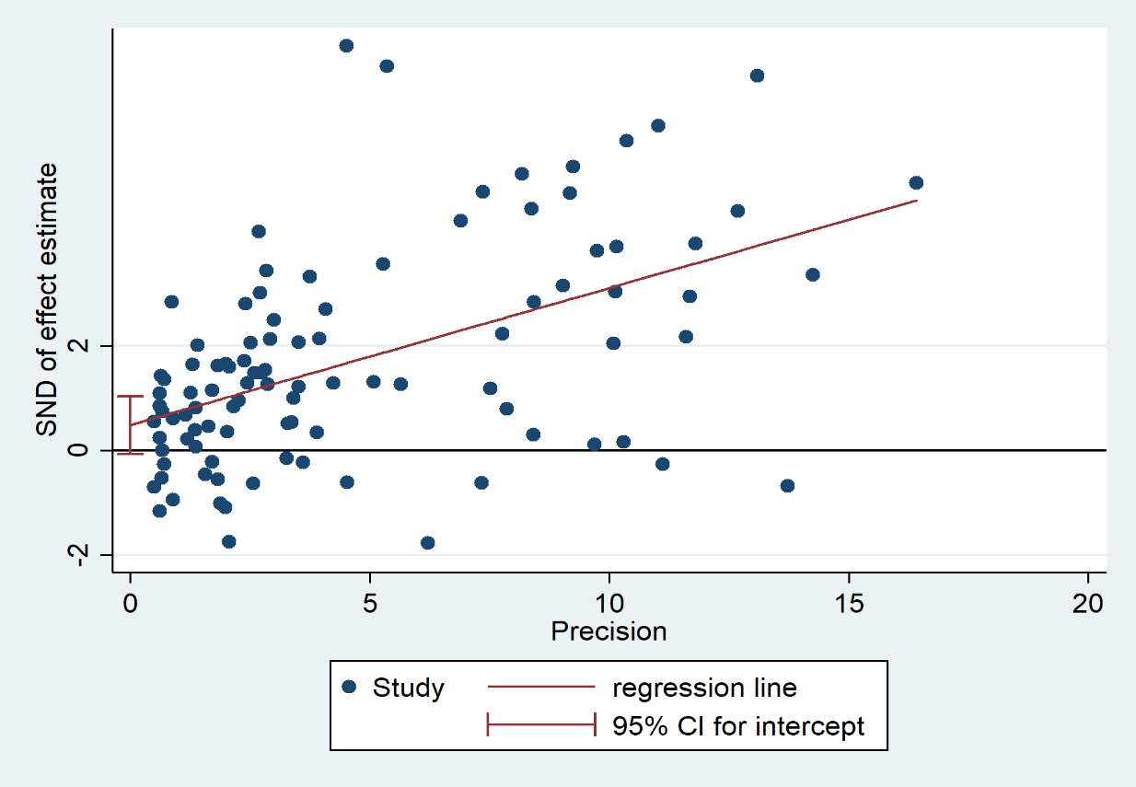
A, control; B, acitretin; C, phototherapy; D, anti-interleukin (anti-IL-17, −23 or −12/23); E, PDE4 inhibitor; F, conventional synthetic disease-modifying anti-rheumatic drugs (csDMARDs); G, anti-TNF-α except infliximab; H, anti-interleukin + csDMARDs and/or corticosteroids; I, infliximab; J, anti-TNF-α + csDMARDs and/or corticosteroids; K, csDMARDs + corticosteroids; L, corticosteroids; M, JAK inhibitor.

References
1. Winthrop KL, Curtis JR, Lindsey S, Tanaka Y, Yamaoka K, Valdez H et al. Herpes Zoster and Tofacitinib: Clinical Outcomes and the Risk of Concomitant Therapy. Arthritis Rheumatol 2017;69:1960-8.
2. Dreiher J, Kresch FS, Comaneshter D , Cohen AD. Risk of Herpes zoster in patients with psoriasis treated with biologic drugs. J Eur Acad Dermatol Venereol 2012;26:1127-32.
3. Zisman D, Bitterman H, Shalom G, Feldhamer I, Comanesther D, Batat E et al. Psoriatic arthritis treatment and the risk of herpes zoster. Ann Rheum Dis 2016;75:131-5.
4. Shalom G, Naldi L, Lebwohl M, Nikkels A, de Jong E, Fakharzadeh S et al. Biological treatment for psoriasis and the risk of herpes zoster: results from the Psoriasis Longitudinal Assessment and Registry (PSOLAR). J Dermatolog Treat 2019;30:534-9.
5. Hagberg KW, Persson R, Vasilakis-Scaramozza C, Niemcryk S, Peng M, Paris M et al. Herpes Zoster, Hepatitis C, and Tuberculosis Risk with Apremilast Compared to Biologics, DMARDs and Corticosteroids to Treat Psoriasis and Psoriatic Arthritis. Clin Epidemiol 2020;12:153-61.
6. Shalom G, Zisman D, Bitterman H, Harman-Boehm I, Greenberg-Dotan S, Dreiher J et al. Systemic Therapy for Psoriasis and the Risk of Herpes Zoster: A 500,000 Person-year Study. JAMA Dermatol 2015;151:533-8.
7. Levandoski KA, Quesenberry CP, Tsai AL , Asgari MM. Herpes Zoster Rates in a Large Cohort of Patients With Systemically Treated Psoriasis. JAMA Dermatol 2018;154:218-9.
8. Burmester GR, Curtis JR, Yun H, FitzGerald O, Winthrop KL, Azevedo VF et al. An Integrated Analysis of the Safety of Tofacitinib in Psoriatic Arthritis across Phase III and Long-Term Extension Studies with Comparison to Real-World Observational Data. Drug Saf 2020;43:379-92.
9. Reich K, Warren RB, Iversen L, Puig L, Pau-Charles I, Igarashi A et al. Long-term efficacy and safety of tildrakizumab for moderate-to-severe psoriasis: pooled analyses of two randomized phase III clinical trials (reSURFACE 1 and reSURFACE 2) through 148 weeks. Br J Dermatol 2020;182:605-17.
10. van de Kerkhof PC, Griffiths CE, Reich K, Leonardi CL, Blauvelt A, Tsai TF et al. Secukinumab long-term safety experience: A pooled analysis of 10 phase II and III clinical studies in patients with moderate to severe plaque psoriasis. J Am Acad Dermatol 2016;75:83-98 e4.
11. Failla V, Jacques J, Castronovo C , Nikkels AF. Herpes zoster in patients treated with biologicals. Dermatology 2012;224:251-6.
12. Papp KA, Bachelez H, Blauvelt A, Winthrop KL, Romiti R, Ohtsuki M et al. Infections from seven clinical trials of ixekizumab, an anti-interleukin-17A monoclonal antibody, in patients with moderate-to-severe psoriasis. Br J Dermatol 2017;177:1537-51.
13. Kalb RE, Fiorentino DF, Lebwohl MG, Toole J, Poulin Y, Cohen AD et al. Risk of Serious Infection With Biologic and Systemic Treatment of Psoriasis: Results From the Psoriasis Longitudinal Assessment and Registry (PSOLAR). JAMA Dermatol 2015;151:961-9.
14. Blauvelt A, Reich K, Papp KA, Kimball AB, Gooderham M, Tyring SK et al. Safety of tildrakizumab for moderate-to-severe plaque psoriasis: pooled analysis of three randomized controlled trials. Br J Dermatol 2018;179:615-22.

