Additional file 5 Forest plots of pooled ORs in various factors
- Age (<30 vs. ≥30)
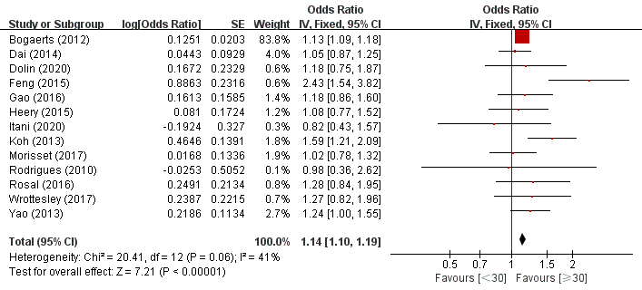
- Employment (No vs. Yes)
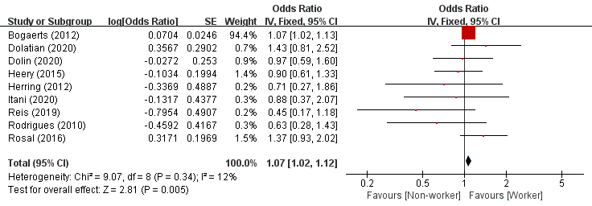
- Pregnancy BMI (Underweight vs. Normal)
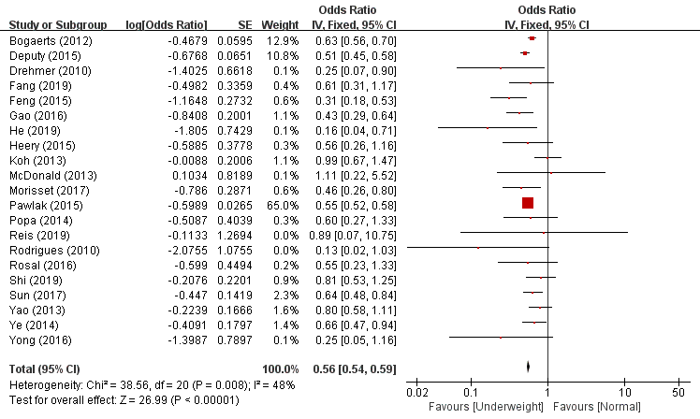

- Pregnancy BMI (Overweight (&obesity) vs. Normal)
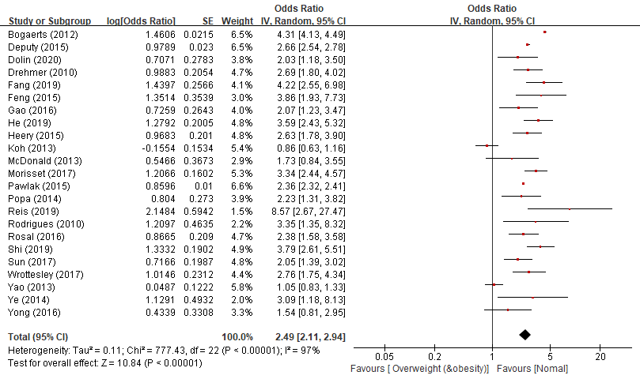
- Parity (Primiparity vs. Multiparity)
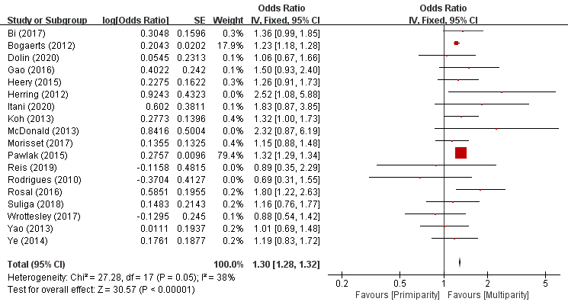
- Planned pregnancy (No vs. Yes)
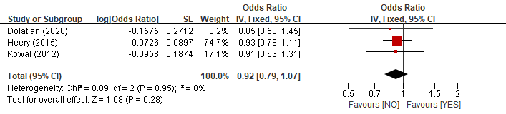

- Smoking (Yes vs. No)
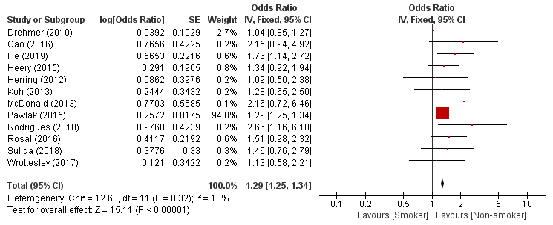
- Alcohol (Yes vs. No)
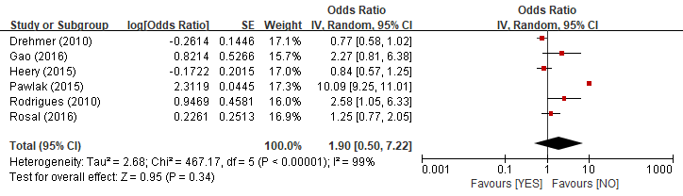
- Prenatal care (Inadequate vs. Adequate)
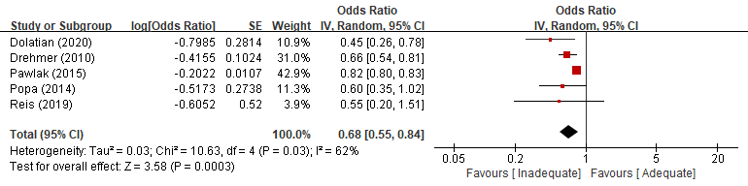
- Marital status (Unmarried (&divorced) vs. Married)
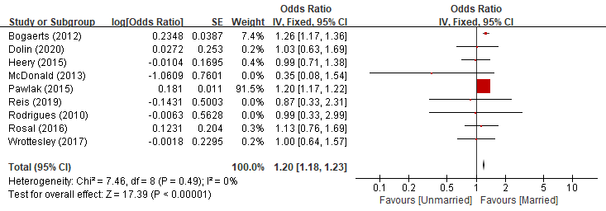
- Food security (No vs. Yes)
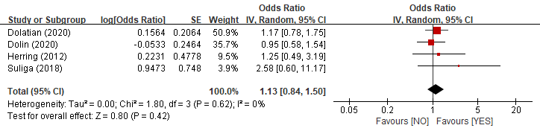
- Nutrition advice or guidance (Not have vs. Have)

