Supplementary Material

Full search strategy for Pubmed database.
#1 Positive-Pressure Respiration[MeSH Terms]
#2 “high-flow nasal cannul*”[Text Word] OR “high flow cannul*”[Text Word] OR “high flow oxygen therapy”[Text Word] OR “high flow oxygen”[Text Word] OR “high flow therapy”[Text Word] OR “HFNC”[Text Word] OR “high flow high humidity nasal cannul*”[Text Word] OR “high-flow warm humidified oxygen” [Text Word] OR “hot humidified high-flow”[Text Word] OR NPPV[Text Word] OR NIPPV[Text Word] OR CPAP[Text Word] OR bCPAP[Text Word] OR "bubble CPAP"[Text Word] OR nCPAP[Text Word] OR BiPAP[Text Word] OR non-invasive[Text Word] OR "non invasive"[Text Word] OR positive-pressure[Text Word] OR "positive pressure"[Text Word] OR "pressure support"[Text Word] OR pressure-support[Text Word] OR "positive airway"[Text Word] OR positive-airway[Text Word] OR airway-pressure[Text Word] OR "airway pressure"[Text Word] OR "pressure control"[Text Word] OR pressure-control[Text Word] OR bi-level*[Text Word] OR bilevel*[Text Word] OR "ventilat* support*"[Text Word] OR "volume control"[Text Word] OR volume-control[Text Word] OR "nasal* ventilat*"[Text Word] OR "mechanical* ventilat*"[Text Word] OR “oxygen therapy” [Text Word] OR “oxygen supplementation” [Text Word] OR “oxygen delivery” [Text Word] OR “conventional oxygen therapy” [Text Word] OR COT[Text Word]
#3 #1 or #2
#4 Pneumonia[MeSH Terms]
#5 Bronchitis[MeSH Terms]
#6 Respiratory Tract Infections[MeSH Terms]
#7 Bronchiolitis[MeSH Terms]
#8 Respiratory Syncytial Viruses[MeSH Terms]
#9 respirat*[Text Word] OR pulmonary*[Text Word] OR "respiratory distress"[Text Word] OR "respiratory insufficiency"[Text Word] OR pneumon*[Text Word] OR bronchopneumon*[Text Word] OR pleuropneumon*[Text Word] OR bronchit*[Text Word] OR tracheobronchit*[Text Word] OR respiratory Sounds[Text Word] OR wheez*[Text Word] OR respiratory tract infection*[Text Word] OR acute respiratory infection*[Text Word] OR lower respiratory infection*[Text Word] OR lower respiratory tract infection*[Text Word] OR lrti[Text Word] OR bronchiolit*[Text Word] OR respiratory syncytial virus infections[Text Word] OR respiratory syncytial virus*[Text Word] OR rsv[Text Word]
#10 #4 or #5 or #6 or #7 or #8 or #9
#11 schoolchild*[Text Word] OR schoolchild[Text Word] OR school child[Text Word] OR school child*[Text Word] OR kid[Text Word] OR kids[Text Word] OR toddler*[Text Word] OR adolescent[Text Word] OR adoles*[Text Word] OR teen*[Text Word] OR boy[Text Word] OR girl*[Text Word] OR minors[Text Word] OR minors*[Text Word] OR underag*[Text Word] OR under ag*[Text Word] OR juvenil*[Text Word] OR youth*[Text Word] OR kindergar*[Text Word] OR puberty[Text Word] OR puber*[Text Word] OR pubescen*[Text Word] OR prepubescen*[Text Word] OR prepuberty*[Text Word] OR pediatrics[Text Word] OR pediatric*[Text Word] OR paediatric*[Text Word] OR peadiatric*[Text Word] OR schools[Text Word] OR nursery school*[Text Word] OR preschool*[Text Word] OR pre school*[Text Word] OR primary school*[Text Word] OR secondary school*[Text Word] OR elementary school*[Text Word] OR elementary school[Text Word] OR high school*[Text Word] OR highschool*[Text Word] OR school age[Text Word] OR schoolage[Text Word] OR school age*[Text Word] OR schoolage*[Text Word] OR infancy[Text Word]
#12 randomized controlled trial[Publication Type] OR controlled clinical trial[Publication Type] OR randomized[Title/Abstract] OR placebo[Title/Abstract] OR randomly[Title/Abstract] OR clinical trials as topic[MeSH Major Topic] OR trial[Publication Type]
#13 animals[MeSH Terms] NOT humans[MeSH Terms]
#14 #12 NOT #13
#15 #3 AND #10 AND #11 AND #14

Supplementary Table 1. A summary of treatment failure definition in all included studies.
Features  Studies | Intervention | Oxygenation | Respiratory rate | Heart rate | Arterial blood gas | Respiratory distress | Timing | Others
Chisti 2015 | CPAP vs SOT and HFNC | Severe hypoxemia  (SpO₂ < 85%) | - | - | PaCO₂ > 60 mmHg and pH < 7.2 in capillary blood gas | Signs of respiratory distress including moderate to severe chest wall in-drawing, tracheal tug, nasal flaring, or grunting respirations | ≥30 min of study intervention | Need for mechanical ventilation; death at any time during hospital stay or within 30 d of discharge; or left hospital against medical advice
Ergul 2018 | HFNC vs SOT | Persistence of low SpO₂ < 92% in the HFNC group/oxygen flow rate of 15L/min in the SOT group | No change or an increase in respiration rate | No change or an increase in heart rate | - | - | At any time point during hospital stay | -
Franklin 2018 | HFNC vs SOT | FIO₂ ≥0.4 in HFNC group; supplemental oxygen > 2L/min in SOT group to maintain SpO₂ ≥92% or 94% depending on the institution | Unchanged or increased | Unchanged or increased | - | - | At the point of hospital admission | An escalation of care during hospital admission; hospital internal early-warning tool triggered a medical review
Kepreotes 2017 | HFNC vs SOT | SpO2 < 90% on maximum therapy | Red zone on an age-appropriate SPOC for respiratory rate on maximum therapy | Red zone on an age-appropriate SPOC for heart rate on maximum therapy | - | Red zone on an age-appropriate SPOC for respiratory distress score (severe) on maximum therapy | - | Clinical decision by the treating physician or medical delegate that the current treatment was insufficient to reverse the deterioration
McCollum 2019 | CPAP vs SOT | Continued oxygen or CPAP requirement | Any respiratory  danger sign | - | - | - | Day 14 of hospitalisation | Temperature ≥ 38 °C
Mile´si 2017 | CPAP vs HFNC | - | Increase > 10bpm compared with baseline, with respiratory rate > 60bpm | - | - | - | - | More than 2 severe apnea episodes per hour; 1-point increase in mWCAS compared with baseline;  1-point increase in the EDIN score compared with baseline, with EDIN > 4
Ramnarayan 2018 | CPAP vs HFNC | - | - | - | - | - | - | An escalation of care or a crossover use of respiratory support
Sarkar 2018 | CPAP vs HFNC | FIO₂ > 0.6 for HFNC with maximum oxygen flow rate to maintain SpO₂ > 94%; FIO2 > 0.6 for nCPAP with PEEP > 8 cmH2O | Unchanged or increased | Unchanged or increased | - | No improvement or increase in RDAI score | - | -
Sitthikarnkha 2018 | HFNC vs SOT | FIO₂ > 0.5 | NOT reduced by 20% or NOT within normal range | NOT reduced by 20% or NOT within normal range | - | - | - | -
Vitaliti 2017 | CPAP vs HFNC | - | - | - | - | - | - | -
Durand 2020 | HFNC vs SOT | FiO₂ > 40% (HFNC group) or flow oxygen > 2 L/min (control group) for SpO₂ ≥ 94% | - | - | Increased PaCO₂ compared to  baseline and/or above 60 mmHg at hour 6 | Elevated m-WCAS score (≥ 1 point) at hour 6 compared to baseline and/or any scores higher than 5 | - | Refractory apnea episodes (more than 3 per hour)
Vahlkvist 2020 | CPAP vs HFNC | - | - | - | - | - | - | A switch of system  (CPAP to HFNC/HFNC to CPAP) or to transmission to the PICU
Liu 2020 | CPAP vs HFNC | - | - | - | - | - |  | Need for transmission to the PICU and mechanical ventilation
Türe 2020 | HFNC vs SOT | Failure to return back to normal | Failure to return back to normal | Failure to return back to normal | - | - | 24 hours after admission | -
Maitland 2021 | HFNC vs SOT | Persistent hypoxaemia SpO₂ < 92% | - | - | - | Persistent respiratory distress | 48 hours after admission | -
Franklin 2020 | HFNC vs SOT | FIO₂ ≥0.4 in HFNC group; supplemental oxygen > 2L/min (subnasal) or > 8 L/min (Hudson mask) in SOT group to maintain SpO₂ ≥92% | Unchanged or increased | Unchanged or increased | - | - | - | Hospital early warning tool necessitates a medical review and the clinician decided on an escalation of care
Cesar 2020 | CPAP vs HFNC | - | - | - | - | - | - | The need to escalate support to noninvasive bilevel pressure ventilation, or endotracheal intubation
CPAP: continuous positive airway pressure; EDIN, neonatal pain and discomfort scale; HFNC, humidified high-flow nasal cannula; mWCAS: modified Wood’s clinical asthma score; PICU: pediatric intensive care unit, SOT, standard oxygen therapy; SpO₂: arterial pulse oximetry; SPOC, standard pediatric observation charts; RDAI: respiratory distress assessment index

Supplementary Table 2. The confidence in OR for treatment failure by GRADE system*.
Comparison | Study limitationsª | Imprecision^{b} | Heterogeneity and  Inconsistency^{c} | Indirectness^{d} | Publication bias^{e} | Confidence in OR  for mortality rate
CPAP vs. SOT | 100% of the estimate  from studies at high risk | OR 0.42, 95% CrI 0.19 to 0.81 | High heterogeneity according  to I² (91%) and P-value  (0.001) in direct comparisons.  No inconsistency between the  direct and indirect estimate (Node-split P=0.1701). | The treatment effects were not significantly  influenced by clinical  modifiers in the network  meta-regression. | Undetectable by the routine  method. The comparison-  adjusted funnel plot for the  network is not suggestive of any dominant publication bias. | Low (Downgrade  by two levels due to  study limitations and heterogeneity).
HFNC vs. SOT | 100% of the estimate  from studies at high risk | OR 0.51, 95% CrI 0.29 to 0.81 | Mild heterogeneity according  to I² (36%) and P-value  (0.13) in direct comparisons.  Significant inconsistency between the direct and indirect estimate (Node-split P=0.0086). | The treatment effects were not significantly  influenced by clinical  modifiers in the network  meta-regression. | Undetectable by the routine  method. The comparison-  adjusted funnel plot for the  network is not suggestive of any dominant publication bias. | Low (Downgrade  by two levels due to  study limitations, and  inconsistency).
CPAP vs. HFNC | 100% of the estimate  from studies at high risk | OR 0.82, 95% CrI 0.42 to 1.51 | Mild heterogeneity according  to I² (0%) and P-value  (0.96) in direct comparisons.  Significant inconsistency between the direct and indirect estimate (Node-split P=0.0080). | The treatment effects were not significantly  influenced by clinical  modifiers in the network  meta-regression. | Undetectable by the routine  method. The comparison-  adjusted funnel plot for the  network is not suggestive of any dominant publication bias. | Very low (Downgrade  by three levels due to  study limitations, imprecision,and  inconsistency).
* Salanti G, Del Giovane C, Chaimani A, Caldwell DM, Higgins JP. Evaluating the quality of evidence from a network meta-analysis. PLoS One. 2014 Jul 3;9(7):e99682. ª The consideration for study limitations was based on the relative contributions of risk of bias in direct evidence. We downgraded by one level for high risk of bias. ^{b} The consideration for imprecision was based on the width of the confidence interval. ^{c} The consideration for heterogeneity and inconsistency was based on the corresponding P value. We downgraded by one level for significant heterogeneity and inconsistency, respectively. ^{d} The consideration for indirectness was based on the results of network meta-regression. We downgraded by one level if the confidence interval of correlation coefficient not included 0. ^{e} The consideration for publication bias was based on the comparison-adjusted funnel plot.
Crls: Cridible intervals, ORs: odd ratios, CPAP: continuous positive airway pressure, HFNC: high-flow nasal cannula, SOT: standard oxygen therapy

Supplementary Table 3. The confidence in OR for intubation rate by GRADE system*.
Comparison | Study limitationsª | Imprecision^{b} | Heterogeneity and  Inconsistency^{c} | Indirectness^{d} | Publication bias^{e} | Confidence in OR  for mortality rate
CPAP vs. SOT | 100% of the estimate  from studies at high risk | OR 0.40, 95% CrI 0.16 to 0.90 | Mild heterogeneity according  to I² (0%) and P-value  (0.41) in direct comparisons.  No inconsistency between the  direct and indirect estimate (Node-split P=0.7756. | The treatment effects were not significantly  influenced by clinical  modifiers in the network  meta-regression. | Undetectable by the routine  method. The comparison-  adjusted funnel plot for the  network is not suggestive of any dominant publication bias. | Moderate (Downgrade  by one level due to  study limitations).
HFNC vs. SOT | 100% of the estimate  from studies at high risk | OR 0.77, 95% CrI 0.37 to 1.50 | Mild heterogeneity according  to I² (6%) and P-value  (0.37) in direct comparisons.  No inconsistency between the  direct and indirect estimate (Node-split P=0.4699). | The treatment effects were not significantly  influenced by clinical  modifiers in the network  meta-regression. | Undetectable by the routine  method. The comparison-  adjusted funnel plot for the  network is not suggestive of any dominant publication bias. | Low (Downgrade  By two levels due to  study limitations, and  imprecision).
BIPAP vs. SOT | 100% of the estimate  from studies at high risk | OR 0.24, 95% CrI 0.05 to 1.05 | Only one head-to-head study,  and no heterogeneity. No indirect comparison and no node-splitting inconsistency. | Meta-regression not performend due to limited studies. No potential effect modifiers from meta-regression. | Undetectable by the routine  method. The comparison-  adjusted funnel plot for the  network is not suggestive of any dominant publication bias. | Low (Downgrade  by one level due to  study limitations, and  imprecision).
CPAP vs. HFNC | 100% of the estimate  from studies at high risk | OR 0.51, 95% CrI 0.26 to 1.01 | Mild heterogeneity according  to I² (0%) and P-value  (0.99) in direct comparisons.  No inconsistency between the  direct and indirect estimate (Node-split P=0.4485). | The treatment effects were not significantly  influenced by clinical  modifiers in the network  meta-regression. | Undetectable by the routine  method. The comparison-  adjusted funnel plot for the  network is not suggestive of any dominant publication bias. | Low (Downgrade  by one level due to  study limitations, and  imprecision).
BIPAP vs. CPAP | 100% of the estimate  from studies at high risk | OR 0.51, 95% CrI 0.26 to 1.01 | No head-to-head study and no  heterogeneity.  Only indirect comparison, and  no node-splitting inconsistency. | Meta-regression not performend due to limited studies. No potential effect modifiers from metaregression. | Undetectable by the routine  method. The comparison-  adjusted funnel plot for the  network is not suggestive of any dominant publication bias. | Low (Downgrade  by two levels due to  study limitations, and  imprecision).
BIPAP vs. HFNC | 100% of the estimate  from studies at high risk | OR 0.32, 95% CrI 0.06 to 1.65 | No head-to-head study and no  heterogeneity.  Only indirect comparison, and  no node-splitting inconsistency. | Meta-regression not performend due to limited studies. No potential effect modifiers from metaregression. | Undetectable by the routine  method. The comparison-  adjusted funnel plot for the  network is not suggestive of any dominant publication bias. | Low (Downgrade  by two levels due to  study limitations, and  imprecision).
* Salanti G, Del Giovane C, Chaimani A, Caldwell DM, Higgins JP. Evaluating the quality of evidence from a network meta-analysis. PLoS One. 2014 Jul 3;9(7):e99682. ª The consideration for study limitations was based on the relative contributions of risk of bias in direct evidence. We downgraded by one level for high risk of bias. ^{b} The consideration for imprecision was based on the width of the confidence interval. ^{c} The consideration for heterogeneity and inconsistency was based on the corresponding P value. We downgraded by one level for significant heterogeneity and inconsistency, respectively. ^{d} The consideration for indirectness was based on the results of network metaregression. We downgraded by one level if the confidence interval of correlation coefficient not included 0. ^{e} The consideration for publication bias was based on the comparison-adjusted funnel plot.
BIPAP:bilevel positive airway pressure, Crls: Cridible intervals, ORs: odd ratios, CPAP: continuous positive airway pressure, HFNC: high-flow nasal cannula, SOT: standard oxygen therapy

Supplementary Table 4. The confidence in OR for mortality rate by GRADE system*.
Comparison | Study limitationsª | Imprecision^{b} | Heterogeneity and  Inconsistency^{c} | Indirectness^{d} | Publication bias^{e} | Confidence in OR  for mortality rate
CPAP vs. SOT | 100% of the estimate  from studies at high risk | OR 0.71, 95% CrI 0.16 to 2.37 | High heterogeneity according  to I² (87%) and P-value  (0.006) in direct comparisons.  No inconsistency between the  direct and indirect estimate (Node-split P=0.7385). | The treatment effects were not significantly  influenced by clinical  modifiers in the network  meta-regression. | Comparison-adjusted funnel plot was not conducted to as too few studies. No publication bias from comparison-adjusted funnel plot. | Very low (Downgrade  by three levels due to  study limitations,  imprecision, and  heterogeneity).
HFNC vs. SOT | 100% of the estimate  from studies at high risk | OR 1.03, 95% CrI 0.29 to 3.86 | Mild heterogeneity according  to I² (0%) and P-value  (0.92) in direct comparisons.  No inconsistency between the  direct and indirect estimate (Node-split P=0.3880). | The treatment effects were not significantly  influenced by clinical  modifiers in the network  meta-regression. | Comparison-adjusted funnel plot was not conducted to as too few studies. No publication bias from comparison-adjusted funnel plot. | Low (Downgrade  by two levels due to  study limitations, and imprecision).
CPAP vs. HFNC | 100% of the estimate  from studies at high risk | OR 0.68, 95% CrI 0.13 to 2.64 | Low heterogeneity according  to I² (0%) and P-value  (0.60) in direct comparisons.  No inconsistency between the  direct and indirect estimate (Node-split P=0.1509). | The treatment effects were not significantly  influenced by clinical  modifiers in the network  meta-regression. | Comparison-adjusted funnel plot was not conducted to as too few studies. No publication bias from comparison-adjusted funnel plot. | Low (Downgrade  by two levels due to  study limitations, and imprecision).
* Salanti G, Del Giovane C, Chaimani A, Caldwell DM, Higgins JP. Evaluating the quality of evidence from a network meta-analysis. PLoS One. 2014 Jul 3;9(7):e99682. ª The consideration for study limitations was based on the relative contributions of risk of bias in direct evidence. We downgraded by one level for high risk of bias. ^{b} The consideration for imprecision was based on the width of the confidence interval. ^{c} The consideration for heterogeneity and inconsistency was based on the corresponding P value. We downgraded by one level for significant heterogeneity and inconsistency, respectively. ^{d} The consideration for indirectness was based on the results of network metaregression. We downgraded by one level if the confidence interval of correlation coefficient not included 0. ^{e} The consideration for publication bias was based on the comparison-adjusted funnel plot.
Crls: Cridible intervals, ORs: odd ratios, CPAP: continuous positive airway pressure, HFNC: high-flow nasal cannula, SOT: standard oxygen therapy

Supplementary Table 5. The SUCRA results for each outcome.
Outcome  SUCRA*(%)  Treatments | Treatment failure | Intubation | Mortality
BIPAP | NA | 88.1 % | NA
CPAP | 89.0 % | 73.0 % | 69.9 %
HFNC | 60.5 % | 28.7 % | 39.3 %
SOT | 42.1 % | 10.2 % | 40.8 %
*Larger SUCRAs denote more effective interventions. BIPAP:bilevel positive airway pressure, CPAP: continuous positive airway pressure, HFNC: high-flow nasal cannula, SOT: standard oxygen therapy, SUCRA: surface under the cumulative ranking curve

Supplementary Table 6. Sensitivity network meta-analysis for treatment failure by omitting the trial conducted by McCollum et al. (18) (ORs and 95% Crls).
Standard Oxygen | 0.26 (0.14, 0.45) | 0.48 (0.33, 0.64)
3.88 (2.21, 7.22) | CPAP | 1.87 (1.11, 3.11)
2.07 (1.55, 3.05) | 0.54 (0.32, 0.9) | HFNC

CPAP: continuous positive airway pressure, Crls: Cridible intervals, HFNC: high-flow nasal cannula, ORs: odd ratios, SOT: standard oxygen therapy

Supplementary Table 7. Sensitivity network meta-analysis for mortality by omitting the trial conducted by McCollum et al. (18) (ORs and 95% Crls).
SOT | 0.23 (0.04, 1.08) | 0.78 (0.27, 2.16)
4.28 (0.93, 23.15) | CPAP | 3.33 (0.79, 16.63)
1.28 (0.46, 3.64) | 0.3 (0.06, 1.27) | HFNC

CPAP: continuous positive airway pressure, Crls: Cridible intervals, HFNC: high-flow nasal cannula, ORs: odd ratios, SOT: standard oxygen therapy

Supplementary Figure 1. Risk of bias assessment of the included studies.

Supplementary Figure 2. Forest plots for the pairwise comparison of treatment failure. (a) CPAP vs. SOT. (b) HFNC vs. SOT. (c) CPAP vs. HFNC. CPAP: continuous positive airway pressure, HFNC: high-flow nasal cannula, SOT: standard oxygen therapy

Supplementary Figure 3. Forest plots for the pairwise comparison of Intubation rate. (a) CPAP vs. SOT. (b) HFNC vs. SOT. (c) CPAP vs. HFNC. (d) BIPAP vs. SOT. BIPAP: bilevel positive airway pressure, CPAP: continuous positive airway pressure, HFNC: high-flow nasal cannula, SOT: standard oxygen therapy

Supplementary Figure 4. Forest plots for the pairwise comparison of in-hospital mortality. (a) CPAP vs. SOT. (b) HFNC vs. SOT. (c) CPAP vs. HFNC. CPAP: continuous positive airway pressure, HFNC: high-flow nasal cannula, SOT: standard oxygen therapy

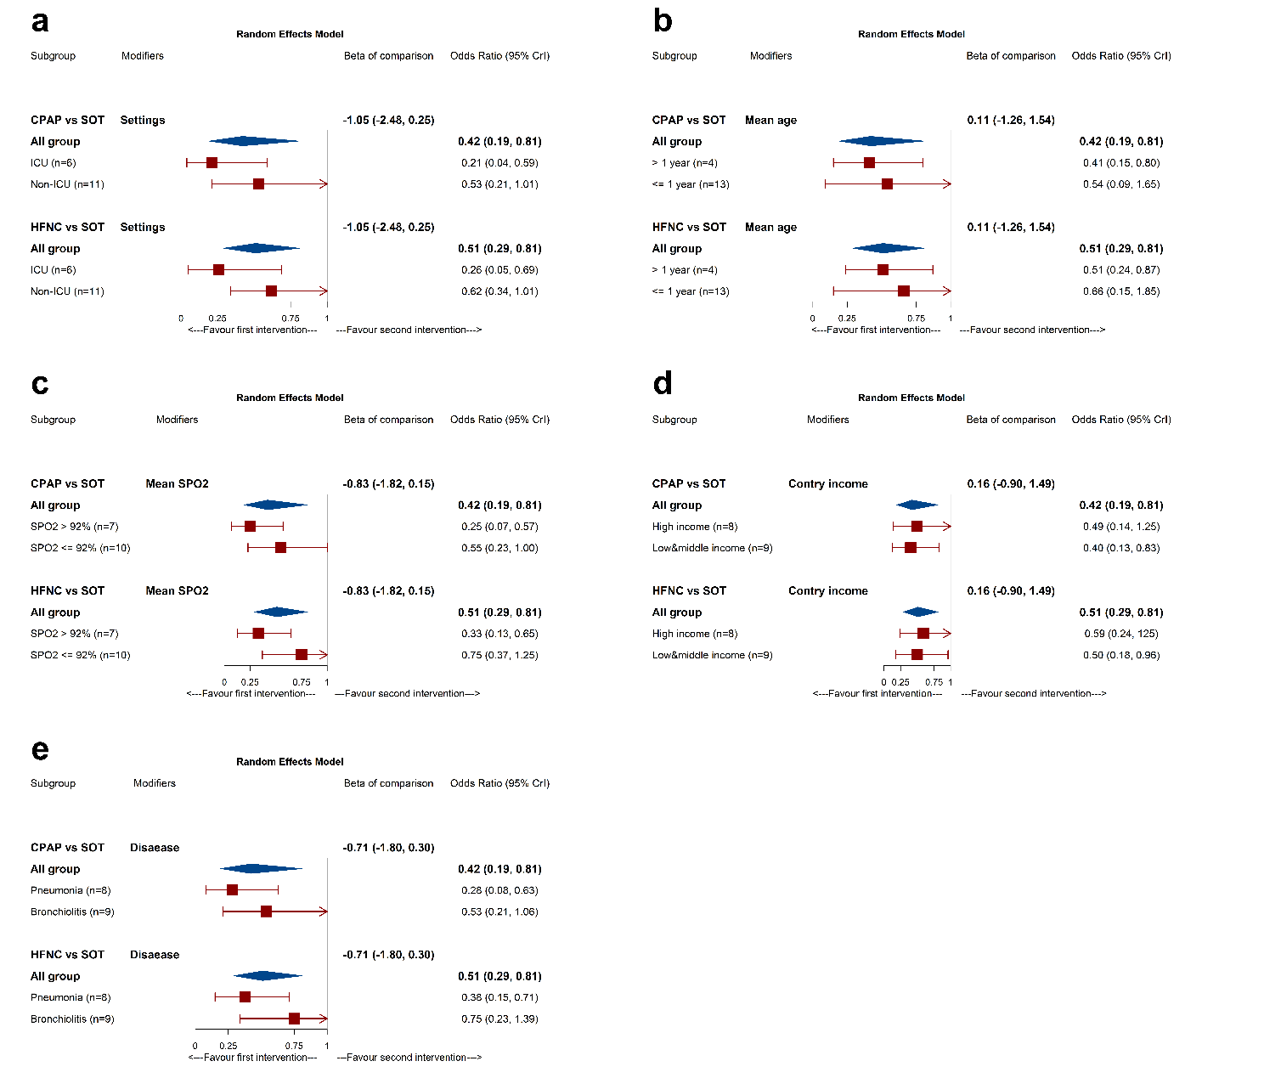

Supplementary Figure 5. Subgroup and network meta-regression analyses for treatment failure compared with SOT.

Subgroup and meta-regression based on: (a) study settings (b) mean age (c) mean SpO₂ (d) contry income and (e) type of disease
* 95% Crls (Cridible intervals) of Beta-coefficient do not include 0 indicates significant subgroup effects.
ORs: odd ratios, 95% Crls (Cridible intervals), CPAP: continuous positive airway pressure, HFNC: high-flow nasal cannula, SOT: standard oxygen therapy
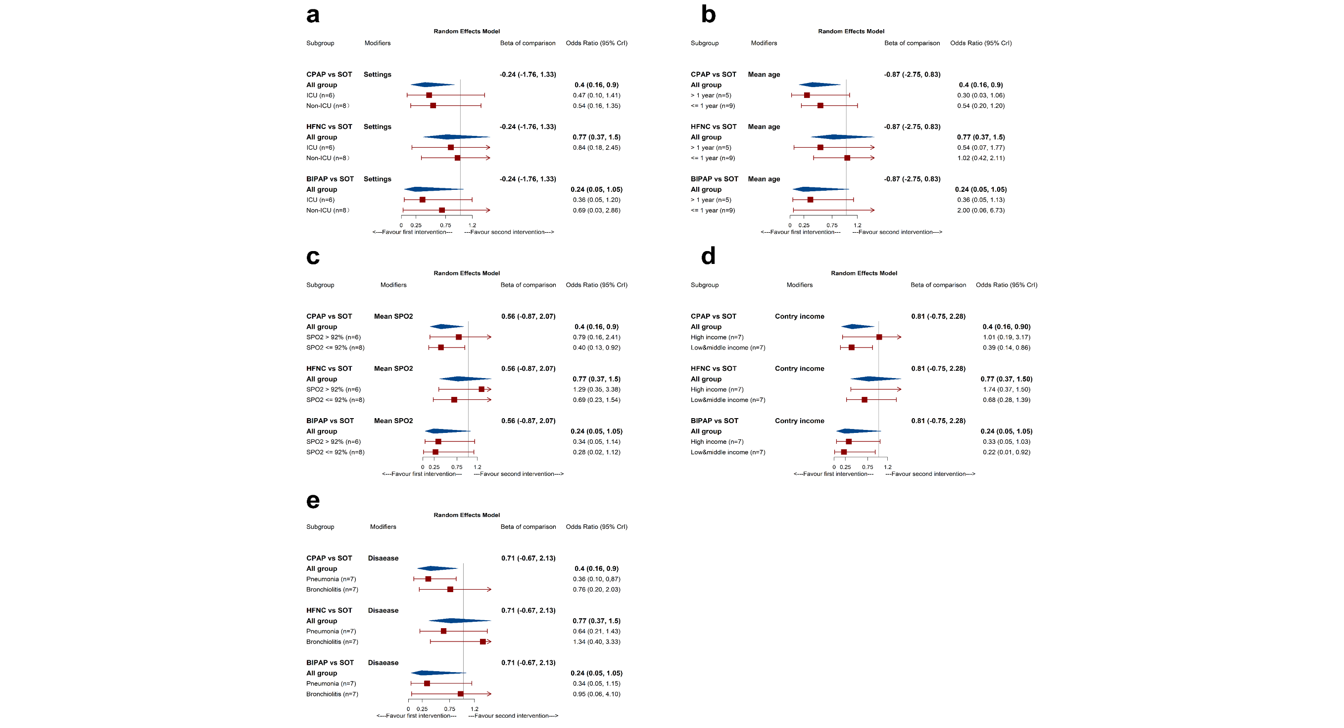

Supplementary Figure 6. Subgroup and network meta-regression analyses for intubation rate compared with SOT.
Subgroup and meta-regression based on: (a) study settings (b) mean age (c) mean SpO₂ (d) contry income and (e) type of disease
* 95% Crls (Cridible intervals) of Beta-coefficient do not include 0 indicates significant subgroup effects.
ORs: odd ratios, 95% Crls (Cridible intervals), BIPAP: bilevel positive airway pressure, CPAP: continuous positive airway pressure, HFNC: high-flow nasal cannula, SOT: standard oxygen therapy

Supplementary Figure 7. Evaluation of the inconsistency heterogeneity for treatment failure by node-splitting method. (a) inconsistency assessments by node-splitting method, (b) heterogeneity assessments

Supplementary Figure 8. Evaluation of the inconsistency heterogeneity for intubation rate by node-splitting method. (a) inconsistency assessments by node-splitting method, (b) heterogeneity assessments

Supplementary Figure 9. Evaluation of the inconsistency heterogeneity for mortality by node-splitting method. (a) inconsistency assessments by node-splitting method, (b) heterogeneity assessments

Supplementary Figure 10. Comparison-adjusted funnel plot. (a) treatment failure, (b) intubation rate. BIPAP: bilevel positive airway pressure, CPAP: continuous positive airway pressure, HFNC: high-flow nasal cannula, SOT: standard oxygen therapy

