Supplementary Material
Supplementary Table 1. Detailed search strategy.
Supplementary Table 2. Details of various studies included in meta-analysis
Supplementary Table 3. Rank probability table for all studies.
Supplementary Table 4. Model diagnostics of the developed consistency model for the outcomes of the study.
Supplementary Table 5. League Table of subgroup analysis (Single tumor studies).
Supplementary Table 6. Rank probability table for subgroup analysis (Single tumor studies).
Supplementary Table 7. League Table of subgroup analysis (Tumor diameter ≤ 3cm).
Supplementary Table 8. Rank probability table for subgroup analysis (Tumor diameter ≤ 3cm).
Supplementary Table 9. The shared beta coefficients and 95% confidence intervals for the three regression parameters.
Supplementary Figure 1. Quality assessment for all studies.
Supplementary Figure 2. Pairwise meta-analysis: LR vs RFA.
Supplementary Figure 3. Pairwise meta-analysis: LR vs RFA+TACE.
Supplementary Figure 4. Pairwise meta-analysis: RFA+TACE vs RFA.
Supplementary Figure 5. Graph of network nodes included in the study.
Supplementary Figure 6. SUCRA plot for all results.
Supplementary Figure 7. To assess publication bias, funnel plots were made for Pairwise meta-analyses involving more than 10 studies.
Supplementary Figure 8. The inconsistencies of all closed-loop structures are detected by the Node-Splitting method. (All studies)
Supplement Figure 9. Hazard ratio (for OS and RFS) along with 95% credible interval (CI) for LR and RFA+TACE compared with RFA for the subgroup analysis (Single tumor studies).
Supplementary Figure 10. The inconsistencies of all closed-loop structures are detected by the Node-Splitting method. (Subgroup analysis for the Single tumor studies)
Supplement Figure 11. Hazard ratio (for OS and RFS) along with 95% credible interval (CI) for LR and RFA+TACE compared with RFA for the subgroup analysis (Tumor diameter ≤ 3cm).
Supplementary Figure 12. The inconsistencies of all closed-loop structures are detected by the Node-Splitting method. (Subgroup analysis for the tumor diameter ≤ 3cm)

Supplementary Table 1. Detailed search strategy.
PUBMED
#1 | "Hepatectomy"[MeSH Terms] OR "surgical procedures, operative"[MeSH Terms] OR "Microsurgery"[MeSH Terms] OR "Hepatectomy"[Title/Abstract] OR "Hepatectomies"[Title/Abstract] OR "hepatic resection"[Title/Abstract] OR "surgical resection"[Title/Abstract] OR "liver surgery"[Title/Abstract] OR "liver resection"[Title/Abstract] OR "Resection"[Title/Abstract] OR "surgery"[Title/Abstract]
#2 | "Radiofrequency Ablation"[MeSH Terms] OR "Radiofrequency Ablation"[Title/Abstract] OR "radio frequency ablation"[Title/Abstract] OR "Ablation"[Title/Abstract] OR "Radiofrequency"[Title/Abstract] OR "rfa therapy"[Title/Abstract] OR "thermal ablation"[Title/Abstract] OR "intervention ablation"[Title/Abstract] OR "interventional ablation"[Title/Abstract] OR "radiological ablation"[Title/Abstract] OR "RFA"[Title/Abstract]
#3 | "chemoembolization, therapeutic"[MeSH Terms] OR ("transcatheter arterial chemoembolization"[Title/Abstract] OR "Embolization"[Title/Abstract] OR "transarterial chemoembolization"[Title/Abstract] OR "transarterial embolization"[Title/Abstract] OR "arterial chemoembolisation"[Title/Abstract] OR "arterial chemoembolization"[Title/Abstract] OR "chemoembolisation"[Title/Abstract] OR "transarterial chemoembolisation"[Title/Abstract] OR "transcatheter arterial chemoembolisation"[Title/Abstract] OR ("Transcatheter"[All Fields] AND "chemoembolisation"[Title/Abstract]) OR "transcatheter chemoembolization"[Title/Abstract] OR ("Transcatheter"[All Fields] AND "oily chemoembolisation"[Title/Abstract]) OR "transcatheter oily chemoembolization"[Title/Abstract]) OR "TACE"[Title/Abstract]
#4 | "carcinoma, hepatocellular"[MeSH Terms] OR "hepatocellular carcinomas"[Title/Abstract] OR "hepatocellular carcinoma"[Title/Abstract] OR "liver cell carcinoma"[Title/Abstract] OR "liver cell carcinomas"[Title/Abstract] OR "hepatic cancer"[Title/Abstract] OR "hepatocellular cancer"[Title/Abstract] OR "hepatic malignancy"[Title/Abstract] OR "hepatic tumor"[Title/Abstract] OR "liver cancer"[Title/Abstract] OR "liver carcinoma"[Title/Abstract] OR "liver malignancy"[Title/Abstract] OR "liver tumor"[Title/Abstract] OR "hepatocellular malignancy"[Title/Abstract] OR "cancer of liver"[Title/Abstract] OR "malignancy of liver"[Title/Abstract] OR "carcinoma of liver"[Title/Abstract] OR "hepatic neoplasm"[Title/Abstract] OR "neoplasm of liver"[Title/Abstract] OR "hepatocellular neoplasm"[Title/Abstract] OR "hepatocellular neoplasia"[Title/Abstract] OR "liver neoplasia"[Title/Abstract] OR "hepatic neoplasia"[Title/Abstract] OR "Hepatoma"[Title/Abstract] OR "Hepatomas"[Title/Abstract] OR "HCC"[Title/Abstract]
#5 | (#1 AND #2 OR (#1 AND #3) OR (#2 AND #3) OR (#1 AND #2 AND #3)) AND #4
#6 | "Randomized Controlled Trial"[Publication Type] OR "Controlled Clinical Trial"[Publication Type] OR "Random Allocation"[MeSH Terms] OR "Comparative Study"[Publication Type] OR "Case-Control Studies"[MeSH Terms] OR "Cohort Studies"[MeSH Terms] OR "Randomized Controlled Trial"[All Fields] OR "randomised controlled study"[All Fields] OR "randomised controlled trial"[All Fields] OR "randomized controlled study"[All Fields] OR "Controlled Clinical Trial"[All Fields] OR "randomized trial"[All Fields] OR "random*"[All Fields] OR "control*"[All Fields] OR "compared"[All Fields] OR "groups"[All Fields] OR "cohort"[All Fields] OR "case control"[All Fields] OR "multivariate"[All Fields] OR "case control*"[All Fields] OR "propensity score"[All Fields] OR "matched"[All Fields] OR "cohort analyses"[All Fields]
#7 | #5 AND #6
EMBASE
#1 | 'liver resection'/exp OR hepatectomy:ti,ab,kw OR hepatectomies:ti,ab,kw OR 'hepatic resection':ti,ab,kw OR 'surgical resection':ti,ab,kw OR 'liver surgery':ti,ab,kw OR 'liver resection':ti,ab,kw OR resection:ti,ab,kw OR surgery:ti,ab,kw
#2 | 'radiofrequency ablation'/exp OR 'radiofrequency ablation':ti,ab,kw OR 'radio frequency ablation':ti,ab,kw OR ablation:ti,ab,kw OR radiofrequency:ti,ab,kw OR 'rfa therapy':ti,ab,kw OR 'thermal ablation':ti,ab,kw OR 'intervention ablation':ti,ab,kw OR 'interventional ablation':ti,ab,kw OR 'radiological ablation':ti,ab,kw OR rfa:ti,ab,kw
#3 | 'chemoembolization'/exp OR 'transcatheter arterial chemoembolization':ti,ab,kw OR embolization:ti,ab,kw OR 'transarterial chemoembolization':ti,ab,kw OR 'transarterial embolization':ti,ab,kw OR 'arterial chemoembolisation':ti,ab,kw OR 'arterial chemoembolization':ti,ab,kw OR chemoembolisation:ti,ab,kw OR 'transarterial chemoembolisation':ti,ab,kw OR 'transcatheter arterial chemoembolisation':ti,ab,kw OR 'transcatheter chemoembolisation':ti,ab,kw OR 'transcatheter chemoembolization':ti,ab,kw OR 'transcatheter oily chemoembolisation':ti,ab,kw OR 'transcatheter oily chemoembolization':ti,ab,kw OR tace:ti,ab,kw
#4 | 'liver cell carcinoma'/exp OR 'hepatocellular carcinomas':ti,ab,kw OR 'hepatocellular carcinoma':ti,ab,kw OR 'liver cell carcinoma':ti,ab,kw OR 'liver cell carcinomas':ti,ab,kw OR 'hepatic cancer':ti,ab,kw OR 'hepatocellular cancer':ti,ab,kw OR 'hepatic malignancy':ti,ab,kw OR 'hepatic tumor':ti,ab,kw OR 'liver cancer':ti,ab,kw OR 'liver carcinoma':ti,ab,kw OR 'liver malignancy':ti,ab,kw OR 'liver tumor':ti,ab,kw OR 'hepatocellular malignancy':ti,ab,kw OR 'cancer of liver':ti,ab,kw OR 'malignancy of liver':ti,ab,kw OR 'carcinoma of liver':ti,ab,kw OR 'hepatic neoplasm':ti,ab,kw OR 'neoplasm of liver':ti,ab,kw OR 'hepatocellular neoplasm':ti,ab,kw OR 'hepatocellular neoplasia':ti,ab,kw OR 'liver neoplasia':ti,ab,kw OR 'hepatic neoplasia':ti,ab,kw OR hepatoma:ti,ab,kw OR hepatomas:ti,ab,kw OR hcc:ti,ab,kw
#5 | (#1 AND #2 OR (#1 AND #3) OR (#2 AND #3) OR (#1 AND #2 AND #3)) AND #4
#6 | 'randomized controlled trial'/exp OR 'controlled clinical trial'/exp OR 'controlled study'/exp OR 'case control study'/exp OR 'cohort analysis'/exp OR 'randomized controlled trial' OR 'randomised controlled study' OR 'randomised controlled trial' OR 'randomized controlled study' OR 'controlled clinical trial' OR 'randomized trial' OR 'random*' OR 'control*' OR 'compared' OR 'groups' OR 'cohort' OR 'case control*' OR 'propensity score' OR 'matched' OR 'cohort analyses'
#7 | #5 AND #6
Cochrane
#1 | MeSH descriptor: [Hepatectomy] explode all trees
#2 | (Hepatectomies):ti,ab,kw OR (hepatic resection):ti,ab,kw OR (liver resection):ti,ab,kw OR (hepatic resection):ti,ab,kw OR (resection):ti,ab,kw
#3 | #1 OR #2
#4 | MeSH descriptor: [Radiofrequency Ablation] explode all trees
#5 | (radio frequency ablation):ti,ab,kw OR (Radiofrequency):ti,ab,kw OR (intervention ablation):ti,ab,kw OR (Radiofrequency Ablation):ti,ab,kw OR (RFA):ti,ab,kw
#6 | #4 OR #5
#7 | MeSH descriptor: [Chemoembolization, Therapeutic] explode all trees
#8 | (transcatheter arterial chemoembolization):ti,ab,kw OR (transarterial chemoembolization):ti,ab,kw OR (Embolization):ti,ab,kw OR (chemoembolization):ti,ab,kw OR (TACE):ti,ab,kw
#9 | #7 OR #8
#10 | MeSH descriptor: [Carcinoma, Hepatocellular] explode all trees
#11 | (hepatocellular carcinomas):ti,ab,kw OR (hepatocellular carcinoma):ti,ab,kw OR (liver cell carcinoma):ti,ab,kw OR (liver cancer):ti,ab,kw OR (HCC):ti,ab,kw
#12 | #10 OR #11
#13 | (#3 AND #6 OR (#3 AND #9) OR (#6 AND #9) OR (#3 AND #6 AND #9)) AND #12

Supplementary Table 2. Details of various studies included in meta-analysis.
Study | Type of study | Year and country | Arm | treatment | No. of  patients | Age (Mean  or Median) | Sex  (M: F) | Follow-up period  (month) | Follow- up methods | Child-Pugh | BCLC | ECOG | HBV  /HCV  /Others | Mean  Tumor size  （cm） | Tumor  number | Overall survival (%) | Recurrence-free survival (%)
Li | PSM | China | LR | NA | 58 | 61.0 | 39:19 | 56.0 | US, CT, MRI, biochemical tests | A:56 | 0:58 | NA | 28/34/NA | 1.90 | 1 | 1year:98.2  3year:88.8  5year:77.7 | 1year:93.0  3year:71.7  5year:57.1
Li | PSM | 2021 | RFA | NA | 58 | 61.0 | 39:19 | 56.0 | US, CT, MRI, biochemical tests | A:57 | 0:58 | NA | 23/27/NA | 1.80 | 1 | 1year:91.4  3year:77.2  5year:60.1 | 1year:91.2  3year:62.0  5year:53.2
Lee | PSM | Korea | LR | laparoscopic | 118 | 59.5 | 91:27 | 30.0 | CT or MRI, biochemical tests | A:118 | NA | NA | 90/10/18 | 1.84 | 1 | NA | 1year:87.0  3year:65.5
Lee | PSM | 2021 | RFA | Percutaneous  (US) | 118 | 60.5 | 88:30 | 28.0 | CT or MRI, biochemical tests | A:118 | NA | NA | 84/12/22 | 1.87 | 1 | NA | 1year:85.1  3year:62.9
Pan | PSM | China | LR | laparoscopic | 118 | 53.0 | 101:17 | 26.2 | NA | A or B | NA | 0 | NA | 2.50 | ≤3 | 1year:97.3  3year:91.0 | 1year:81.5  3year:56.9
Pan | PSM | 2020 | RFA | Percutaneous  (US) | 236 | 56.0 | 206:30 | 24.2 | NA | A or B | NA | 0 | NA | 2.55 | ≤3 | 1year:99.5  3year:79.0 | 1year:62.7  3year:39.9
Chong | PSM | China | LR | laparoscopic or  robotic | 59 | 57.7 | 46:13 | 47.3 | US or CT | A:59  B:0 | 0:23  A:36 | NA | 48/4/- | 2.00 | ≤3 | 1year:94.9  3year:88.2  5year:82.5 | 1year:86.3  3year:68.0  5year:68.0
Chong | PSM | 2020 | RFA | laparoscopic or percutaneous | 59 | 59.3 | 46:13 | 47.3 | US or CT | A:58  B:1 | 0:24  A:35 | NA | 48/4/- | 2.30 | ≤3 | 1year:96.6  3year:78.7  5year:53.3 | 1year:59.3  3year:25.3  5year:15.9
Ye | PSM | China | LR | anatomical or non-  anatomical | 154 | ≤60:103  ＞60:51 | 141:13 | NA | CT or MRI, biochemical tests | A:139  B:15 | NA | NA | 135/2/- | 3-4:113  4-5:41 | 1 | 1year:93.0  3year:63.0  5year:40.0 | 1year:76.0  3year:30.0  5year:15.0
Ye | PSM | 2019 | RFA | Percutaneous  (US) | 154 | ≤60:103  ＞60:51 | 134:20 | NA | CT or MRI, biochemical tests | A:144  B:10 | NA | NA | 134/5/- | 3-4:111  4-5:43 | 1 | 1year:95.0  3year:58.0  5year:34.0 | 1year:72.0  3year:30.0  5year:10.0
Kim. T. H | PSM | Korea | LR | anatomical or non-  anatomical | 48 | 56.2 | 38:10 | 59.1 | CT or MRI, biochemical tests, PET,  X-ray | A:48 | 0:48 | 0:48 | 36/5/7 | 1.57 | 1 | 1year:97.9  3year:88.8  5year:77.0 | 1year:89.6  3year:57.7  5year:54.7
Kim. T. H | PSM | 2019 | RFA | Percutaneous  (US) | 48 | 58.7 | 35:13 | 63.3 | CT or MRI, biochemical tests, PET,  X-ray | A:48 | 0:48 | 0:48 | 34/8/6 | 1.53 | 1 | 1year:97.9  3year:91.6  5year:79.2 | 1year:87.3  3year:50.5  5year:29.9
Lee. H. W | RCT | Korea | LR | anatomical | 29 | 55.6 | 23:6 | 60.0 | CT or MRI, biochemical tests | A:29 | NA | NA | NA | 2-4 | 1 | 3year: 96.6  5year: 83.4 | 3year:66.7  5year:44.4
Lee. H. W | RCT | 2018 | RFA | Percutaneous  (US or CT) | 34 | 56.1 | 24:10 | 60.0 | CT or MRI, biochemical tests | A:34 | NA | NA | NA | 2-4 | 1 | 3year: 97.1  5year: 86.2 | 3year:44.1  5year:31.2
Ng. K.K.C | RCT | China | LR | open approach | 109 | 55.0 | 89:20 | 93.0 | CT  biochemical tests | A:107  B:2 | NA | NA | 99/5/- | 2.90 | ≤3 | 1year: 94.5  3year: 80.6  5year: 66.5 | 1year: 74.1  3year: 50.9  5year: 41.5
Ng. K.K.C | RCT | 2017 | RFA | Percutaneous  (US) | 109 | 57.0 | 86:23 | 93.0 | CT  biochemical tests | A:104  B:5 | NA | NA | 95/0/- | 2.60 | ≤3 | 1year: 95.4  3year: 82.3  5year: 66.4 | 1year: 70.6  3year: 46.6  5year: 33.6
Song | PSM | China | LR | laparoscopic | 78 | 48.0 | 70:8 | 31.2 | US, CT, X-ray, biochemical tests | A:78  B:0 | 0:33  A:45 | 0:76  1:1  2:1 | 73/-/- | ＜4 | 1 | 1year:96.2  3year:84.1 | 1year:82.1  3year:60.0
Song | PSM | 2016 | RFA | Percutaneous  (US) | 78 | 48.0 | 70:8 | 31.2 | US, CT, X-ray, biochemical tests | A:76  B:2 | 0:40  A:38 | 0:75  1:3  2:0 | 77/-/- | ＜4 | 1 | 1year:96.2  3year:78.8 | 1year:65.4  3year:37.6
Liu | PSM | China | LR | anatomical | 79 | 61.0 | 55:24 | 43.0 | NA | A:79 | NA | 0:69  1:10 | 46/31/7 | ≤2 | 1 | 1year:97.0  3year:97.0  5year:80.0 | 1year:92.0  3year:65.0  5year:48.0
Liu | PSM | 2016 | RFA | Percutaneous  (US) | 79 | 63.0 | 52:27 | 44.0 | NA | A:79 | NA | 0:68  1:11 | 36/30/9 | ≤2 | 1 | 1year:97.0  3year:83.0  5year:66.0 | 1year:68.0  3year:36.0  5year:18.0
Kang. T. W | PSM | Korea | LR | non-  anatomical | 99 | 54.0 | 77:22 | 59.7 | CT, X-ray, biochemical tests | A:95  B:4 | 0:46  A:53 | 0 | 83/8/4 | 2.00 | 1 | 3year:92.7  5year:90.2 | 3year:67.1  5year:54.4
Kang. T. W | PSM | 2015 | RFA | Percutaneous  (US) | 99 | 55.0 | 77:22 | 50.9 | CT, X-ray, biochemical tests | A:95  B:4 | 0:50  A:49 | 0 | 83/8/4 | 1.90 | 1 | 3year:95.7  5year:87.2 | 3year:53.3  5year:48.9
Jiang | PSM | China | LR | open approach | 140 | 53.0 | 123:17 | 29.8 | US, CT, MRI, biochemical tests | A:139  B:1 | A:140 | 0 | 129/NA/NA | 2.40 | ≤3 | 1year:95.0  3year:72.9  5year:38.9 | 1year:84.3  3year:52.4  5year:18.9
Jiang | PSM | 2015 | RFA | Percutaneous  laparoscopic  open methods | 140 | 55.0 | 118:22 | 29.8 | US, CT, MRI, biochemical tests | A:135  B:5 | A:140 | 0 | 121/NA/NA | 2.30 | ≤3 | 1year:90.0  3year:74.8  5year:38.9 | 1year:85.0  3year:35.8  5year:10.1
Fang | RCT | China | LR | anatomical or non-  anatomical | 60 | 53.5 | 46:14 | 40.0 | X-ray, CT, MRI, biochemical tests | A:43  B:17 | NA | NA | 52/NA/NA | 2.28 | ≤3 | 1year:93.7  3year:77.5 | 1year:90.4  3year:41.3
Fang | RCT | 2014 | RFA | Percutaneous  (US or CT) | 60 | 51.4 | 42:18 | 40.0 | X-ray, CT, MRI, biochemical tests | A:32  B:23  C:5 | NA | NA | 55/NA/NA | 2.21 | ≤3 | 1year:97.5  3year:82.5 | 1year:91.6  3year:55.4
Pompili | PSM | Italy | LR | anatomical or non-  anatomical | 116 | 67.0 | 87:29 | 41.0 | US, CT, MRI, biochemical tests | A:116 | NA | NA | 11/78/26 | 2.30 | 1 | 1year:95.5  3year:76.0 | NA
Pompili | PSM | 2013 | RFA | NA | 116 | 69.0 | 92:24 | 38.0 | US, CT, MRI, biochemical tests | A:116 | NA | NA | 17/78/21 | 2.30 | 1 | 1year:97.3  3year:78.1 | NA
Feng | RCT | China | LR | anatomical | 84 | 47.0 | 75:9 | 36.0 | X-ray, CT, MRI, biochemical tests | A:43  B:41 | NA | NA | NA | 2.60 | ≤2 | 1year:96.0  3year:74.8 | 1year:90.6  3year:61.1
Feng | RCT | 2012 | RFA | Percutaneous  (US) | 84 | 51.0 | 79:5 | 36.0 | X-ray, CT, MRI, biochemical tests | A:39  B:45 | NA | NA | NA | 2.40 | ≤2 | 1year:93.1  3year:67.2 | 1year:86.2  3year:49.6
Huang | RCT | China | LR | anatomical | 115 | 55.9 | 85:30 | 60.0 | US, CT, MRI, biochemical tests | A:106  B:9 | NA | NA | 104/6/5 | ≤5 | ≤3 | 1year:98.3  3year:92.2  5year:75.7 | 1year:85.2  3year:60.9  5year:51.3
Huang | RCT | 2010 | RFA | Percutaneous  (US) | 115 | 56.6 | 79:36 | 60.0 | US, CT, MRI, biochemical tests | A:110  B:5 | NA | NA | 101/4/10 | ≤5 | ≤3 | 1year:87.0  3year:69.6  5year:54.8 | 1year:81.7  3year:46.1  5year:28.7
Chen | RCT | China | LR | anatomical | 90 | 49.4 | 75:15 | 29.2 | X-ray, CT, MRI, biochemical tests | A:90 | NA | NA | NA | ≤5 | 1 | 1year:93.3  3year:73.4 | 1year: 86.6  3year: 69.0
Chen | RCT | 2006 | RFA | Percutaneous | 71 | 51.9 | 56:15 | 27.9 | X-ray, CT, MRI,  biochemical tests | A:71 | NA | NA | NA | ≤5 | 1 | 1year:95.8  3year:71.4 | 1year: 85.9  3year: 64.1
Lee. H. J | PSM | Korea | LR | anatomical | 26 | 59.6 | 22:4 | 48.4 | CT or MRI, biochemical tests | A:26  B:0 | A:26 | 0 | 13/7/10 | 3.58 | 1 | 1year:96.2  3year:91.3  5year:62.1 | 1year:88.5  3year:48.2  5year:26.8
Lee. H. J | PSM | 2019 | RFA+  TACE | Percutaneous  (US)  C-TACE | 26 | 62.4 | 21:5 | 41.9 | CT or MRI, biochemical tests | A:25  B:1 | A:26 | 0 | 14/6/6 | 3.60 | 1 | 1year:100.0  3year:87.5  5year:56.5 | 1year:100.0  3year:71.2  5year:33.4
Lee. H. J | PSM | Korea | LR | laparoscopic or  Open | 49 | 60.8 | 37:12 | 41.0 | CT or MRI, biochemical tests | A:49 | A:49 | NA | 33/7/8 | 2.47 | 1 | 1year:93.9  3year:86.7  5year:74.6 | 1year:83.7  3year:63.4  5year:45.4
Lee. H. J | PSM | 2017 | RFA+  TACE | NA(US)  C-TACE | 49 | 61.7 | 37:12 | 34.3 | CT or MRI, biochemical tests | A:49 | A:49 | NA | 36/3/7 | 2.55 | 1 | 1year:95.9  3year:87.4  5year:87.4 | 1year:91.7  3year:63.1  5year:55.2
Bholee | PSM | China | LR | anatomical or non-  anatomical | 148 | 52.2 | 136:12 | 50.2 | CT or MRI, biochemical tests | A:144  B:4 | NA | NA | 135/2/NA | 3.00 | ≤3 | 1year:91.2  3year:64.4  5year:47.7 | 1year:68.9  3year:49.2  5year:40.9
Bholee | PSM | 2017 | RFA+  TACE | Percutaneous  (US)  C-TACE | 74 | 54.9 | 68:6 | 56.9 | CT or MRI, biochemical tests | A:70  B:4 | NA | NA | 70/4/NA | 2.90 | ≤3 | 1year:94.6  3year:75.1  5year:55.3 | 1year:87.8  3year:48.3  5year:33.5
H. Liu | RCT | China | LR | anatomical | 100 | 49.0 | 94:6 | 56.0 | X-ray, CT, MRI,  biochemical tests | A:98  B:2 | NA | NA | 90/NA/NA | 3.00 | ≤3 | 1year: 97.0  3year: 83.7  5year: 61.9 | 1year: 94.0  3year:68.2  5year:48.4
H. Liu | RCT | 2016 | RFA+  TACE | Percutaneous  (US)  C-TACE | 100 | 52.0 | 86:14 | 56.0 | X-ray, CT, MRI,  biochemical tests | A:96  B:4 | NA | NA | 87/NA/NA | 2.80 | ≤3 | 1year: 96.0  3year: 67.2  5year: 45.7 | 1year:83.0  3year:44.9  5year:35.5
Takuma | PSM | Japan | LR | anatomical | 75 | 70.0 | 48:27 | 45.0 | US, CT, MRI, biochemical tests | A:69  B:6 | NA | NA | 5/60/NA | 2.30 | ≤3 | 1year:95.0  3year:87.0  5year:75.0 | 1year:79.0  3year:53.0  5year:32.0
Takuma | PSM | 2013 | RFA+  TACE | Percutaneous  (US)  C-TACE | 75 | 70.0 | 56:19 | 45.0 | US, CT, MRI, biochemical tests | A:71  B:4 | N A | NA | 4/62/NA | 2.20 | ≤3 | 1year:99.0  3year:88.0  5year:70.0 | 1year:85.0  3year:35.0  5year:17.0
Zhang | RCT | China | RFA | Percutaneous  (US) | 95 | 55.3 | 71:24 | 50.0 | X-ray, CT, US, biochemical tests | A:90  B:5 | NA | 0 | 83/6/NA | 3.39 | ≤3 | 1year:85.4  3year:57.9  5year:43.2 | 1year:64.2  3year:37.9  5year:27.4
Zhang | RCT | 2021 | RFA+  TACE | Percutaneous  (US)  C-TACE | 94 | 53.3 | 75:19 | 56.0 | X-ray, CT, US, biochemical tests | A:90  B:4 | NA | 0 | 85/6/NA | 3.47 | ≤3 | 1year:94.9  3year:69.1  5year:52.0 | 1year:78.7  3year:54.3  5year:41.4
Morimoto | RCT | Japan | RFA | Percutaneous  (US) | 18 | 73.0 | 12:6 | 32.0 | CT, US, biochemical tests | A:16  B:2 | NA | 0:12  1:6 | 0/16/2 | 3.70 | 1 | 1year:89.0  3year:80.0  5year:69.0 | NA
Morimoto | RCT | 2010 | RFA+  TACE | Percutaneous  (US)  C-TACE | 19 | 70.0 | 15:4 | 30.0 | CT, US, biochemical tests | A:18  B:1 | NA | 0:12  1:7 | 0/17/2 | 3.60 | 1 | 1year:100.0  3year:93.0  5year:68.0 | NA
Shibata | RCT | Japan | RFA | Percutaneous  (US or CT) | 43 | 69.8 | 33:10 | 30.4 | CT,  biochemical tests | A:33  B:10 | NA | NA | 9/30/NA | 1.60 | ≤3 | 1year: 100.0  3year: 84.5 | 1year: 74.3  3year: 29.7
Shibata | RCT | 2009 | RFA+  TACE | Percutaneous  (US or CT)  C-TACE | 46 | 67.2 | 31:15 | 30.4 | CT,  biochemical tests | A:32  B:14 | NA | NA | 12/32/NA | 1.70 | ≤3 | 1year: 100.0  3year: 84.8 | 1year: 71.3  3year: 48.8

Supplementary Table 3. Rank probability table for all studies.
 | Treatment | Rank 1 | Rank 2 | Rank 3 | SUCRA
OS at 1 year | LR | 0.04 | 0.69 | 0.28 | 0.38
OS at 1 year | RFA | 0.02 | 0.28 | 0.70 | 0.16
OS at 1 year | RFA+TACE | 0.94 | 0.04 | 0.02 | 0.96
OS at 3 years | LR | 0.57 | 0.42 | 0.01 | 0.78
OS at 3 years | RFA | 0.01 | 0.13 | 0.87 | 0.07
OS at 3 years | RFA+TACE | 0.42 | 0.46 | 0.12 | 0.65
OS at 5 years | LR | 0.68 | 0.32 | 0.01 | 0.84
OS at 5 years | RFA | 0.01 | 0.09 | 0.90 | 0.05
OS at 5 years | RFA+TACE | 0.32 | 0.59 | 0.09 | 0.61
RFS at 1 year | LR | 0.22 | 0.77 | 0.01 | 0.61
RFS at 1 year | RFA | 0.00 | 0.03 | 0.97 | 0.01
RFS at 1 year | RFA+TACE | 0.77 | 0.21 | 0.02 | 0.88
RFS at 3 years | LR | 0.79 | 0.21 | 0.00 | 0.89
RFS at 3 years | RFA | 0.00 | 0.05 | 0.95 | 0.02
RFS at 3 years | RFA+TACE | 0.21 | 0.74 | 0.05 | 0.58
RFS at 5 years | LR | 0.83 | 0.17 | 0.00 | 0.91
RFS at 5 years | RFA | 0.00 | 0.03 | 0.97 | 0.02
RFS at 5 years | RFA+TACE | 0.17 | 0.79 | 0.03 | 0.57

Supplementary Table 4. Model diagnostics of the developed consistency model for the outcomes of the study.
Outcome | Residual deviance (Dbar) | Leverage (PD) | Deviance Information Criterion (DIC) | Number of data points | I²
OS at 1 year | 20.4 | 6.33 | 26.71 | 22 | 0%
OS at 3 years | 24.7 | 12.9 | 37.6 | 24 | 7%
OS at 5 years | 17.6 | 9.5 | 27.1 | 17 | 9%
RFS at 1 year | 23.0 | 12.3 | 35.3 | 21 | 13%
RFS at 3 years | 24.8 | 15.1 | 39.8 | 23 | 11%
RFS at 5 years | 18.1 | 11.5 | 29.6 | 16 | 17%

Supplementary Table 5. League Table of subgroup analysis (Single tumor studies).
 | Treatment | LR | RFA | RFA+TACE
OS at 1 year | LR vs | NA | 1.12(0.52,2.21) | 2.25(0.38,13.77)
 | RFA vs | 0.90 (0.45, 1.92) | NA | 2.02(0.32,13.79)
 | RFA+TACE vs | 0.44 (0.07, 2.60) | 0.50 (0.07, 3.11) | NA
OS at 3 years | LR vs | NA | 0.82 (0.56, 1.14) | 1.12 (0.44, 2.99)
 | RFA vs | 1.22 (0.88, 1.79) | NA | 1.36 (0.52, 3.85)
 | RFA+TACE vs | 0.90 (0.33, 2.26) | 0.74 (0.26, 1.92) | NA
OS at 5 years | LR vs | NA | 0.78 (0.55, 1.12) | 1.14 (0.58, 2.20)
 | RFA vs | 1.29 (0.89, 1.83) | NA | 1.46 (0.72, 2.97)
 | RFA+TACE vs | 0.88 (0.45, 1.72) | 0.68 (0.34, 1.39) | NA
RFS at 1 year | LR vs | NA | 0.65 (0.39, 1.06) | 2.52(0.61,11.57)
 | RFA vs | 1.53 (0.94, 2.59) | NA | 3.87(0.86,19.59)
 | RFA+TACE vs | 0.40 (0.09, 1.65) | 0.26 (0.05, 1.16) | NA
RFS at 3 years | LR vs | NA | 0.70 (0.53, 0.90) | 1.34 (0.68, 2.72)
 | RFA vs | 1.42 (1.11, 1.88) | NA | 1.91 (0.93, 4.12)
 | RFA+TACE vs | 0.75 (0.37, 1.48) | 0.52 (0.24, 1.08) | NA
RFS at 5 years | LR vs | NA | 0.68 (0.49, 0.93) | 1.27 (0.68, 2.34)
 | RFA vs | 1.46 (1.07, 2.04) | NA | 1.85 (0.92, 3.72)
 | RFA+TACE vs | 0.79 (0.43, 1.48) | 0.54 (0.27, 1.08) | NA

Supplementary Table 6. Rank probability table for subgroup analysis (Single tumor studies).
 | Treatment | Rank1 | Rank2 | Rank3 | SUCRA
OS at 1 year | LR | 0.07 | 0.40 | 0.52 | 0.27
OS at 1 year | RFA | 0.17 | 0.51 | 0.32 | 0.42
OS at 1 year | RFA+TACE | 0.76 | 0.09 | 0.15 | 0.80
OS at 3 years | LR | 0.37 | 0.57 | 0.06 | 0.65
OS at 3 years | RFA | 0.04 | 0.28 | 0.68 | 0.18
OS at 3 years | RFA+TACE | 0.58 | 0.16 | 0.26 | 0.66
OS at 5 years | LR | 0.34 | 0.61 | 0.05 | 0.64
OS at 5 years | RFA | 0.03 | 0.16 | 0.81 | 0.11
OS at 5 years | RFA+TACE | 0.64 | 0.22 | 0.14 | 0.75
RFS at 1 year | LR | 0.09 | 0.87 | 0.03 | 0.53
RFS at 1 year | RFA | 0.01 | 0.06 | 0.93 | 0.04
RFS at 1 year | RFA+TACE | 0.90 | 0.07 | 0.04 | 0.93
RFS at 3 years | LR | 0.19 | 0.80 | 0.00 | 0.59
RFS at 3 years | RFA | 0.00 | 0.04 | 0.96 | 0.02
RFS at 3 years | RFA+TACE | 0.81 | 0.16 | 0.04 | 0.88
RFS at 5 years | LR | 0.21 | 0.78 | 0.01 | 0.60
RFS at 5 years | RFA | 0.00 | 0.04 | 0.96 | 0.02
RFS at 5 years | RFA+TACE | 0.79 | 0.17 | 0.04 | 0.88

Supplementary Table 7. League Table of subgroup analysis (Tumor diameter ≤ 3cm).
 | Treatment | LR | RFA | RFA+TACE
OS at 1 year | LR vs | NA | 0.97 (0.56, 1.77) | 1.46 (0.61, 3.57)
OS at 1 year | RFA vs | 1.03 (0.56,1.80) | NA | 1.52 (0.53, 4.22)
OS at 1 year | RFA+TACE vs | 0.68 (0.28,1.64) | 0.66 (0.24,1.90) | NA
OS at 3 years | LR vs | NA | 0.81 (0.56,1.14) | 0.91 (0.53, 1.57)
OS at 3 years | RFA vs | 1.23 (0.88,1.79) | NA | 1.13 (0.61, 2.13)
OS at 3 years | RFA+TACE vs | 1.09 (0.64,1.89) | 0.89 (0.47,1.63) | NA
OS at 5 years | LR vs | NA | 0.71 (0.46,1.07) | 0.98 (0.58, 1.76)
OS at 5 years | RFA vs | 1.40 (0.94,2.19) | NA | 1.37 (0.72, 2.92)
OS at 5 years | RFA+TACE vs | 1.02 (0.57,1.72) | 0.73 (0.34,1.39) | NA
RFS at 1 year | LR vs | NA | 0.66 (0.42,1.06) | 1.12 (0.55, 2.22)
 | RFA vs | 1.51 (0.95,2.39) | NA | 1.68 (0.77, 3.62)
 | RFA+TACE vs | 0.89 (0.45,1.81) | 0.59 (0.28,1.30) | NA
RFS at 3 years | LR vs | NA | 0.66 (0.51,0.85) | 0.77 (0.52, 1.16)
 | RFA vs | 1.51 (1.18,1.95) | NA | 1.17 (0.76, 1.84)
 | RFA+TACE vs | 1.29 (0.86,1.91) | 0.85 (0.54,1.32) | NA
RFS at 5 years | LR vs | NA | 0.59 (0.39,0.86) | 0.81 (0.49, 1.38)
 | RFA vs | 1.70 (1.17,2.55) | NA | 1.39 (0.74, 2.71)
 | RFA+TACE vs | 1.23 (0.72,2.03) | 0.72 (0.37,1.35) | NA

Supplementary Table 8. Rank probability table for subgroup analysis (Tumor diameter ≤ 3cm).

 | Treatment | Rank1 | Rank2 | Rank3 | SUCRA
OS at 1 year | LR | 0.10 | 0.52 | 0.37 | 0.36
OS at 1 year | RFA | 0.16 | 0.35 | 0.49 | 0.33
OS at 1 year | RFA+TACE | 0.74 | 0.13 | 0.13 | 0.80
OS at 3 years | LR | 0.58 | 0.38 | 0.04 | 0.77
OS at 3 years | RFA | 0.07 | 0.30 | 0.63 | 0.22
OS at 3 years | RFA+TACE | 0.35 | 0.32 | 0.33 | 0.51
OS at 5 years | LR | 0.52 | 0.46 | 0.02 | 0.75
OS at 5 years | RFA | 0.03 | 0.14 | 0.83 | 0.10
OS at 5 years | RFA+TACE | 0.46 | 0.40 | 0.15 | 0.65
RFS at 1 year | LR | 0.36 | 0.62 | 0.03 | 0.66
RFS at 1 year | RFA | 0.02 | 0.09 | 0.89 | 0.06
RFS at 1 year | RFA+TACE | 0.63 | 0.29 | 0.08 | 0.77
RFS at 3 years | LR | 0.90 | 0.10 | 0.00 | 0.95
RFS at 3 years | RFA | 0.00 | 0.22 | 0.78 | 0.11
RFS at 3 years | RFA+TACE | 0.09 | 0.68 | 0.22 | 0.44
RFS at 5 years | LR | 0.80 | 0.19 | 0.00 | 0.90
RFS at 5 years | RFA | 0.00 | 0.13 | 0.87 | 0.07
RFS at 5 years | RFA+TACE | 0.19 | 0.68 | 0.13 | 0.53

Supplementary Table 9. The shared beta coefficients and 95% confidence intervals for the three regression parameters.

Model | Covariate | Outcome | Input standardisation | Centering value | Beta(95%CI)
Regression model | Study type | OS at 1 year | (Type - 0.41) / 1 | 0.41 | -0.32(-1.20-0.56)
Regression model | Study type | OS at 3 years | (Type - 0.42) / 1 | 0.42 | -0.02(-0.56-0.54)
Regression model | Study type | OS at 5 years | (Type - 0.35) / 1 | 0.35 | 0.06(-0.46-0.63)
Regression model | Study type | RFS at 1 year | (Type - 0.38) / 1 | 0.38 | 0.43(-0.15-1.02)
Regression model | Study type | RFS at 3 years | (Type - 0.39) / 1 | 0.39 | 0.15(-0.22-0.54)
Regression model | Study type | RFS at 5 years | (Type - 0.31) / 1 | 0.31 | 0.07(-0.43-0.60)
Regression model | year | OS at 1 year | (Year-2015.45) / 8.34 | 2015.45 | 0.18(-0.66-1.04)
Regression model | year | OS at 3 years | (Year-2015.54)/ 8.04 | 2015.54 | -0.07(-0.57-0.43)
Regression model | year | OS at 5 years | (Year-2016.65) / 6.63 | 2016.65 | 0.01(-0.49-0.48)
Regression model | year | RFS at 1 year | (Year-2016.10) / 8.39 | 2016.10 | -0.32(-0.85-0.21)
Regression model | year | RFS at 3 years | (Year-2016.13) / 8.05 | 2016.13 | -0.06(-0.41-0.29)
Regression model | year | RFS at 5 years | (Year-2017.06) / 5.86 | 2017.06 | -0.03(-0.50-0.42)
Regression model | Sample size | OS at 1 year | (Sample size- 84.77) / 75.40 | 84.77 | 0.03(-1.00-1.07)
Regression model | Sample size | OS at 3 years | (Sample size- 83.04) / 75.86 | 83.04 | 0.09(-0.54-0.71)
Regression model | Sample size | OS at 5 years | (Sample size- 82.41) / 84.85 | 82.41 | 0.20(-0.38-0.71)
Regression model | Sample size | RFS at 1 year | (Sample size- 88.00) / 71.32 | 88.00 | 0.17(-0.53-0.83)
Regression model | Sample size | RFS at 3 years | (Sample size- 85.91) / 72.53 | 85.91 | 0.23(-0.17-0.62)
Regression model | Sample size | RFS at 5 years | (Sample size- 86.38) / 80.87 | 86.38 | 0.34(-0.15-0.80)

Supplementary Figure 1. Quality assessment for all studies.
A: Risk of bias of randomized controlled trials.
B: Risk of bias of cohort studies.
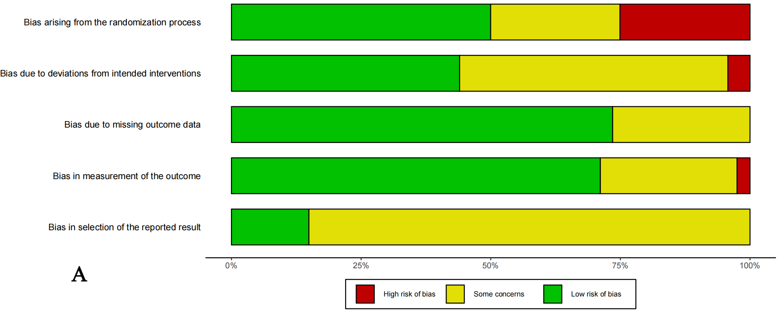
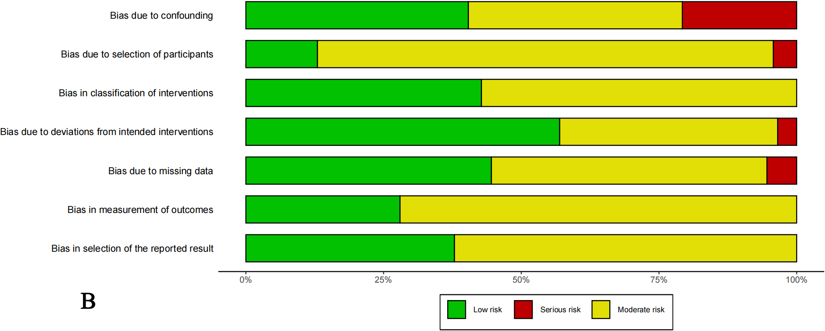

Supplementary Figure 2. Pairwise meta-analysis: LR vs RFA.
A: 1, 3, and 5-year Overall survival.
B: 1, 3, and 5-year Recurrence-free survival.
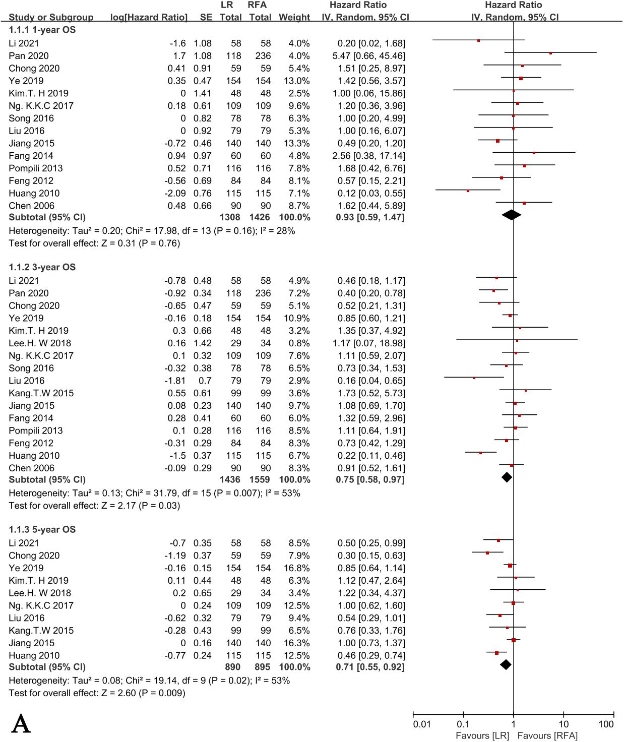

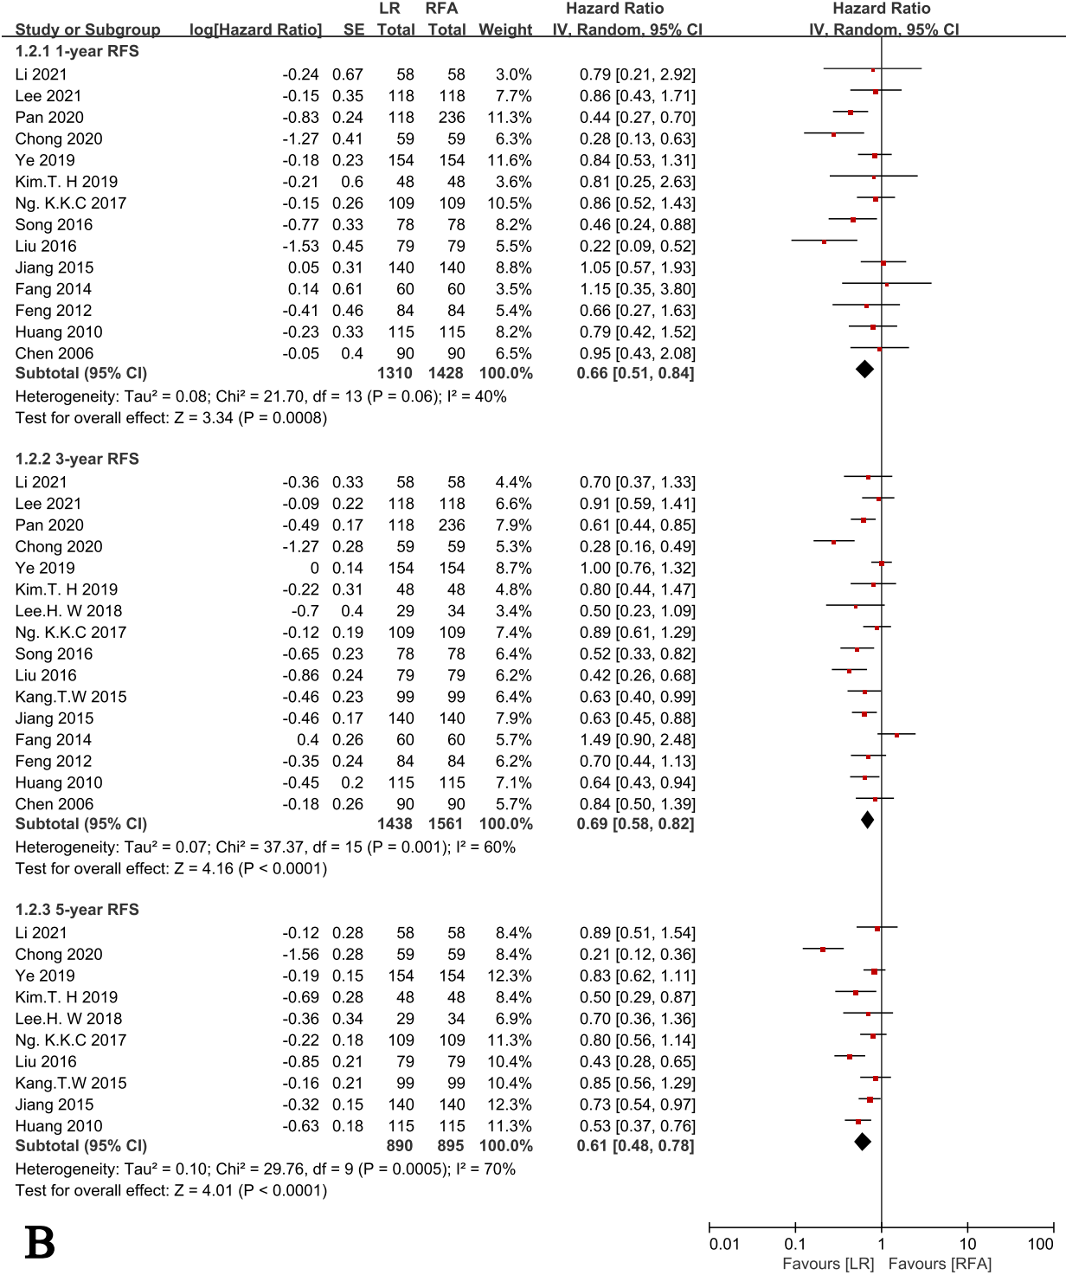

Supplementary Figure 3. Pairwise meta-analysis: LR vs RFA+TACE.
A: 1, 3, and 5-year Overall survival.
B: 1, 3, and 5-year Recurrence-free survival.
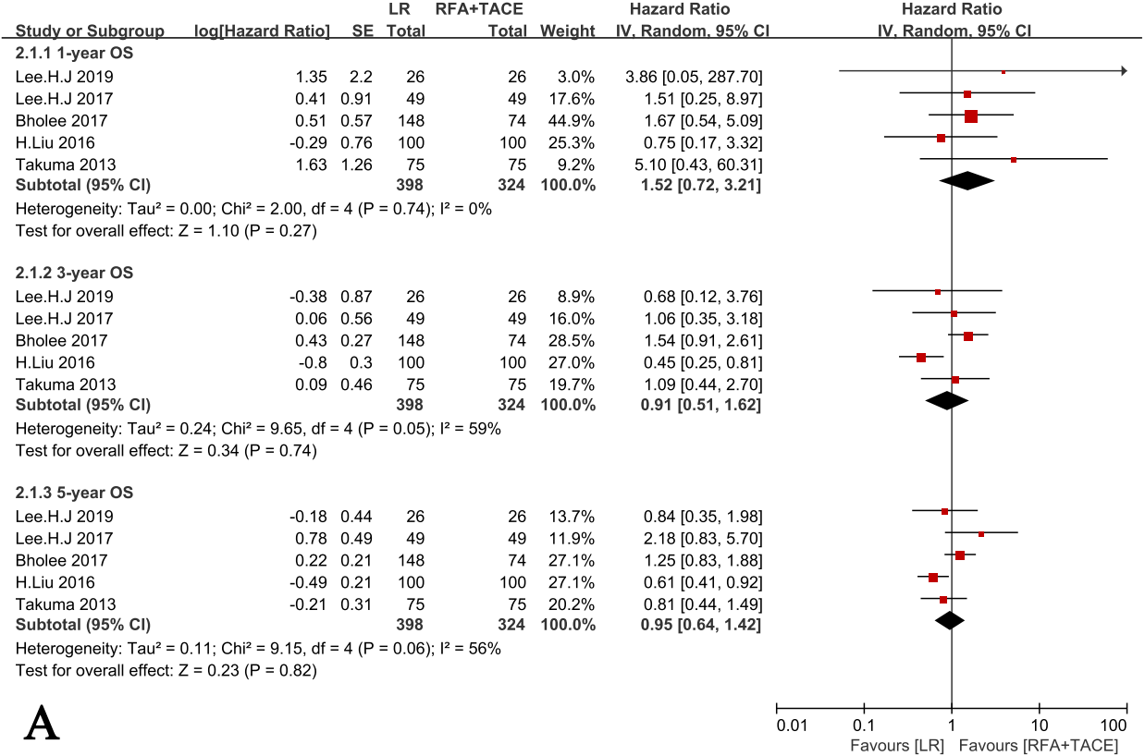

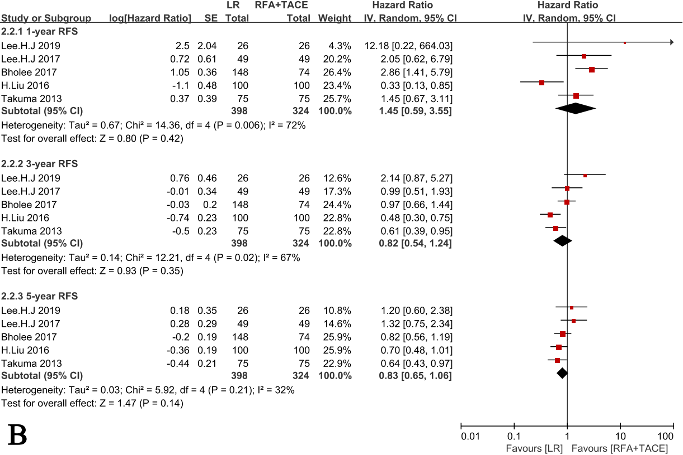

Supplementary Figure 4. Pairwise meta-analysis: RFA+TACE vs RFA.
A: 1, 3, and 5-year Overall survival.
B: 1, 3, and 5-year Recurrence-free survival.
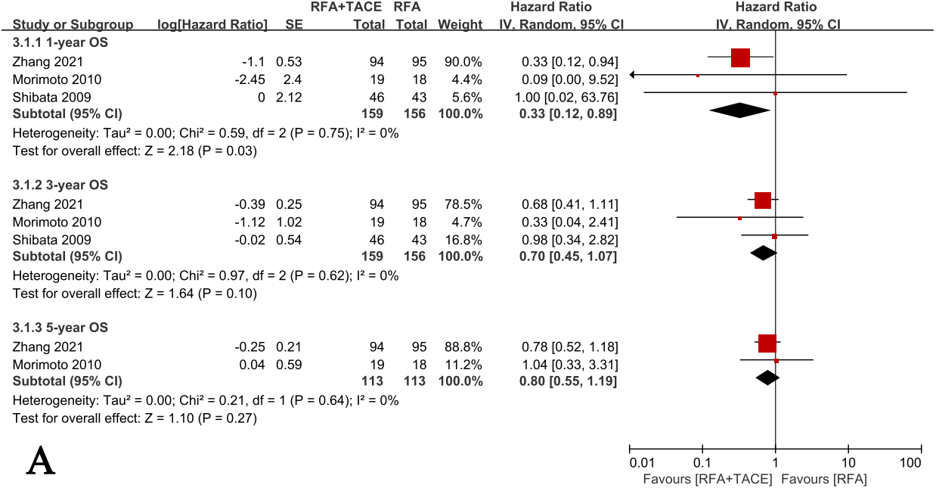
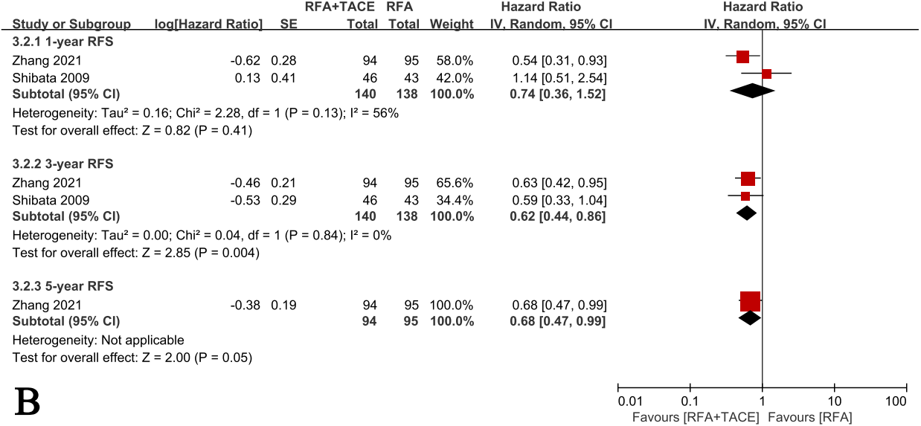

Supplementary Figure 5: Graph of network nodes included in the study, the circles represent interventions, and the line thickness between the two treatment nodes indicates the number of comparative studies.
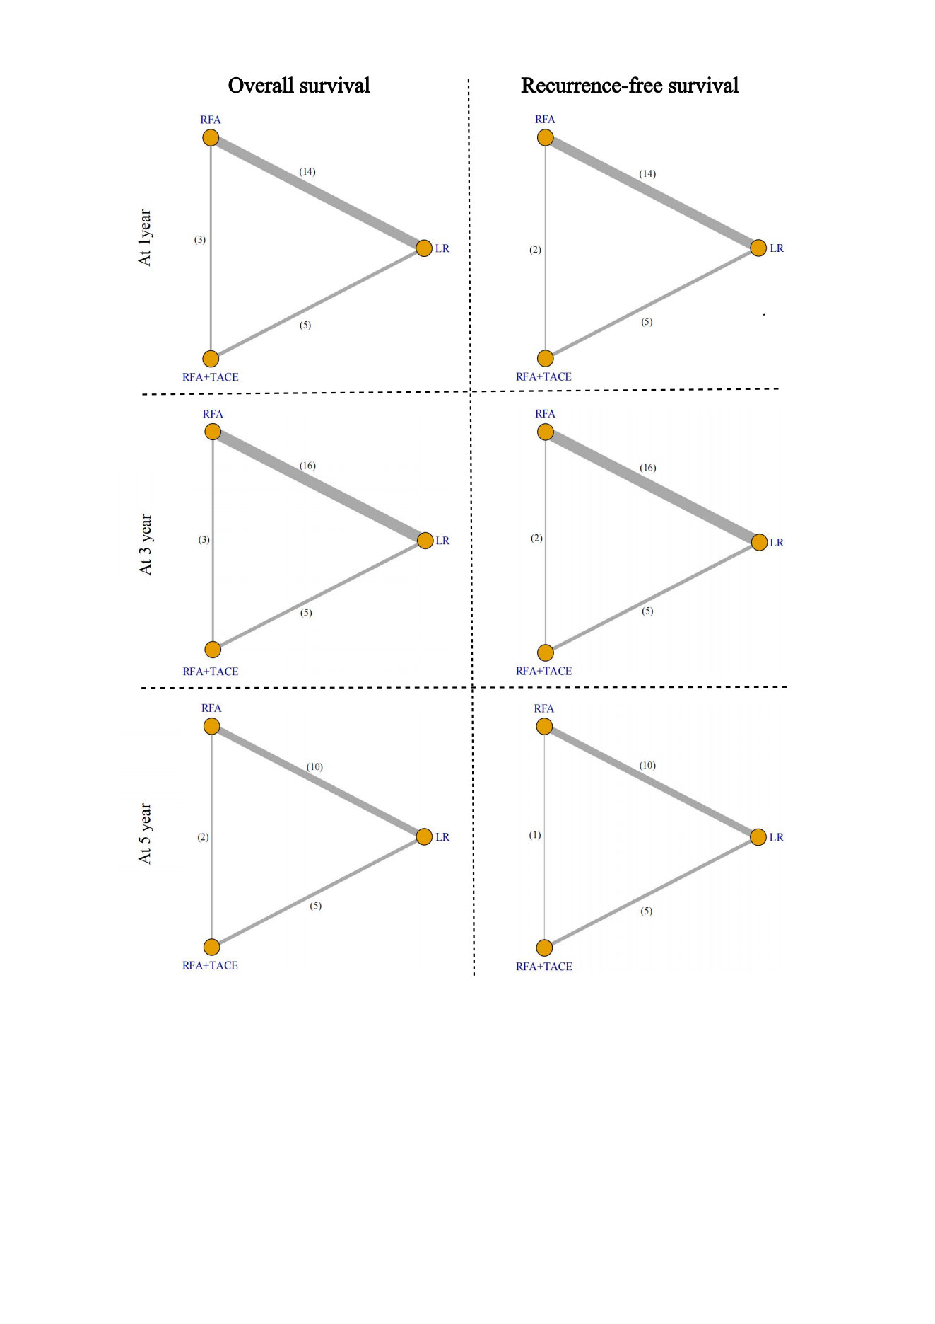

Supplementary Figure 6. SUCRA plot for all results.
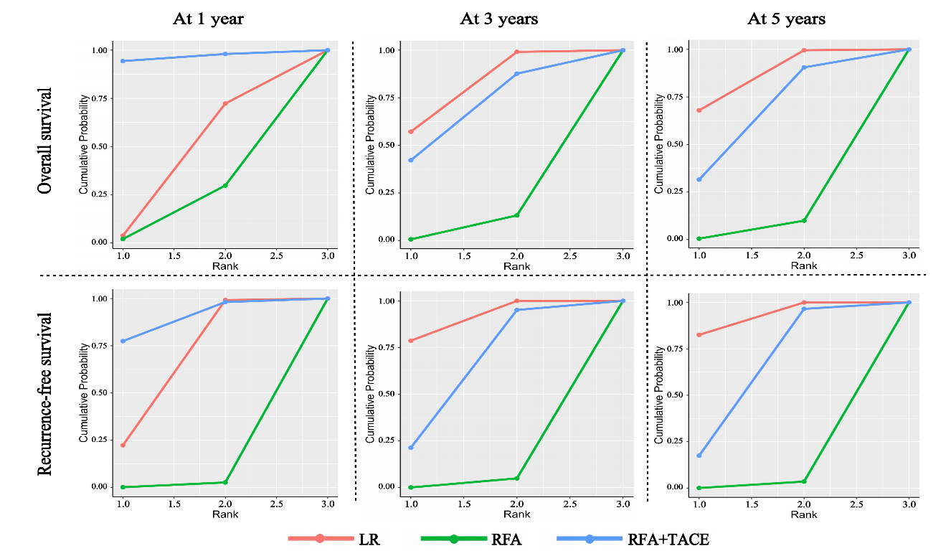

Supplementary Figure 7. To assess publication bias, funnel plots were made for Pairwise meta-analyses involving more than 10 studies.
A: Funnel plots (LR vs RFA): 1, 3, and 5-year Overall survival.
B: Funnel plots (LR vs RFA): 1, 3, and 5-year Recurrence-free survival.
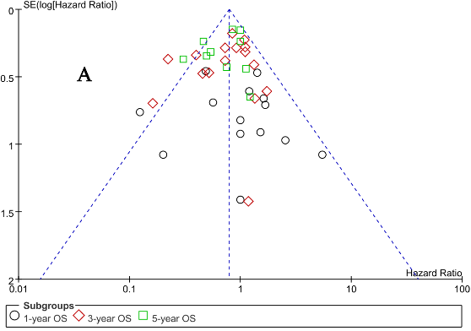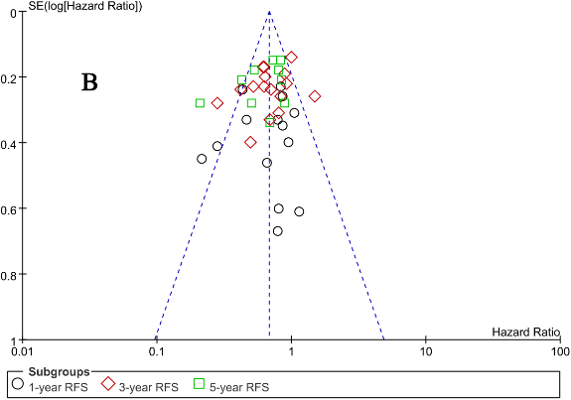

Supplementary Figure 8. The inconsistencies of all closed-loop structures are detected by the Node-Splitting method. (All studies)
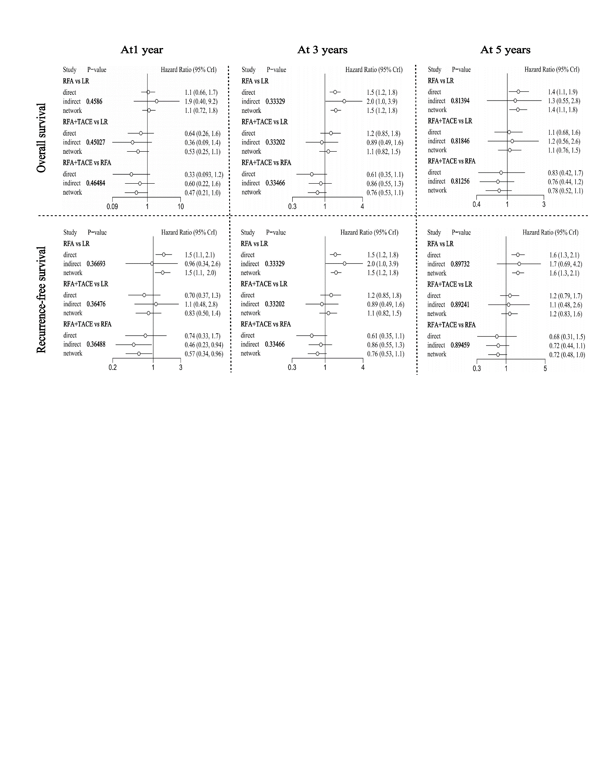

Supplement Figure 9. Hazard ratio (for OS and RFS) along with 95% credible interval (CI) for LR and RFA+TACE compared with RFA for the subgroup analysis (Single tumor studies).
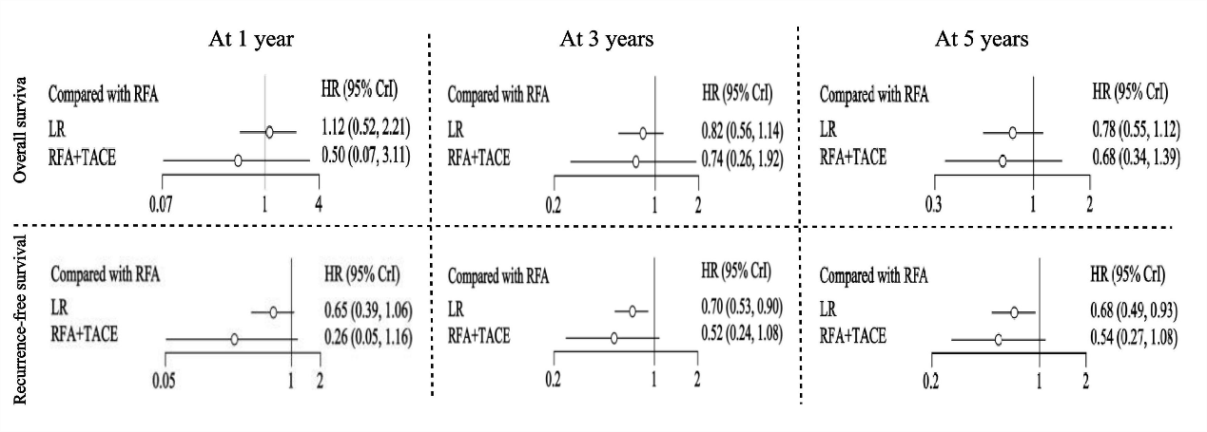

Supplementary Figure 10. The inconsistencies of all closed-loop structures are detected by the Node-Splitting method. (Subgroup analysis for the Single tumor studies)
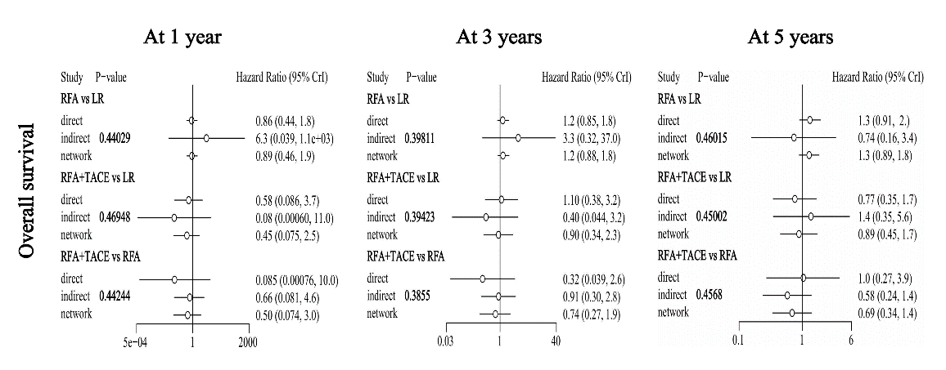
Supplement Figure 11. Hazard ratio (for OS and RFS) along with 95% credible interval (CI) for LR and RFA+TACE compared with RFA for the subgroup analysis (Tumor diameter ≤ 3cm).
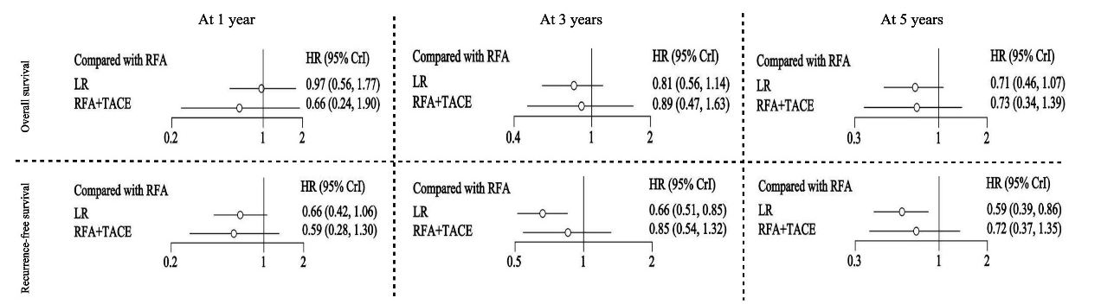

Supplementary Figure 12. The inconsistencies of all closed-loop structures are detected by the Node-Splitting method. (Subgroup analysis for the tumor diameter ≤ 3cm)


