Supplementary Information
Sensitivity analyses.
WAIST CIRCUMFERENCE
Follow up duration:
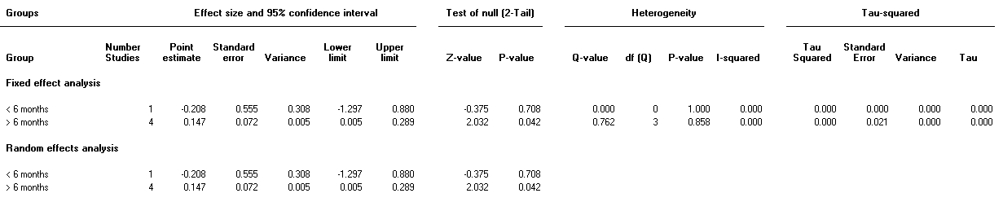
Exercise in intervention yes/no:
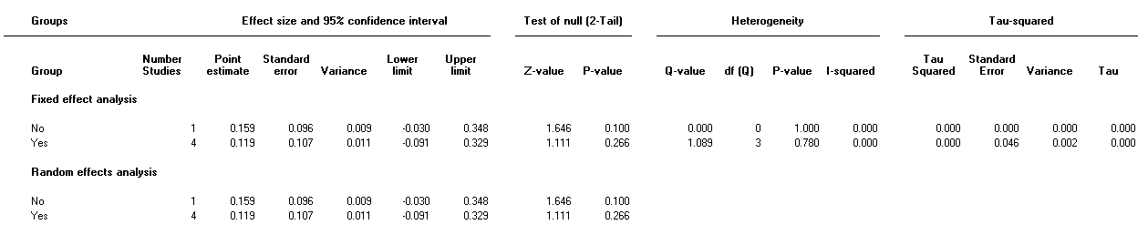

Sample size >75 = big:
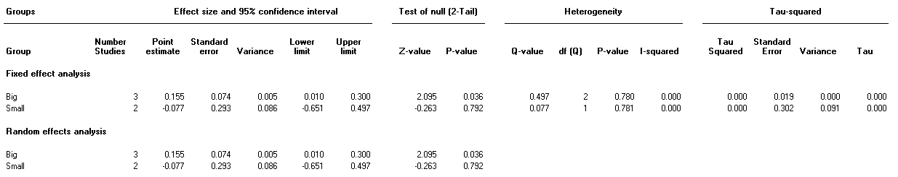
BMI
Follow up duration:
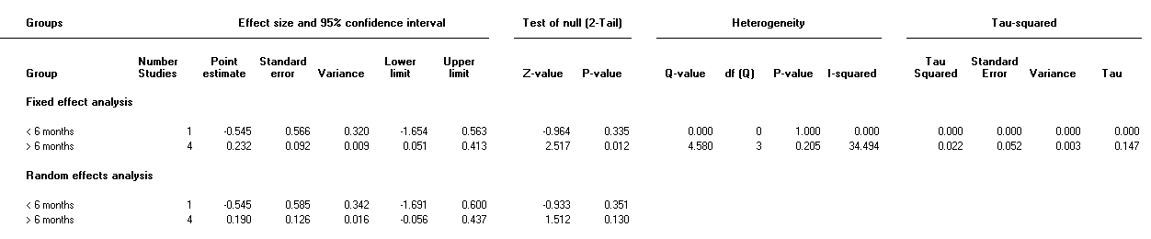

Exercise in intervention yes/no
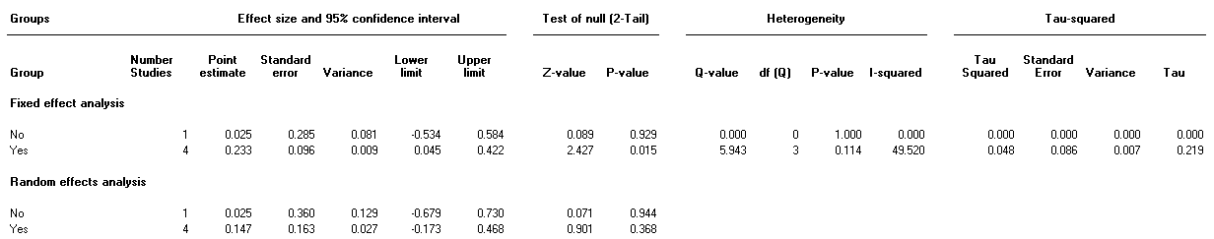

Sample size >75 = big:
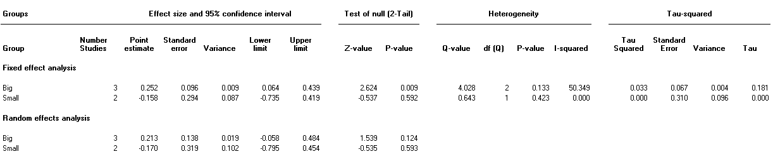

WEIGHT
Follow up duration:
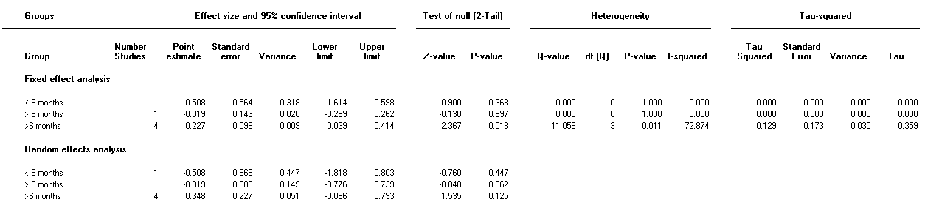
Exercise in intervention yes/no:
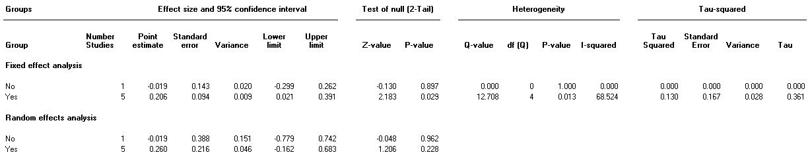

Sample size, >75 = big:
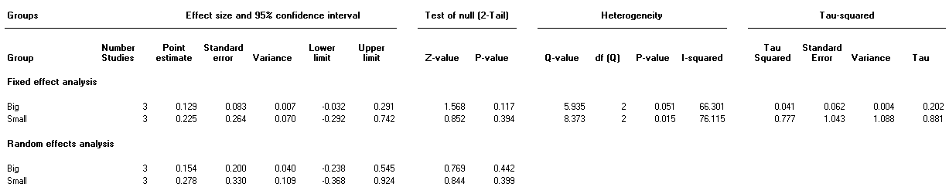
BLOOD PRESSURE SYSTOLIC
Follow up duration:
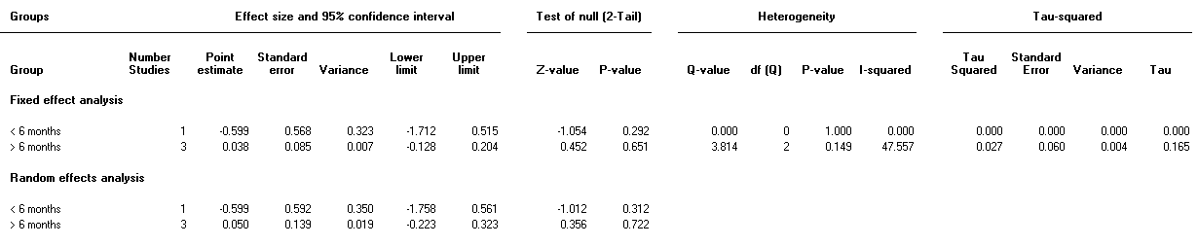

Exercise in intervention yes/no:
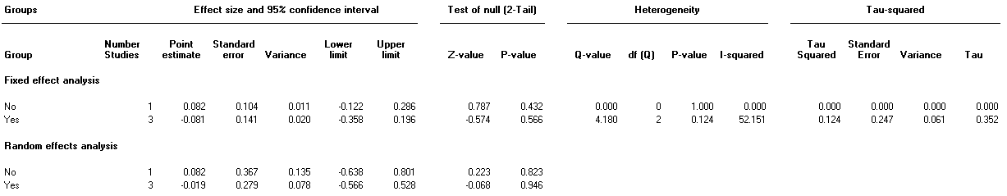

Sample size. > 75 = big:
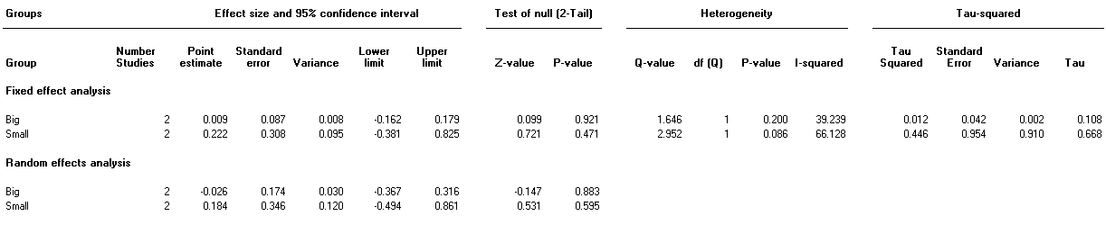

TRIGLYCERIDES
Follow up duration: all included studies had a long follow up duration, so no sensitivity analysis has been performed.
Sample size. >75 =big:
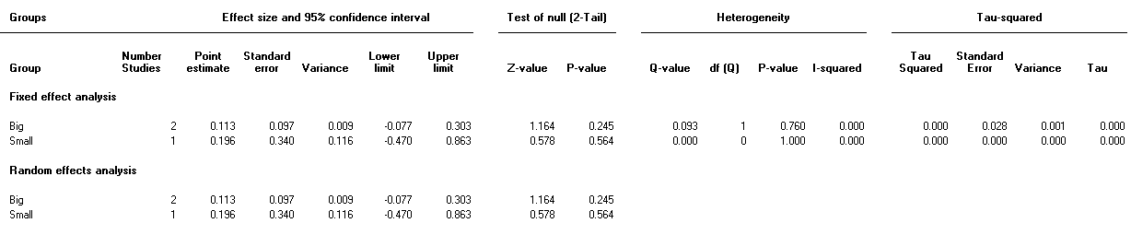
Exercise in intervention yes/no:
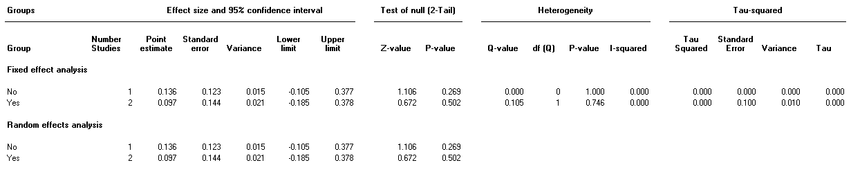

HDL
Follow up duration: all included studies had a long follow up duration, so no sensitivity analysis has been performed.
Exercise in intervention yes/no:
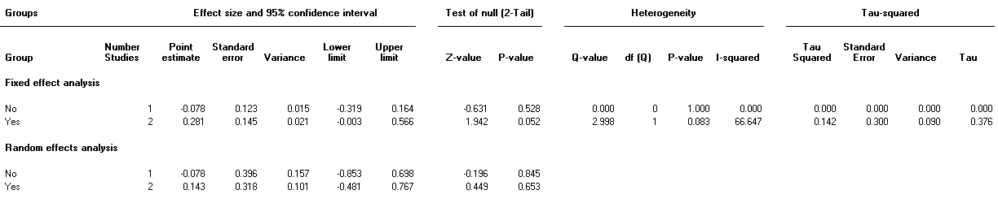
Sample size. > 75 = big:
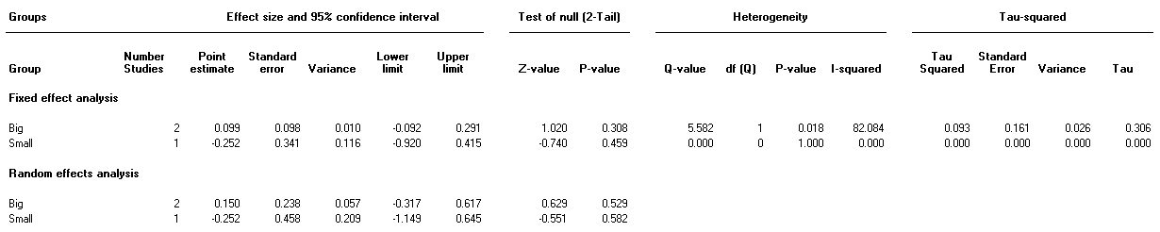

METABOLIC RISK
Follow up duration: all included studies had a long follow up duration, so no sensitivity analysis has been performed.
Exercise in intervention yes/no:
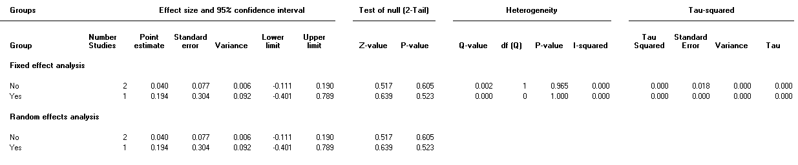
Sample size. >75 = big:


