Search strategy

PubMed:
((((((type 2 diabetes) OR (Type 2 Diabetes Mellitus)) OR (Diabetes Mellitus, Type II)) OR (Diabetes, Type 2)) OR (Diabetes Mellitus, Type 2[MeSH Terms])) AND (((((((Dulaglutide) OR (Albiglutide)) OR (Semaglutide)) OR (GLP-1)) OR (Exenatide[MeSH Terms])) OR (Liraglutide[MeSH Terms])) OR (Glucagon-Like Peptide 1[MeSH Terms]))) AND ((((Dementia[MeSH Terms]) OR (Cognitive Dysfunction[MeSH Terms])) OR (Cognition[MeSH Terms])) OR ((((cognitive impairment) OR (cognitive decline)) OR (cognitive function)) OR (Mild Cognitive Impairment)))

Embase：
('non insulin dependent diabetes mellitus'/exp OR 'type 2 diabetes' OR 'Type 2 Diabetes Mellitus' OR 'Diabetes Mellitus, Type II' OR 'Diabetes, Type 2' OR 'Diabetes Mellitus, Type 2') AND ('glucagon like peptide 1'/exp OR 'glucagon like peptide 1' OR 'exendin 4'/exp OR 'exendin 4' OR 'liraglutide'/exp OR 'liraglutide' OR 'semaglutide'/exp OR 'semaglutide' OR 'albiglutide'/exp OR 'albiglutide' OR 'dulaglutide'/exp OR 'dulaglutide' OR 'glp-1' OR 'exenatide') AND ('dementia'/exp OR 'cognitive defect'/exp OR 'cognitive dysfunction' OR 'cognition'/exp OR 'cognitive impairment' OR 'cognitive decline'/exp OR 'cognitive function' OR 'mild cognitive impairment'/exp)

Cochrane Library (CENTRAL):
#1 ("type 2 diabetes mellitus"):ti,ab,kw
#2 (Diabetes Mellitus, Type II):ti,ab,kw
#3 (Diabetes, Type 2):ti,ab,kw
#4 (type 2 diabetes):ti,ab,kw
#5 MeSH descriptor: [Diabetes Mellitus, Type 2] explode all trees
#6 #1 OR #2 OR #3 OR #4 OR #5
#7 MeSH descriptor: [Exenatide] explode all trees
#8 MeSH descriptor: [Liraglutide] explode all trees
#9 MeSH descriptor: [Glucagon-Like Peptide 1] explode all trees
#10 (Dulaglutide):ti,ab,kw
#11 (Albiglutide):ti,ab,kw
#12 (Semaglutide):ti,ab,kw
#13 (GLP-1):ti,ab,kw
#14 #7 OR #8 OR #9 OR #10 OR #11 OR #12 OR #13
#15 MeSH descriptor: [Dementia] explode all trees
#16 MeSH descriptor: [Cognitive Dysfunction] explode all trees
#17 MeSH descriptor: [Cognition] explode all trees
#18 (cognitive impairment):ti,ab,kw
#19 (cognitive decline):ti,ab,kw
#20 (cognitive function):ti,ab,kw
#21 (Mild Cognitive Impairment):ti,ab,kw
#22 #15 OR #16 OR #17 OR #18 OR #19 OR #20 OR #21
#23 #6 AND #14 AND #22

Clinicaltrials.gov:
#1 Condition or disease: Diabetes Mellitus, Type 2
#2 Other terms: ((Dementia[MeSH Terms]) OR (Cognitive Dysfunction[MeSH Terms])) OR (Cognition[MeSH Terms])) OR ((((cognitive impairment) OR (cognitive decline)) OR (cognitive function)) OR (Mild Cognitive Impairment)))
#3 Study types: interventional
#4 Study results: studies with results

STable 1. Characteristics of the included studies.
Study | Year | Sample | GLP-1 RA | Control | Treatment duration | Age |  | History of cardio-cerebrovascular disease | MMSE |  | MoCA
 |  |  |  |  |  | GLP-1 RA | Control | History of cardio-cerebrovascular disease | GLP-1 RA | Control | GLP-1 RA | Control
Cheng et al. | 2022 | 24 | Liraglutide | Dapagliflozin | 16 weeks | 51.9±10.2 | 57.0±9.5 | No | 29.14±0.45 | 29.14±0.45 | 27.55±0.57 | 26.98±0.68
Cheng et al. | 2022 | 24 | Liraglutide | Acarbose | 16 weeks | 51.9±10.2 | 56.4±8.9 | No | 29.14±0.45 | 28.91±0.57 | 27.55±0.57 | 26.76±0.79
Cheng et al. | 2022 | 12 | Liraglutide | Self-control | 16 weeks | 51.9±10.2 |  | No | 28.68±0.45 | 29.14±0.45 | 26.98±0.79 | 27.55±0.57
Li et al. | 2021 | 47 | Liraglutide | Non-GLP-1 analog | 12 weeks | 55.0±11.9 | 59.5±7.4 | No | 28.96±1.00 | 27.48±1.73 | — | —
Li et al. | 2021 | 47 | Liraglutide | Self-control | 12 weeks | 55.0±11.9 |  | No | 27.92±1.86 | 28.96±1.00 | — | —
Cukierman-  Yaffe et al. | 2020 | 6348 | Dulaglutide | Placebo | 60 months | 65.5±6.4 | 65.5±6.4 | Yes | — | — | 24·62±4.44 | 24·62±4.53
Cukierman-  Yaffe et al. | 2020 | 4448 | Dulaglutide | Self-control | 60 months | 65.5±6.4 |  | Yes | — | — | 24.58±4.09 | 24·62±4.44
Wang et al. | 2020 | 60 | Liraglutide | Sitagliptin | 6 months | 66.1±5.9 | 67.2±7.1 | Yes | 22.70±1.80 | 26.83±0.91 | 22.23±2.18 | 23.73±2.03
Wang et al. | 2020 | 30 | Liraglutide | Self-control | 6 months | 66.1±5.9 |  | Yes | 25.37±1.16 | 22.70±1.80 | 22.20±2.35 | 22.23±2.18
Zhang et al. | 2019 | 19 | Liraglutide,  Exenatide | Self-control | 3 months | 52.1±10.2 |  | No | — | — | 26.60±2.40 | 27.90±1.90

STable2. Risk of bias assessment (Newcastle-Ottawa Quality Assessment Scale criteria).
Study | Selection | Comparability | Outcome | Quality score
Li, 2021 | **** | * | *** | 8
Zhang, 2019 | **** | ** | *** | 9

SFigure1. Risk of bias graph: review authors' judgements about each risk of bias item presented as percentages across all included studies.

SFigure2. Risk of bias summary: review authors' judgements about each risk of bias item for each included study.

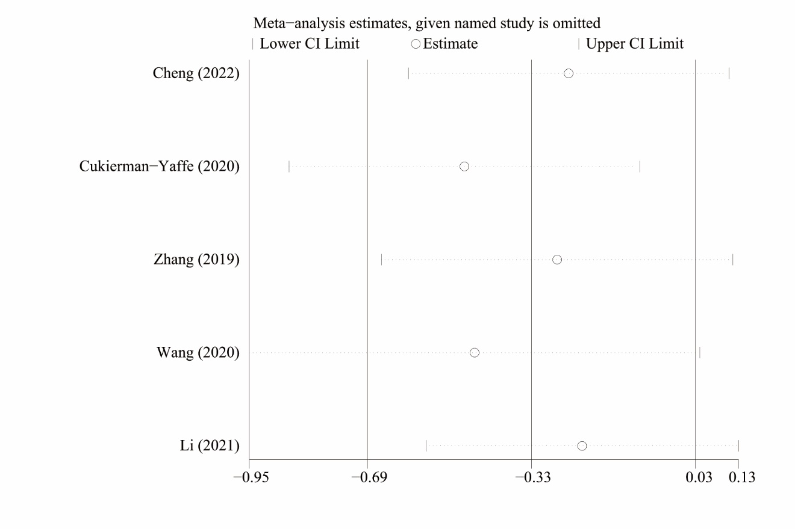
SFigure.3 Sensitivity analyses of self-controlled studies.

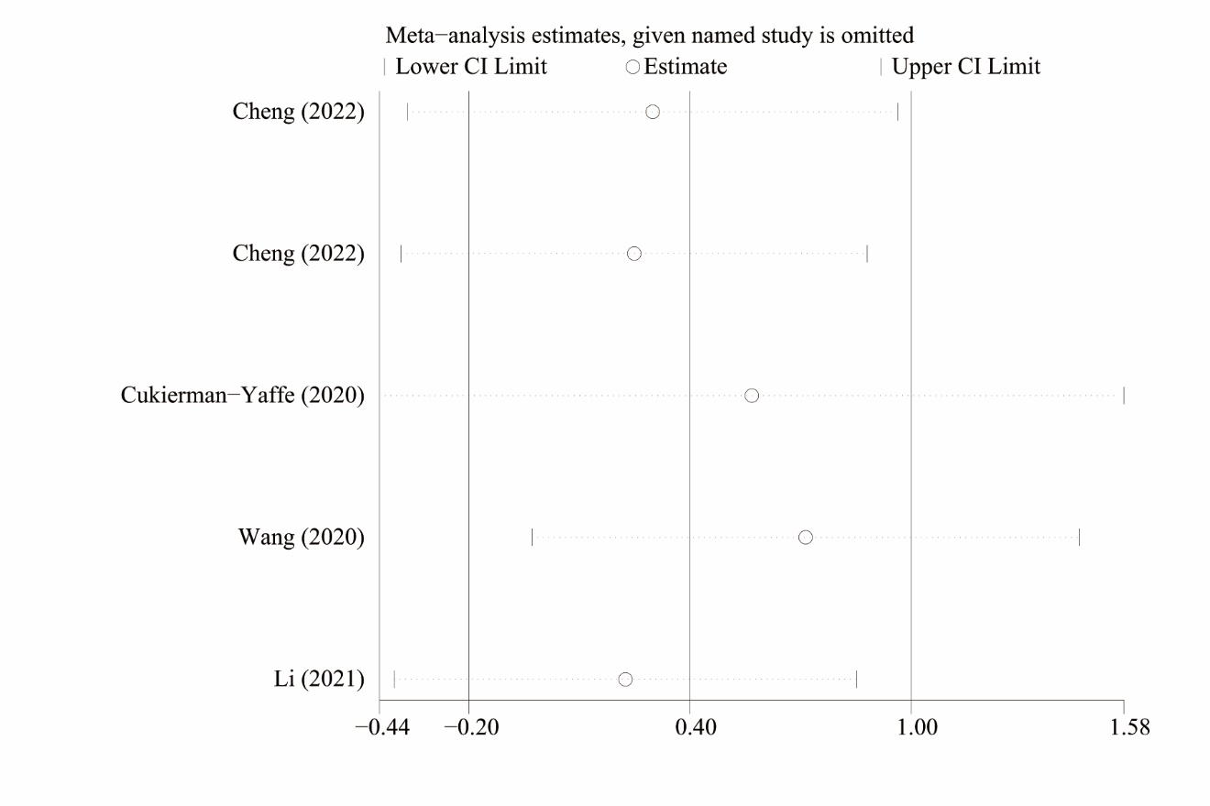
SFigure.4 Sensitivity analyses of non-GLP-1 analog-treated controlled studies.

