S5 Figure. Validation: Network sidesplit, Forest plot by design and Inconsistency model of primary analysis

- Network sidesplit

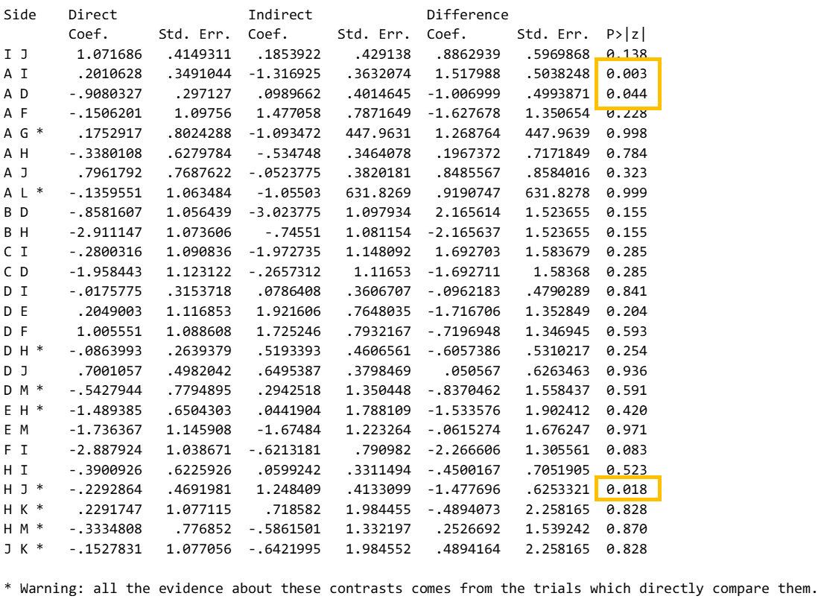

* The results are derived from direct evidence only.
Note: A= blood product; B= blood product combination therapy; C= botulinum toxin; D= corticosteroid; E= corticosteroid combination therapy; F= hyaluronic acid; G= needling; H= non-injections; I= placebo; J= prolotherapy; K= prolocombo; L= surgery; M=wait-see policy; Yellow= p<0.05 indicating significant difference between direct and indirect estimates

- Forest plot by design

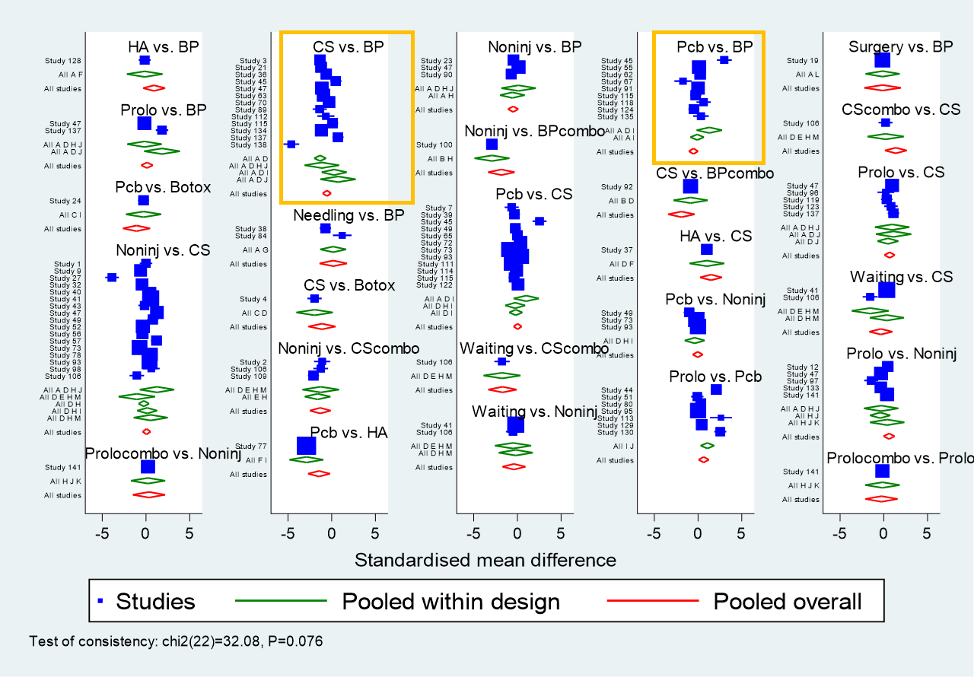

Note: BP= blood product; BPcombo= blood product combination therapy; Botox= botulinum toxin; CS= corticosteroid; CScombo= corticosteroid combination therapy; HA= hyaluronic acid; Noninj= non-injections; Pcb= placebo; Prolo= prolotherapy
Yellow:
Direct estimate from A-D-I (blood product - corticosteroid - placebo) studies did not overlap with the overall estimates for placebo-blood product comparison (yellow outline).
Direct estimates from A-D (blood product - corticosteroid) studies did not overlap with the estimates from A-D-I studies and from overall

- Inconsistency model for primary analysis
Note: BP= blood product; BPcombo= blood product combination therapy; Botox= botulinum toxin; CS= corticosteroid; CScombo= corticosteroid combination therapy; HA= hyaluronic acid; Noninj= non-injections; Pcb= placebo; Prolo= prolotherapy

