Electronic Supplementary Material
Temporary Mechanical Circulatory Support in
COVID-19 Patients:
a Systematic Review of Literature

Silvia Mariani^{a,b}, MD, Maria Elena De Piero^{a,b}, MD, Justine M. Ravaux^{a,b}, MD, Alexander Saelmansª, Michal J. Kawczynski^{a,b}, MD, Bas C.T. van Bussel^{c,d}, MD, PhD, Michele Di Mauro^{a,b}, MD, PhD, Anne Willers^{a,b}, MD, Justyna Swol^{e}, MD, PhD, Mariusz Kowalewski^{f}, MD, Thijs S.R Delnoij^{c}, MD, Iwan C C van der Horst^{b,c}, MD, PhD, Jos Maessen^{a,b}, MD, PhD, Roberto Lorusso^{a,b}, MD, PhD.

ª Cardio-Thoracic Surgery Department, Heart and Vascular Centre, Maastricht University Medical Centre (MUMC), Maastricht, The Netherlands.
^{b} Cardiovascular Research Institute Maastricht (CARIM), Maastricht, The Netherlands.
^{c} Department of Intensive Care Medicine, Maastricht University Medical Centre (MUMC), Maastricht, The Netherlands.
^{d} Care And Public Health Research Institute (CAPHRI), Maastricht University, Maastricht, The Netherlands
^{e} Department of Pneumology, Allergology and Sleep Medicine, and Intensive Care Medicine, Paracelsus Medical University, General Hospital Nuremberg, Nuremberg, Germany.
^{f} Clinical Department of Cardiac Surgery, Central Clinical Hospital of the Ministry of Interior and Administration, Centre of Postgraduate Medical Education, Warsaw, Poland.
^{g} Department of Cardiology, Heart and Vascular Centre, Maastricht University Medical Centre (MUMC), Maastricht, The Netherlands.

Corresponding author:
Silvia Mariani, MD
Cardio-Thoracic Surgery Department
Heart and Vascular Centre
Maastricht University Medical Centre (MUMC+)
P. Debyelaan, 25
6202 AZ Maastricht - The Netherlands
Phone: +31621468395
E-Mail: s.mariani1985@gmail.com

Running head: Mechanical Circulatory Support for COVID-19 patients

- Supplemental Methods
PubMed search strategy
(“Extracorporeal Membrane Oxygenation” OR “Extracorporeal Membrane Oxygenation” OR “ECMO Treatment” OR “ECMO Treatments” OR “Treatment, ECMO” OR “Treatments, ECMO” OR “Oxygenation, Extracorporeal Membrane” OR “Extracorporeal Membrane Oxygenations” OR “Membrane Oxygenation, Extracorporeal” OR “Membrane Oxygenations, Extracorporeal” OR “Oxygenations, Extracorporeal Membrane” OR “Extracorporeal Life Support” OR “Extracorporeal Life Supports” OR “Life Support, Extracorporeal” OR “Life Supports, Extracorporeal” OR “Support, Extracorporeal Life” OR “Supports, Extracorporeal Life” OR “ECLS Treatment” OR “ECLS Treatments” OR “Treatment, ECLS” OR “Treatments, ECLS” OR “ECMO” OR "ECLS" OR “Impella“ OR “Tandem heart“ OR “Mechanical support“ OR “Mechanical circulatory support“ OR “MCS“ OR “Assist device“ OR “VAD“)
AND
(“coronavirus” OR “coronavirus-19” OR “COVID-19 Virus Disease “ OR “COVID 19” OR “COVID-19 Virus Disease” OR “COVID 19 Virus Disease” OR “COVID-19 Virus Diseases” OR “Disease, COVID-19 Virus” OR “Virus Disease, COVID-19” OR “COVID-19 Virus Infection” OR “COVID 19 Virus Infection” OR “COVID-19 Virus Infections” OR “Infection, COVID-19 Virus” OR “Virus Infection, COVID-19” OR “2019-nCoV Infection” OR “2019 nCoV Infection” OR “2019-nCoV Infections” OR “Infection, 2019-nCoV” OR “Coronavirus Disease-19” OR “Coronavirus Disease 19” OR “2019 Novel Coronavirus Disease” OR “2019 Novel Coronavirus Infection” OR “2019-nCoV Disease” OR “2019 nCoV Disease” OR “2019-nCoV Diseases” OR “Disease, 2019-nCoV” OR “COVID19” OR “Coronavirus Disease 2019” OR “Disease 2019, Coronavirus” OR “SARS Coronavirus 2 Infection” OR “SARS-CoV-2 Infection” OR “Infection, SARS-CoV-2” OR “SARS CoV 2 Infection” OR “SARS-CoV-2 Infections” OR “COVID-19 Pandemic” OR “COVID 19 Pandemic” OR “COVID-19 Pandemics” OR “Pandemic, COVID-19” OR “severe acute respiratory syndrome coronavirus 2”)

Data extraction:
Numbers of studies assessed, included and excluded were recorded. Duplicate reporting of studies was carefully assessed and indicated.
The following questions were considered for a qualitative analysis of the studies:
1. Was the study population well described?
2. Were the outcomes of interest clearly defined?
3. Were the exposures of interest (primary and secondary) well defined?
4. Did the article state both inclusion and exclusion criteria?
5. Were the analysed variables clearly defined?
6. How was missing data managed?
7. Were more than 10 events per variable included?
8. Were criteria used to determine indication for treating postoperative complications?
9. Was the follow-up for following variables of interest well stated?
Aside from details relating to included study quality the following groups of data were extracted:
- Study characteristics: authors, PubMed ID, country of origin, year of publication, reason for eligibility/exclusion for review, date of publication, study design.
- Population characteristics: inclusion criteria, COVID-19 diagnostic criteria, age, female, body mass index, left ventricular ejection fraction, n-terminal prohormone of brain natriuretic peptide (NT proBNP), creatine kinase myocardial band (CK-MB), troponin, pre-existant cardiac disease, acute respiratory distress syndrome, septic shock, acute heart failure, cardiogenic shock, right heart failure, myocardial infarction, myocarditis, cardiac arrest, cardiopulmonary resuscitation, inotrope and vasopressor use, prone positioning before ECMO, partial pressure of arterial oxygen / fraction of inspired oxygen (PaO2/FiO2) ratio before ECMO, pre-ECMO acute physiology and chronic health evaluation (APACHE) and sequential organ failure assessment score (SOFA)
- Exposures: number of intervention groups, detailed nature of intervention and detailed nature of comparator, overall ECMO patients, ECMO configuration (VV, VA, V-VA, other), conversion VV to VA/V-VA with reason, median duration on ECMO, awake ECMO,
- Outcomes: time on ECMO, still ongoing ECMO at publication time, length of stay, in hospital/30 days mortality, mortality at follow-up, ECMO-related complications.
- Results: number of participants allocated to each group, sample size, summary data. Reasons why an included study did not contribute data on a particular outcome were carefully recorded and the possibility of selective reporting of results on particular outcomes were considered.
- Miscellaneous: funding sources, conclusions, comments.

- Supplemental Tables
Supplemental Table 1 - Overview of overlapping publications.
Author | Inclusion | Study period | Patients (n) | Study center
Helms et al. [1] | No | March 2020 | 150 (12 ECLS) | Strasbourg University Hospital, Strasbourg, France
Falcoz et al. [2] | Yes | Mar 2020-Apr 2020 | 17 ECLS | Strasbourg University Hospital, Strasbourg, France
Jacobs et al. [3] | No | Mar 2020-Apr 2020 | 32 | SCOPE Registry, USA
Jacobs et al. [4] | No | Mar 2020-Oct 2021 | 100 | SCOPE Registry, USA
Jacobs et al. [3] | Yes | Mar 2020-Dec 2020 | 200 | SCOPE Registry, USA
Schmidt et al. [5] | No | Mar 2020-May 2020 | 492 (83 ECLS) | Paris ECMO-COVID-19 investigators, Paris, USA
Schmidt et al. [6] | Partial | Mar 2020 Jan 2021 | 159 ECMO (71 included) | Paris ECMO-COVID-19 investigators, Paris, USA
Lebreton et al. [7] | Yes | Mar 2020-Jun 2020 | 302 ECLS | Paris ECMO-COVID-19 investigators, Paris, USA
Durak et al. [8] | No | Mar 2020-Apr 2020 | 17 ECLS | Uniklinik RWTH Aachen, Aachen, Germany
Zayat et al. [9] | Yes | Mar 2020-Apr 2020 | 17 ECLS | Uniklinik RWTH Aachen, Aachen, Germany
Li Rui et al. [10] | No | Jan 2020-Apr 2020 | 25 ECLS | Tongji Hospital of Huazhong University of Science and Technology, Wuhan, China
Yang et al. [11] | No | Jan 2020-May 2020 | 73 ECLS | 21 ICUs in Hubei province (including Wuhan), China
Xuan et al. [12] | No | Feb 2020-Apr 2020 | 5 ECLS | Leishenshan Hospital, Wuhan, China
Fang et al. [13] | Yes | Jan 2020-Jun 2020 | 88 ECLS | Tongji Hospital and Union Hospital of Huazhong University of Science and Technology, Zhongnan Hospital and Renmin Hospital of Wuhan University, Wuhan Jinyintan Hospital, Wuhan Pulmonary Hospital, and Leishenshan Hospital.
Suwalski et al. [14] | No | Mar 2020-Mar 2021 | 75 ECLS | Central Clinical Hospital of the Ministry of Interior, Warsaw, Poland
Suwalski et al. [15] | Yes | Mar 2020-May 2021 | 78 ECLS
Mustafa et al. [16] | No | Mar 2020-Jul 2020 | 40 OxyRVAD | Advocate Christ Medical Center and Rush University Health System, Chigago, USA
Mustafa et al. [17] | No | Mar 2020-Jun 2021 | 80 OxyRVAD | Advocate Christ Medical Center and Rush University Health System, Chigago, USA
Saeed et al. [18] | Yes | Mar 2020-Sep 2020 | 292 ECLS (59 OxyRVAD) | COVID-19 ECMO Working Group
Barbaro et al. [19] | Yes | Jan 2020-May 2020 | 1035 ECLS | ELSO Registry
Rabie et al. [20] | Yes | Mar 2020-Sep 2020 | 307 ECLS | SWAAC ELSO: overlap of 26 patients with Barbaro et al. 2020
Barbaro et al. [21] | No | Jan 2020-Dec 2020 | 4812 ECLS | ELSO Registry - lack of ECLS type definition for all patients
ECLS, extracorporeal life support; ELSO, extracorporeal life support organization.

Supplemental Table 2 - MCS Case Report Study and Patients characteristics
Authors | Year | Selection (4 points) | Comparability (2 points) | Outcome (3 points) | Total
Agerstrand et al. [22] | 2021 | **** | * | *** | 8
Akhtar et al. [23] | 2020 | **** | ** | *** | 9
Barbaro et al. [19] | 2020 | ** | * | ** | 5
Cain et al. [24] | 2021 | *** | * | * | 5
Dreier et al. [25] | 2021 | **** | * | *** | 8
Falcoz et al. [2] | 2020 | **** | ** | ** | 8
Fang et al. [13] | 2021 | **** | * | *** | 8
Gresser et al. [26] | 2021 | **** | * | ** | 8
Hekimian et al. [27] | 2021 | **** | * | *** | 8
Jacobs et al. [28] | 2021 | **** | ** | *** | 9
Lenka et al. [29] | 2020 | *** | * | *** | 7
Li Xin et al. [30] | 2020 | **** | * | ** | 7
Li Shuanglei et al. [31] | 2021 | *** | * | ** | 6
Loforte et al. [32] | 2021 | **** | ** | *** | 9
Magunia et al. [33] | 2021 | *** | * | * | 5
Oliveira et al. [34] | 2021 | **** | ** | ** | 8
Paisey et al. [35] | 2021 | **** | * | *** | 8
Raasveld et al. [36] | 2021 | **** | * | *** | 8
Rabie et al. [20] | 2021 | **** | ** | ** | 8
Rajajee et al. [37] | 2021 | *** | * | *** | 7
Ribeiro Queiros et al. [38] | 2021 | *** | ** | ** | 7
Rieg et al. [39] | 2020 | *** | ** | *** | 8
Saeed et al. [18] | 2021 | **** | ** | *** | 9
Schmidt et al. [6] | 2021 | **** | ** | ** | 8
Shih et al. [40] | 2021 | *** | * | ** | 6
Sromicki et al. [41] | 2021 | *** | * | ** | 6
Suwalski et al. [15] | 2021 | *** | ** | ** | 7
Zayat et al. [9] | 2020 | **** | ** | *** | 9

Supplemental Table 3 - Inclusion criteria and COVID-19 assessment by study
Author | Inclusion criteria | COVID-19 diagnostic criteria
Agerstrand et al. [22] | Patients > 18 years old at the time of ECMO initiation, laboratory-confirmed SARS-CoV-2 infection. | RT-PCR
Akhtar et al. [23] | Positive test for SARS-COV2, placed on ECMO following the NHR ECMO referral criteria. | RT-PCR
Barbaro et al. [19] | All patients diagnosed with COVID-19, aged 16 years or older, who had ECMO support. | Confirmed presence of severe acute respiratory syndrome coronavirus 2 (SARS-CoV-2) on laboratory testing
Cain et al. [24] | COVID-19 adult patients treated with RVAD or invasive mechanical ventilation alome | Na
Dreier et al. [25] | All patients placed on V-V ECMO for COVID-19 induced ARDS. | RT-PCR from respiratory samples
Falcoz et al. [2] | All patients referred to the five ICUs of the Strasbourg University Hospital for severe ARDS due to COVID-19 and that had been supported by ECMO after failure of optimal medical treatment, including neuromuscular blocking agents, | RT-PCR
Falcoz et al. [2] | protective ventilation, and high positive end-expiratory pressure (PEEP). | RT-PCR
Fang et al. [13] | Patients who had been diagnosed with COVID-19 according to the Guidelines on Diagnosis and Treatment | Guidelines on Diagnosis and Treatment for New Coronavirus Pneumonia (5th edition), published by the National Health Commission of the People's Republic of China
Fang et al. [13] | for New Coronavirus Pneumonia (5th edition), published by the National Health Commission of the People’s Republic of China.
Gresser et al. [26] | All COVID-19 patients already discharged or deceased by end of January 2021 with positive SARS-CoV-2 PCR testing and  computed tomography (CT) scans within 48 h of hospital admission. | SARS-CoV-2 PCR testing
Hekimian et al. [27] | Patients over 16 years old with COVID-19 who were admitted for suspected acute or fulminant myocarditis and included multisystem inflammatory syndrome. | RT-PCR or serology
Jacobs et al. [28] | Patients with confirmed COVID-19 who were supported with ECMO. | Na
Lenka et al. [29] | 18 years or older with laboratory-confirmed COVID-19 admitted to the medical intensive care unit. | RT-PCR assay of nasopharyngeal or oropharyngeal swab or lower respiratory tract specimens
Li Xin et al. [30] | COVID-19 patients requiring ECMO according to the Shanghai ECMO Support for COVID-19 Guideline (Shanghai Expert Consensus on Comprehensive Treatment of COVID 2019). | Shanghai ECMO Support for COVID-19 Guideline (Shanghai Expert Consensus on Comprehensive Treatment of Coronavirus Disease 2019
Li Shuanglei et al. [31] | (1) Laboratory confirmed COVID‐19 cases (2) Fulfilled the Berlin definition for ARDS.7 (3) Met ECMO initial criteria: (1) reversible respiratory failure with hypoxemia (partial pressure of arterial oxygen to the fraction of inspired oxygen (PaO2/FiO2) ratio less than 50 mmHg for more than three hours or PaO2/FiO2 ratio less than 80 mmHg for more than 6 h; (2) Arterial blood pH less than 7.25 with a partial pressure of arterial carbon dioxide (PaCO2) of at least 60 mmHg for  more than 6 h with respiratory rate more than 35 breaths per minute; (3) Plateau pressure more than 30‐35 cmH2O despite optimization of mechanical ventilation. (4) None of the following contraindications to ECMO: (1) mechanical ventilation at high settings (FiO2 > 0.9, plateau pressure greater than 30 cmH2O for ≥7 days; (2) major pharmacologic immunosuppression (absolute neutrophil count <400/mm3; (3) central nervous system hemorrhage that is recent or expanding; (4) nonrecoverable comorbidity, such as major central nervous system damage or terminal malignancy | RT reverse‐transcriptase polymerase chain reaction assays using specimens from both the upper respiratory tract (nasopharyngeal and oropharyngeal) and lower respiratory tract (expectorated sputum, endotracheal aspirate, or bronchoalveolar lavage), according to the world health organization criteria
Loforte et al. [32] | Patients ≥ 18 years old who underwent ECMO support for confirmed COVID-19 respiratory distress syndrome. | RT-PCR on serum and nasopharyngeal plus lower respiratory tract swab samples
Magunia et al. [33] | Requirement for ICU treatment due to COVID-19 confirmed by a positive SARS-CoV-2 PCR test. | SARS-CoV-2 PCR test.
Oliveira et al. [34] | All patients with COVID-19 who met criteria for critical care admission from AdventHealth hospitals. | RT-PCR testing of a nasopharyngeal sample or tracheal aspirate
Paisey et al. [35] | All patients undergoing adjunctive hemadsorption treatment. | Na
Raasveld et al. [36] | Patients aged 18 years and older and received ECMO during their ICU admission due to confirmed COVID-19. | RT-PCR
Rabie et al. [20] | COVID-19 patients requiring ECMO for refractory hypoxemia and severe respiratory acidosis with or without circulatory failure | Na
Rajajee et al. [37] | Functional and cognitive outcome, anxiety, depression and post-traumatic stress disorder in COVID-19 patients on ECMO | Na
Ribeiro Queiros et al. [38] | Cardiovascular impact of severe COVID-19 | nasopharyngeal swab for SARS-CoV-2 and ecidence of pneumonia
Rieg et al. [39] | All hospitalized patients with detection of SARS-CoV-2 using PCR in a respiratory sample. | PCR-confirmed SARS-CoV-2 infection in a respiratory sample
Saeed et al. [18] | Patients aged 18 years and older, with COVID-19 confirmed with a positive RT-PCR reaction assay, who received ECMO support. | RT-PCR
Schmidt et al. [6] | All consecutive adults, with laboratory-confirmed SARSCov-2 infection, who received venoarterial (VA)- or venovenous (VV)-ECMO for severe ARDS | real-time RT-PCR on nasopharyngeal swabs, or lower respiratory tract aspirates
Shih et al. [40] | Patients with laboratory-confirmed COVID-19 and patients with laboratory-confirmed influenza A or B, all of whom had refractory ARDS and were placed on ECMO | Na
Sromicki et al. [41] | COVID‐19 patients, were treated with ECMO therapy. | Na
Suwalski et al. [15] | All consecutive cases of COVID-19 ECMOs admitted to the Centre of Extracorporeal Therapies (CET—Warsaw, Poland). | Na
Zayat et al. [9] | All adult inpatients (≥18 years old) who were diagnosed with COVID-19, according to the WHO interim guidance, who developed severe COVID-19 with ARDS, requiring ECMO support. | RT-PCR, throat-swabs, tracheal secretions, or bronchoscopic alveolar lavage.
ARDS = Acute Respiratory Distress Syndrome, COVID-19 = coronavirus disease 2019, ECMO = Extra-Corporeal Membrane Oxygenation, Na = Not available, RT-PCR = Real-Time Reverse Transcription Polymerase Chain Reaction, WHO = World Health Organization.

Supplemental Figures
Supplemental Figure 1 –Forest plots showing the pooled median values of time from intubation to ECMO cannulation.
- 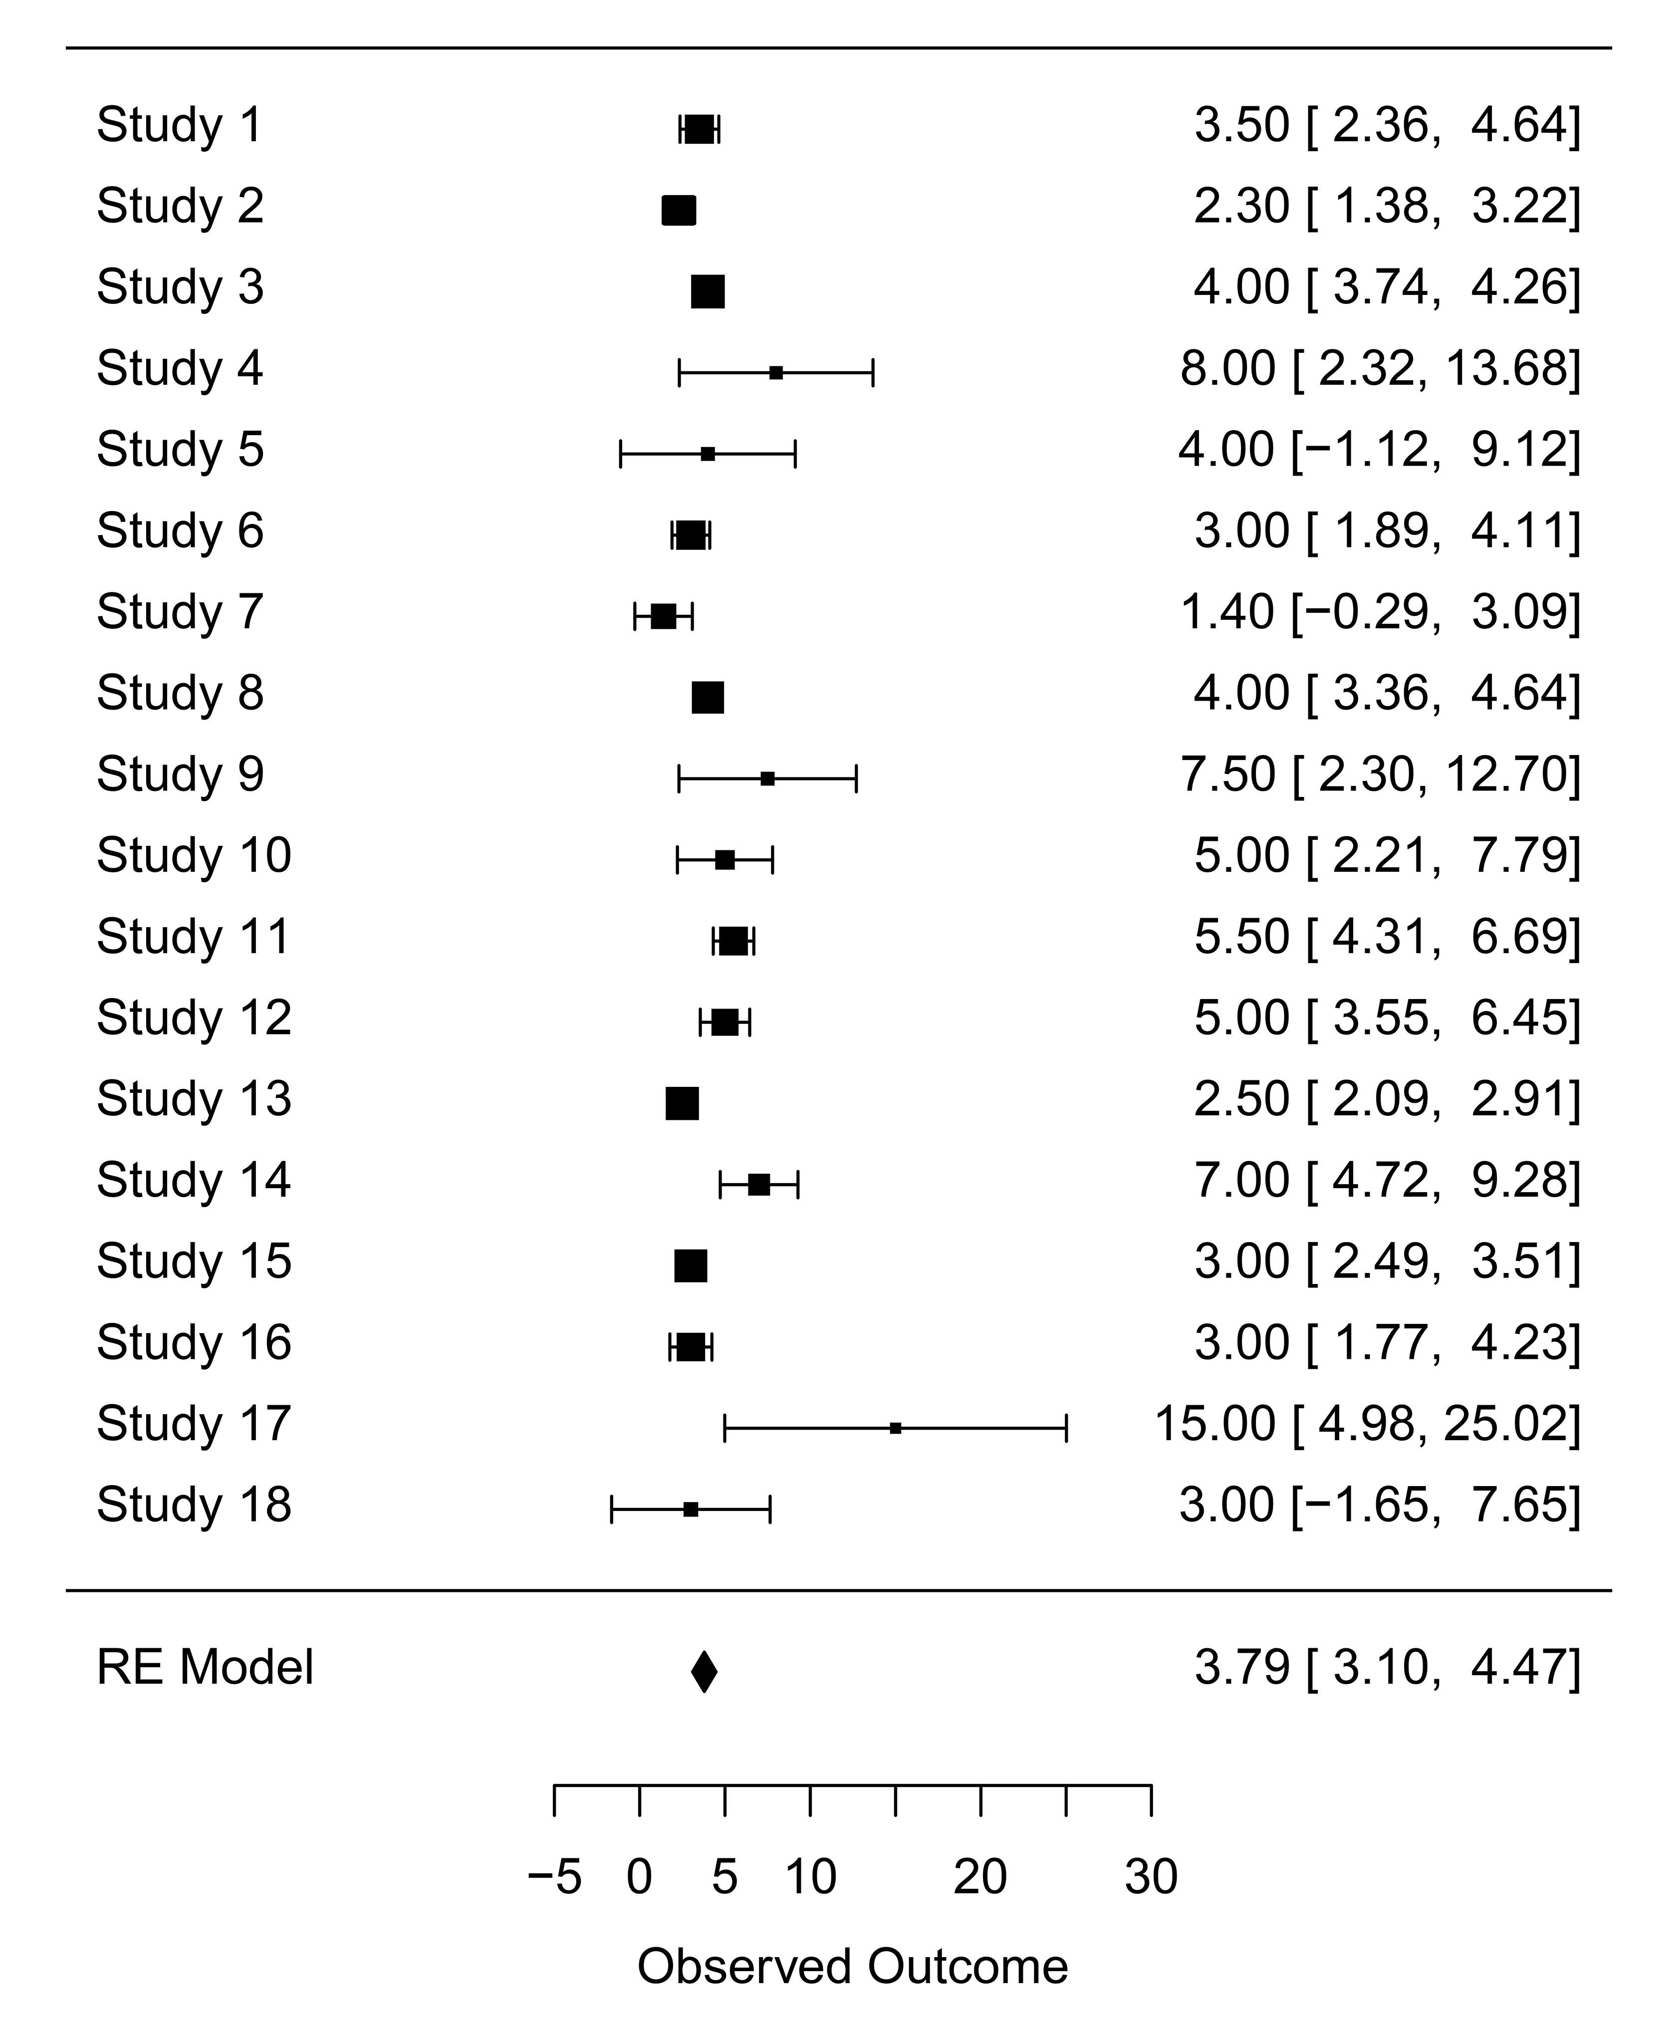

Supplemental Figure 2 –Forest plots showing the pooled median values of ECMO duration time.
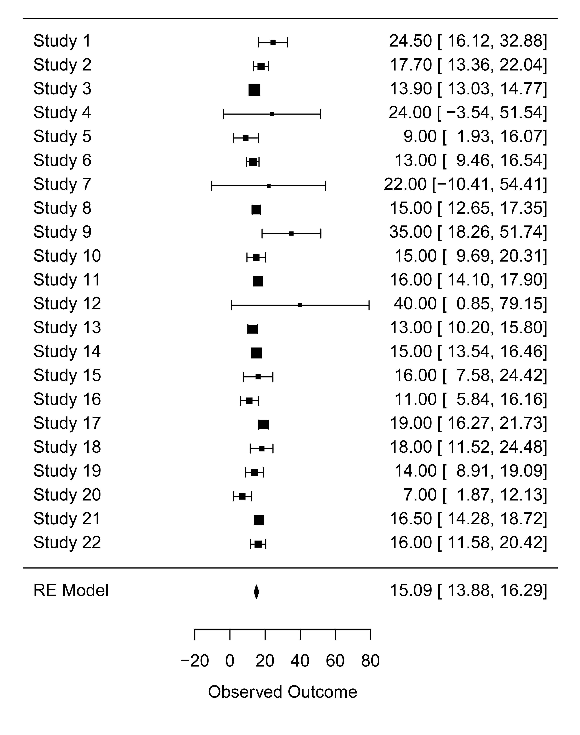

- References
1. Helms J, Tacquard C, Severac F, Leonard-Lorant I, Ohana M, Delabranche X, et al. High risk of thrombosis in patients with severe SARS-CoV-2 infection: a multicenter prospective cohort study. Intensive Care Med. 2020;46:1089-98.
2. Falcoz PE, Monnier A, Puyraveau M, Perrier S, Ludes PO, Olland A, et al. Extracorporeal Membrane Oxygenation for Critically Ill Patients with COVID-19-related Acute Respiratory Distress Syndrome: Worth the Effort? Am J Respir Crit Care Med. 2020;202:460-3.
3. Jacobs JP, Stammers AH, St Louis J, Hayanga JWA, Firstenberg MS, Mongero LB, et al. Extracorporeal Membrane Oxygenation in the Treatment of Severe Pulmonary and Cardiac Compromise in Coronavirus Disease 2019: Experience with 32 Patients. ASAIO J. 2020;66:722-30.
4. Jacobs JP, Stammers AH, Louis JS, Hayanga JWA, Firstenberg MS, Mongero LB, et al. Multi-institutional Analysis of 100 Consecutive Patients with COVID-19 and Severe Pulmonary Compromise Treated with Extracorporeal Membrane Oxygenation: Outcomes and Trends Over Time. ASAIO J. 2021;67:496-502.
5. Schmidt M, Hajage D, Lebreton G, Monsel A, Voiriot G, Levy D, et al. Extracorporeal membrane oxygenation for severe acute respiratory distress syndrome associated with COVID-19: a retrospective cohort study. The Lancet Respiratory Medicine. 2020;8:1121-31.
6. Schmidt M, Langouet E, Hajage D, James SA, Chommeloux J, Brechot N, et al. Evolving outcomes of extracorporeal membrane oxygenation support for severe COVID-19 ARDS in Sorbonne hospitals, Paris. Crit Care. 2021;25:355.
7. Lebreton G, Schmidt M, Ponnaiah M, Folliguet T, Para M, Guihaire J, et al. Extracorporeal membrane oxygenation network organisation and clinical outcomes during the COVID-19 pandemic in Greater Paris, France: a multicentre cohort study. The Lancet Respiratory Medicine. 2021.
8. Durak K, Kersten A, Grottke O, Zayat R, Dreher M, Autschbach R, et al. Thromboembolic and Bleeding Events in COVID-19 Patients receiving Extracorporeal Membrane Oxygenation. Thorac Cardiovasc Surg. 2021.
9. Zayat R, Kalverkamp S, Grottke O, Durak K, Dreher M, Autschbach R, et al. Role of extracorporeal membrane oxygenation in critically Ill COVID-19 patients and predictors of mortality. Artif Organs. 2020.
10. Li R, Hu S, Chen P, Jiang J, Cui G, Wang DW. Saving critically ill COVID-19 patients with mechanical circulatory support. Ann Transl Med. 2021;9:1221.
11. Yang X, Hu M, Yu Y, Zhang X, Fang M, Lian Y, et al. Extracorporeal Membrane Oxygenation for SARS-CoV-2 Acute Respiratory Distress Syndrome: A Retrospective Study From Hubei, China. Front Med (Lausanne). 2020;7:611460.
12. Xuan W, Chen C, Jiang X, Zhang X, Zhu H, Zhang S, et al. Clinical characteristics and outcomes of five critical COVID-19 patients treated with extracorporeal membrane oxygenation in Leishenshan Hospital in Wuhan. J Clin Anesth. 2020;67:110033.
13. Fang J, Li R, Chen Y, Qin JJ, Hu M, Huang CL, et al. Extracorporeal Membrane Oxygenation Therapy for Critically Ill Coronavirus Disease 2019 Patients in Wuhan, China: A Retrospective Multicenter Cohort Study. Curr Med Sci. 2021;41:1-13.
14. Suwalski P, Drobinski D, Smoczynski R, Franczyk M, Sarnowski W, Gajewska A, et al. Analysis of 75 consecutive COVID-19 ECMO cases in Warsaw Centre for Extracorporeal Therapies. Kardiol Pol. 2021;79:851-4.
15. Suwalski P, Staromlynski J, Braczkowski J, Bartczak M, Mariani S, Drobinski D, et al. Transition from Simple V-V to V-A and Hybrid ECMO Configurations in COVID-19 ARDS. Membranes (Basel). 2021;11.
16. Mustafa AK, Alexander PJ, Joshi DJ, Tabachnick DR, Cross CA, Pappas PS, et al. Extracorporeal Membrane Oxygenation for Patients With COVID-19 in Severe Respiratory Failure. JAMA Surg. 2020;155:990-2.
17. Mustafa AK, Joshi DJ, Alexander PJ, Tabachnick DR, Cross CA, Jweied EE, et al. Comparative Propensity Matched Outcomes in Severe COVID-19 Respiratory Failure-Extracorporeal Membrane Oxygenation or Maximum Ventilation Alone. Ann Surg. 2021;274:e388-e94.
18. Saeed O, Tatooles AJ, Farooq M, Schwartz G, Pham DT, Mustafa AK, et al. Characteristics and outcomes of patients with COVID-19 supported by extracorporeal membrane oxygenation: A retrospective multicenter study. J Thorac Cardiovasc Surg. 2021.
19. Barbaro RP, MacLaren G, Boonstra PS, Iwashyna TJ, Slutsky AS, Fan E, et al. Extracorporeal membrane oxygenation support in COVID-19: an international cohort study of the Extracorporeal Life Support Organization registry. Lancet. 2020;396:1071-8.
20. Rabie AA, Azzam MH, Al-Fares AA, Abdelbary A, Mufti HN, Hassan IF, et al. Implementation of new ECMO centers during the COVID-19 pandemic: experience and results from the Middle East and India. Intensive Care Med. 2021;47:887-95.
21. Barbaro RP, MacLaren G, Boonstra PS, Combes A, Agerstrand C, Annich G, et al. Extracorporeal membrane oxygenation for COVID-19: evolving outcomes from the international Extracorporeal Life Support Organization Registry. The Lancet. 2021;398:1230-8.
22. Agerstrand C, Dubois R, Takeda K, Uriel N, Lemaitre P, Fried J, et al. Extracorporeal Membrane Oxygenation for Coronavirus Disease 2019: Crisis Standards of Care. ASAIO J. 2021;67:245-9.
23. Akhtar W, Olusanya O, Baladia MM, Young H, Shah S. SARS-CoV-2 and ECMO: early results and experience. Indian J Thorac Cardiovasc Surg. 2020:1-8.
24. Cain MT, Smith NJ, Barash M, Simpson P, Durham LA, 3rd, Makker H, et al. Extracorporeal Membrane Oxygenation with Right Ventricular Assist Device for COVID-19 ARDS. J Surg Res. 2021;264:81-9.
25. Dreier E, Malfertheiner MV, Dienemann T, Fisser C, Foltan M, Geismann F, et al. ECMO in COVID-19-prolonged therapy needed? A retrospective analysis of outcome and prognostic factors. Perfusion. 2021:267659121995997.
26. Gresser E, Reich J, Sabel BO, Kunz WG, Fabritius MP, Rubenthaler J, et al. Risk Stratification for ECMO Requirement in COVID-19 ICU Patients Using Quantitative Imaging Features in CT Scans on Admission. Diagnostics (Basel). 2021;11.
27. Hékimian G, Kerneis M, Zeitouni M, Cohen-Aubart F, Chommeloux J, Bréchot N, et al. Coronavirus Disease 2019 Acute Myocarditis and Multisystem Inflammatory Syndrome in Adult Intensive and Cardiac Care Units. Chest. 2021;159:657-62.
28. Jacobs JP, Stammers AH, St Louis JD, Hayanga JWA, Firstenberg MS, Mongero LB, et al. Multi-institutional Analysis of 200 COVID-19 Patients treated with ECMO:Outcomes and Trends. Ann Thorac Surg. 2021.
29. Lenka J, Chhabria MS, Sharma N, Tan BE, Boppana LKT, Venugopal S, et al. Clinical characteristics and outcomes of critically ill patients with COVID-19 in a tertiary community hospital in upstate New York. J Community Hosp Intern Med Perspect. 2020;10:491-500.
30. Li X, Guo Z, Li B, Zhang X, Tian R, Wu W, et al. Extracorporeal Membrane Oxygenation for Coronavirus Disease 2019 in Shanghai, China. ASAIO J. 2020;66:475-81.
31. Li S, Xiong J, Du Z, Lai W, Ma X, Feng Z, et al. Extracorporeal membrane oxygenation (ECMO) for critically ill patients with coronavirus disease 2019 (COVID-19): A retrospective cohort study. J Card Surg. 2021;36:3554-60.
32. Loforte A, Di Mauro M, Pellegrini C, Monterosso C, Pelenghi S, Degani A, et al. Extracorporeal Membrane Oxygenation for COVID-19 Respiratory Distress Syndrome: An Italian Society for Cardiac Surgery Report. ASAIO J. 2021;67:385-91.
33. Magunia H, Lederer S, Verbuecheln R, Gilot BJ, Koeppen M, Haeberle HA, et al. Machine learning identifies ICU outcome predictors in a multicenter COVID-19 cohort. Crit Care. 2021;25:295.
34. Oliveira E, Parikh A, Lopez-Ruiz A, Carrilo M, Goldberg J, Cearras M, et al. ICU outcomes and survival in patients with severe COVID-19 in the largest health care system in central Florida. PLoS One. 2021;16:e0249038.
35. Paisey C, Patvardhan C, Mackay M, Vuylsteke A, Bhagra SK. Continuous hemadsorption with cytokine adsorber for severe COVID-19: A case series of 15 patients. Int J Artif Organs. 2021;44:664-74.
36. Raasveld SJ, Delnoij TSR, Broman LM, Lansink-Hartgring AO, Hermans G, De Troy E, et al. Extracorporeal Membrane Oxygenation in Patients With COVID-19: An International Multicenter Cohort Study. J Intensive Care Med. 2021:8850666211007063.
37. Rajajee V, Fung CM, Seagly KS, Park PK, Raghavendran K, Machado-Aranda DA, et al. One-Year Functional, Cognitive, and Psychological Outcomes Following the Use of Extracorporeal Membrane Oxygenation in Coronavirus Disease 2019: A Prospective Study. Crit Care Explor. 2021;3:e0537.
38. Queiros PR, Ferreira ND, Caeiro D, Ponte M, Guerreiro C, Silva M, et al. [Fighting the pandemic with collaboration at heart: Report from cardiologists in a COVID-19-dedicated Portuguese intensive care unit]. Rev Port Cardiol (Engl Ed). 2021.
39. Rieg S, von Cube M, Kalbhenn J, Utzolino S, Pernice K, Bechet L, et al. COVID-19 in-hospital mortality and mode of death in a dynamic and non-restricted tertiary care model in Germany. PLoS One. 2020;15:e0242127.
40. Shih E, Squiers JJ, DiMaio JM, George T, Banwait J, Monday K, et al. Outcomes of Extracorporeal Membrane Oxygenation in Patients With Severe Acute Respiratory Distress Syndrome Caused by COVID-19 Versus Influenza. Ann Thorac Surg. 2021.
41. Sromicki J, Schmiady M, Maisano F, Mestres CA. ECMO therapy in COVID-19: An experience from Zurich. J Card Surg. 2021;36:1707-12.

