Supplementary Materials
Supplementary Figure legends
Figure S1. Funnel plots of analyses for 24h post-treatment UGE.
Figure S2. Funnel plots of analyses for 24h UGE delta changes.
Figure S3. Means plots for 24h post-treatment UGE in different levels of renal function.
Figure S4. Means plots for 24h UGE delta changes in different levels of renal function.
Figure S5. Post-treatment UGE in patients with different levels of renal function (take eGFR=60 mL/min/1.73 m² as the cut-off value)
Figure S6. Post-treatment UGE in patients with different levels of renal function (take eGFR=30 mL/min/1.73 m² as the cut-off value)
Figure S7. UGE delta changes in patients with different levels of renal function (take eGFR=60 mL/min/1.73 m² as the cut-off value)
Figure S8. UGE delta changes in patients with different levels of renal function (take eGFR=30 mL/min/1.73 m² as the cut-off value)

Supplementary Table legends
Table S1. The risk of bias for included trials of UGE assessment
Table S2.Description of 24h post-treatment UGE in different levels of renal function
Table S3.ANOVA tendency analysis for 24h post-treatment UGE in different levels of renal function
Table S4.Description of 24h UGE delta changes in different levels of renal function
Table S5.ANOVA tendency analysis for 24h UGE delta changes in different levels of renal function

Figure S1. Funnel plots of analyses for 24h post-treatment UGE.
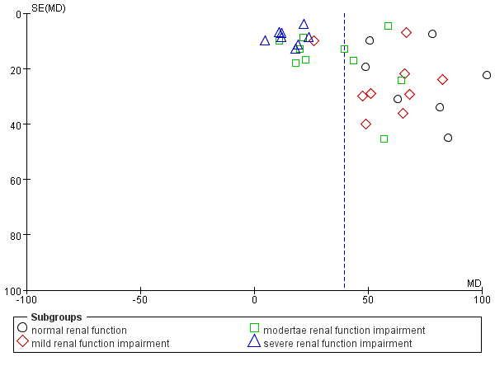

Figure S2. Funnel plots of analyses for 24h UGE delta changes.
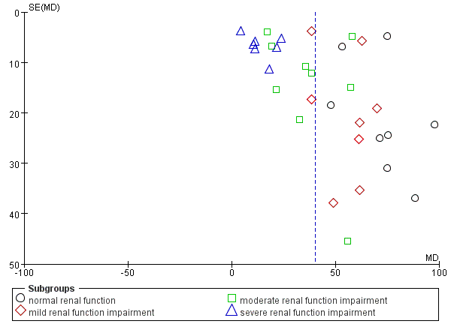

Figure S3. Means plots for 24h post-treatment UGE in different levels of renal function.

Figure S4. Means plots for 24h UGE delta changes in different levels of renal function.

Figure S5. Post-treatment UGE in patients with different levels of renal function
(take eGFR=60 mL/min/1.73 m² as the cut-off value)
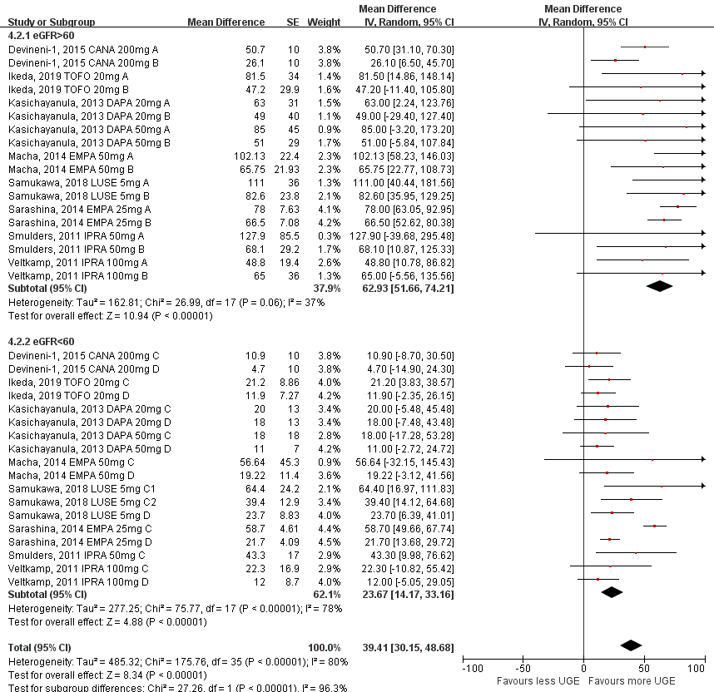

Figure S6. Post-treatment UGE in patients with different levels of renal function
(take eGFR=30 mL/min/1.73 m² as the cut-off value)
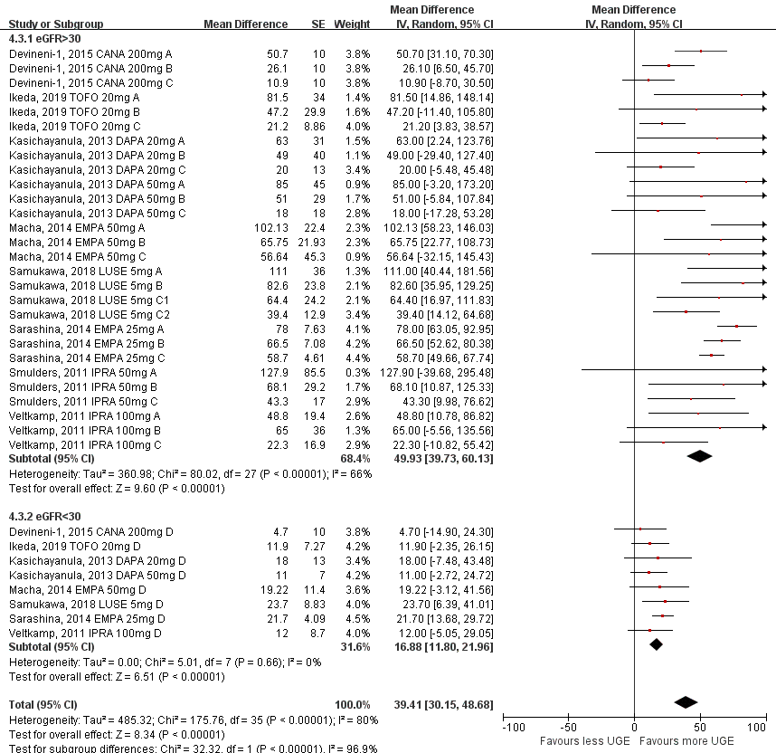
Figure S7. UGE delta changes in patients with different levels of renal function
(take eGFR=60 mL/min/1.73 m² as the cut-off value)
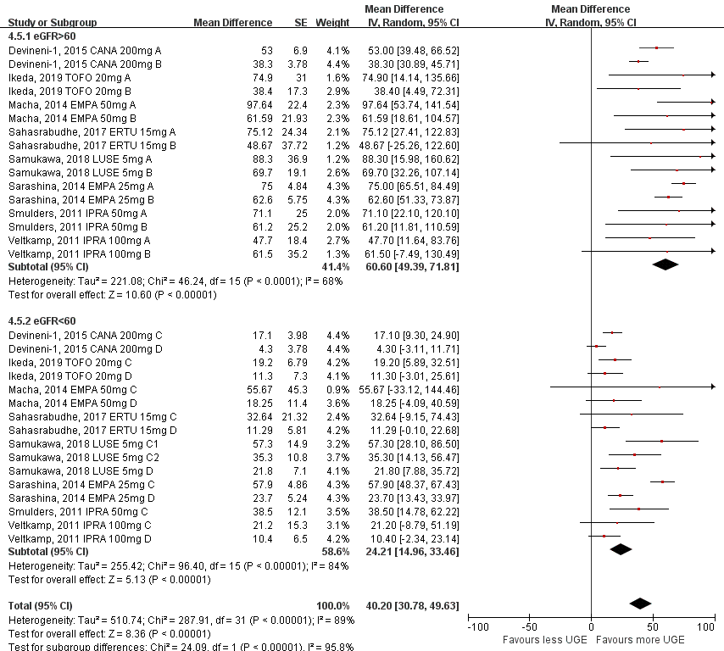
Figure S8. UGE delta changes in patients with different levels of renal function
(take eGFR=30 mL/min/1.73 m² as the cut-off value)
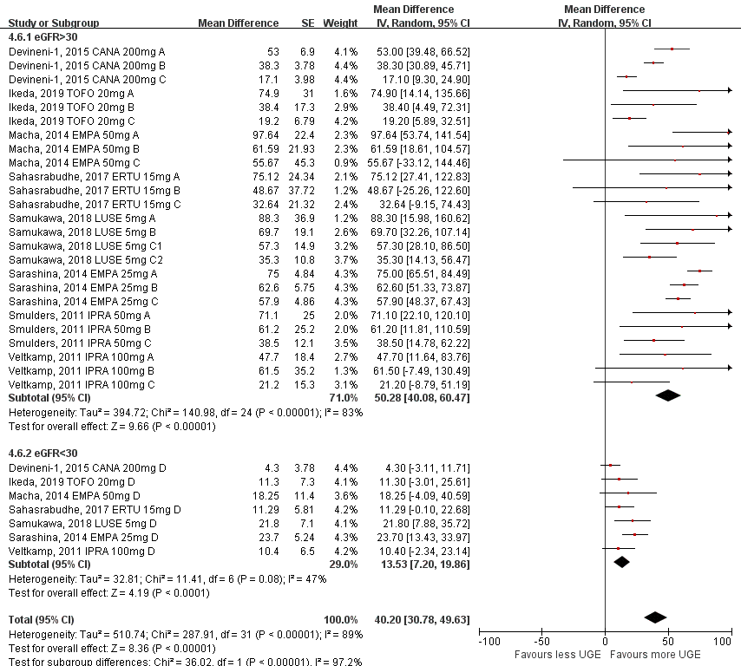
Table S1. The risk of bias for included trials of UGE assessment
Author, year | Adequate randomization sequence generation | Adequate  allocation concealment | Blinding  of participants and caregivers | Binding of  outcome assessors  and adjudicators | Free of infrequent  missing outcome data | Free of selective outcome reporting | Free of other bias
Devineni et al, 2015² | No  Open-label, parallel-group | No  Open-label, parallel-group | No  Open-label, parallel-group | No  Open-label, parallel-group | Definitely Yes | Definitely yes | Probably yes  Generally balanced baseline  characteristics across groups
Ikeda et al, 2019³ | No  Open-label, parallel-group | No  Open-label, parallel-group | No  Open-label, parallel-group | No  Open-label, parallel-group | Definitely Yes | Definitely yes | Probably yes  Generally balanced baseline  characteristics across groups
Macha et al, 2015⁴ | No  Open-label, parallel-group | No  Open-label, parallel-group | No  Open-label, parallel-group | No  Open-label, parallel-group | Definitely Yes | Definitely yes | Probably yes  Generally balanced baseline  characteristics across groups
Sahasrabudhe et al, 2017⁵ | No  Open-label, parallel-group | No  Open-label, parallel-group | No  Open-label, parallel-group | No  Open-label, parallel-group | Definitely Yes | Definitely yes | Probably yes  Generally balanced baseline  characteristics across groups
Samukawa et al, 2018⁶ | No  Open-label, parallel-group | No  Open-label, parallel-group | No  Open-label, parallel-group | No  Open-label, parallel-group | Definitely Yes | Definitely yes | Probably yes  Generally balanced baseline  characteristics across groups
Sarashina et al, 2014⁷ | No  Open-label, parallel-group | No  Open-label, parallel-group | No  Open-label, parallel-group | No  Open-label, parallel-group | Definitely Yes | Definitely yes | Probably yes  Generally balanced baseline  characteristics across groups
Smulders et al, 2011^{8,9} | No  Open-label, parallel-group | No  Open-label, parallel-group | No  Open-label, parallel-group | No  Open-label, parallel-group | Definitely Yes | Definitely yes | Probably yes  Generally balanced baseline  characteristics across groups
Veltkamp et al, 2011^{9,10} | No  Open-label, parallel-group | No  Open-label, parallel-group | No  Open-label, parallel-group | No  Open-label, parallel-group | Definitely Yes | Definitely yes | Probably yes  Generally balanced baseline  characteristics across groups

Table S2.Description of 24h post-treatment UGE in different levels of renal function
 | N | Mean | SD | SE | 95% CIs of Mean |  | Min | Max
 |  |  |  |  | LL | UL | Min | Max
1 | 9 | 83.114444 | 26.9490933 | 8.9830311 | 62.399538 | 103.829351 | 48.8000 | 127.9000
2 | 9 | 57.916667 | 16.4037724 | 5.4679241 | 45.307611 | 70.525722 | 26.1000 | 82.6000
3 | 10 | 35.484000 | 19.5129218 | 6.1705277 | 21.525297 | 49.442703 | 10.9000 | 64.4000
4 | 8 | 15.277500 | 6.4083913 | 2.2657085 | 9.919951 | 20.635049 | 4.7000 | 23.7000
Total | 36 | 48.509444 | 31.0678953 | 5.1779826 | 37.997581 | 59.021308 | 4.7000 | 127.9000
SD standard deviation, SE standard error, CI confidence intervals, LL lower limit, UL upper limit, Min minimum, Max maximum.

Table S3.ANOVA tendency analysis for 24h post-treatment UGE in different levels of renal function
 |  |  | SS | DF | MS | F | P
SSB |  |  | 22105.536 | 3 | 7368.512 | 20.193 | .000
SSB | LT | unweighted | 21852.756 | 1 | 21852.756 | 59.886 | .000
SSB | LT | weighted | 22049.781 | 1 | 22049.781 | 60.426 | .000
SSB | LT | variance | 55.754 | 2 | 27.877 | .076 | .927
SSW |  |  | 11676.958 | 32 | 364.905
Total |  |  | 33782.494 | 35
SS sum of squares, DF degree of freedom, MS mean square, SSB sum of squares between groups, SSW sum of squares
within groups, LLA Linear Term

Table S4.Description of 24h UGE delta changes in different levels of renal function
 | N | Mean | SD | SE | 95% CIs of Mean |  | Min | Max
 |  |  |  |  | LL | UL | Min | Max
1 | 8 | 72.845000 | 16.4613478 | 5.8199653 | 59.082969 | 86.607031 | 47.7000 | 97.6400
2 | 8 | 55.245000 | 11.9044217 | 4.2088487 | 45.292654 | 65.197346 | 38.3000 | 69.7000
3 | 9 | 37.201111 | 16.5217451 | 5.5072484 | 24.501374 | 49.900849 | 17.1000 | 57.9000
4 | 7 | 14.434286 | 6.9923336 | 2.6428537 | 7.967456 | 20.901116 | 4.3000 | 23.7000
Total | 32 | 45.642813 | 25.0691903 | 4.4316486 | 36.604406 | 54.681219 | 4.3000 | 97.6400
SD standard deviation, SE standard error, CI confidence intervals, LL lower limit, UL upper limit, Min minimum, Max maximum.

Table S5.ANOVA tendency analysis for 24h UGE delta changes in different levels of renal function
 |  |  | SS | DF | MS | F | P
SSB |  |  | 14116.454 | 3 | 4705.485 | 24.554 | .000
SSB | LT | unweighted | 14113.369 | 1 | 14113.369 | 73.645 | .000
SSB | LT | weighted | 14054.928 | 1 | 14054.928 | 73.340 | .000
SSB | LT | variance | 61.526 | 2 | 30.763 | .161 | .852
SSW |  |  | 5365.939 | 28 | 191.641
Total |  |  | 19482.393 | 31
SS sum of squares, DF degree of freedom, MS mean square, SSB sum of squares between groups, SSW sum of squares
within groups, LLA Linear Term.
References in supplement
1. Kasichayanula S, Liu X, Pe Benito M, et al. The influence of kidney function on dapagliflozin exposure, metabolism and pharmacodynamics in healthy subjects and in patients with type 2 diabetes mellitus. Br J Clin Pharmacol. 2013;76(3):432-44.
2. Devineni D, Curtin CR, Marbury TC, et al. Effect of hepatic or renal impairment on the pharmacokinetics of canagliflozin, a sodium glucose co-transporter 2 inhibitor. Clin Ther. 2015;37(3):610-628.
3. Ikeda S, Takano Y, Schwab D, et al. Effect of Renal Impairment on the Pharmacokinetics and Pharmacodynamics of Tofogliflozin (A SELECTIVE SGLT2 Inhibitor) in Patients with Type 2 Diabetes Mellitus. Drug Res (Stuttg). 2019;69(6):314-322.
4. Macha S, Mattheus M, Halabi A, et al. Pharmacokinetics, pharmacodynamics and safety of empagliflozin, a sodium glucose cotransporter 2 (SGLT2) inhibitor, in subjects with renal impairment. Diabetes Obes Metab. 2014;16(3):215-22.
5. Sahasrabudhe V, Terra SG, Hickman A, et al. The Effect of Renal Impairment on the Pharmacokinetics and Pharmacodynamics of Ertugliflozin in Subjects With Type 2 Diabetes Mellitus. J Clin Pharmacol. 2017;57(11):1432-1443.
6. Samukawa Y, Haneda M, Seino Y, et al. Pharmacokinetics and Pharmacodynamics of Luseogliflozin, a Selective SGLT2 Inhibitor, in Japanese Patients With Type 2 Diabetes With Mild to Severe Renal Impairment. Clin Pharmacol Drug Dev. 2018;7(8):820-828.
7. Sarashina A, Ueki K, Sasaki T, et al. Effect of renal impairment on the pharmacokinetics, pharmacodynamics, and safety of empagliflozin, a sodium glucose cotransporter 2 inhibitor, in Japanese patients with type 2 diabetes mellitus. Clin Ther. 2014;36(11):1606-1615.
8. Smulders R, Ishikawa H, Nakajo I, et al. The effect of renal impairment on the pharmacokinetics and urinary glucose excretion of the SGLT2 inhibitor ipragliflozin (ASP1941) in Japanese type 2 diabetes mellitus patients. Poster presentation at the 47th Annual Meeting of the European Association for the Study of Diabetes (EASD), Lisbon, Portugal; September 12–16, 2011. Abstract Number: 847.
9. Kadokura T, Zhang W, Krauwinkel W, et al. Clinical pharmacokinetics and pharmacodynamics of the novel SGLT2 inhibitor ipragliflozin. Clin Pharmacokinet. 2014;53(11):975-88.

