Supplementary Material

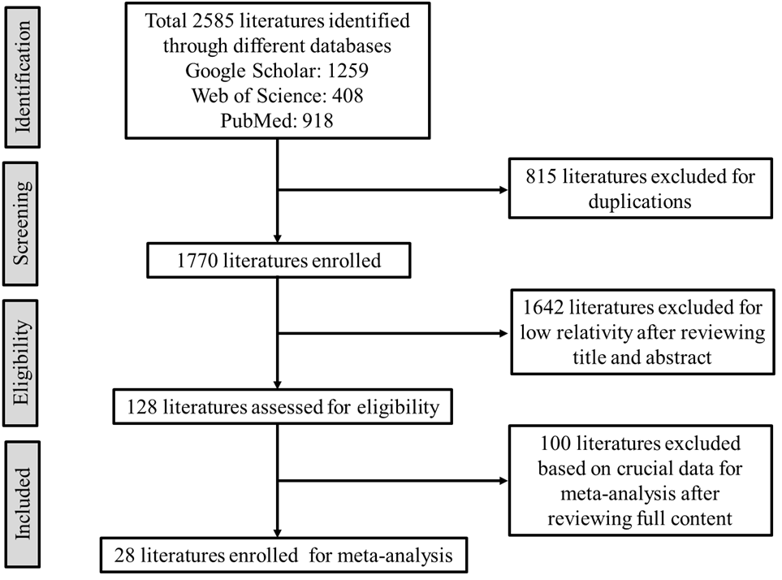
Supplementary Figure 1. The study selection flowchart. Randomized controlled trials published before September 2021 in the PubMed, Goggle scholar, and Web of Science databases were searched following the Preferred Reporting Items for Systematic Review and Meta-Analysis (PRISMA) guidelines.

Supplementary Figure 2. Number of studies meeting individual PEDro [Physiotherapy Evidence Database] criteria.

