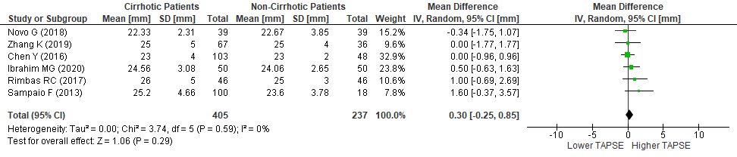
S6 Fig. The mean difference in tricuspid annular plane systolic excursion between patients with and without cirrhosis. SD , standard deviation; IV , inverse variance; CI , confidence interval; df , degrees of freedom; Chi² , chi-squared statistic; p , p-value; I² , I-squared heterogeneity statistic; Z , Z statistic

