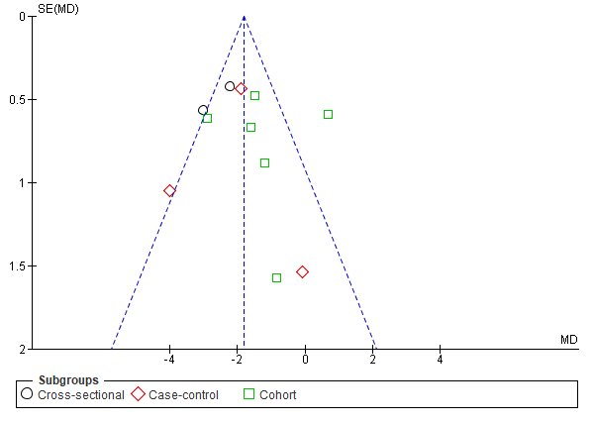
S8 Fig. Funnel Plot for Publication Bias on Studies Evaluating Left Ventricular Global Longitudinal Strain based on Subgroup Analysis According to Study Design in Fig 5.

