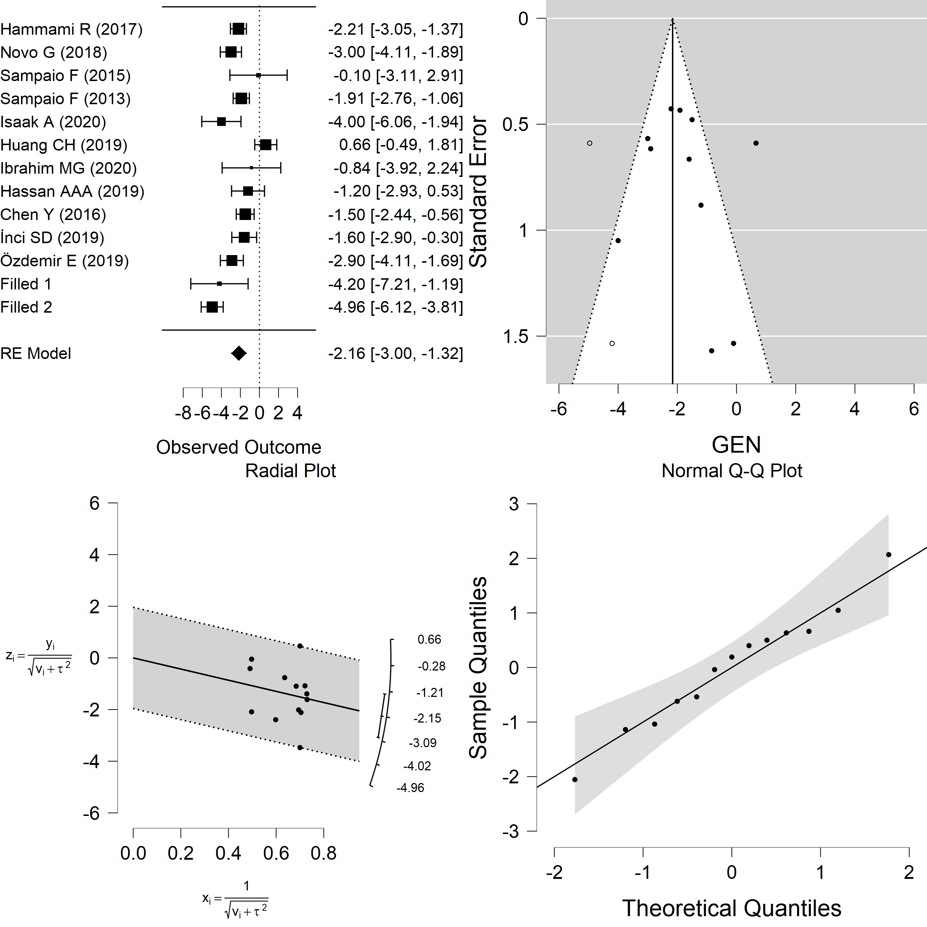
S9 Fig. Trim-and-fill analysis for the funnel plot in Fig 5. GEN generated the mean difference.

