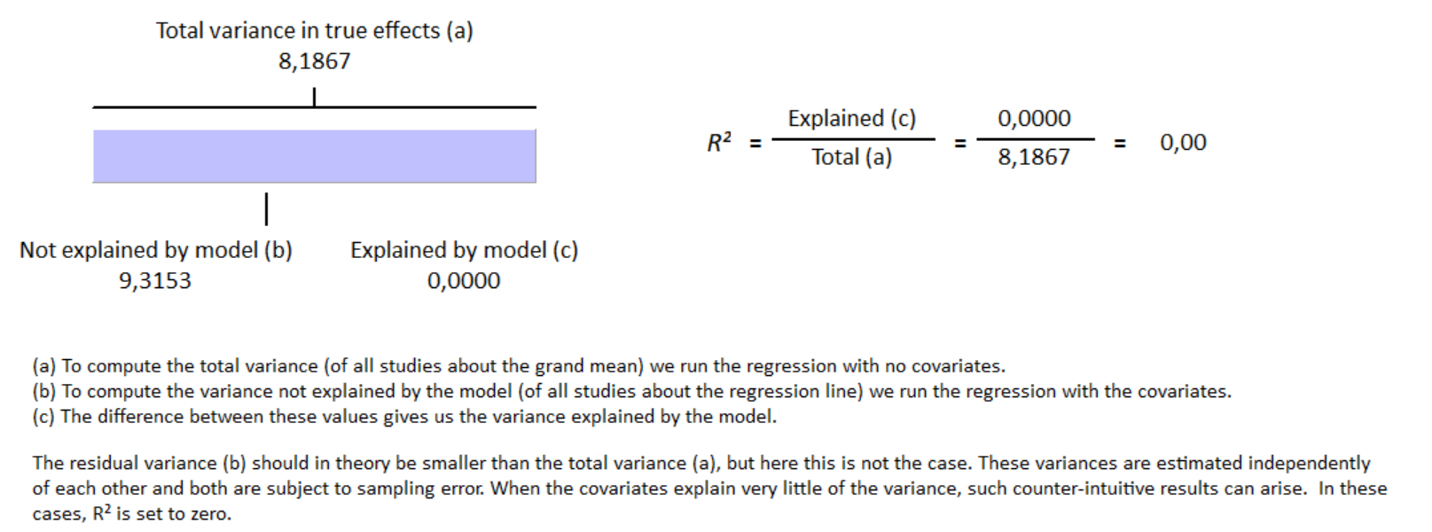
S10 Fig Meta-regression result for study design covariate have no influence on GLS reduction in group with cirrhosis with R² = 0%

