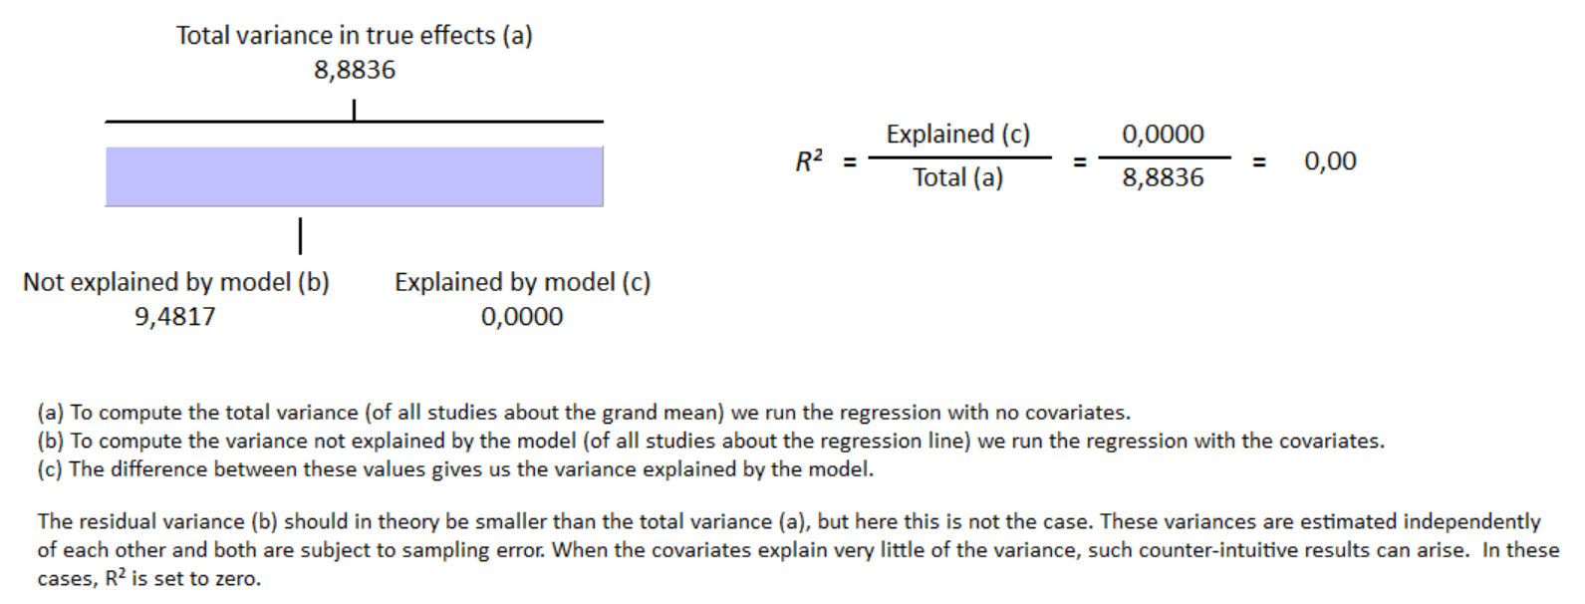
S11 Fig Meta-regression result for proportion of male subjects covariate have no influence on GLS Reduction in group with cirrhosis with R² = 0%

