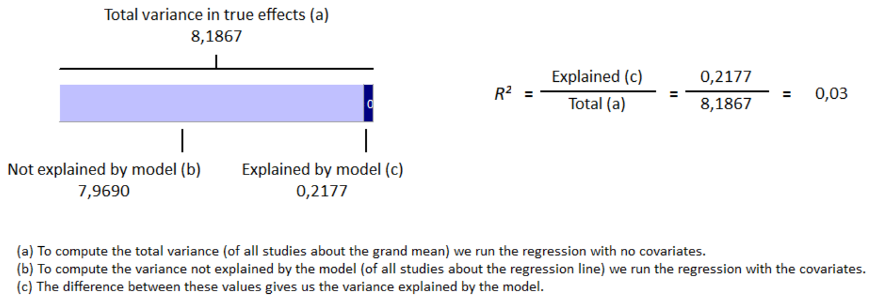
S12 Fig Meta-regression result for age covariate have no influence on GLS reduction in group with cirrhosis with R² = 3%

