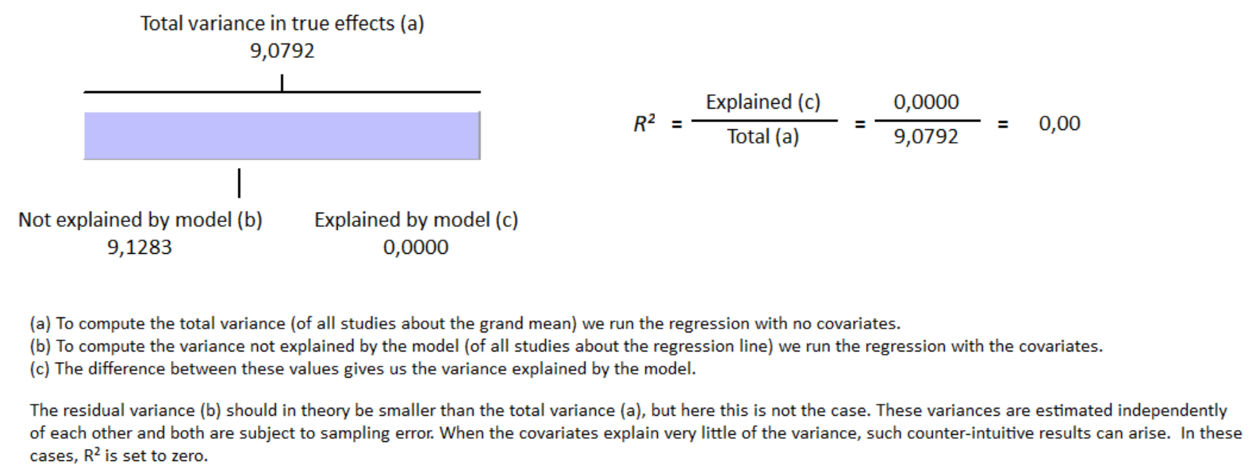
S14 Fig Meta-regression result for proportion of viral etiology covariate have no influence on GLS reduction in group with cirrhosis with R² = 0%

