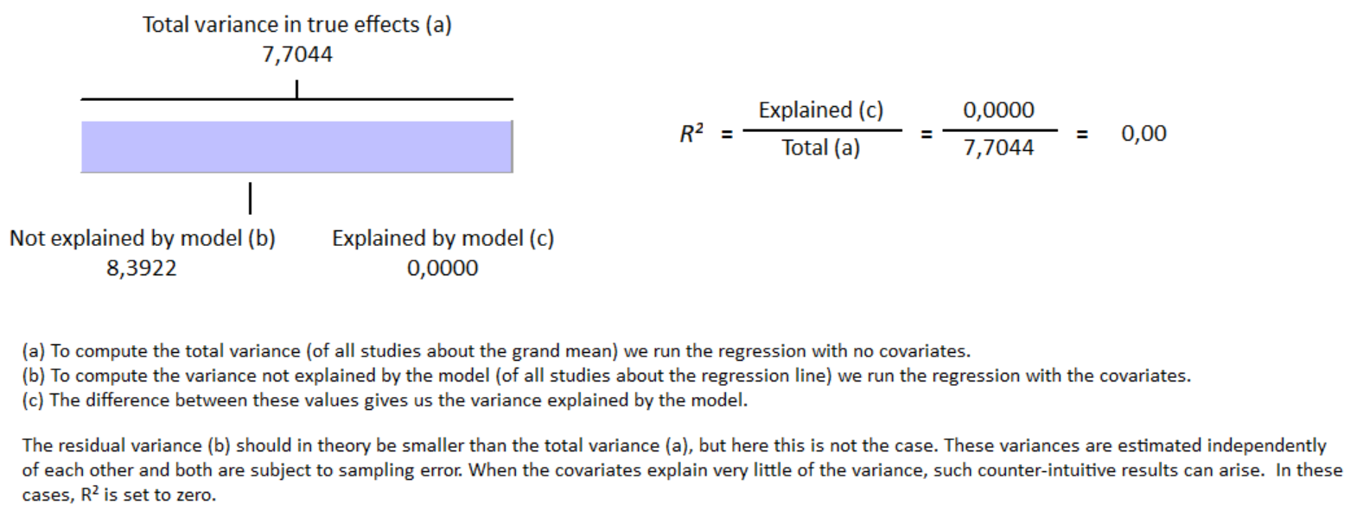
S15 Fig Meta-regression result for baseline left ventricular ejection fraction in group with cirrhosis have no influence on GLS reduction in group with cirrhosis with R² = 0%

