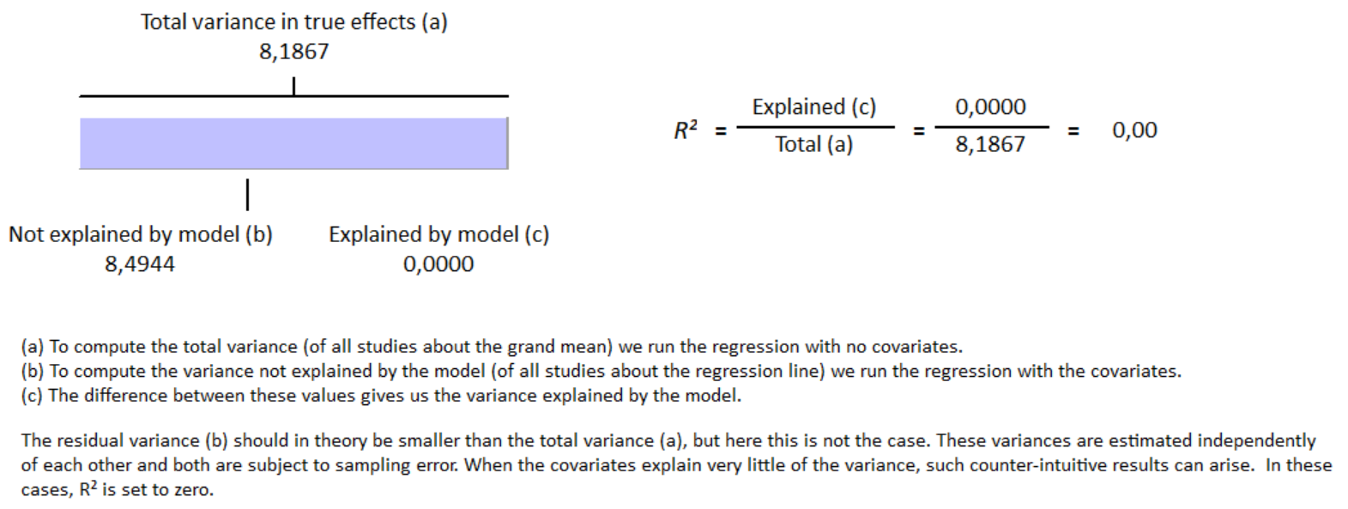
S16 Fig Meta-regression result for Newcastle Ottawa Scale Score have no influence on GLS reduction in group with cirrhosis with R² = 0%

