Supplementary Material

Supplementary Tables

Supplementary Table 1. Newcastle-Ottawa quality assessment scale.
Author, Ref # | Selection |  | Comparability |  | Outcome
 | Points (max 4) | Risk of bias | Points (max 2) | Risk of bias | Points (max 3) | Risk of bias
Ali et al. 2020 | 4 | Low | 2 | Low | 2 | Medium
Besler et al. 2018 | 3 | Medium | 1 | Medium | 3 | Low
Braun et al. 2018 | 3 | Medium | 2 | Low | 2 | Medium
Braun et al. 2019 | 3 | Medium | 1 | Medium | 2 | Medium
Cai et al. 2020 | 4 | Low | 2 | Low | 3 | Low
Camplelo-Parada et al. 2015 | 2 | Medium | 1 | Medium | 2 | Medium
Davidson et al. 2021 | 3 | Medium | 1 | Medium | 2 | Medium
Dregrer et al. 2020 | 4 | Low | 2 | Low | 3 | Low
Fam et al. 2019 | 2 | Medium | 1 | Medium | 2 | Medium
Fam et al. 2021 | 2 | Medium | 1 | Medium | 2 | Medium
Hahn et al. 2017 | 3 | Medium | 1 | Medium | 2 | Medium
Hahn et al. 2020 | 2 | Medium | 1 | Medium | 2 | Medium
Kitamura et al. 2021 | 2 | Medium | 1 | Medium | 3 | Low
Kodali et al. 2021 | 3 | Medium | 1 | Medium | 2 | Medium
Lurz et al. 2018 | 4 | Low | 2 | Low | 2 | Medium
Lauten et al. 2018 | 2 | Medium | 1 | Medium | 2 | Medium
Mehr et al. 2019 | 2 | Medium | 1 | Medium | 3 | Low
Nickening et al. 2017 | 2 | Medium | 1 | Medium | 2 | Medium
Nickening et al. 2019 | 3 | Medium | 1 | Medium | 3 | Low
Nickening et al. 2019 | 3 | Medium | 1 | Medium | 3 | Low
Orban et al. 2020 | 3 | Medium | 2 | Low | 3 | Low
Perlman et al. 2018 | 2 | Medium | 2 | Low | 2 | Medium
Perlman et al. 2017 | 3 | Medium | 1 | Medium | 3 | Low
Rommel et al. 2019 | 3 | Medium | 1 | Medium | 3 | Low
Ruf et al. 2021 | 3 | Medium | 1 | Medium | 2 | Medium
Sugiura et al. 2020 | 3 | Medium | 2 | Low | 2 | Low
Two independent reviewers undertook quality assessment and allocated stars/points for adherence to following criteria:
• Selection (adequate selection and definition of groups)
• Comparability (comparability of two groups for a selected variable and comparability for other variables)
• Outcome (modality of assessment, enough length of follow-up and adequacy of follow-up)
Studies with 4 stars for selection, 2 for comparability, and 3 for outcome were defined at low risk of bias. Studies with 2 or 3 stars for selection, 1 for comparability, and 2 for outcome were defined at medium risk. Any study with a score of 1 for selection or outcome ascertainment, or 0 for any of the three domains, was deemed at high risk of bias.

Supplementary Table 2. Meta-regression analysis.
 | 30-day mortality |  | 1-year mortality
 | p | slope | p | slope
Atrial Fibrillation | 0.993 | 0.00 | 0.735 | -0.02
Age | 0.349 | -0.10 | 0.227 | -0.44
BMI | 0.662 | -0.38 | 0.205 | -1.83
Concomitant MR treatment | 0.357 | -0.01 | 0.732 | -0.01
Follow-up duration, weeks | 0.683 | 0.00 | 0.377 | 0.04
Hypertension, % | 0.841 | 0.00 | 0.956 | 0.01
LVEF, % | 0.223 | -0.06 | 0.429 | -0.11
Male, % | 0.739 | 0.01 | 0.882 | -0.01
N patients | 0.156 | -0.01 | 0.419 | -0.01
NYHA class III-IV, % | 0.424 | 0.02 | 0.290 | 0.07
PASP, mean | 0.727 | -0.01 | 0.732 | 0.11
Previous CABG, % | 0.066 | 0.05 | NA | NA
Previous Cardiac Surgery, % | 0.244 | 0.01 | 0.507 | 0.01
Previous PMK lead, % | 0.328 | 0.02 | 0.101 | 0.13
Previous AVR, % | 0.081 | 0.04 | NA | NA
Previous MVR, % | 0.780 | 0.01 | NA | NA
RA Volume, mean | 0.801 | 0.01 | 0.072 | -0.05
RV FAC, % | 0.471 | -0.07 | NA | NA
RV basal diameter, mean | 0.258 | 0.02 | 0.052 | NA
TAPSE, mean | 0.569 | -0.09 | 0.029 | 1.29
TR EROA, mean | 0.144 | 0.97 | 0.338 | 2.48
TR Reg Volume, mean | 0.503 | 0.01 | NA | NA
Tricuspid annulus diameter, mean | 0.758 | 0.02 | 0.040 | 0.42

Supplementary Figures

Full-text articles excluded, with reasons (n = 11):
- Duplicate data (n = 6)
- Study exploring different outcomes (n = 5)
- Design studies (n = 1)
Records identified through other sources
(n = 0)
Records identified through database searching
(n = 2718)
Records after duplicates removed
(n = 720)
Records excluded
(n = 1959)
Studies included in quantitative synthesis (meta-analysis)
(n = 27)
Studies included in qualitative synthesis
(n = 27)
Full-text articles assessed for eligibility
(n = 39)
Records screened
(n = 1998)

Identification

Eligibility

Included

Screening

Supplementary Figure 1. Meta-analysis flow-chart.

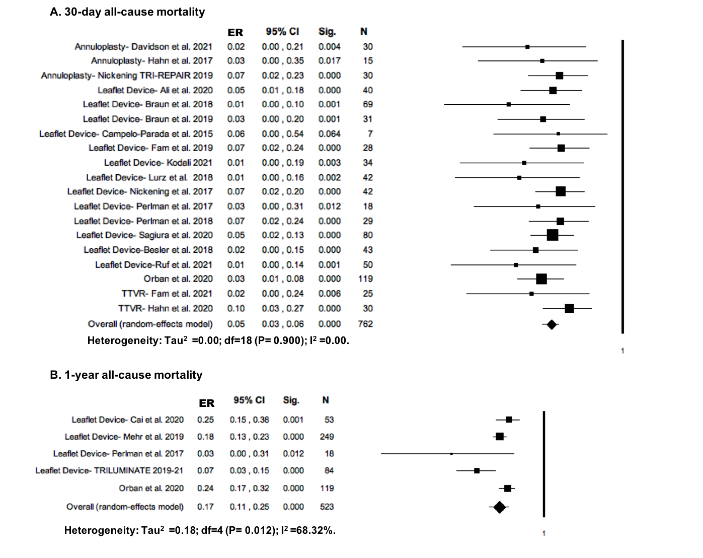

Supplementary Figure 2. Sensitivity analyses for 30-day (A) and 1-year mortality (B), after removing CAVI studies.

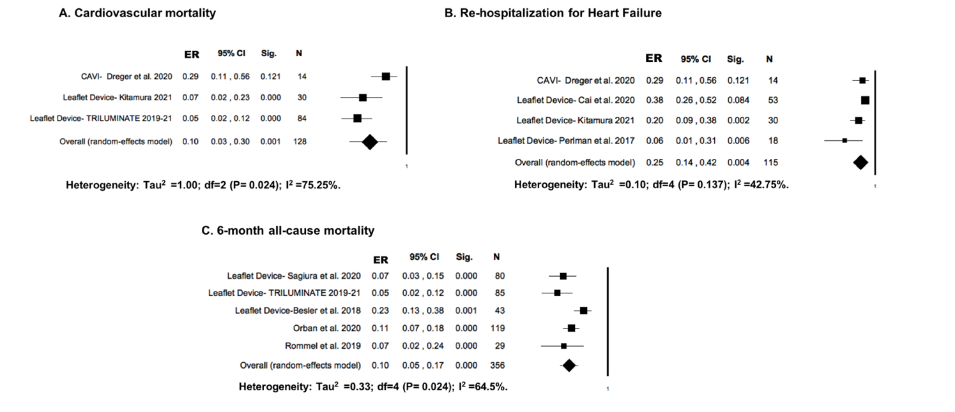

Supplementary Figure 3. Forrest-plot for the incidence of 1-year cardiovascular mortality (A), re-hospitalization for heart failure (B), and 6-month all-cause mortality.

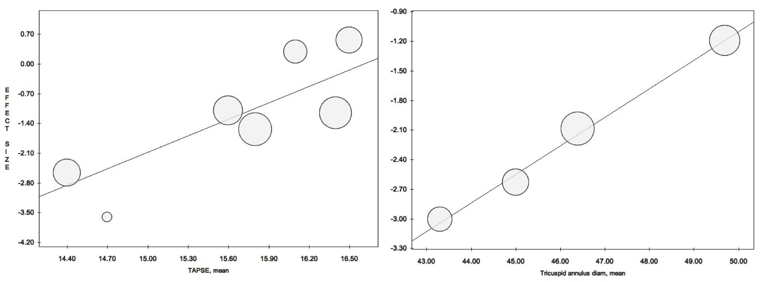

Supplementary Figure 4. Representative plots of significant effects modifiers.

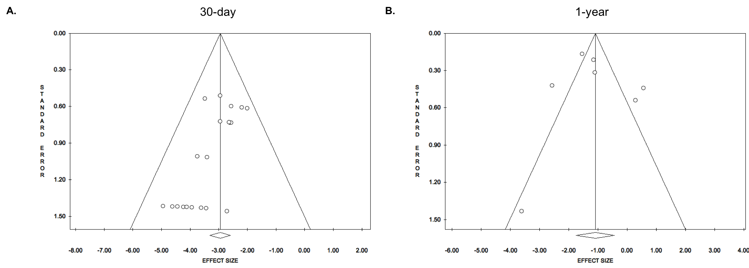

Supplementary Figure 5. Representative funnel plots for the analyzed outcomes of interest.

