Supplement materials

The Efficacy and Safety of HoLEP for Benign Prostatic Hyperplasia with Volume More Than 80ml: A Systematic Review and Meta-analysis

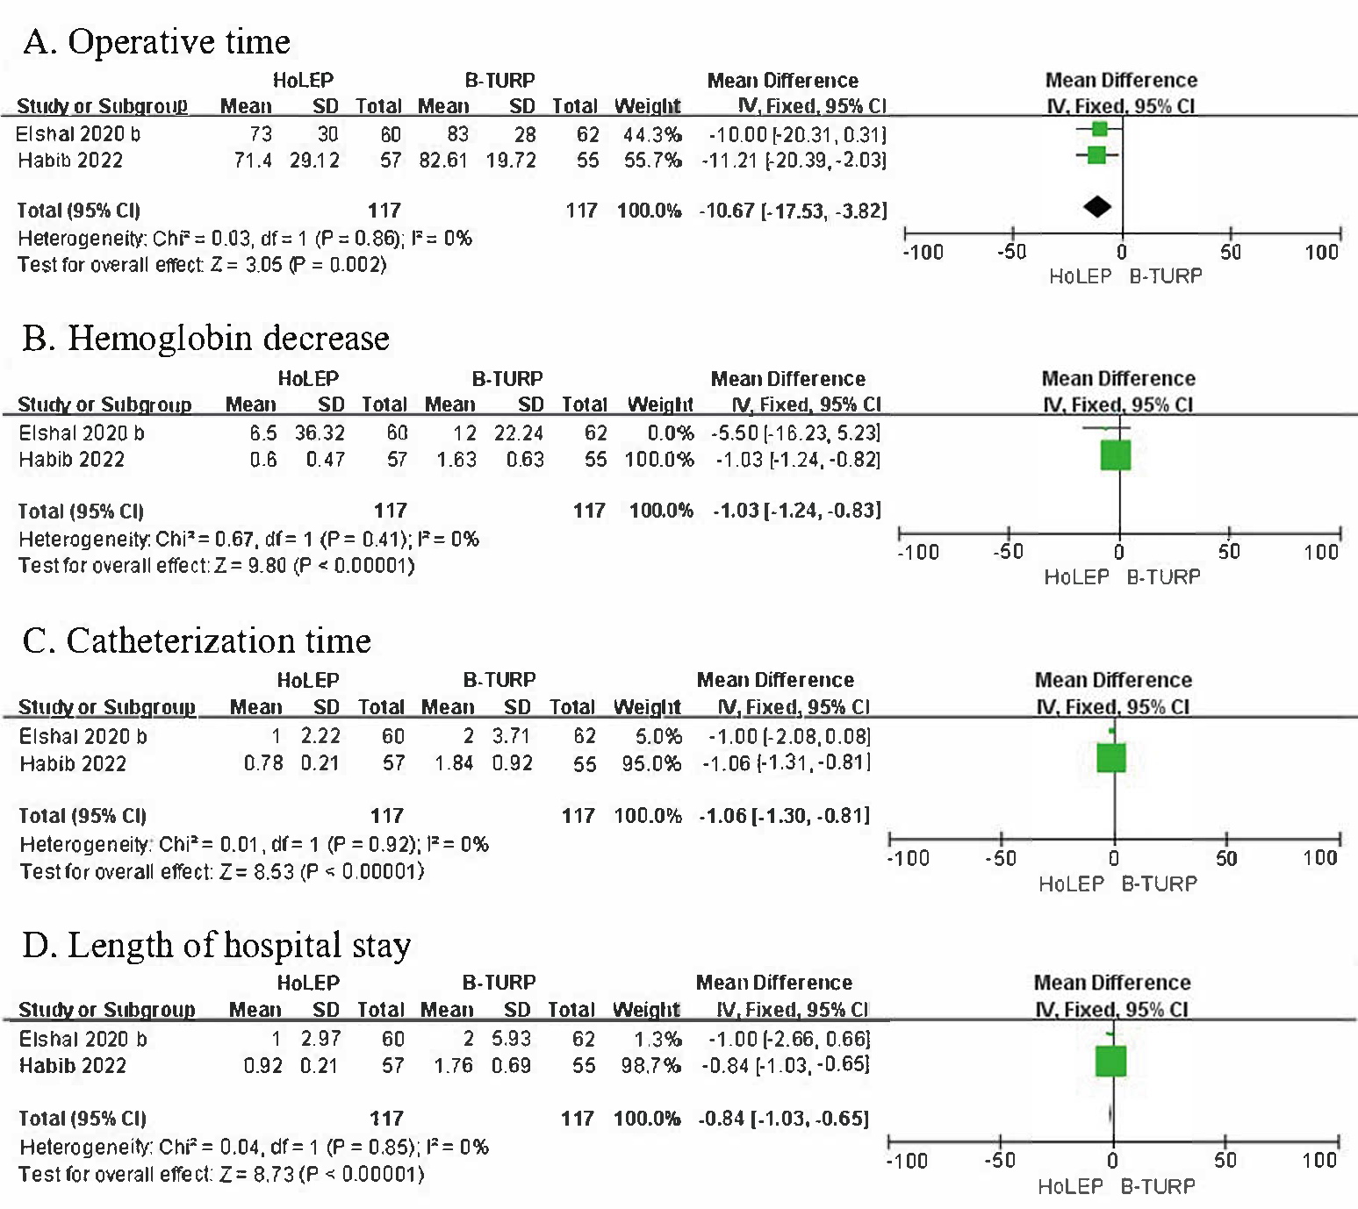
Supplement figure.1 The sub-analysis of HoLEP and B-TURP in treating BPH which the prostate was more than 80ml during perioperative period.

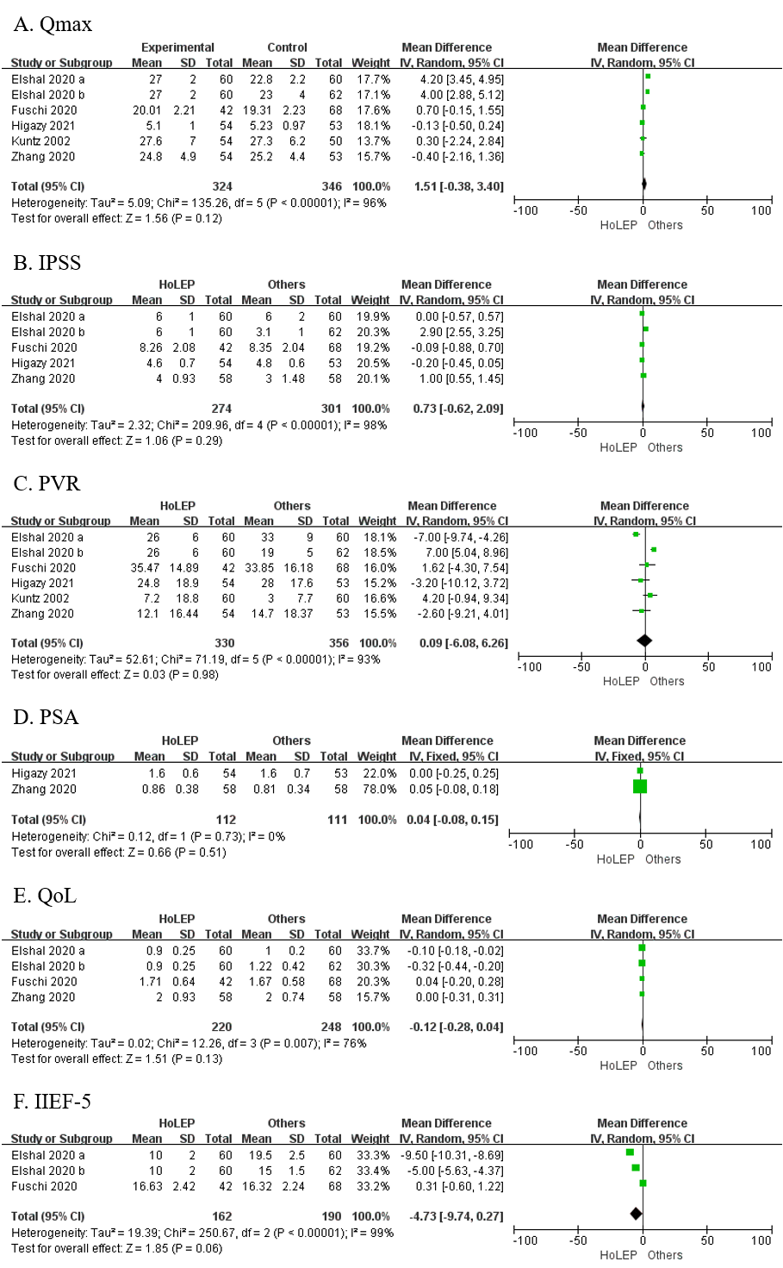
Supplement figure.2 The analysis of HoLEP and other surgeries in treating BPH which the prostate was more than 80ml during 3-4th month after surgery

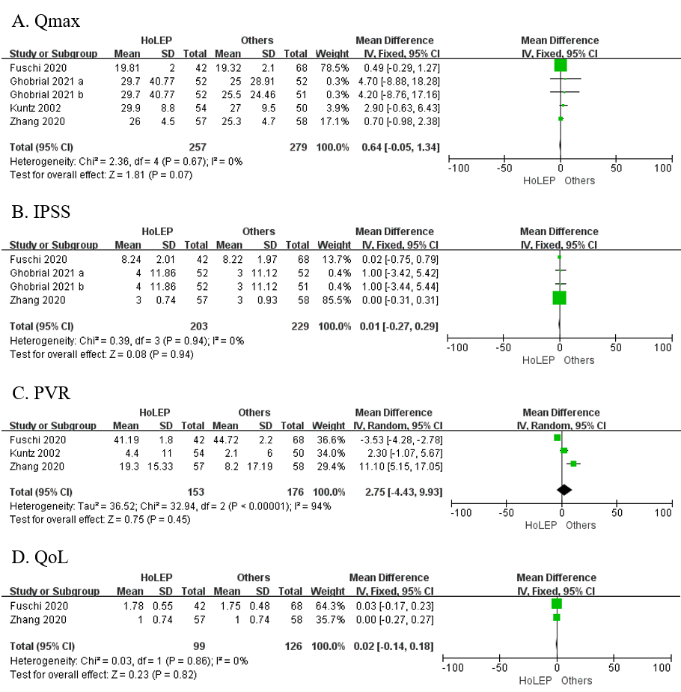
Supplement figure.3 The analysis of HoLEP and other surgeries in treating BPH which the prostate was more than 80ml during 6th month after surgery.

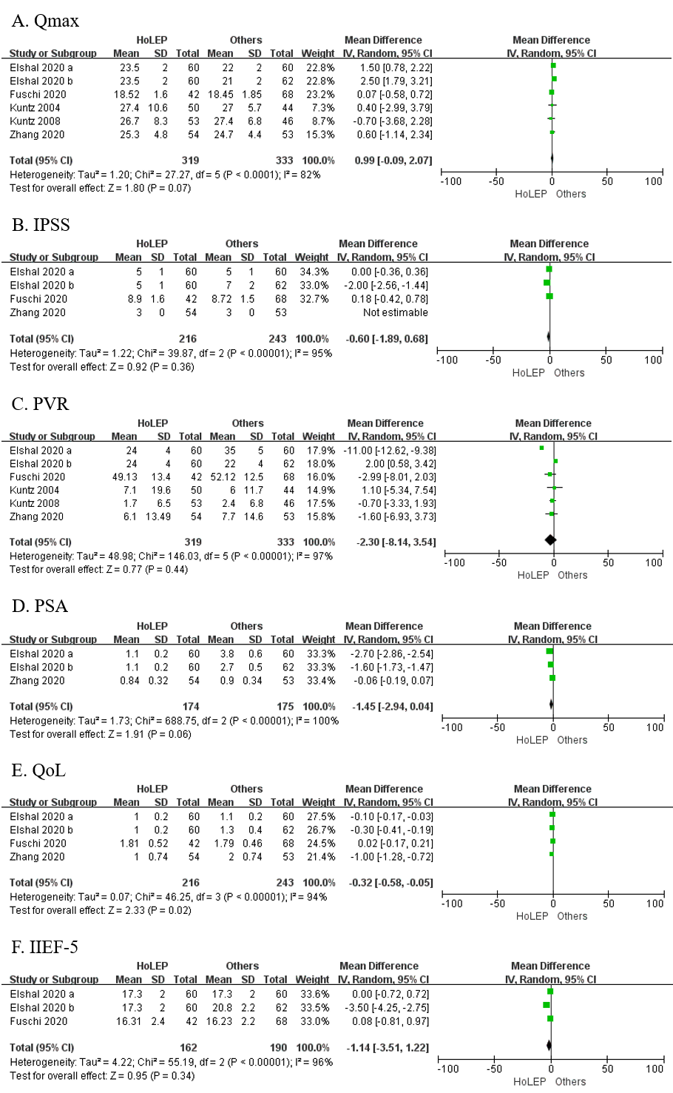
Supplement figure.4 The analysis of HoLEP and other surgeries in treating BPH which the prostate was more than 80ml during 12-24th month after surgery.

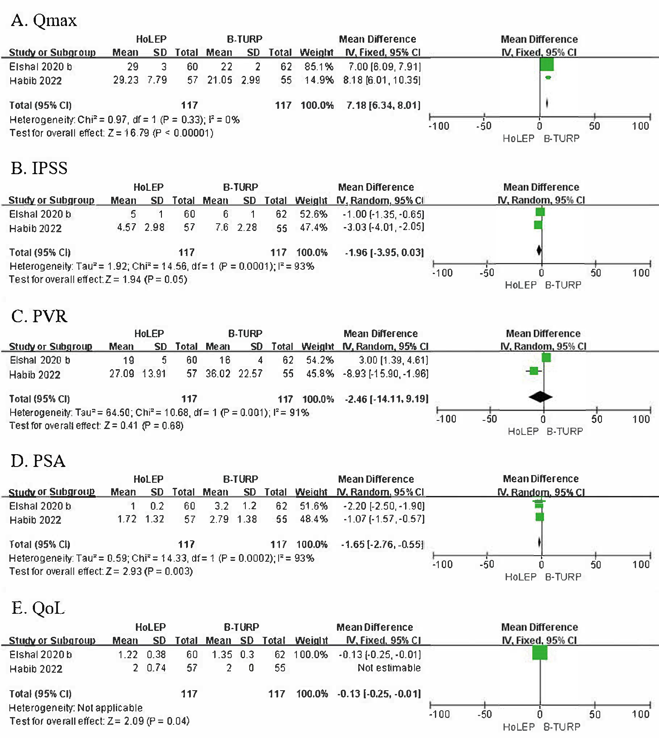
Supplement figure.5 The sub-analysis of HoLEP and B-TURP in treating BPH which the prostate was more than 80ml during 36th month after surgery.

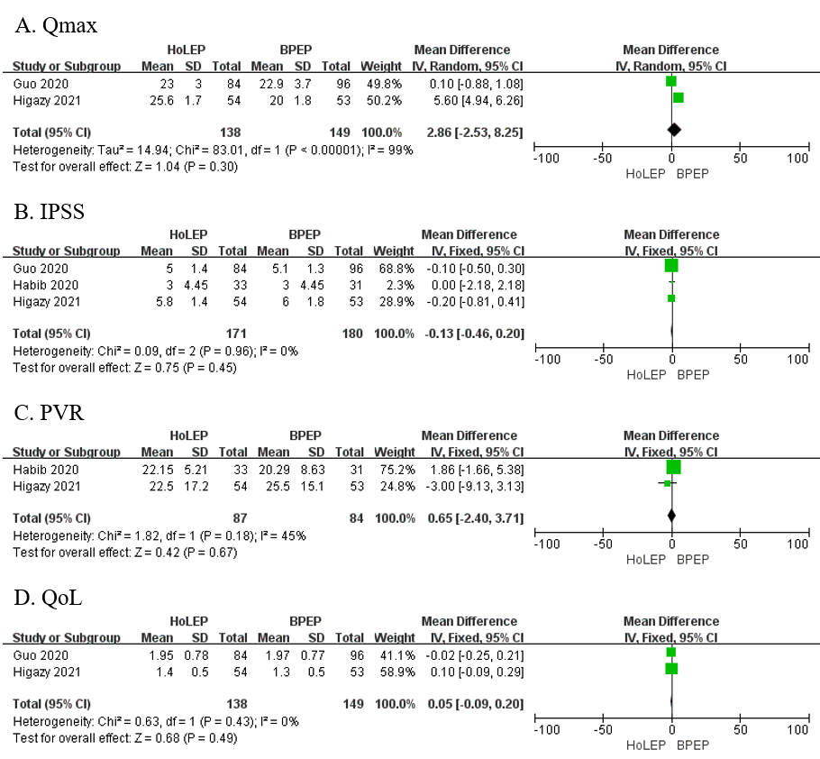
Supplement figure.6 The sub-analysis of HoLEP and BPEP in treating BPH which the prostate was more than 80ml during 12th month after surgery.

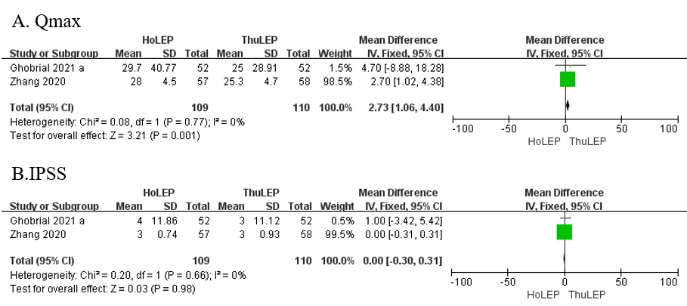
Supplement figure.7 The sub-analysis of HoLEP and ThuLEP in treating BPH which the prostate was more than 80ml during 6th month after surgery

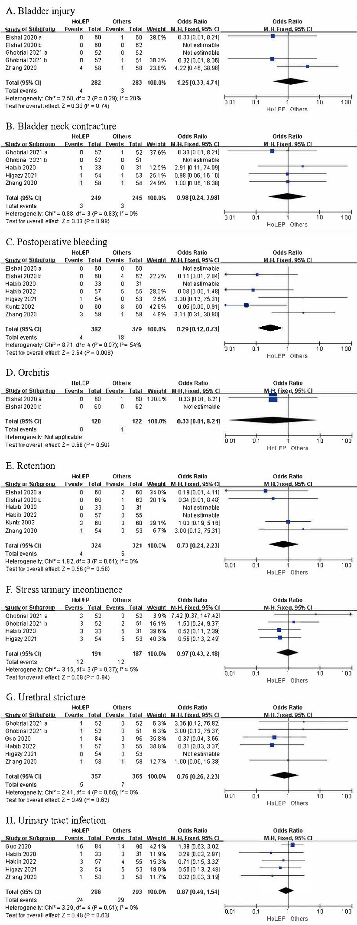
Supplement figure.8 The analysis of complication of HoLEP and other surgeries in treating BPH which the prostate was more than 80ml.

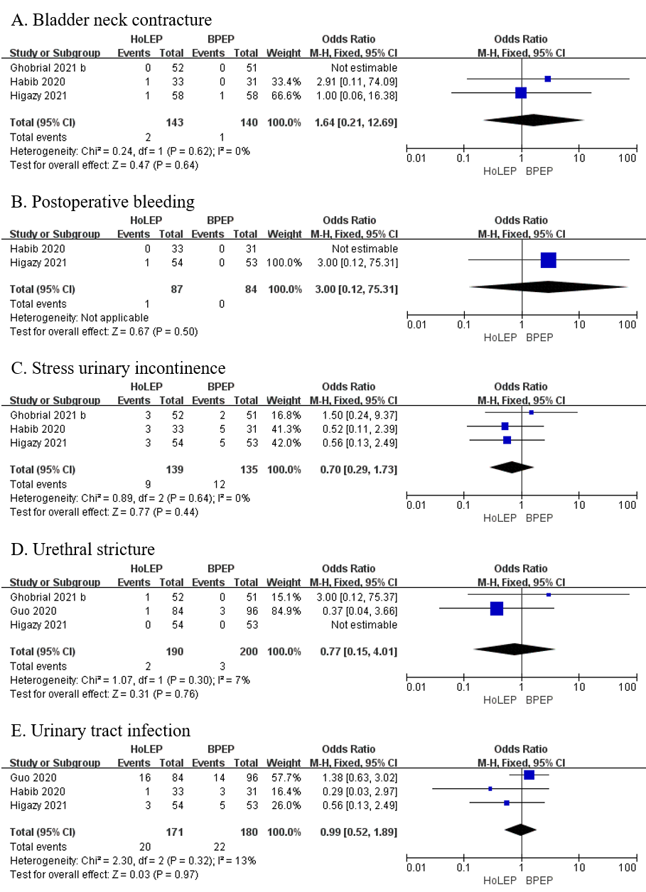
Supplement figure.9 The sub-analysis of complication of HoLEP and BPEP in treating BPH which the prostate was more than 80ml.

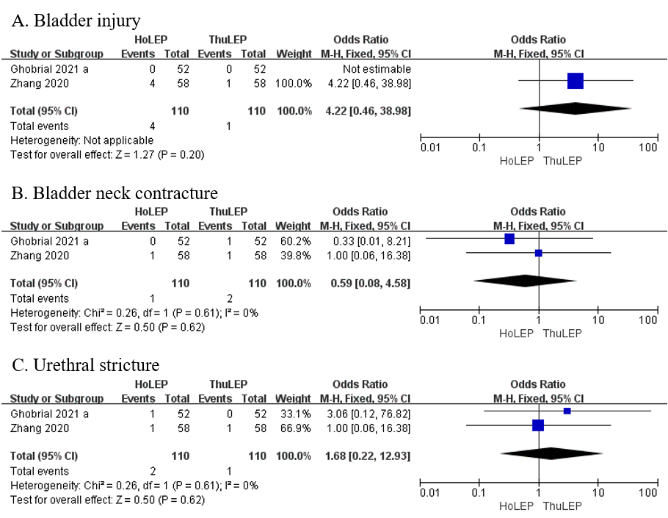
Supplement figure.10 The sub-analysis of complication of HoLEP and ThuLEP in treating BPH which the prostate was more than 80ml.

