Figure S1 - Network plots for pain outcomes at all follow-up times including smaller trials.
Figure S2 - Network plots for function outcomes at all follow-up times including smaller trials.
ACU = Acupuncture (inc. electro acupuncture); CONTROL = Placebo/no intervention; ELEC = Other electrotherapy (inc. PSWD, PEMF or PRF); ESWT = Extra corporeal shock wave therapy; EXE = Exercise (as part of multimodal physiotherapy); LASER = Laser therapy (inc. HILT or LLLT); MAN = Manual therapy; NSAIDS = NSAIDS; RINJ = PRP injection (platelet rich plasma/autologous blood) or hyaluronic injection ; SINJ = Steroid injection; TAPE = Taping; TENS = Microcurrent (MENS); ULTRA = Ultrasound therapy; SURG = Surgery (Split into: open surgery & arthroscopic surgery); NAT = Naturopathic care.
Figure S3 - Network plots for pain outcomes at short Mid-term and long-term follow-up times excluding small trials with <60 participants at randomisation + excluding trials which are not low risk of bias for randomisation and analysis.
Note: Line width represents the number of trials providing direct evidence for the comparison. Node size and numbers represent the number of participants receiving the treatment.
Pain T2, T4

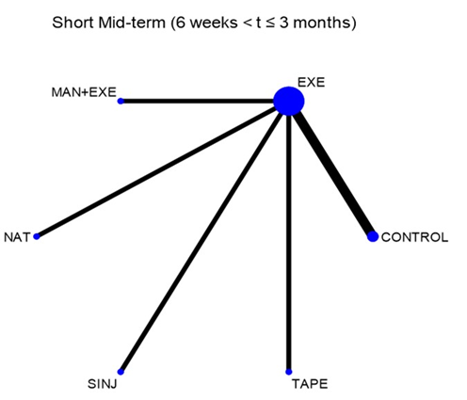
  No. | all RoB | low RoB
  studies | 20 | 6
  treatments | 13 | 6
  Treatm~t | SUCRA | PrBest | MeanRank | Pr(top 3)
  NAT | 98.8 | 94.5 | 1.1 | 99.9
  TAPE | 77.1 | 5 | 2.1 | 96.9
  EXE | 52.5 | 0 | 3.4 | 61.1
  MAN+EXE | 45.7 | 0.5 | 3.7 | 37.7
  SINJ | 20.7 | 0 | 5 | 4.4
  CONTROL | 5.1 | 0 | 5.7 | 0
CONTROL |  |  |  |  | 0.57 (0.25,0.89)
0.84 (0.38,1.30) | TAPE |  |  |  | -0.27 (-0.6,0.06)
0.21 (-0.31,0.74) | -0.63 (-1.16,-0.09) | SINJ |  |  | 0.36 (-0.06,0.78)
1.31 (0.77,1.86) | 0.47 (-0.08,1.02) | 1.10 (0.49,1.71) | NAT |  | -0.74 (-1.18,-0.3)
0.51 (-0.07,1.08) | -0.34 (-0.92,0.25) | 0.29 (-0.34,0.93) | -0.81 (-1.46,-0.16) | MAN+EXE | 0.06 (-0.41,0.54)
0.57 (0.25,0.89) | -0.27 (-0.60,0.06) | 0.36 (-0.06,0.78) | -0.74 (-1.18,-0.30) | 0.06 (-0.41,0.54) | EXE

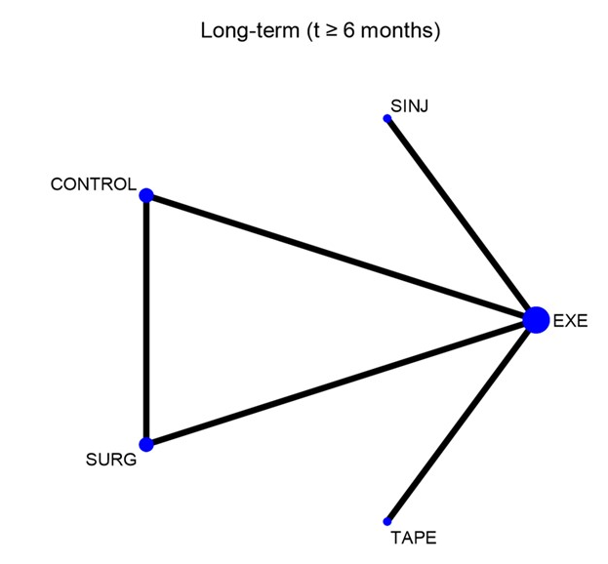
  No. | all RoB | low RoB
  studies | 7 | 3
  treatments | 9 | 5
  Treatm~t | SUCRA | PrBest | MeanRank | Pr(top 3)
  SURG | 94.5 | 82 | 1.2 | 99.2
  CONTROL | 60.8 | 6.7 | 2.6 | 84
  TAPE | 53.1 | 10.5 | 2.9 | 72.1
  EXE | 31.2 | 0.2 | 3.8 | 33.3
  SINJ | 10.3 | 0.6 | 4.6 | 11.4
CONTROL |  | 0.26 (-0.11,0.62) |  | -0.16 (-0.51,0.19)
-0.04 (-0.53,0.44) | TAPE |  |  | -0.12 (-0.45,0.22)
0.26 (-0.11,0.62) | 0.30 (-0.18,0.78) | SURG |  | -0.42 (-0.77,-0.07)
-0.34 (-0.86,0.19) | -0.29 (-0.81,0.22) | -0.59 (-1.12,-0.06) | SINJ | 0.18 (-0.22,0.57)
-0.16 (-0.51,0.19) | -0.12 (-0.45,0.22) | -0.42 (-0.77,-0.07) | 0.18 (-0.22,0.57) | EXE

Treatment abbreviations: CONTROL = Placebo/no intervention; EXE = Exercise (as part of multimodal physiotherapy); MAN = Manual therapy; SINJ = Steroid injection; TAPE = Taping; SURG = Surgery (split into: open surgery & arthroscopic surgery); NAT = Naturopathic care.
Figure S4 - Network plots for function outcomes at short Mid-term and long-term follow-up times excluding small trials with <60 participants at randomisation + excluding trials which are not low risk of bias for randomisation and analysis

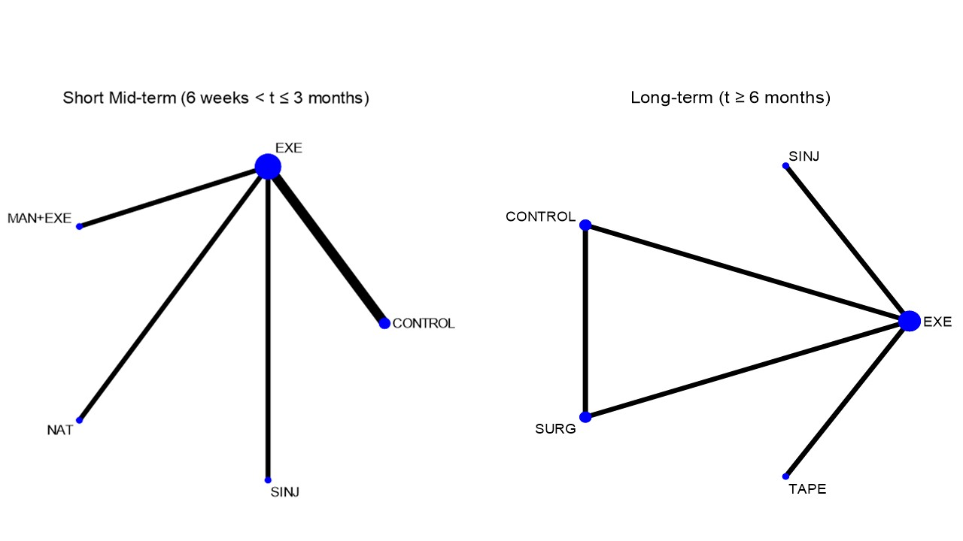
  No. | all RoB | low RoB
  studies | 20 | 5
  treatments | 13 | 5
  Treatm~t | SUCRA | PrBest | MeanRank | Pr(Top 3)
  NAT | 95.9 | 87 | 1.2 | 99.4
  MAN+EXE | 56.2 | 9 | 2.8 | 72.6
  EXE | 55.9 | 1 | 2.8 | 86.2
  SINJ | 38.5 | 3 | 3.5 | 40.7
  CONTROL | 3.5 | 0 | 4.9 | 1.1
CONTROL |  |  |  | 0.74 (0.29,1.19)
0.55 (-0.21,1.30) | SINJ |  |  | 0.19 (-0.22,0.61)
1.35 (0.58,2.11) | 0.80 (-0.06,1.66) | NAT |  | -0.61 (-1.04,-0.17)
0.74 (-0.05,1.53) | 0.19 (-0.69,1.08) | -0.61 (-1.50,0.28) | MAN+EXE | 0.00 (-0.48,0.48)
0.74 (0.28,1.19) | 0.19 (-0.41,0.79) | -0.61 (-1.22,0.01) | 0.00 (-0.65,0.65) | EXE

No. | all RoB | low RoB
studies | 9 | 3
treatments | 9 | 5
Treatm~t | SUCRA | PrBest | MeanRank | Pr(Top 3)
TAPE | 88.5 | 63.3 | 1.5 | 99.3
SURG | 80.5 | 34.1 | 1.8 | 98.2
CONTROL | 44.1 | 1.9 | 3.2 | 72.4
EXE | 22.1 | 0 | 4.1 | 14.2
SINJ | 14.8 | 0.7 | 4.4 | 15.9

CONTROL |  | 0.25 (-0.12,0.61) |  | -0.15 (-0.5,0.2)
0.34 (-0.15,0.82) | TAPE |  |  | -0.48 (-0.82,-0.15)
0.25 (-0.12,0.61) | -0.09 (-0.58,0.39) | SURG |  | -0.39 (-0.74,-0.04)
-0.22 (-0.75,0.30) | -0.56 (-1.08,-0.04) | -0.47 (-0.99,0.06) | SINJ | 0.07 (-0.32,0.47)
-0.15 (-0.50,0.20) | -0.48 (-0.82,-0.15) | -0.39 (-0.74,-0.04) | 0.07 (-0.32,0.47) | EXE

Note: Line width represents the number of trials providing direct evidence for the comparison. Node size and numbers represent the number of participants receiving the treatment.
Function T2, T4

Treatment abbreviations: CONTROL = Placebo/no intervention; EXE = Exercise (as part of multimodal physiotherapy); MAN = Manual therapy; SINJ = Steroid injection; TAPE = Taping; SURG = Surgery (split into: open surgery & arthroscopic surgery); NAT = Naturopathic care.

Forest plots of direct evidence
Pain T1
Pain T3

Function T1

Function T2

Function T3

Function T4


