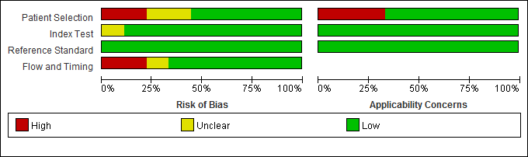
Supplementary Fig. 1. QUADAS-2 risk of bias and applicability concerns (key question 2).

