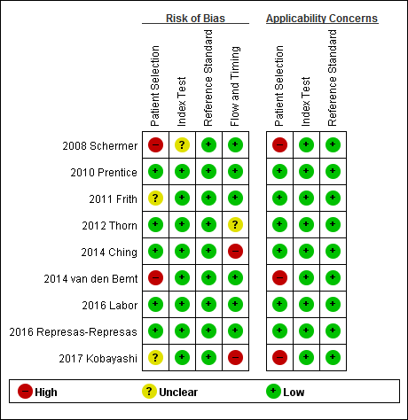
Supplementary Fig. 2. QUADAS-2 risk of bias and applicability concerns of included studies (key question 2).

