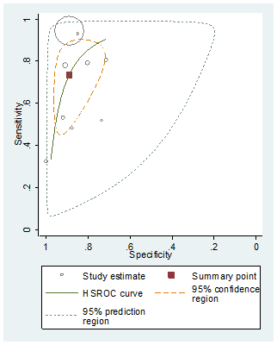  (A) | 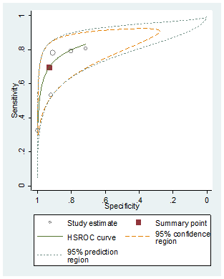  (B)
Supplementary Fig. 3. HSROC model applied to (A) full studies, (B) studies targeted to the general population (key question 2).
HSROC = hierarchical summary receiver-operating characteristic curve.

