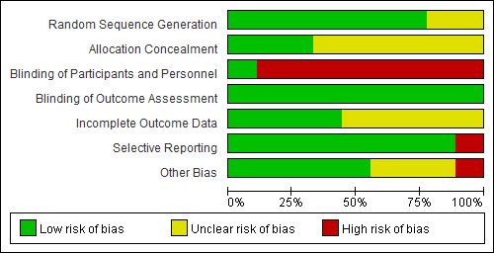
Supplementary Fig. 4. Risk of bias assessment (key question 4).

