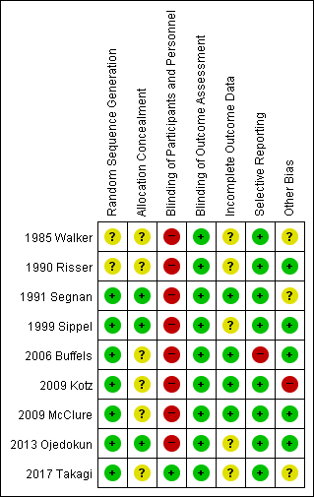
Supplementary Fig. 5. Risk of bias assessment of included studies (key question 4).

