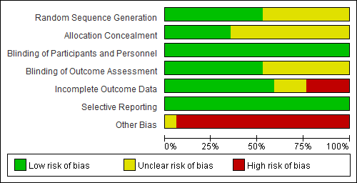
Supplementary Fig. 6. Risk of bias assessment (key question 6-1, pharmacotherapy).

