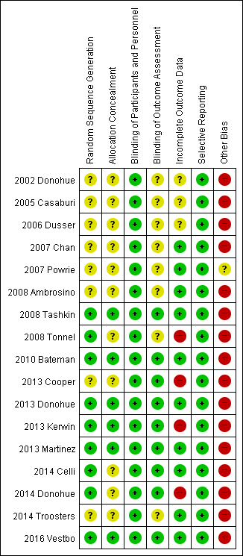
Supplementary Fig. 7. Risk of bias assessment of included studies (key question 6-1, pharmacotherapy).

