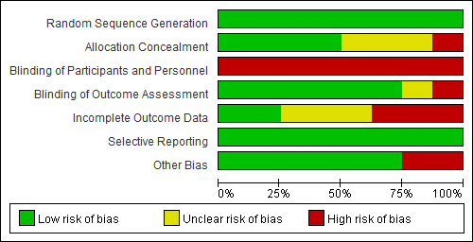
Supplementary Fig. 8. Risk of bias assessment (key question 6-1, pulmonary rehabilitation).

