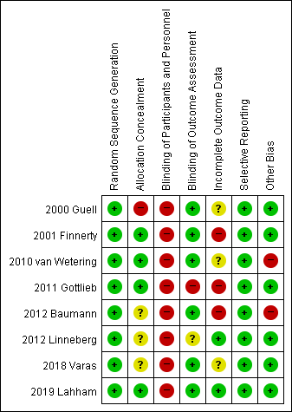
Supplementary Fig. 9. Risk of bias assessment of included studies (key question 6-1, pulmonary rehabilitation).

