- Comparing BCS+RT vs BCS
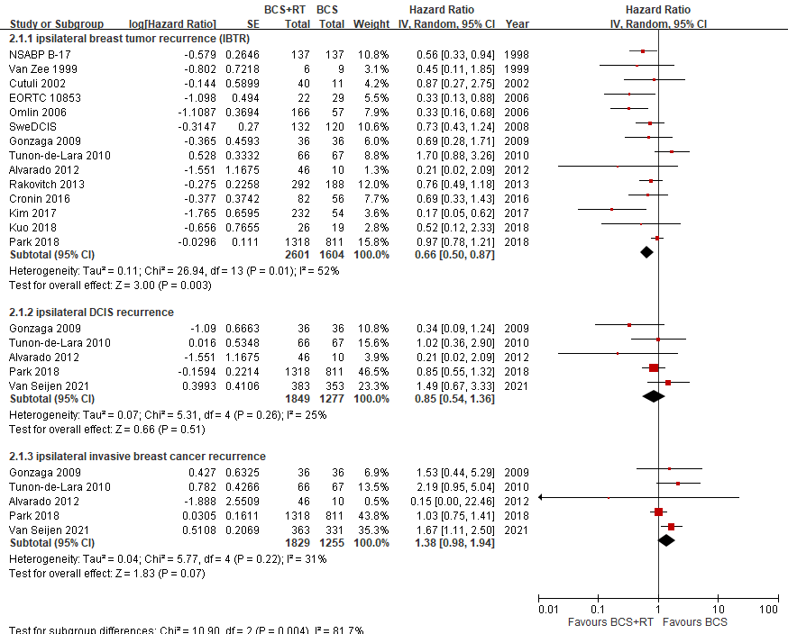

- Comparing BCS+RT vs MT
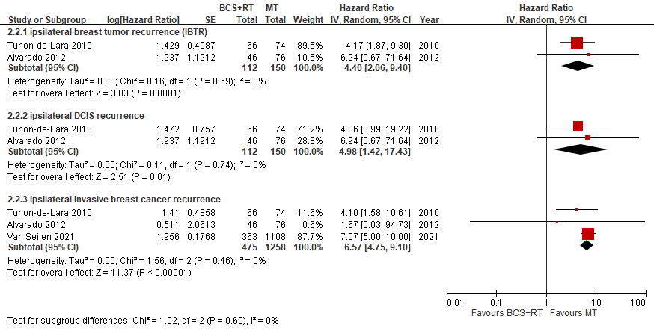
Supplementary Fig. S2 Comparison of local control among local treatment modalities in patients ≤ 50 years of age treated for DCIS
A. Comparing BCS+RT vs BCS; B. Comparing BCS+RT vs MT
BCS+RT: breast conserving surgery with adjuvant radiotherapy, BCS: breast conserving surgery, SE: standard error, IV: inverse variance, CI: confidence interval, IBTR: ipsilateral breast tumor recurrence, DCIS: ductal carcinoma in situ, MT: total mastectomy

