A. Stratified by cutoff age
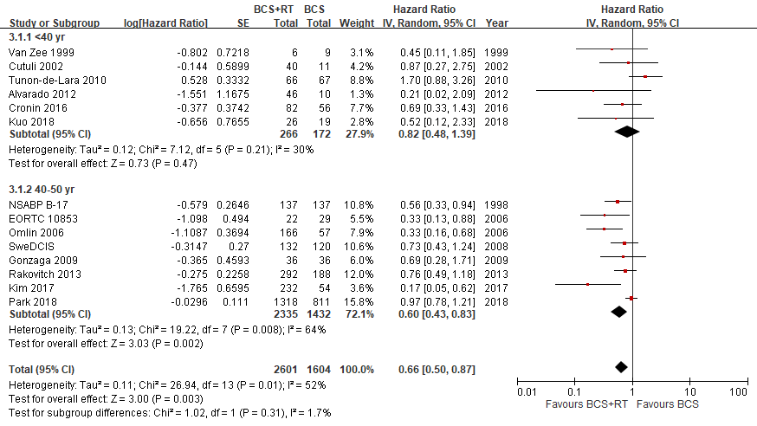
B. Stratified by median follow-up time
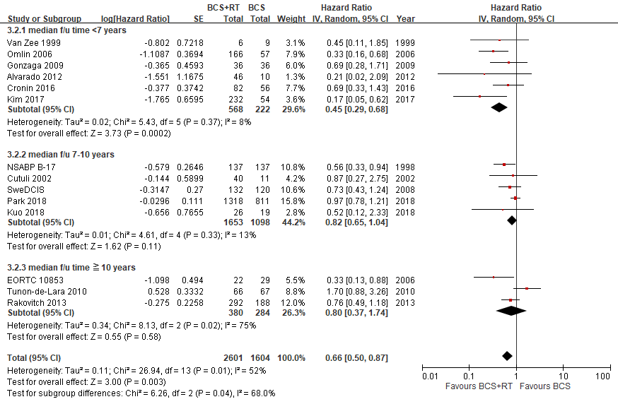

C. Stratified by hormone therapy useª
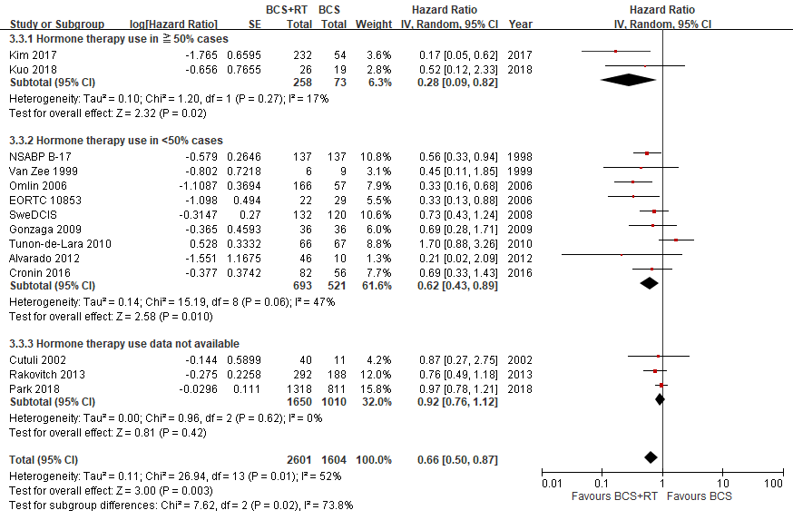
D. Stratified by surgical margin status^{b}
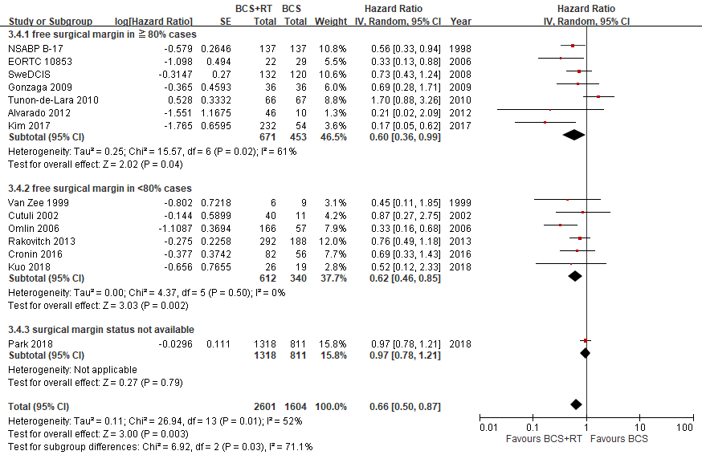
E. Stratified by study design
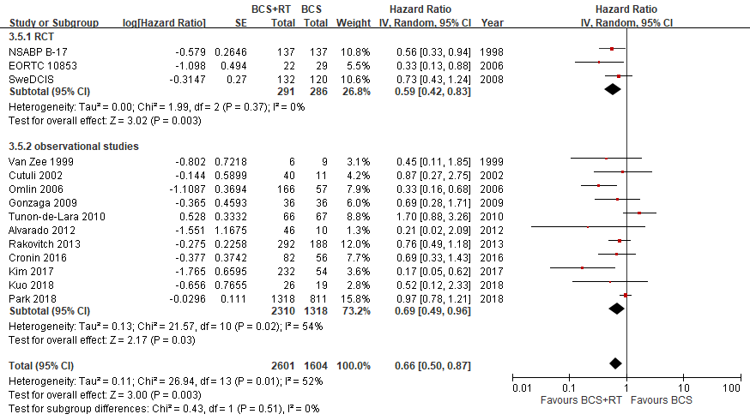
F. Stratified by +/- multivariate analysis^{c}
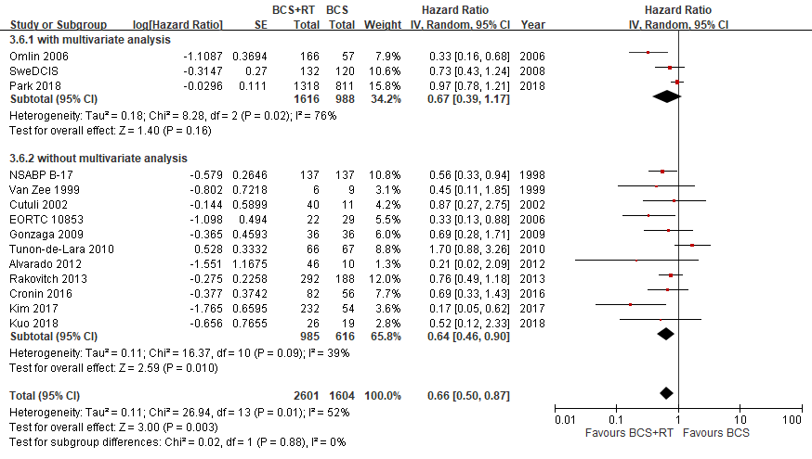

G. Stratified by boost irradiation
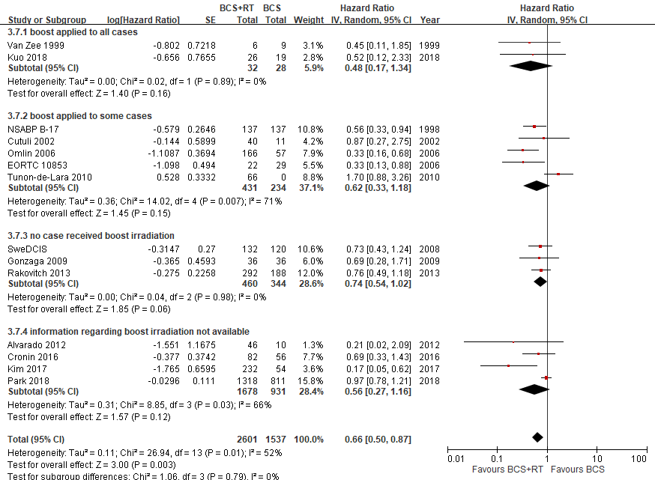

H. Stratified by patient-included year^{d}
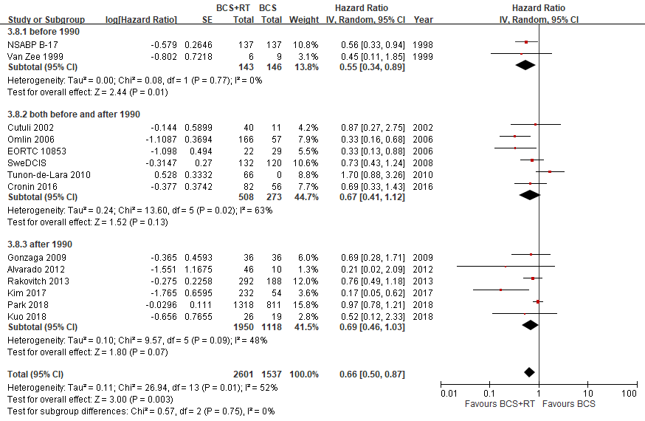
Supplementary Fig. S3 Subgroup analysis of ipsilateral breast tumor recurrence (IBTR) comparing breast conserving surgery with adjuvant radiotherapy (BCS+RT) to breast conserving surgery (BCS) in DCIS women diagnosis at 50 year-old or less A. Stratified by cutoff age; B. Stratified by median follow-up time; C. Stratified by hormone therapy use; D. Stratified by surgical margin status; E. Stratified by study design; F. Stratified by +/- multivariate analysis; G. Stratified by boost irradiation; H. Stratified by patient-included year..
SE: standard error, IV: inverse variance, CI: confidence interval
ªThe incidence of positive estrogen receptor in DCIS was ranged 49-77.8 % ⁵⁹. Therefore,  50% was chosen as the cutoff value for subgroup analysis, indicating a more regular use of hormone therapy in the study population. The studies were listed by decreasing order of proportion of hormone therapy use.
^{b}In order to compare with the EBCTCG study including 4 large RCTs having the free surgical margin rate of 80% or more,  80% was chosen as the cutoff value for subgroup analysis. The studies were listed by decreasing order of proportion of patients achieving free surgical margin.
^{c}Factors corrected in studies with multivariate analysis: Omlin 2006: age, detection method, tumor size, necrosis, tumor grade, margin status, oestrogen-receptor status; Park 2018: age, year of diagnosis, race, registry region, tumor grade, histology, size, hormone receptor status; SWeDCIS: tumor size, focality, margin status, mode of detection.
^{d}Patient-included year was taken as substitutional index for technique of radiation therapy. Case inclusion before 1990 was considered at risk for suboptimal RT techniques⁶⁰.

