A. Comparing BCS+RT vs BCS
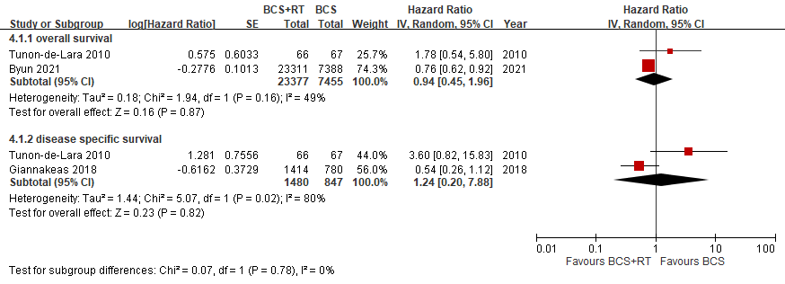

B. Comparing BCS+RT vs MT
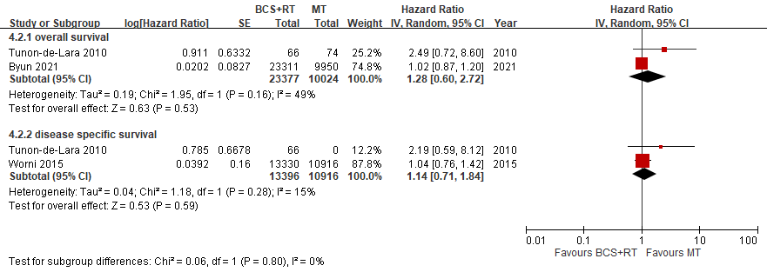
Supplementary Fig. S4 Comparison of survival among local treatment modalities in patients ≤ 50 years of age treated for DCIS
A. Comparing BCS+RT vs BCS; B. Comparing BCS+RT vs MT
BCS+RT: breast conserving surgery with adjuvant radiotherapy, BCS: breast conserving surgery, SE: standard error, IV: inverse variance, CI: confidence interval, MT: total mastectomy

