Supplementary Table S1. PRISMA 2020 checklist

Section and Topic | Item # | Checklist item | Location where item is reported
TITLE
Title | 1 | Identify the report as a systematic review. | 1
ABSTRACT
Abstract | 2 | See the PRISMA 2020 for Abstracts checklist. | 2
INTRODUCTION
Rationale | 3 | Describe the rationale for the review in the context of existing knowledge. | 4
Objectives | 4 | Provide an explicit statement of the objective(s) or question(s) the review addresses. | 5
METHODS
Eligibility criteria | 5 | Specify the inclusion and exclusion criteria for the review and how studies were grouped for the syntheses. | 6
Information sources | 6 | Specify all databases, registers, websites, organisations, reference lists and other sources searched or consulted to identify studies. Specify the date when each source was last searched or consulted. | 6
Search strategy | 7 | Present the full search strategies for all databases, registers and websites, including any filters and limits used. | Table 1
Selection process | 8 | Specify the methods used to decide whether a study met the inclusion criteria of the review, including how many reviewers screened each record and each report retrieved, whether they worked independently, and if applicable, details of automation tools used in the process. | 7
Data collection process | 9 | Specify the methods used to collect data from reports, including how many reviewers collected data from each report, whether they worked independently, any processes for obtaining or confirming data from study investigators, and if applicable, details of automation tools used in the process. | 7
Data items | 10a | List and define all outcomes for which data were sought. Specify whether all results that were compatible with each outcome domain in each study were sought (e.g. for all measures, time points, analyses), and if not, the methods used to decide which results to collect. | N/A
Data items | 10b | List and define all other variables for which data were sought (e.g. participant and intervention characteristics, funding sources). Describe any assumptions made about any missing or unclear information. | N/A
Study risk of bias assessment | 11 | Specify the methods used to assess risk of bias in the included studies, including details of the tool(s) used, how many reviewers assessed each study and whether they worked independently, and if applicable, details of automation tools used in the process. | 6
Effect measures | 12 | Specify for each outcome the effect measure(s) (e.g. risk ratio, mean difference) used in the synthesis or presentation of results. | N/A
Synthesis methods | 13a | Describe the processes used to decide which studies were eligible for each synthesis (e.g. tabulating the study intervention characteristics and comparing against the planned groups for each synthesis (item #5)). | 7
Synthesis methods | 13b | Describe any methods required to prepare the data for presentation or synthesis, such as handling of missing summary statistics, or data conversions. | N/A
Synthesis methods | 13c | Describe any methods used to tabulate or visually display results of individual studies and syntheses. | 7
Synthesis methods | 13d | Describe any methods used to synthesize results and provide a rationale for the choice(s). If meta-analysis was performed, describe the model(s), method(s) to identify the presence and extent of statistical heterogeneity, and software package(s) used. | N/A
Synthesis methods | 13e | Describe any methods used to explore possible causes of heterogeneity among study results (e.g. subgroup analysis, meta-regression). | N/A
Synthesis methods | 13f | Describe any sensitivity analyses conducted to assess robustness of the synthesized results. | N/A
Reporting bias assessment | 14 | Describe any methods used to assess risk of bias due to missing results in a synthesis (arising from reporting biases). | N/A
Certainty assessment | 15 | Describe any methods used to assess certainty (or confidence) in the body of evidence for an outcome. | N/A
RESULTS
Study selection | 16a | Describe the results of the search and selection process, from the number of records identified in the search to the number of studies included in the review, ideally using a flow diagram. | Figure S1
Study selection | 16b | Cite studies that might appear to meet the inclusion criteria, but which were excluded, and explain why they were excluded. | Figure S1
Study characteristics | 17 | Cite each included study and present its characteristics. | Table 3
Risk of bias in studies | 18 | Present assessments of risk of bias for each included study. | Table 4
Results of individual studies | 19 | For all outcomes, present, for each study: (a) summary statistics for each group (where appropriate) and (b) an effect estimate and its precision (e.g. confidence/credible interval), ideally using structured tables or plots. | Table 6
Results of syntheses | 20a | For each synthesis, briefly summarise the characteristics and risk of bias among contributing studies. | 9
Results of syntheses | 20b | Present results of all statistical syntheses conducted. If meta-analysis was done, present for each the summary estimate and its precision (e.g. confidence/credible interval) and measures of statistical heterogeneity. If comparing groups, describe the direction of the effect. | 9
Results of syntheses | 20c | Present results of all investigations of possible causes of heterogeneity among study results. | Table 5
Results of syntheses | 20d | Present results of all sensitivity analyses conducted to assess the robustness of the synthesized results. | N/A
Reporting biases | 21 | Present assessments of risk of bias due to missing results (arising from reporting biases) for each synthesis assessed. | N/A
Certainty of evidence | 22 | Present assessments of certainty (or confidence) in the body of evidence for each outcome assessed. | N/A
DISCUSSION
Discussion | 23a | Provide a general interpretation of the results in the context of other evidence. | 11
Discussion | 23b | Discuss any limitations of the evidence included in the review. | 12
Discussion | 23c | Discuss any limitations of the review processes used. | 12
Discussion | 23d | Discuss implications of the results for practice, policy, and future research. | 12
OTHER INFORMATION
Registration and protocol | 24a | Provide registration information for the review, including register name and registration number, or state that the review was not registered. | N/A
Registration and protocol | 24b | Indicate where the review protocol can be accessed, or state that a protocol was not prepared. | N/A
Registration and protocol | 24c | Describe and explain any amendments to information provided at registration or in the protocol. | N/A
Support | 25 | Describe sources of financial or non-financial support for the review, and the role of the funders or sponsors in the review. | 1
Competing interests | 26 | Declare any competing interests of review authors. | 1
Availability of data, code and other materials | 27 | Report which of the following are publicly available and where they can be found: template data collection forms; data extracted from included studies; data used for all analyses; analytic code; any other materials used in the review. | N/A

Supplementary Table S2. Ultrasound protocol reporting
Citation | Sonographer experience (blinded) | US machine (transducer) | US machine settings | Participant positioning | Scanning protocol
Ahmed et al. (2017) | Radiologist who was expert in soft tissue sonography | Hitachi Aloka Ultrasound Machine (the Hitachi Aloka medical, Ltd, Tokyo, Japan)  10–15 MHz linear transducer. | - | Prone positioning with feet hanging off the examination table in a neutral position at 90° of flexion | Scanned in longitudinal and transverse planes.  Mean values of 3 measurements used for statistical analysis
Bandinelli et al. (2013) | Experienced rheumatologist (blinded to clinical examination) | My Lab 70 XVG US machine (Esaote  Biomedical, Genoa, Italy  6-18 MHz linear probe | PD was standardised with pulse repetition  frequency of 750 Hz and gain of 53 dB | Prone positioning and feet hanging over the edge of the examination table at 90° of flexion. Confirmed using goniometer. | Room set to 20°C for assessing Power Doppler (PD) signal
ElMallah et al. (2020) |  | General Electric Logic P5 R4.0. (General Electric, Milwaukee, Wisconsin, USA)  Multi-frequency, linear transducer probe 3–12 MHz
Falsetti et al. (2003) | Experienced operator blinded to results of radiography | Toshiba Tosbee SAL 240  Linear 7.5 MHz probe, and an Aquaflesh gel pad spacer when necessary |  |  | Scanned bilaterally and symmetrically, with both longitudinal and transverse scans.
Farouk et al. (2010) | Examiner (doctor) was blinded to clinical examination | Esaote MyLab 70x vision. (Esaote medical system Italy)  9–11 MHz probe |  |  | An adequate amount of gel was used to obtain the best visualization of superficial soft tissues.  Subjects were not allowed to assume nonsteroidal anti-inflammatory drugs three weeks before US examination.  Longitudinal and transvers scans of Achilles tendons were obtained.
Fiorenza et al. (2020) | Rheumatologist trained in using US to assess entheseal pathology in MSK. Blinded to clinical and serological data. | MyLab Twice machine (Esaote, Florence, Italy)  6–18 MHz linear probe | Doppler frequency of 9.1MHz with a pulse repetition frequency  (PRF) of 750 mHz | Prone positioning with the feet hanging  over the edge of the examination table  at 90° of flexion | Patients taking NSAIDs were asked to stop  24 hours before US examinations.
Freeston et al. (2014) | Trained ultrasonographer blinded to clinical examination | Philips HDI 5000 (Best) machine  12–5 and 15–7 MHz linear transducers | PD assessed using a PRF of 750 Hz and medium wall filter. Gain was adjusted until background signal was removed. | Prone positioning with the feet hanging  over the edge of the examination table  at 90° of flexion | Scanned in both longitudinal and transverse planes
Galluzzo et al. (2000) | Radiologist who was expert in soft tissue sonography blinded to clinical examination | Hitachi AU 280  7.5 MHz linear array  Transducer and stand-off pad for Achilles tendon |  |  | Scanned in both longitudinal and transverse planes
Litinsky et al. (2016) | Rheumatologist - unblinded | ATL HDI 3000 (SonoSite, M-Turbo).  Linear 7–4-MHz and compact linear  10–5-MHz probes |  |  | Same machine and same settings used throughout the study. Performed in a darkened room. Care taken to not apply pressure to anatomic structures under examination.
Marchesoni et al. (2012) | Rheumatologist experienced in MSK US and blinded to clinical examination | Logiq5 machine  (General Electrics Medical Systems, Milwaukee, WI, USA)  Broadband high-frequency (8-15 MHz) transducer | B-mode frequency 12-15 MHz, PD PRF 750Hz, Doppler frequency 6.7-7.5 MHz, and low wall filters applied. Focus positioned at the level of the region of interest. Color gain was adjusted to just below the level that caused the appearance of noise artefacts. Color box positioned at the level of the enthesis, enlarging the box to the upper part of the image. | Patients positioned to optimise PD US scanning of entheses.
Michelsen et al. (2017) | Rheumatologist experienced in US | Siemens Acuson  S2000 or GE logic E  Both with multifrequency linear transducer (6–18 MHz) | Resolution improved using highest B-mode frequency without losing resolution. Settings adjusted to optimise contrast between structures. PD frequency of 9 (10) MHz, PRF of 391 (400) Hz. PD gain optimised by increasing  gain until artefacts appeared, then by reducing gain until artefacts disappeared. | Patients prone with ankles in passive plantarflexion | Scanned in both longitudinal and transverse planes
Perrotta et al. (2016) | Radiologist experienced in MSK sonography who was blinded to clinical examination | MyLab 70 XVG machine  Broadband 6–18 linear probe | Grey-scale frequency 12–15 MHz; PD frequency 6.7–7.5 MHz; PD PRF 750 Hz; low-wall filters. Focus positioned at region of interest. Colour box enlarged to upper part of the image. |  | Gel applied to skin to provide acoustic interface. Probe pressure on anatomical structures kept to a minimum. Scanned in both longitudinal and transverse planes with probe parallel and perpendicular to tendon fibres.
Wervers et al. (2018) | Trained sonographer blinded to clinical examination | Esaote MyLab60  Probe LA-435 (6–18 MHz) and Probe LA-523 (4–13 MHz) | Probe LA-435 (6–18 MHz, PD frequency 8.3MHz, PRF 750Hz, wall filter 3 applied)  Probe LA-523 (4–13 MHz, 6.3 MHz, PD 750 Hz,  and a wall filter of 4)  Colour gain was set at  the disappearance of colour noise in the bone underneath the enthesis | Patients positioned according to MASEI (62) recommendations
Woodburn et al. (2013) |  | Esaote MyLab 25 Gold machine (Esaote, Genova,  Italy)  LA435 Linear Array probe (18-6 MHz) | Frequencies of 18 and 10 MHz for superficial and deep structures, respectively. PD PRF 0.5kHz and standard region of interest
Xie et al. (2019) | Two experienced rheumatologists blinded to diagnosis and clinical examination | MyLab 30 CV; ESAOTE SpA, Genoa, Italy)  Multi-frequency linear transducer (18 MHz) | PD PRF 750Hz and gain 53dB | Prone positioning with the feet hanging  over the edge of the examination table  at 90° of flexion | Room temperature set to 20°C for PDUS

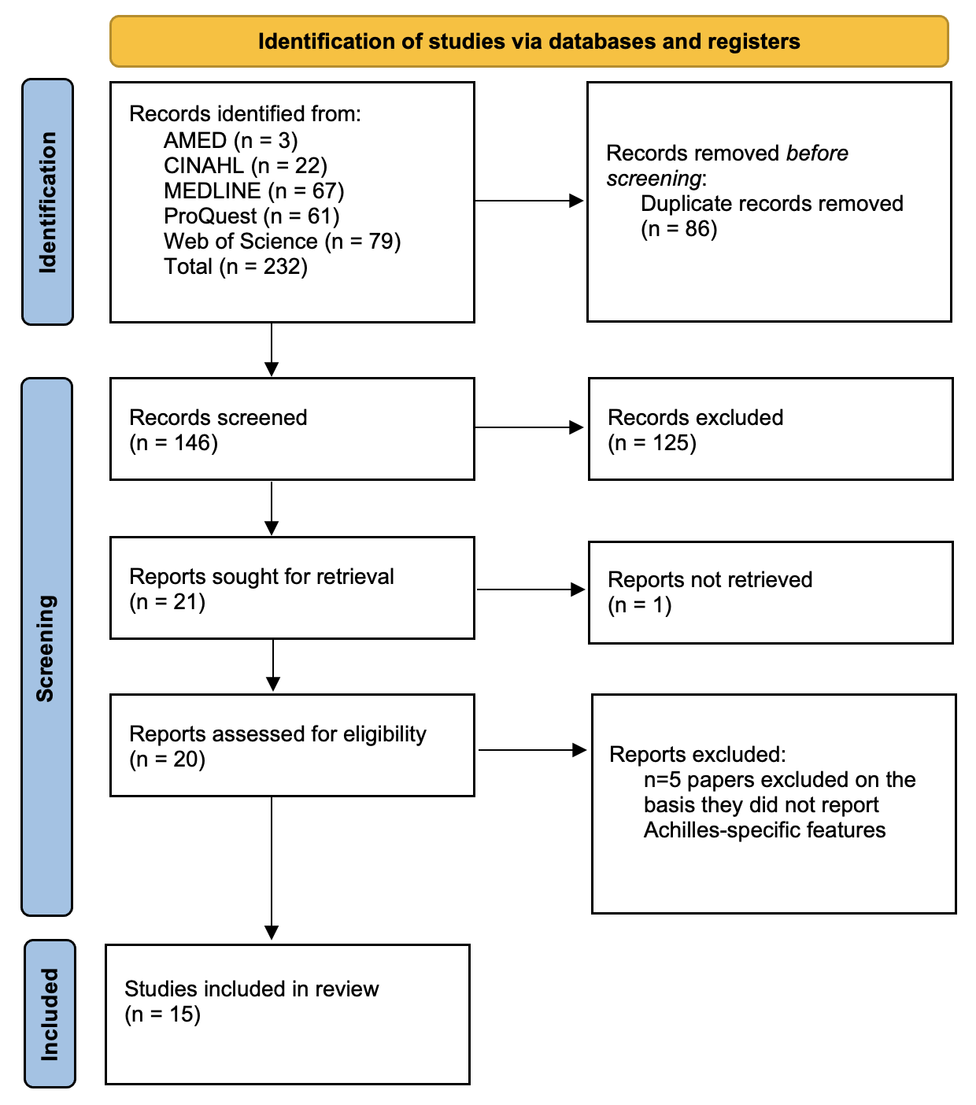

Supplementary Figure S1. PRISMA 2020 flow diagram for new systematic reviews which included searches of databases and registers only.
From: Page MJ, McKenzie JE, Bossuyt PM, Boutron I, Hoffmann TC, Mulrow CD, et al. The PRISMA 2020 statement: an updated guideline for reporting systematic reviews. BMJ 2021;372:n71. doi: 10.1136/bmj.n71

For more information, visit: http://www.prisma-statement.org/

