Supplementary materials

Supplementary material 1: Search queries for current study
PubMed
- "Patient Readmission"[mh] OR readmit*[tiab] OR rehospitali*[tiab] OR Return to Hospital[tiab] OR Postdischarge[tiab] OR Post discharge[tiab] OR Post-discharge[tiab] OR ex-COVID-19[tiab] OR discharged patients[tiab] OR discharged survivors[tiab] OR discharged coronavirus disease 2019 patients[tiab]
- "COVID-19"[mh] OR "SARS-CoV-2"[mh] OR COVID-19[tiab] OR SARS-CoV-2[tiab] OR COVID 19[tiab] OR COVID-19 Virus Disease[tiab] OR COVID 19 Virus Disease[tiab] OR COVID-19 Virus Diseases[tiab] OR COVID-19 Virus Infection[tiab] OR COVID 19 Virus Infection[tiab] OR COVID-19 Virus Infections[tiab] OR 2019-nCoV Infection[tiab] OR 2019 nCoV Infection[tiab] OR 2019-nCoV Infections[tiab] OR Coronavirus Disease-19[tiab] OR Coronavirus Disease 19[tiab] OR 2019 Novel Coronavirus Disease[tiab] OR 2019 Novel Coronavirus Infection[tiab] OR 2019-nCoV Disease[tiab] OR 2019 nCoV Disease[tiab] OR 2019-nCoV Diseases[tiab] OR COVID19[tiab] OR Coronavirus Disease 2019[tiab] OR SARS Coronavirus 2 Infection[tiab] OR SARS-CoV-2 Infection[tiab] OR SARS CoV 2 Infection[tiab] OR SARS-CoV-2 Infections[tiab] OR COVID-19 Pandemic[tiab] OR COVID 19 Pandemic[tiab] OR COVID-19 Pandemics[tiab] OR Coronavirus Disease 2019 Virus[tiab] OR 2019 Novel Coronavirus[tiab] OR 2019 Novel Coronaviruses[tiab] OR Wuhan Seafood Market Pneumonia Virus[tiab] OR SARS-CoV-2 Virus[tiab] OR SARS CoV 2 Virus[tiab] OR SARS-CoV-2 Viruses[tiab] OR Virus, SARS-CoV-2[tiab] OR 2019-nCoV[tiab] OR COVID-19 Virus[tiab] OR COVID 19 Virus[tiab] OR COVID-19 Viruses[tiab] OR Virus, COVID-19[tiab] OR Wuhan Coronavirus[tiab] OR SARS Coronavirus 2[tiab] OR Severe Acute Respiratory Syndrome Coronavirus 2[tiab]
- #1 AND #2

Embase
- 'hospital readmission'/exp OR ‘readmit*’:ab,ti OR ‘rehospitali*’:ab,ti OR ‘Return to Hospital’:ab,ti OR ‘Postdischarge’:ab,ti OR ‘Post discharge’:ab,ti OR ‘Post-discharge’:ab,ti OR ‘ex-COVID-19’:ab,ti OR ‘discharged patients’:ab,ti OR ‘discharged survivors’:ab,ti OR ‘discharged coronavirus disease 2019 patients’:ab,ti
- 'coronavirus disease 2019'/exp OR 'Severe acute respiratory syndrome coronavirus 2'/exp OR ‘COVID-19’:ab,ti OR ‘SARS-CoV-2’:ab,ti OR ‘COVID 19’:ab,ti OR ‘COVID-19 Virus Disease’:ab,ti OR ‘COVID 19 Virus Disease’:ab,ti OR ‘COVID-19 Virus Diseases’:ab,ti OR ‘COVID-19 Virus Infection’:ab,ti OR ‘COVID 19 Virus Infection’:ab,ti OR ‘COVID-19 Virus Infections’:ab,ti OR ‘2019-nCoV Infection’:ab,ti OR ‘2019 nCoV Infection’:ab,ti OR ‘2019-nCoV Infections’:ab,ti OR ‘Coronavirus Disease-19’:ab,ti OR ‘Coronavirus Disease 19’:ab,ti OR ‘2019 Novel Coronavirus Disease’:ab,ti OR ‘2019 Novel Coronavirus Infection’:ab,ti OR ‘2019-nCoV Disease’:ab,ti OR ‘2019 nCoV Disease’:ab,ti OR ‘2019-nCoV Diseases’:ab,ti OR ‘COVID19’:ab,ti OR ‘Coronavirus Disease 2019’:ab,ti OR ‘SARS Coronavirus 2 Infection’:ab,ti OR ‘SARS-CoV-2 Infection’:ab,ti OR ‘SARS CoV 2 Infection’:ab,ti OR ‘SARS-CoV-2 Infections’:ab,ti OR ‘COVID-19 Pandemic’:ab,ti OR ‘COVID 19 Pandemic’:ab,ti OR ‘COVID-19 Pandemics’:ab,ti OR ‘Coronavirus Disease 2019 Virus’:ab,ti OR ‘2019 Novel Coronavirus’:ab,ti OR ‘2019 Novel Coronaviruses’:ab,ti OR ‘Wuhan Seafood Market Pneumonia Virus’:ab,ti OR ‘SARS-CoV-2 Virus’:ab,ti OR ‘SARS CoV 2 Virus’:ab,ti OR ‘SARS-CoV-2 Viruses’:ab,ti OR ‘Virus, SARS-CoV-2’:ab,ti OR ‘2019-nCoV’:ab,ti OR ‘COVID-19 Virus’:ab,ti OR ‘COVID 19 Virus’:ab,ti OR ‘COVID-19 Viruses’:ab,ti OR ‘Virus, COVID-19’:ab,ti OR ‘Wuhan Coronavirus’:ab,ti OR ‘SARS Coronavirus 2’:ab,ti OR ‘Severe Acute Respiratory Syndrome Coronavirus 2’:ab,ti
- #1 AND #2

Scopus
- Title-ABS-KEY (“Patient Readmission OR readmit*” OR “rehospitali*” OR “Return to Hospital” OR “Postdischarge” OR “Post discharge” OR “Post-discharge” OR “ex-COVID-19” OR “discharged patients” OR “discharged survivors” OR “discharged coronavirus disease 2019 patients” )
- Title-ABS-KEY (“COVID-19” OR “SARS-CoV-2” OR “COVID 19” OR “COVID-19 Virus Disease” OR “COVID 19 Virus Disease” OR “COVID-19 Virus Diseases” OR “COVID-19 Virus Infection” OR “COVID 19 Virus Infection” OR “COVID-19 Virus Infections” OR “2019-nCoV Infection” OR “2019 nCoV Infection” OR “2019-nCoV Infections” OR “Coronavirus Disease-19” OR “Coronavirus Disease 19” OR “2019 Novel Coronavirus Disease” OR “2019 Novel Coronavirus Infection” OR “2019-nCoV Disease” OR “2019 nCoV Disease” OR “2019-nCoV Diseases” OR “COVID19” OR “Coronavirus Disease 2019” OR “SARS Coronavirus 2 Infection” OR “SARS-CoV-2 Infection” OR “SARS CoV 2 Infection” OR “SARS-CoV-2 Infections” OR “COVID-19 Pandemic” OR “COVID 19 Pandemic” OR “COVID-19 Pandemics” OR “Coronavirus Disease 2019 Virus” OR “2019 Novel Coronavirus” OR “2019 Novel Coronaviruses” OR “Wuhan Seafood Market Pneumonia Virus” OR “SARS-CoV-2 Virus” OR “SARS CoV 2 Virus” OR “SARS-CoV-2 Viruses” OR “Virus, SARS-CoV-2” OR “2019-nCoV” OR “COVID-19 Virus” OR “COVID 19 Virus” OR “COVID-19 Viruses” OR “Virus, COVID-19” OR “Wuhan Coronavirus” OR “SARS Coronavirus 2” OR “Severe Acute Respiratory Syndrome Coronavirus 2”)
- #1 AND #2

Web of Science
- TS=(“Patient Readmission OR readmit*” OR “rehospitali*” OR “Return to Hospital” OR “Postdischarge” OR “Post discharge” OR “Post-discharge” OR “ex-COVID-19” OR “discharged patients” OR “discharged survivors” OR “discharged coronavirus disease 2019 patients” )
- TS=(“COVID-19” OR “SARS-CoV-2” OR “COVID 19” OR “COVID-19 Virus Disease” OR “COVID 19 Virus Disease” OR “COVID-19 Virus Diseases” OR “COVID-19 Virus Infection” OR “COVID 19 Virus Infection” OR “COVID-19 Virus Infections” OR “2019-nCoV Infection” OR “2019 nCoV Infection” OR “2019-nCoV Infections” OR “Coronavirus Disease-19” OR “Coronavirus Disease 19” OR “2019 Novel Coronavirus Disease” OR “2019 Novel Coronavirus Infection” OR “2019-nCoV Disease” OR “2019 nCoV Disease” OR “2019-nCoV Diseases” OR “COVID19” OR “Coronavirus Disease 2019” OR “SARS Coronavirus 2 Infection” OR “SARS-CoV-2 Infection” OR “SARS CoV 2 Infection” OR “SARS-CoV-2 Infections” OR “COVID-19 Pandemic” OR “COVID 19 Pandemic” OR “COVID-19 Pandemics” OR “Coronavirus Disease 2019 Virus” OR “2019 Novel Coronavirus” OR “2019 Novel Coronaviruses” OR “Wuhan Seafood Market Pneumonia Virus” OR “SARS-CoV-2 Virus” OR “SARS CoV 2 Virus” OR “SARS-CoV-2 Viruses” OR “Virus, SARS-CoV-2” OR “2019-nCoV” OR “COVID-19 Virus” OR “COVID 19 Virus” OR “COVID-19 Viruses” OR “Virus, COVID-19” OR “Wuhan Coronavirus” OR “SARS)
- #1 AND #2

Supplementary material 2: Risk of bias assessment
Research question or objective (item 1) and study population (item 2) were clearly specified in all studies. In addition, patient’s requirement (item 4), assessment of exposure (COVID-19) prior to outcome (hospital readmissions and mortality) (item 6) and clear and valid measurement of outcomes (item 11) were low risk of bias in all included papers. While sample size calculation (item 5) and blinding status of outcome assessment (item 12) were not clearly reported in any study.
The risk of bias of participation rate at least 50% (item 3) in 74 studies was low, 6 studies high risk and for 11 studies was cannot determine. In addition, the risk of bias of sufficient timeframe for outcome assessment (item 7) was cannot determined for 17 studies. A clear and valid diagnosis of COVID-19 (item 9) was not reported and cannot determine in 13 and 13 studies, respectively. Finally, loss to follow up (item 13) in 2 studies cannot determine and was more than 20% in 5 studies. Accordingly, the overall risk of bias was high in 50 studies, some concern in 4 studies, and was low in 37 papers (supplementary table 1).

Supplementary tables and figures

Supplementary Table 1: Summary of risk of bias assessment among included studies
Study | Item 1 | Item 2 | Item 3 | Item 4 | Item 5 | Item 6 | Item 7 | Item 8 | Item 9 | Item 10 | Item 11 | Item 12 | Item 13 | Item 14 | Overall
An, 2020 | Yes | Yes | Yes | Yes | No | Yes | CD | Yes | Yes | Yes | Yes | NR | Yes | NA | High
Atalla, 2021 | Yes | Yes | Yes | Yes | No | Yes | Yes | No | Yes | No | Yes | NR | Yes | NA | Low
Ayoubkhani, 2021 | Yes | Yes | Yes | Yes | No | Yes | Yes | No | NR | No | Yes | NR | Yes | NA | High
Bajaj, 2021 | Yes | Yes | Yes | Yes | No | Yes | Yes | No | NR | No | Yes | NR | Yes | NA | High
Banerjee, 2021 | Yes | Yes | Yes | Yes | No | Yes | Yes | No | Yes | No | Yes | NR | Yes | NA | Low
Barreto, 2021 | Yes | Yes | Yes | Yes | No | Yes | Yes | No | CD | No | Yes | NR | Yes | NA | High
Bowles, 2021 | Yes | Yes | Yes | Yes | No | Yes | Yes | No | Yes | No | Yes | NR | Yes | NA | Low
Cao, 2020 | Yes | Yes | Yes | Yes | No | Yes | CD | No | Yes | No | Yes | NR | Yes | NA | High
Carrillo-Garcia, 2021 | Yes | Yes | Yes | Yes | No | Yes | Yes | No | CD | No | Yes | NR | Yes | NA | High
Chai, 2021 | Yes | Yes | Yes | Yes | No | Yes | Yes | No | Yes | No | Yes | NR | Yes | NA | Low
Chaudhry, 2021 | Yes | Yes | Yes | Yes | No | Yes | CD | No | NR | No | Yes | NR | Yes | NA | High
Chen J, 2020 | Yes | Yes | Yes | Yes | No | Yes | Yes | No | Yes | No | Yes | NR | Yes | NA | Low
Chen SL, 2020 | Yes | Yes | Yes | Yes | No | Yes | Yes | No | Yes | No | Yes | NR | Yes | NA | Low
Choi, 2021 | Yes | Yes | Yes | Yes | No | Yes | Yes | No | Yes | No | Yes | NR | Yes | NA | Low
Chopra, 2020 | Yes | Yes | Yes | Yes | No | Yes | Yes | No | NR | No | Yes | NR | Yes | NA | High
Connolly, 2021 | Yes | Yes | Yes | Yes | No | Yes | CD | No | NR | No | Yes | NR | Yes | NA | High
Divanoglou, 2021 | Yes | Yes | Yes | Yes | No | Yes | Yes | No | CD | No | Yes | NR | Yes | NA | High
Donnelly, 2021 | Yes | Yes | Yes | Yes | No | Yes | Yes | No | CD | No | Yes | NR | Yes | NA | High
Frontera, 2021 | Yes | Yes | No | Yes | No | Yes | Yes | No | Yes | No | Yes | NR | Yes | NA | High
Gabriel, 2021 | Yes | Yes | CD | Yes | No | Yes | CD | No | NR | Yes | Yes | NR | CD | NA | High
García-Abellán, 2021 | Yes | Yes | Yes | Yes | No | Yes | Yes | No | Yes | Yes | Yes | NR | Yes | NA | Low
Gąsior, 2021 | Yes | Yes | Yes | Yes | No | Yes | Yes | No | NR | No | Yes | NR | Yes | NA | High
Giannis, 2021 | Yes | Yes | Yes | Yes | No | Yes | Yes | No | NR | No | Yes | NR | Yes | NA | High
Gordon, 2020 | Yes | Yes | No | Yes | No | Yes | CD | No | Yes | No | Yes | NR | Yes | NA | High
Guarin, 2021 | Yes | Yes | Yes | Yes | No | Yes | Yes | No | Yes | Yes | Yes | NR | Yes | NA | Low
Gudipati, 2020 | Yes | Yes | No | Yes | No | Yes | Yes | No | NR | No | Yes | NR | No | NA | High
Gunster, 2021 | Yes | Yes | Yes | Yes | No | Yes | Yes | No | Yes | No | Yes | NR | Yes | NA | Low
Gutiérrez, 2021 | Yes | Yes | Yes | Yes | No | Yes | CD | No | Yes | No | Yes | NR | Yes | NA | High
Gwin, 2021 | Yes | Yes | Yes | Yes | No | Yes | Yes | No | Yes | Yes | Yes | NR | Yes | NA | Low
Hasan, 2021 | Yes | Yes | Yes | Yes | No | Yes | Yes | No | Yes | No | Yes | NR | Yes | NA | Low
Herc, 2020 | Yes | Yes | CD | Yes | No | Yes | Yes | No | CD | No | Yes | NR | Yes | NA | High
Hernández-Biette, 2020 | Yes | Yes | CD | Yes | No | Yes | CD | No | Yes | Yes | Yes | NR | Yes | NA | High
Holloway, 2021 | Yes | Yes | CD | Yes | No | Yes | Yes | No | Yes | No | Yes | NR | Yes | NA | High
Huang C, 2021 | Yes | Yes | Yes | Yes | No | Yes | Yes | Yes | Yes | Yes | Yes | NR | Yes | NA | Low
Huang CW, 2021 | Yes | Yes | Yes | Yes | No | Yes | Yes | No | Yes | No | Yes | NR | Yes | NA | Low
Islam, 2021 | Yes | Yes | CD | Yes | No | Yes | Yes | No | Yes | No | Yes | NR | Yes | NA | High
Jain, 2020 | Yes | Yes | No | Yes | No | Yes | Yes | No | NR | No | Yes | NR | No | NA | High
Jalilian Khave, 2021 | Yes | Yes | Yes | Yes | No | Yes | Yes | No | NR | Yes | Yes | NR | Yes | NA | High
Jeon, 2020 | Yes | Yes | Yes | Yes | No | Yes | Yes | Yes | Yes | Yes | Yes | NR | Yes | NA | Low
Kingery, 2021 | Yes | Yes | Yes | Yes | No | Yes | Yes | No | Yes | No | Yes | NR | Yes | NA | Low
Kirkegaard, 2021 | Yes | Yes | Yes | Yes | No | Yes | Yes | No | Yes | No | Yes | NR | Yes | NA | Low
Lavery, 2020 | Yes | Yes | Yes | Yes | Yes | Yes | Yes | No | Yes | Yes | Yes | NR | Yes | NA | Low
Lee, 2020 | Yes | Yes | CD | Yes | No | Yes | Yes | No | Yes | No | Yes | NR | CD | NA | High
Leijte, 2020 | Yes | Yes | Yes | Yes | No | Yes | Yes | No | Yes | No | Yes | NR | Yes | NA | Low
Leon, 2021 | Yes | Yes | Yes | Yes | No | Yes | Yes | No | Yes | No | Yes | NR | Yes | NA | Low
Li C, 2020 | Yes | Yes | Yes | Yes | No | Yes | Yes | No | Yes | No | Yes | NR | Yes | NA | Concern
Luo, 2020 | Yes | Yes | Yes | Yes | No | Yes | Yes | No | Yes | No | Yes | NR | Yes | NA | Low
Maestre-Muñiz, 2021 | Yes | Yes | Yes | Yes | No | Yes | Yes | No | Yes | No | Yes | NR | Yes | NA | Low
Medler, 2020 | Yes | Yes | CD | Yes | No | Yes | CD | No | Yes | No | Yes | NR | Yes | NA | High
Medranda, 2021 | Yes | Yes | Yes | Yes | No | Yes | Yes | No | Yes | Yes | Yes | NR | Yes | NA | Concern
Meije, 2021 | Yes | Yes | Yes | Yes | No | Yes | Yes | No | Yes | Yes | Yes | NR | No | NA | High
Menges, 2021 | Yes | Yes | No | Yes | No | Yes | Yes | No | Yes | No | Yes | NR | Yes | NA | High
Mooney, 2021 | Yes | Yes | Yes | Yes | Yes | Yes | Yes | No | Yes | No | Yes | NR | Yes | NA | Low
Navvas, 2021 | Yes | Yes | Yes | Yes | No | Yes | Yes | No | Yes | No | Yes | NR | Yes | NA | Low
Nematshahi, 2021 | Yes | Yes | Yes | Yes | No | Yes | Yes | No | Yes | No | Yes | NR | Yes | NA | low
Pan, 2021 | Yes | Yes | Yes | Yes | No | Yes | CD | No | Yes | No | Yes | NR | Yes | NA | High
Parra, 2020 | Yes | Yes | Yes | Yes | No | Yes | CD | No | Yes | No | Yes | NR | Yes | NA | High
Pettit, 2021 | Yes | Yes | Yes | Yes | No | Yes | Yes | No | Yes | No | Yes | NR | Yes | NA | Low
Pourhoseingholi, 2021 | Yes | Yes | Yes | Yes | No | Yes | Yes | No | CD | No | Yes | NR | Yes | NA | High
Qiao,2020 | Yes | Yes | CD | Yes | No | Yes | Yes | No | Yes | No | Yes | NR | Yes | NA | High
Quilliot, 2021 | Yes | Yes | Yes | Yes | No | Yes | Yes | No | CD | No | Yes | NR | Yes | NA | High
Ramos-Martínez, 2021 | Yes | Yes | Yes | Yes | No | Yes | Yes | No | Yes | No | Yes | NR | Yes | NA | Low
Reyes Gill, 2021 | Yes | Yes | Yes | Yes | No | Yes | Yes | No | Yes | No | Yes | NR | Yes | NA | Low
Richardson, 2020 | Yes | Yes | Yes | Yes | No | Yes | CD | No | Yes | No | Yes | NR | Yes | NA | High
Rodriguez, 2021 (Age<18 mixed) | Yes | Yes | Yes | Yes | No | Yes | Yes | No | Yes | No | Yes | NR | Yes | NA | Low
Roig-Marín, 2021 | Yes | Yes | Yes | Yes | No | Yes | Yes | No | Yes | No | Yes | NR | Yes | NA | Low
Romero-Duarte, 2021 | Yes | Yes | Yes | Yes | No | Yes | Yes | No | Yes | No | Yes | NR | Yes | NA | Low
Saab, 2021 | Yes | Yes | Yes | Yes | No | Yes | Yes | No | Yes | No | Yes | NR | Yes | NA | Concern
Shallal, 2020 | Yes | Yes | Yes | Yes | No | Yes | Yes | No | Yes | No | Yes | NR | Yes | NA | Low
Siddiqui, 2021 | Yes | Yes | Yes | Yes | No | Yes | Yes | Yes | Yes | No | Yes | NR | Yes | NA | Low
Somani, 2020 | Yes | Yes | Yes | Yes | No | Yes | CD | No | Yes | No | Yes | NR | Yes | NA | High
Spence, 2021 | Yes | Yes | Yes | Yes | No | Yes | Yes | No | CD | Yes | Yes | NR | Yes | NA | High
Spinicci, 2021 | Yes | Yes | Yes | Yes | No | Yes | Yes | No | NR | No | Yes | NR | Yes | NA | High
Stockman, 2021 | Yes | Yes | CD | Yes | No | Yes | Yes | No | NR | No | Yes | NR | Yes | NA | High
Suárez-Robles, 2020 | Yes | Yes | CD | Yes | No | Yes | Yes | No | Yes | No | Yes | NR | Yes | NA | High
Tian, 2020 | Yes | Yes | CD | Yes | No | Yes | Yes | No | Yes | No | Yes | NR | Yes | NA | High
Todt, 2021 | Yes | Yes | Yes | Yes | No | Yes | Yes | No | Yes | No | Yes | NR | Yes | NA | Low
Uyaroglu, 2021 | Yes | Yes | Yes | Yes | No | Yes | Yes | No | CD | No | Yes | NR | Yes | NA | High
van den Borst,2021 | Yes | Yes | Yes | Yes | No | Yes | Yes | No | CD | No | Yes | NR | Yes | NA | High
Venturelli, 2021 | Yes | Yes | No | Yes | No | Yes | Yes | No | CD | No | Yes | NR | No | NA | High
Verna, 2021 | Yes | Yes | Yes | Yes | No | Yes | Yes | No | CD | No | Yes | NR | Yes | NA | High
Wang, 2020 | Yes | Yes | Yes | Yes | No | Yes | Yes | No | Yes | No | Yes | NR | Yes | NA | Concern
Weber, 2021 | Yes | Yes | Yes | Yes | No | Yes | Yes | No | CD | No | Yes | NR | Yes | NA | High
Wu, 2021 | Yes | Yes | Yes | Yes | No | Yes | Yes | No | Yes | No | Yes | NR | No | NA | High
Yan, 2020 | Yes | Yes | Yes | Yes | No | Yes | CD | No | Yes | Yes | Yes | NR | Yes | NA | High
Yang, 2020 | Yes | Yes | Yes | Yes | No | Yes | Yes | No | Yes | Yes | Yes | NR | Yes | NA | Low
Ye X, 2021 | Yes | Yes | Yes | Yes | No | Yes | Yes | No | Yes | Yes | Yes | NR | Yes | NA | Low
Ye S, 2021 | Yes | Yes | Yes | Yes | No | Yes | CD | No | Yes | No | Yes | NR | Yes | NA | High
Yeo, 2021 | Yes | Yes | Yes | Yes | No | Yes | Yes | No | Yes | No | Yes | NR | Yes | NA | Low
Yuan, 2020 | Yes | Yes | Yes | Yes | No | Yes | CD | No | Yes | No | Yes | NR | Yes | NA | High
Zheng, 2020 | Yes | Yes | Yes | Yes | No | Yes | CD | No | Yes | No | Yes | NR | Yes | NA | High
CD: Cannot determine. Concern: Some concern; NA: Not applicable; No: High risk; NR: Not reported; Yes: Low risk

Supplementary Table 2: Level of evidence for each outcome of interest. Adopted from GRADE recommendation
Risk factor | Number of studies | Risk of bias | Imprecision | Inconsistency  (I² range) | Indirectness | Publication bias | Judgment and level of evidence
Hospital readmission
30-day Readmission | 47 | High | No serious imprecision | 99.04% | No serious indirectness | Not present | The level of evidence is very low.  - Presence of high risk of bias  - Presence of very serious inconsistency
90-day Readmission | 65 | High | No serious imprecision | 99.33% | No serious indirectness | Not present | The level of evidence is very low.  - Presence of high risk of bias  - Presence of very serious inconsistency
1-year readmission | 82 | High | No serious imprecision | 99.46% | No serious indirectness | Not present | The level of evidence is very low.  - Presence of high risk of bias  - Presence of very serious inconsistency
Post-discharge all-cause of mortality
30-day mortality | 12 | High | No serious imprecision | 99.79% | No serious indirectness | Not present | The level of evidence is very low.  - Presence of high risk of bias  - Presence of very serious inconsistency
90-day mortality | 25 | High | No serious imprecision | 99.46% | No serious indirectness | Not present | The level of evidence is very low.  - Presence of high risk of bias  - Presence of very serious inconsistency
1-year mortality | 43 | High | Serious | 99.60% | No serious indirectness | Not present | The level of evidence is very low.  - Presence of high risk of bias  - Presence of very serious inconsistency

Supplementary figure 1: Forest plot for prevalence of hospital readmission during 30-day after recovery of COVID-19 patients. CI: Confidence interval.
Supplementary figure 2: Forest plot for prevalence of hospital readmission during 90-day after recovery of COVID-19 patients. CI: Confidence interval.
Supplementary figure 3: Post-discharge all-cause mortality of COVID-19 patients during 30-day after recovery. CI: Confidence interval.

Supplementary figure 4: Post-discharge all-cause mortality of COVID-19 patients during 90-day after recovery. CI: Confidence interval.

Supplementary figure 5: Meta-regression of mean age of COVID-19 patients and hospital readmission and post-discharge all-cause mortality. CI: Confidence interval; Coef.: Meta-regression coefficient.
Supplementary figure 6: Funnel plot for publication bias among studies on hospital readmission and post-discharge all-cause mortality.
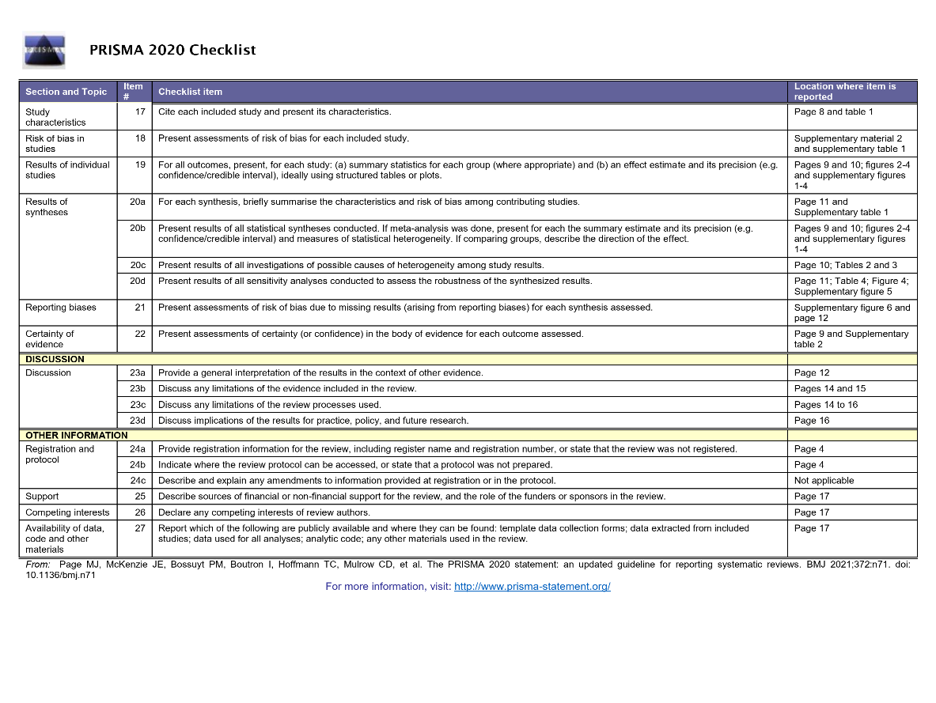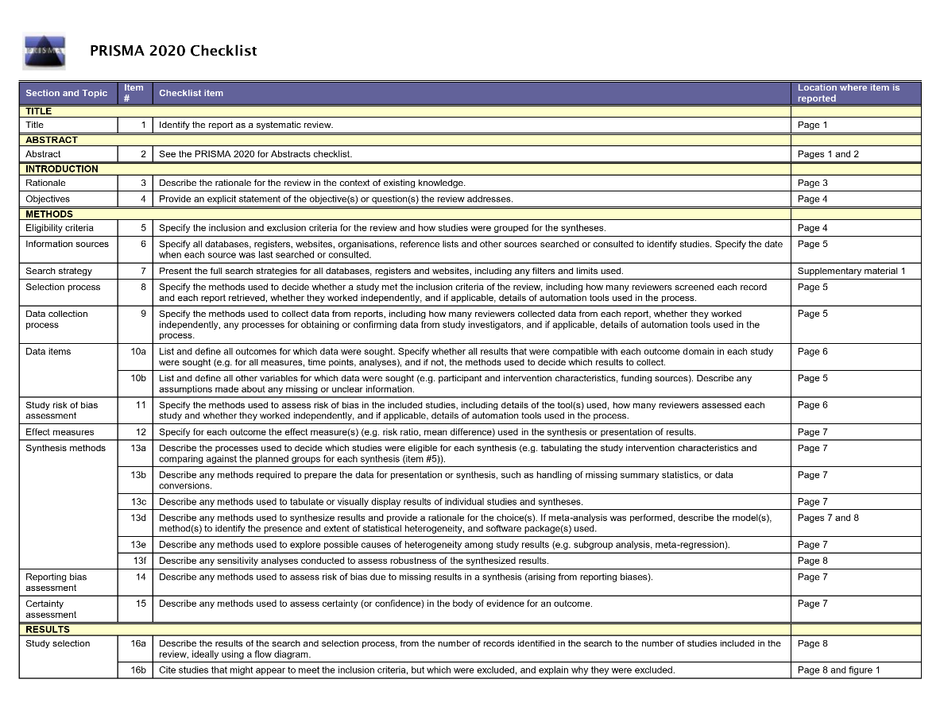
Supplementary figure 7: PRISMA 2020 checklist.

